A few more hurdles to clear in fixed income markets

Ninety One

As we approach the second anniversary of the first rate hike by the South African Reserve Bank, Ninety One SA Fixed Income portfolio managers, Malcolm Charles and Adam Furlan, outline recent developments that suggest we could be at the top of the interest rate cycle.

It has been a tumultuous 24 months for fixed income, and South African fixed income certainly did not escape the broader bear market. Driving this was a combination of stubbornly rising inflation, aggressive monetary policy tightening and souring sentiment among investors – all coupled with some homegrown challenges.
The year began on a positive note, as China finally reopened from its Covid lockdown and US inflation appeared to be slowing. But market sentiment subsequently soured as a combination of resilient economic data in Europe, robust US labour market data and stubborn core inflation in the US caused investors to anticipate tighter monetary policy. This led to a re-appraisal of long-term interest rates, with 10-year US treasuries reaching more than 5% in October.
Interest rates are now expected to remain higher for longer. Rates volatility continued to be the dominant theme, as negative headlines from the banking sector (in the US and Europe) and concerns around US debt ceiling negotiations kept investors cautious. The recent escalation of violence in the Middle East has added to the multitude of geopolitical risks.
Against this challenging backdrop, the SA rates market came under pressure and the rand suffered as a result of a strengthening US dollar and heightened geopolitical tensions – relating to allegations over links with Russia and concerns around a potential visit by President Putin during the BRICS summit. The move by the Financial Action Task Force to greylist the country earlier in the year was a further headwind.
Figure 1: The rand underperformed relative to expectations driven by a flurry of headwinds
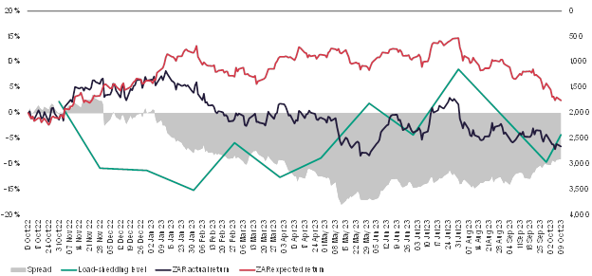

Source: Ninety One, Bloomberg and Deutsche Bank, 9 October 2023.

Reason for optimism but a few more hurdles to overcome
Looking ahead, it’s safe to say the worst is behind us. Global central bankers, after being slow to act, have now delivered aggressive rate hikes to try and get ahead of the prevailing risks.

First to inflation. After proving stubbornly sticky, inflation in South Africa is back inside the target band, allowing the South African Reserve Bank (SARB) to pause its hiking cycle. We are of the opinion that inflation will continue to remain within the SARB’s 3-6% target band for the foreseeable future and should be back at the midpoint of the target range in the second half of next year.
Potential impacts on oil prices because of the Middle East conflict will keep the SARB cautious for now, but rate cuts can be expected towards the latter parts of 2024.
Figure 2: The SARB has controlled inflation
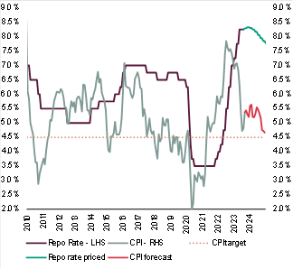
Source: Ninety One, October 2023.

The Fed may not be far behind
November saw the Fed keep the target range for the federal funds rate steady for the second meeting in a row, increasing the likelihood that we are at the top of the hiking cycle. Headline inflation (CPI) for September was unchanged at 3.7% year-on-year, while markets had expected a slight decline. Core inflation slowed to 4.1% year-on-year. Despite a resilient labour market in the US, Fed governors warned of the impacts of higher long-term treasury yields on US financial conditions, with the market now starting to price in the top of the interest rate cycle.

In a further positive shift, recent economic data fuelled increasing optimism that the Fed could bring inflation under control without driving the US economy into a recession. Other positive dynamics for the global economy include the recent pledge of support by officials in China to lift the country’s economy and support the struggling property sector, although concrete measures of support have so far disappointed market participants.

Encouraging signs on the domestic front
We have seen encouraging signs of a turnaround at Eskom combined with huge private investment into generation capacity, which should help draw a line under the load-shedding that has weighed heavily on the economy. The SARB initially slashed its GDP forecasts in the wake of the intensified power cuts early this year. But the economy has proved to be quite buoyant despite the load-shedding, and we anticipate that GDP will grow by 0.6% this year. Although it's still early days for Eskom to steady the ship, the state-owned power utility continues to receive much-needed help from private sector investment, providing some optimism for growth next year.
In addition, geopolitical risks receded after South Africa clarified its neutral stance on the Russia-Ukraine war, and President Ramaphosa since undertook efforts to broker peace negotiations and engage with a variety of global leaders. South Africa hosted a successful BRICS summit and managed to convince Russian President, Vladimir Putin, not to attend in person and thus avoid a diplomatic and legal mess. After some uncertainty, South Africa successfully hosted the recent African Growth and Opportunity Act (AGOA) forum and should see the AGOA benefits retained when it is voted on in early 2024. These developments have helped reduce some of the risk premium embedded in the rand and local fixed income assets.
But beware of lingering clouds
Despite the various improvements to the macro environment, there are still some headwinds facing fixed income markets. In South Africa, fixed income is particularly sensitive to volatility in developed markets, especially monetary policy adjustments by the Fed. However, with the Fed possibly nearing the end of its interest rate hiking cycle, this should bring some stability to local fixed income assets. In addition, the risks of fiscal challenges as a result of lower commodity prices and ongoing load-shedding are now well priced into local government bonds, with 30-year yields around 13% (October 2023). National Treasury will need to continue to rein in expenditure where possible to consolidate the debt trajectory.

What this backdrop means for investors
Despite these last few hurdles facing the asset class, investors are being more than adequately compensated for the associated risks. Investors are currently being offered very attractive yields, with the yield on the 10-year South African government bond currently exceeding 12% – well above inflation and cash. The current high yields on local government bonds bode well for the fixed income return outlook, with income being an important driver of returns.

Figure 3: SA valuations are particularly attractive
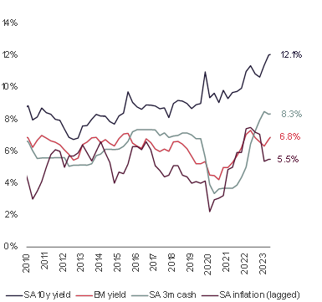

Source: Bloomberg and Ninety One, 9 October 2023.

Conclusion
As global inflation continues to moderate, we are seeing central bankers signalling that they are at or near the peak of the hiking cycle that has been a headwind for global fixed income markets. With the prospect of interest rates stabilising and economic growth showing more resilience than anticipated, we expect global investors to become more comfortable investing in emerging markets again.
On the domestic front, we are now starting to see upward revisions to GDP forecasts. At the same time, the SARB paused its policy-tightening measures at the most recent MPC meeting. As these headwinds continue to dissipate, we believe South African government bonds remain attractive, once again offering investors the opportunity to earn returns well ahead of inflation.

