China: Structural and cyclical challenges present opportunities

Ninety One

Iain Cunningham, Head of Multi-Asset Growth at Ninety One discusses some of the structural and cyclical aspects of the Chinese economy and why Ninety One currently sees attractive investment opportunities in the region.

China faces several structural headwinds, which are well recognised by investors and Chinese authorities. The primary structural challenges are fourfold: a real estate imbalance, a local government and state-owned enterprise leverage imbalance, weakening demographics and geopolitical headwinds.

Before delving into each, we believe it’s important to remember that China is a command economy with a relatively closed capital account. Thus, Chinese authorities broadly control the flow of money and credit across the economy by instructing state-owned banks how much to lend and to whom. This differs from capitalist economies where central banks raise and lower interest rates to impact the cost of money and credit and, therefore, its flow. Here, banks and other profit-maximising private participants decide how much to lend and to whom. Therefore, a default in China is typically a policy decision.

China also enacts what authorities refer to as “cross-cyclical policy”, interpreted as “taking action sooner, in smaller steps and with a focus on the longer term”. This drives China’s regulation cycle, which has followed a pattern over the past decade: When the economy is doing well, new regulations are introduced to address structural issues, and when the economy is weak, prior regulations are often partly repealed as authorities seek to boost confidence. China’s economy and policy dynamics are therefore quite different to that of most other economies around the world.

Mounting real estate woes
Chinese authorities identified the real estate market as a key issue some time ago. After a decade of rapid growth, real estate investment as a percentage of GDP peaked in 2014 at just over 14% (at the end of 2021 it was 13% of GDP), according to IMF data. China’s objective is to manage this sector lower over multiple cycles, in line with the cross-cyclical policy. Essentially, when times are good, authorities will likely clamp down on it and when times are tough, they are going to seek to stabilise the sector but stimulate and grow other areas of the economy that they want to support. As a result, we should see real estate shrinking as a percentage of GDP over the longer term, making this a sector in which we would not want to invest.

The current down cycle in real estate is policy driven – in late 2020, the “three red lines” policy – which restricts the amount of new borrowing property developers can raise each year – was introduced for property developers to force a reduction in debt levels and an increase in liquidity. This was coupled with broader regulations limiting the likes of multiple home purchases and increasing loan to value ratios. We expect authorities to continue to do what it takes to achieve stability in the sector in the near term. But don’t be surprised if there is another clampdown in the years ahead, and then again longer-term.

Bailouts affecting the banking sector
Another key imbalance is local government and state-owned enterprise leverage. Again, this is well known to authorities, and they clamped down hard on this through H1 2021 to address off-balance sheet liabilities or “hidden debts”. This has, without doubt, contributed to weaker growth in recent years by reducing the spending of local governments. At July’s Politburo meeting, Chinese authorities pledged to “implement a comprehensive debt solution” for local governments. In recent months, debt swaps have been announced for several provinces, and state banks have been told to do the same more broadly. This is effectively a refinancing of debt, extending maturities at much lower interest rates. It is a bailout that will allow local governments to continue to function, but it will reduce the profitability of Chinese banks – another sector to avoid.

Figure 1: Breakdown of China’s debt
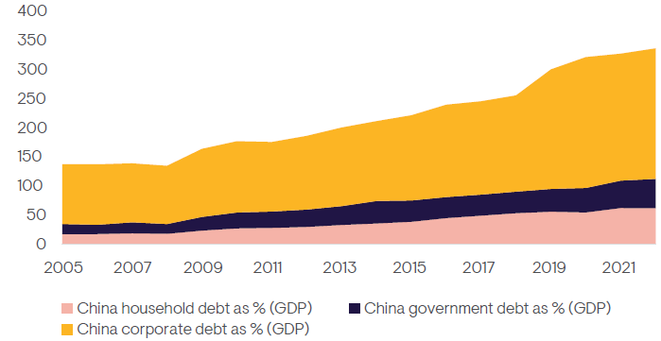
Source: Bloomberg, December 2022.
Weakening demographics put spotlight on productivity
Demographics also represent a challenge on a forward-looking basis versus the past, with the overall population having peaked and the working age population beginning to decline. One counter to this is the prospect for further urbanisation, with China’s urbanisation rate standing at close to 65% at the end of 2022 and most developed economies having urbanisation rates of 70-90%. Our central case would be that these forces largely offset one another, making demographics neutral for the rest of this decade.
Productivity gains, therefore, will be required to drive growth going forward. China is coming from a low base in terms of productivity, with the average income per capita being a little over $12 000 vs. over $75 000 in the US, for example. When Japan’s population peaked in the early 1990s, per capita incomes exceeded that of the US at the time. Chinese authorities know this, and it’s a key reason why they have been seeking to address monopolistic behaviour and are directing stimulus at technological development and science to drive productivity gains.

Figure 2: China’s rapid urbanisation
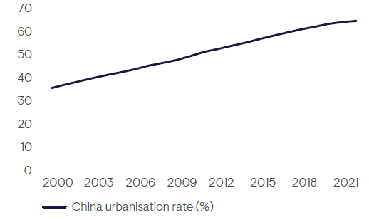
Source: Bloomberg, December 2022.
Figure 3: Productivity gains key to drive Chinese growth
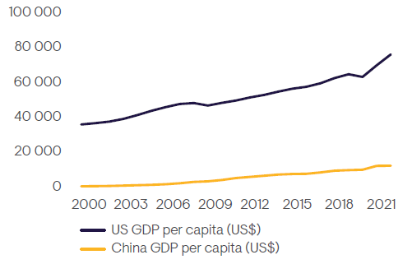
Source: Bloomberg, December 2022.
Geopolitical headwinds
“De-risking” by the developed world in recent years and the reworking of supply chains have reduced foreign direct investment into China and exports to the US. Our central scenario going forward is a multi-polar world, where connectivity between the developed world and China is reduced, but decoupling is impossible due to the degree that economies are interconnected. While this negatively impacts Chinese exports to much of the developed world, trade with other countries around the world has been rising sharply. IMF estimates for the G7 countries vs. BRICS countries (pre-expanded) place their share of GDP, at purchasing power parity, now at 29.9% vs. 32.1%, respectively, in 2023. As a result of the increasing importance of countries outside of the G7, Chinese exports have continued to rise in recent years and remain stable as a percentage of global exports.
Figure 4: Chinese exports resilient as companies find new terrain
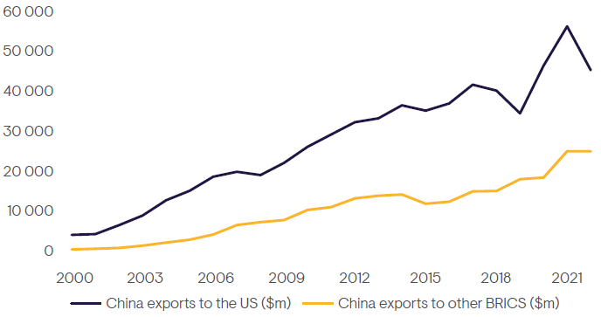
Source: Bloomberg, December 2022.
An improving outlook – who will be the winners and losers?
As we have detailed here, we expect a more benign outcome for the Chinese economy over the medium term. Economic growth will continue to moderate, but productivity gains should drive growth. While some areas of the economy will remain under pressure, others should thrive. For example, real estate will be in decline (as a percentage of GDP); the banking system will be required to absorb losses, but per capita income growth will support ongoing trends in premiumisation and localisation; digitalisation will see increased penetration; medical technology will be supported by an ageing population; and certain financial institutions will be beneficiaries of state efforts to divert future marginal savings from real estate into capital markets over time, through the likes of pension reform. What’s more, Chinese policy makers have shown that they are pragmatic, and we wouldn’t be surprised to see more inventive policies if required.

