Navigating the variety and complexity of SA Income Funds

Michael Dodd, Senior Fund Analyst at Morningstar South Africa

Income funds continue to be an incredibly popular and important component of South African investors’ portfolios. The more predictable returns, especially when compared to volatile domestic equity markets, have attracted investors to the relative safety of income-oriented funds. In the below article, we summarise some of our latest research in the SA Income Fund landscape (click here to read the full report: An in-depth look at SA Income Funds).

The graph below shows that assets in the Association for Savings and Investment South Africa’s (ASISA) three largest Fixed Income fund categories have grown from a collective R167-billion (at the end of 2012) to R817 billion (as at the end of September 2023).

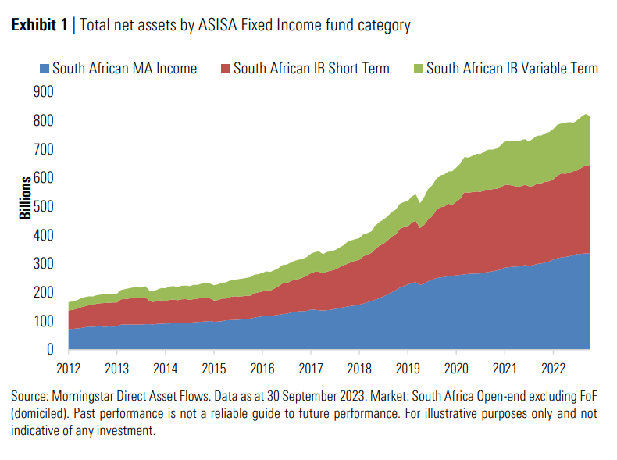

The South African Multi-Asset Income category

SA Multi-Asset (MA) Income has proven to be especially popular and is the largest income category by assets. The graph below shows that the category has seen consistent new fund launches, with the number of unique funds more than doubling over the last decade.

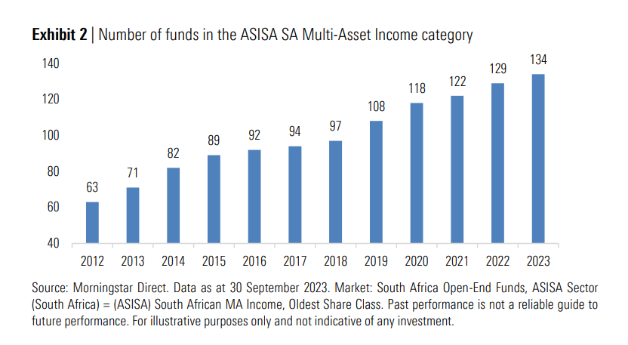

Increased flexibility relative to other income categories has been a meaningful contributor to the popularity of SA MA Income funds. The category allows for less constrained capital allocation and allows managers to construct portfolios with the objective of maximising income across a wider opportunity set of investable instruments.

Understanding the drivers of risk and return

Fund managers overseeing SA MA Income mandates can access less traditional fixed income assets to enhance incremental returns over more conservative income categories. More specifically, managers can use more aggressive asset allocation, duration and credit management strategies to potentially improve fund payoff profiles. Minimum disclosure documents (MDDs) provide a useful starting point to understand how these different risk levers are positioned in the fund.

- Asset Allocation
Asset allocation disclosure provides valuable information about the makeup of a fund which, in turn, can provide insights into a fund’s risk characteristics. Disclosure is relatively transparent, with most MDDs providing line of sight into the main underlying instrument exposures as well as breaking out domestic and offshore allocations. The SA MA Income category allows for total equity allocations up to a maximum of 10% and up to 25% for total property exposure. While these assets do generally provide greater upside participation, they also introduce increased downside risk to portfolios. This allows investors to assess expected return-for-risk trade-offs, particularly where equity and property allocations are close to maximum allowable levels.

- Duration
The SA MA Income category has no explicit duration limits. The risk and return parameters of individual funds can vary meaningfully depending on underlying mandates and investment strategies. Higher duration carries relatively higher interest rate risk which potentially exposes investors to increased drawdowns and downside risk if not appropriately managed. Unfortunately, fund duration is not a mandatory disclosure and is not usually shown on MDDs. While this is a gap in the industry, some asset managers have been more proactive in disclosing this key risk metric to allow for improved transparency and comparability across peer group funds.

- Credit
Fund allocations to domestic credit are typically spread across banks, state-owned enterprises (SOEs) and corporates. Banks trade with relatively good liquidity while price discovery has generally been weak in SOEs and broader corporate credit where market breadth is especially narrow. MDD disclosure is relatively generic, and while a general breakdown of aggregate credit exposure is sometimes shown, liquidity risk is often understated because of market structure constraints. Funds with high credit exposure should also be carefully assessed to more reliably estimate the reward-for-risk profile that is often skewed by relatively low volatility.

Has increased flexibility improved performance?

In an environment where local rand-denominated assets have generally underperformed, it’s important to understand if the greater flexibility available to SA MA Income fund managers has generally benefitted investors.

The graph below shows the average performance of the SA MA Income category versus the more conservative SA Interest Bearing (IB) Short Term peer set. The latter is a fund category that restricts the investable universe to fixed income securities and limits duration to a maximum of two years.

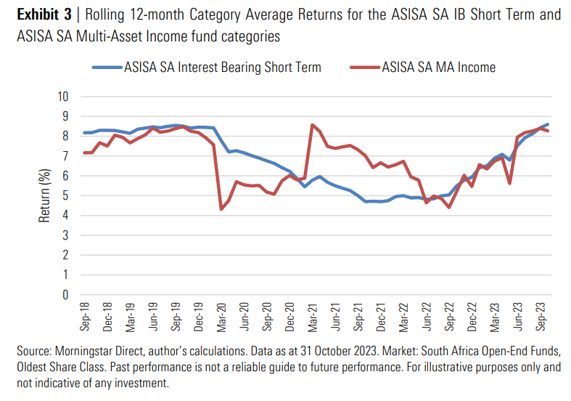

The average SA MA Income fund is shown to deliver performance approximately in line with more conservatively managed SA IB Short Term peers over the last five years. The SA MA Income category has also experienced greater volatility and deeper drawdowns during market shocks like the COVID-19 induced market selloff in 2020. Returns of the SA IB Short Term category are more closely aligned with the interest rate cycle, falling gradually as rates were cut post[1]pandemic and rising as interest rates have normalised towards higher levels this year.

Narrowing the focus to consider performance during a particularly turbulent period for SA bond markets in the second quarter of 2023 also shows mixed results. The graph below shows the monthly returns of all funds in the SA MA Income category in May and June of 2023.

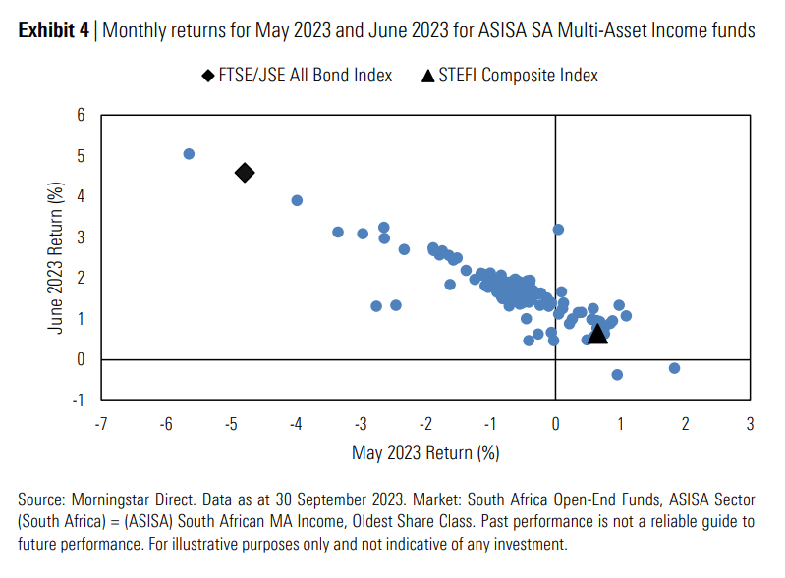
There are two key takeaways from the graph above:
- The SA Bond market sold off heavily in May 2023 (-4.8%) which contributed to SA MA Income funds with higher duration experiencing drawdowns commensurate with that of the FTSE/JSE All Bond Index. While most of these funds rebounded the following month, elevated volatility in the current environment is likely to expose funds with more aggressive risk profiles or inadequate strategies to appropriately manage interest rate risk.
- There were several funds that produced positive return outcomes in both months. These funds fall broadly into two types of approaches: defensive managers with shorter duration profiles and managers who are making extensive use of credit instruments that may not mark-to-market regularly.
In conclusion
As is evident from the growth in the fund category, income funds remain extremely popular. While the category has grown significantly, all income funds are not created equal. This is especially true for SA MA Income funds with the flexibility to allocate capital across a wider opportunity set.

On a reward-for-risk basis, the average SA MA Income fund does not appear to sufficiently compensate more cautious investors looking for relatively stable income-oriented returns. Lagging disclosure requirements also increase the complexity of assessing performance and risk, particularly where duration and credit are being used to enhance returns.

Following a robust manager research and selection process that leverages both quantitative and qualitative analysis to understand process, as well as estimate forward-looking risk and return is fundamental to our investment approach at Morningstar. Ultimately, as investors in a number of these funds, understanding their risk characteristics and subsequent return expectations is key. We believe that these are best understood by assessing the levers of return that managers can pull and how managers use these levers to construct their funds.

