The new meme stock craze likely to end in tears in Asia

Robin Parbrook, Co-Head of Asian Equity Alternative Investments at Schroders

Some sectors in Asia are seeing bubbles emerge. Just as with the US meme stock craze, it’s not likely to have a happy ending for many over-exuberant retail investors.
Bubbles are appearing in certain sectors in Taiwan and Korea. In the latter case, it resembles the US meme stock trend that resulted in the dramatic rise and decline in shares such as Gamestop.
Artificial intelligence in T-AI-wan
In Taiwan anything considered an artificial intelligence (AI) play has recently been rapidly inflated by retail investors.
In particular, basic box assembly companies and contract manufacturers like Quanta, Wistron and Inventec rose 50% in July alone, according to Factset. Their share prices have more than doubled year-to-date. In the case of Wistron, its share price has more than quadrupled over the period.
All three companies, among other products, assemble AI servers. Asian retail investors now seem to believe this will change their businesses to a dramatic extent. This is unlikely in our view.
Assembling an AI server will not be so different from assembling a traditional server. And considering AI servers are far more powerful, we believe the overall volume of servers to be assembled may actually fall.
All three companies have consistently had very thin operating margins on their assembly business of 1-2%, reflecting the low value added nature of what they actually do.
We don’t doubt that AI is a potentially ground-breaking technology, but it’s still in its relative infancy and applications are still to be defined.
The scientist and futurist Roy Amara stated that “we tend to overestimate the effect of a technology in the short run and underestimate the effect in the long run”. This has become known as Amara’s Law. We believe that with this in mind, we are currently running close to the peak of inflated expectations when it comes to supposed AI stocks in Taiwan at least.
Chart 1: AI and server names in Taiwan – peak of inflated expectations?
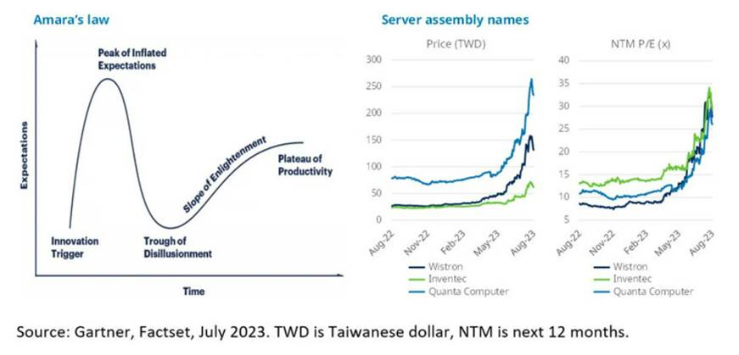
"Mr Batt-Man" and Korean EV mania
In Korea the retail fervour appears even more irrational and is more akin to the meme stock craze we saw in the US.
The Korean retail investor has become fixated with perceived electric vehicle (EV) battery plays. This is all on the back of US regulations under the Inflation Reduction Act to encourage onshore investment in the sector and also to exclude Chinese battery names from the US market.
This has led to a Korean retail buying spree in the sector all encouraged by a questionable online “red-hot stock” tipster who calls himself “Mr Batt-Man” - or "Mr Battery" - and who now has a huge retail following.
This has led to some quite extraordinary moves in selected stocks in Korea, with thematic names like Ecopro, Posco Future M, Ecopro BM and Posco (despite being 80% a steel company) all doubling since end March and rising 60-70% in July alone.
Chart 2: Mr Batt-Man’s EV picks hit the big time
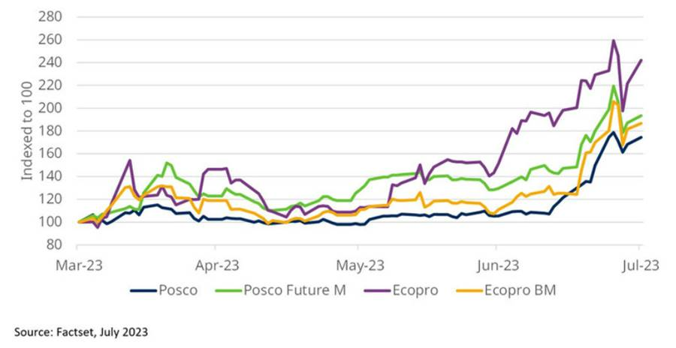
We have no doubt this will end in tears. Korean market turnover on several days in July was close to the highest in history (for the KOSDAQ index it has exceeded past highs), with 40-50% of the turnover concentrated in just four or five battery names. Intraday moves in battery stocks have also been wild and volatile.
It is all the more perplexing for us as, while we can understand the retail fervour in AI-related stocks given the global hype, in the EV battery space this is a uniquely Korean concept.
Elsewhere in the region, battery names are weak as investors worry about slowing EV demand in China and huge industry overcapacity in the battery space, most especially in cathodes, anodes and separators (the stocks being ramped by Mr Batt-Man).
As Chart 3 below shows, potential industry overcapacity is very large and the recent performance of Chinese battery names appears to better reflect reality.
Chart 3: Oversupply and share price warning signs in China
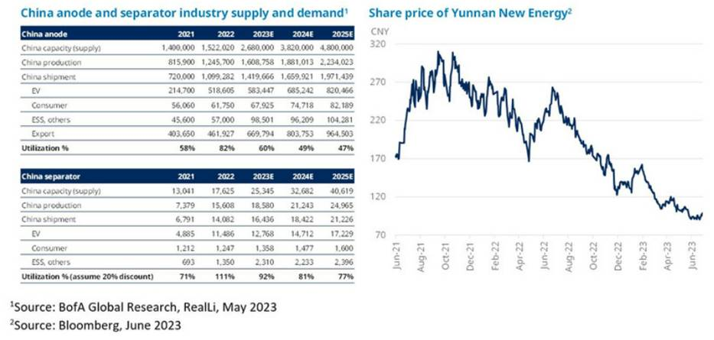
Any reference to sectors/countries/stocks/securities are for illustrative purposes only and not a recommendation to buy or sell any financial instrument/securities or adopt any investment strategy.
*The views and opinions contained herein are those of the individuals to whom they are attributed and may not necessarily represent views expressed or reflected in other Schroders communications, strategies or funds.

