Has China finally slid into a debt/deflation spiral?
David Rees, Senior Emerging Markets Economist at Schroders
Although weaker Chinese domestic demand is causing concern, this may not be the start of a long-term economic depression.
The latest batch of data will have done little to calm fears about the health of China’s economy. An apparent collapse in domestic demand meant that imports were far weaker than expected in July, while the economy slid into deflation last month as consumer prices fell by 0.3% compared to the same period a year earlier (y/y).
If ever evidence was needed to back up claims of "Japanification" and a debt/deflation spiral, then this appeared to be it. This is in marked contrast to most other parts of the world where our regime shift work suggests that the risks to structural inflation and interest rates are skewed to the upside.
Fears of a debt/deflation spiral cannot be dismissed entirely. After all, China is an economy that has excess supply, while demand is softer than we had assumed following the removal of the zero-Covid policy.
Booming travel failed to translate into broader economic growth, not least because the clampdown on speculative real estate purchases in recent years has cut off a key source of demand in the economy and avenue for policy transmission. Indeed, the July credit data again showed that, with house purchases still very weak, there is little demand for credit from households. This helps to explain why plentiful liquidity has so far failed to make it into the real economy in recent months. And China’s enormous stock of debt is well documented.
We will in due course look at the prospects of China descending into a long-term deflationary spiral like that seen in Japan. And there are clearly some parallels given the amount of leverage exposed to the over-supplied and expensive real estate market.
However, there are a few reasons to think that July did not mark the beginning of a long-term depression.
For a start, it is not obvious that the collapse in China’s imports in July was entirely due to weak domestic demand. Part of the slump in imports was due to weak purchases of high-tech intermediate goods such as semi-conductors. Some of that may have been caused by the US ban on technology exports to China that has been ratcheted up in recent weeks. As we have discussed in our regime shift work, the emergence of a new world order is a threat to globalisation. However, much of the recent decline in technology imports appears to have been due to cyclical weakness in the global manufacturing cycle. This may soon start to reverse, with some leading indicators suggesting that global manufacturing PMI will climb back above 50 by the fourth quarter of this year.
China imported fewer intermediate goods as global demand softened
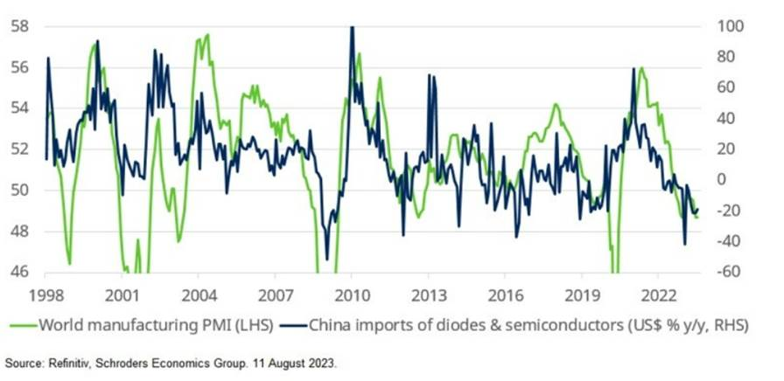
Meanwhile, price effects also cloud the import picture, particularly for commodities. Indeed, while China’s imports of commodities are generally contracting in nominal, year-on-year terms, they are actually growing in volume terms. Iron ore import volumes were 4.6% y/y higher last month, copper rose 8% y/y and oil import volumes were up by almost 25% y/y. China’s demand for commodities would be stronger if its housing market was stronger. But this suggests that weak Chinese demand is not the sole reason for low commodity prices, and it is worth noting that the Bloomberg commodity price index (Bcom) is also simply following the global manufacturing cycle.
Commodity prices continue to track the global manufacturing cycle
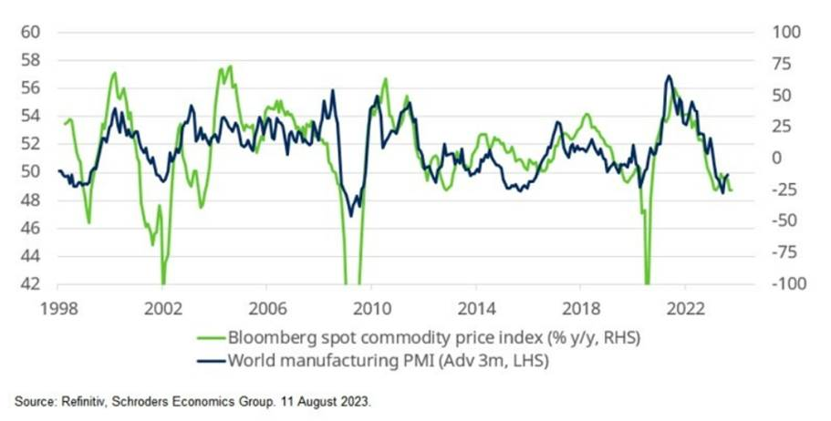
Commodity price movements also help to explain China’s fall into deflation. As the chart below shows, while headline inflation fell to -0.3% y/y in July, from 0% in June, much of the decline was due to commodity-related fields. The water, electricity and fuel component has been negative for several months as the effect of past energy price increases washes out of inflation. This has been a welcome driver of disinflation in other parts of the world, whereas the much lower starting point in China has caused it to be deflationary.
Food dragged China into deflation in July
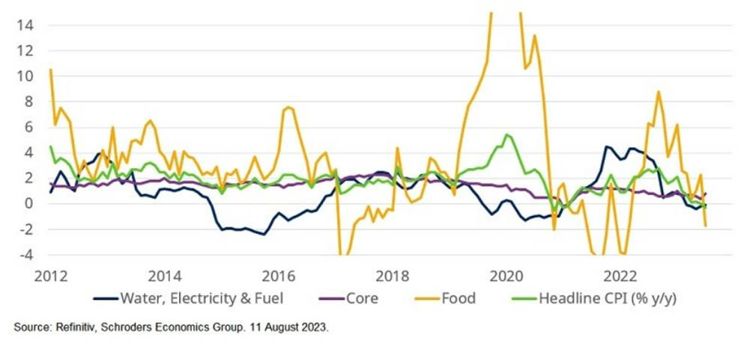
However, the big shift in July came from the food component. Again, food inflation has been declining globally and is a key reason why other emerging markets have room to start cutting interest rates. Those trends have been compounded in China by a collapse in pork prices after a surge in supply. Pork CPI, which accounts for about 3% of the overall basket of goods, fell to -26% y/y last month, from -7.2% y/y in June. That meant pork alone knocked around 0.5%-pt off headline inflation.
Beyond that, core inflation rose to a six-month high of 0.8% y/y in July. Admittedly, core goods slipped to -1.3% y/y, the lowest reading since the global financial crisis. But the decline in core goods prices has come alongside producer price deflation, which can also be blamed in large part on movements in global commodity prices. If commodity prices were to remain around current levels, PPI will remain negative until early-2024.
PPI has also been dragged down by commodity prices
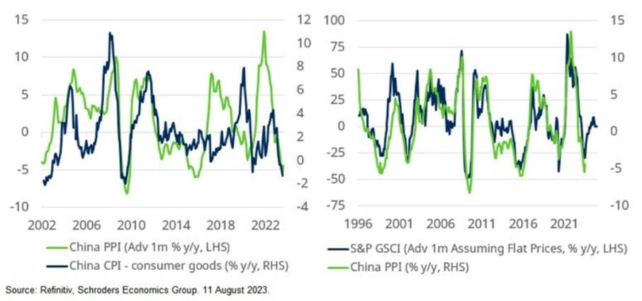
Core services inflation, which is more linked to domestic activity, accelerated in July as those sectors such as tourism that have benefitted from the removal of the zero-covid policy have shown some price pressures.
Strong post-Covid demand is pushing up services inflation
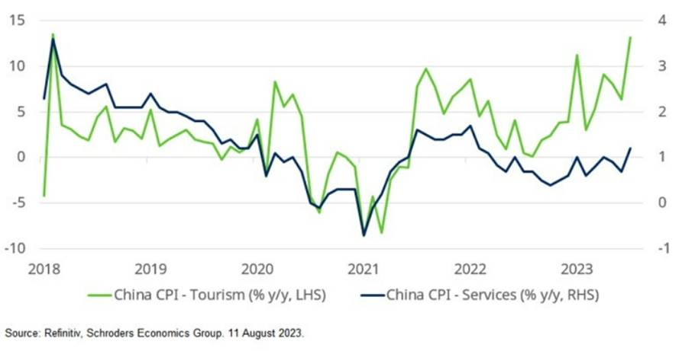
The upshot is that while China’s economy is clearly struggling and faces long term challenges that will weigh on growth, the recent slide into deflation appears to have more to do with the unwinding of past increases in global commodity prices as it does weak domestic demand. If we are right, then the current bout of deflation is likely to last months rather than years.

