What might oil back above $90 mean for US inflation?

George Brown, Economist at Schroders

With surging oil prices continuing to make investors nervous as US inflation climbs sharply, we look at the implications for the global economy.

A little over a year ago, the annual rate of US CPI inflation stood at a four-decade high of around 9%. Today, it is 3.7%. This stark reversal has been largely due to last year’s jump in energy prices unwinding. But output cuts by OPEC+ have seen oil prices rise by 20% over the past three months, with Brent crude back above $90 per barrel for the first time since November 2022. This is in complete contrast to last year when recession fears drove prices down 20% over the same period.
Will the increased energy costs be largely absorbed by US business?
Alongside numerous unplanned refinery outages, this has caused gasoline prices to spike just as the US summer driving season moved into top gear. In August alone, pump prices rose some 30 cents to $3.80 per gallon.
After accounting for seasonal effects, the contribution of gasoline prices in the US ought to shift from -1.0 to -0.1 percentage points to annual CPI inflation in August. In isolation, this would push the US headline CPI rate back above 4% in August.
With oil prices back on the rise, is history set to repeat itself?
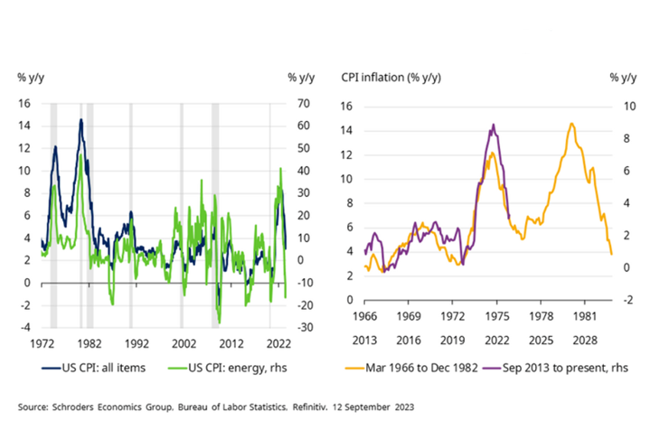
But what do higher oil prices mean for core CPI in the US? While energy is not directly included, oil is an important intermediate input for goods and services. Consider the ubiquity of plastic, for instance, of which about 90% is created from fossil-based sources. As such, there will be some knock-on impact from rising oil prices to core inflation. And with core goods and services accounting for roughly 80% of the CPI basket, it is important to quantify what the impact is likely to be.
As there are no official figures on the commodity content of core CPI, we instead utilise estimates from Goldman Sachs. They reach these with the use of the input-output tables from the national accounts in conjunction with the PCE bridge provided by the Bureau of Economic Analysis, before then matching the PCE categories to the CPI equivalents.
While their analysis suggests energy costs make-up as much as 15.9% of some categories, in aggregate they account for just 1.7% of overall core CPI. Why so low? Partly because rents comprise such a large share of the price basket, but even excluding these makes little difference. Rather, it is mainly due to the prices charged by producers being diluted by wholesale and retail margins, which can often account for half or more of the prices paid by consumers.
Energy is a small share of core CPI prices and firms pass on less than half of increases
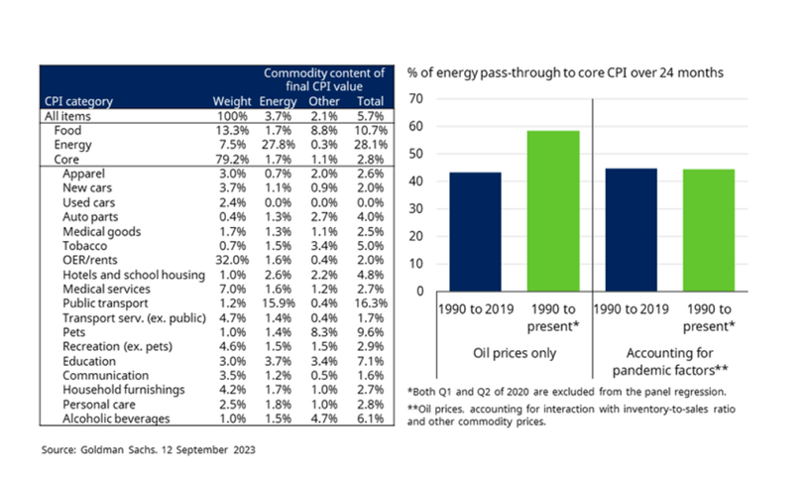
Still, margins are sometimes used to absorb higher energy costs. Goldman Sachs estimate that firms passed through 45% of rises before the pandemic, but this climbs to 60% when including data over the past three years. They ascribe the pick-up in the passthrough rate to lower competitive pressure amidst demand/supply imbalances and less willingness to absorb oil price increases due to broad-based cost pressures. After accounting for these, they estimate that the passthrough rate is in line with what it was before 2020 (i.e. 45%).
Putting this all together, we can assume that roughly half of the 20% rise in oil prices over the past three months will be passed on. And since energy prices account for 1.7% of core CPI, this suggests the total inflationary impact will be less than 0.2 percentage points. Given that this will be spread across several months, it should be barely perceptible.
Offshoring helped reduce impact of rising energy prices
Even the impact on headline inflation ought to be more muted than it has been in the past. This is because the energy intensity of the economy, which is calculated as total energy consumption divided by GDP, has fallen sharply over the past few decades. Last year, it stood at 5.02 thousand British thermal units per dollar, nearly 60% below what is what during the 1979 energy crisis.
Sharp fall in US energy intensity due to offshoring of goods production
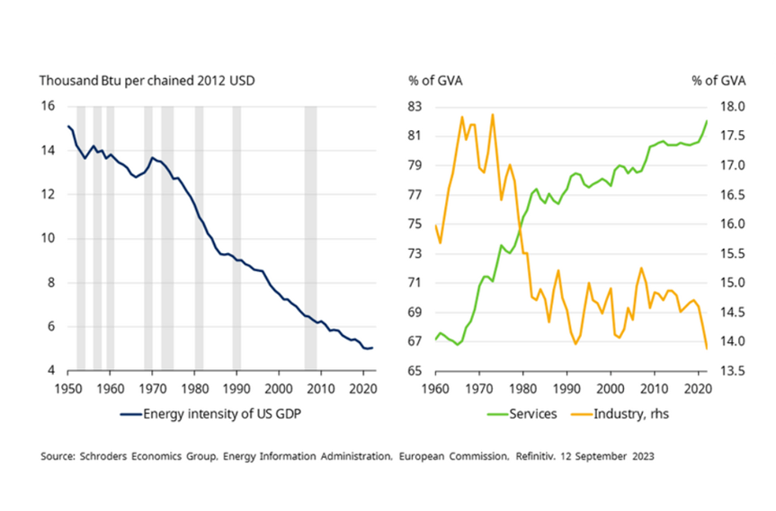
There are two reasons for this. First, the relative efficiency of buildings, vehicles and industrial processes have improved over the decades. Technological progress has played a role here, but so have regulatory initiatives. For instance, the Corporate Average Fuel Economy (CAFE) standards have ensured that miles per gallon of new vehicles have increased 32% since 2004. This is despite horsepower increasing 20% and weight increasing 4% over the same period.
Secondly, the service sector accounts for a larger share of the economy after the offshoring of energy-intensive sectors to countries such as China and Mexico. The states of Oregon and Washington have witnessed a 50% decline in energy intensity over the past two decades. This has occurred after transitioning their economies from energy-intensive industries, such as forestry and agriculture, to less energy-intensive industries, such as electronics and information technology.
Continued tightness of US jobs market the key factor
However, the services sector is more labour-intensive than goods producing sectors, for which capital can more easily be substituted. And so while oil prices have risen sharply, investors should instead be more concerned by the continued tightness of the US jobs market. On one measure, the ratio of job openings to unemployment, it is the tightest seen since the late 1960s with 1.5 vacancies for every person out of work and looking for a job.
These strains are gradually easing, but they could well persist. There could, for instance, be some instances of labour hoarding, with firms being reluctant to lay off staff in the face of deteriorating economic conditions. While this is generally uncommon in the US, given the ease at which workers can be fired and re-hired, the hiring difficulties experienced over recent years may well cause a shift in behaviour among employers.
Excess demand for workers is keeping wage growth elevated
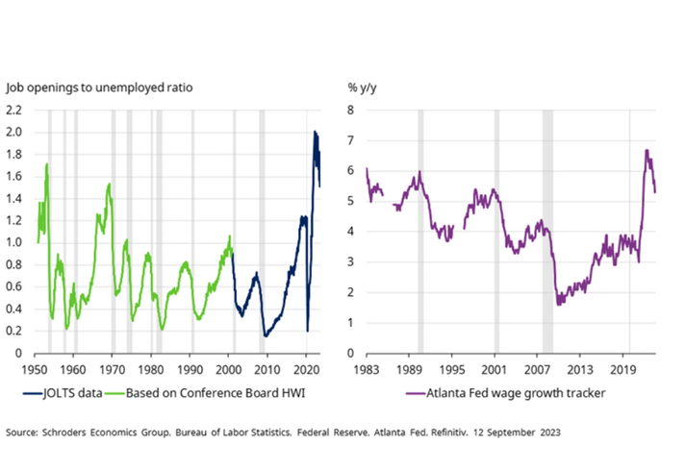
Excess demand for labour could keep wage growth elevated. While the Atlanta Fed wage tracker has rolled over, it suggests that pay is still growing at over 5% per annum. But as we highlight in our recently updated forecasts, ultimately it is not wages, but unit labour costs adjusted for productivity which matter for both companies and inflation. Encouragingly, recent figures suggest that output per head is now returning to its pre-pandemic trend.
Ensuring that this is sustained is central to the soft landing narrative playing out. The recent rise in business investment is certainly encouraging on this front, but capital expenditure does not always translate to productivity gains. And while advancements in Artificial Intelligence (AI) could in theory have multiple use cases, new technologies often take time to be deployed widely across the economy and so any material boost to productivity seems some way off.
So while we expect US core CPI inflation to ease to 2.6% by the end of next year, there is a risk that it could prove more sticky. But it will be the labour market, not oil prices, which will determine whether this is the case.

