How can bond investors fairly score countries for ESG?
Schroders
It’s challenging for bond investors to score sovereigns on their environmental, social and governance (ESG) performance, often leading to a bias towards richer countries. But the Schroders fixed income team has developed a framework that gives countries a more level playing field.

Marcus Jennings - Sustainability & Macro Strategist, Global Unconstrained Fixed Income, Schroders
James Ringer - Fixed Income Portfolio Manager, Schroders
Karen Wright - Associate Investment Director, Global Unconstrained Fixed Income, Schroders

Although sustainability metrics are increasingly being used in sovereign fixed income markets, there is still no consensus on the appropriate approaches for assessing a country's environmental, social and governance (ESG) performance.

Moreover, there is a noticeable bias in sovereign sustainability scores, which tend to be strongly linked to a country's level of development. As such, addressing this “income bias” in ESG scores remains a key challenge.

As highlighted by the World Bank, this issue is particularly pertinent when constructing investment portfolios based on sovereign ESG scores. Favouring countries with higher ESG scores tilts a portfolio towards richer countries and away from poorer ones, where most investments are needed.

CHART 1: Average ESG scores across seven ESG providers are highly correlated with GNI per capita across 133 countries. The regression line exhibits a significantly positive slope.

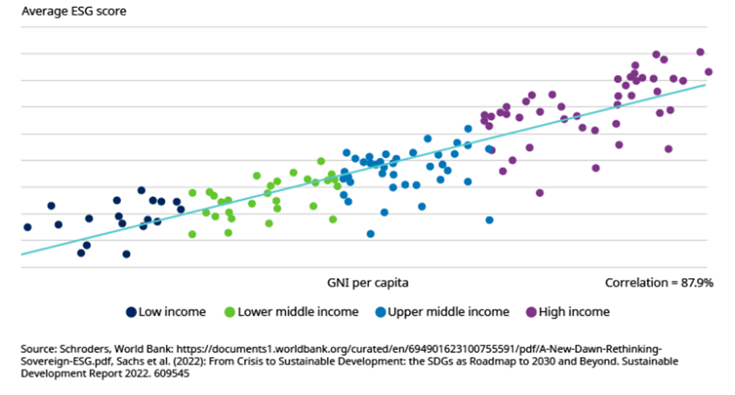
The income bias in ESG scores is often attributed to the stronger institutional frameworks of more developed nations, as well as their better fiscal and economic standing, which enables them to make greater progress towards achieving the United Nations’ Sustainable Development Goals (UN SDGs).

To address this issue, here on Schroders’ fixed income team we’ve developed a framework that enables a more equitable comparison of a country's sustainable progress. Although the sheer size of the government bond market may limit the influence of capital flows compared to the corporate sector, there are still measures we can take to promote a level playing field for developing nations within a global context.

This philosophy is centred around promoting sustainable development across all countries, regardless of their level of development, while also avoiding laggards from a global perspective. At the same time, we aim to deliver returns to investors.

How to assess sovereign sustainability more equally?

Our sustainable framework is designed to enable a fairer assessment of sovereign sustainability. We use a set of predefined criteria based on publicly available data to build a sustainable portfolio, which is actively managed using a top-down ESG integrated approach.

The sovereign sustainable universe within the framework is anchored around the UN SDGs, which provide deep coverage of sustainable issues with 169 targets and 17 development goals. The countries are grouped into four income brackets (high, upper-middle, lower-middle, and low income) defined by the World Bank. This way it is easier to compare the sustainable progress of countries at a similar level of development.

When ranking the UN SDG total scores within each income bracket it is important to put equal weighting on all development goals to avoid moralistic judgements. The top proportion of sustainable performers within each income bracket are the ones best suited, and thus selected, to our investable universe.

CHART 2: SDG scores are ranked and within each income bracket, only the top scoring countries meet the minimum investable criteria (i.e. above the blue line)

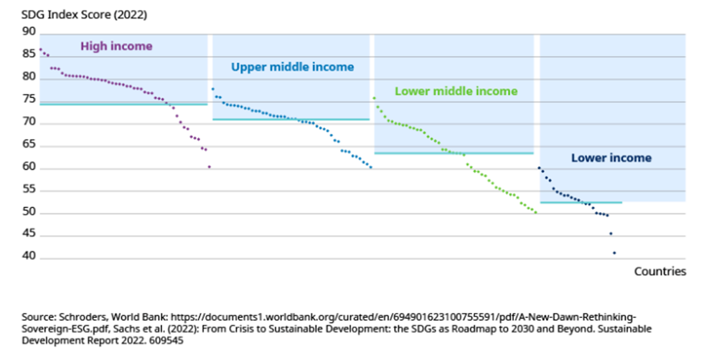

A more equitable way to assess countries' progress in achieving the SDGs is to compare those within the same income group. For instance, comparing middle-income countries like Brazil and South Africa provides a fairer evaluation than comparing the US to South Africa, since the former two are at a similar stage of economic development.

This approach helps to avoid income bias in sustainable scoring and provides a more just comparison of countries' sustainability efforts. In this example, Brazil makes the threshold for inclusion based on the SDG test. However, South Africa does not currently meet the minimum threshold for inclusion based on its SDG score, which lags its bracket’s median. Out of the 17 UN SDGs South Africa particularly lags in terms of SDG 1, ‘No poverty’, with a greater percentage of the population estimated to be living under the poverty threshold of USD 1.90 a day compared to its peers.

CHART 3: Comparing two countries with equal footing

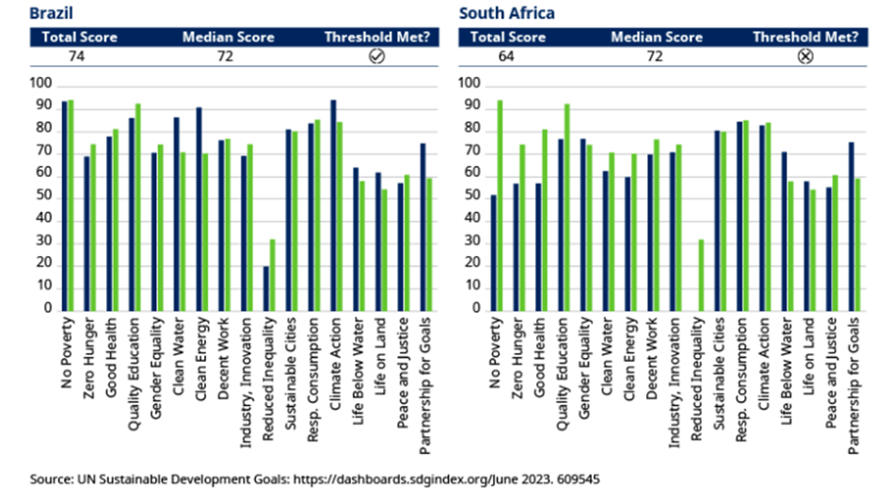

Overlaying additional sustainable criteria

To further improve the sustainability characteristics of countries included in this framework, we used two additional criteria. Firstly, we require governments to have a credible net zero pledge stated in a policy document, indicating a serious commitment to addressing climate change. It’s not sufficient for a government to simply have a net zero pledge, but the sovereigns included in the sustainable universe must demonstrate a serious commitment in addressing the issue of climate change.

Secondly, we believe that sovereign sustainable development requires the citizens of a country to be able to enjoy a degree of political and civil liberty. To ensure impartiality, we use Freedom House as a leading independent source of democracy and political freedom. Only countries deemed 'Free' and 'Partly Free' are considered, aware that setting too strict criteria around political freedoms might penalize poorer countries. However, countries deemed 'Not Free' face a greater challenge to achieving long-run sustainable economic growth and are excluded.

What lies ahead?

Although important steps in addressing the income bias in sustainable scoring have been taken, there is a need to continue improving the methodologies used today. As governments make progress in addressing key issues around climate change and broader sustainable issues, investors need to adapt their approach to capture the leaders in sustainable development.

By creating a framework that accounts for income bias, we aim to encourage sustainable development and promote the progress of countries that might otherwise be overlooked, while also delivering returns. This approach will continue to evolve as governments and societies change, but our commitment to promoting sustainable development and levelling the playing field for global sovereign investing will remain at the core of our philosophy.

*The views and opinions contained herein are those of Schroders’ investment teams and/or Economics Group, and do not necessarily represent Schroder Investment Management North America Inc.’s house views. These views are subject to change. This information is intended to be for information purposes only and it is not intended as promotional material in any respect.

