With cash earning more than 8%, why risk money on the stock market?

Duncan Lamont, CFA - Head of Strategic Research at Schroders

Increased savings rates mean savers globally can earn upwards of 5% on deposits. So doesn’t it make sense to cut risk and stick to the safety of cash?

Cash savers in the UK are benefiting from the highest returns in almost two decades, with some popular accounts paying over 5%. In South Africa the allure of cash is even stronger, with some accounts offering up to 8.9%, with no deposit minimum. The rise in returns globally has been rapid, with rates today in several regions many times higher than a year ago. Unsurprisingly savers are committing more to cash ISAs than at any point in the past five years*.

After a long spell in which nominal returns on cash were virtually zero, investors are now rethinking the role deposits should play in wider portfolios. Schroders’ May 2023 survey of UK financial advisers – coming as the Bank of England raised interest rates for the 12th time since the start of 2022 – found nine in ten advisers were “having conversations with clients about long-term investing versus cash deposits”.

The situation in SA is similar. “This is a genuine asset allocation issue for local managers, and a big talking point for wealth advisers and their clients,” says Philip Robotham, Head of Intermediary for Schroders in South Africa.

With the South African Reserve Bank only recently leaving its key repo rate unchanged at a 14-year high of 8.25% after a tightening cycle after 10 consecutive rate hikes, aren’t investors right to reconsider cash?

All savers’ circumstances are different, and some may have excellent reasons to be holding cash. But just because savings rates are rising does not mean cash is keeping pace with inflation.
Popular UK savings rates vs inflation
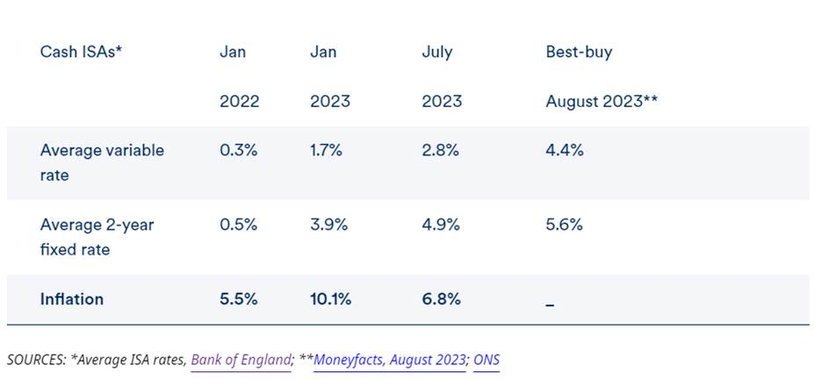
As shown, cash returns after inflation – or “real” returns – remain negative, even though rates have risen strongly. Negative returns mean losses. And the jump in inflation since early 2022 means that the value of cash is now eroding at a faster pace than for most of the previous decade, even if the cash earns today’s top available rates.

So for many the key question of where to make long-term investments remains as relevant as ever. In fact it is even more important.
Cash or equities: what are the chances of beating inflation?
The certainty offered by cash lies only in its nominal value. R100 today will still be R100 in future years. There is no certainty its spending power will hold up, however. Low inflation will see the money retain its spending power to some degree, but high inflation will erode it quickly.

Time is the critical factor. Over short periods cash is likely to fare better against inflation. Over long periods, cash fares worse, even where inflation is relatively low.

The chart below crunches historic returns on cash and stock market investments in the US over a range of timeframes extracted from 96 years’ data. It then sets these against inflation over the same timeframes.
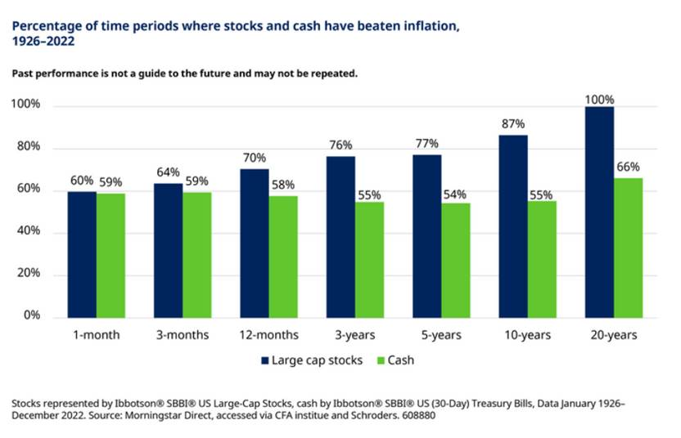
The results are stark. The chart shows that over very short periods – three months or less – there has not been much difference in the likelihood of cash or shares beating inflation. But for longer periods the gap widens conclusively.

- The likelihood of cash savings beating inflation has been about 60:40 for the majority of all timeframes.
- The likelihood of stock market investments beating inflation has reached 100% where the investments are held for 20 years.

In other words, for every 20-year timeframe in the past 96 years, equities delivered inflation-beating returns.

So while stock market investments may be risky in the short run, when viewed against inflation they have offered far more certainty in the long run.

The stock market has delivered strong long-term returns through very different conditions

The recent era of ultra-low interest rates, from which we’re now emerging, has meant that cash has been unattractive for investors. That is despite the fact that inflation until recently has been low.
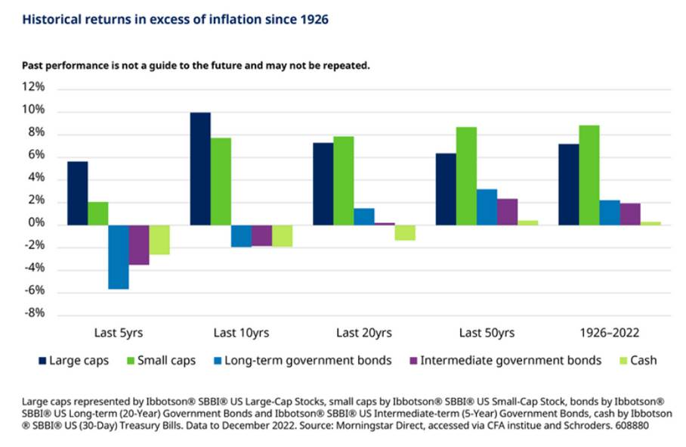

In the past five, ten and 20 years, cash savings have failed to keep up with price rises and so depositors would be worse off.

Over very long periods – during which inflation and interest rates have gone through both highs and lows – cash has retained its spending power, but only just.
By contrast, stock market investments have delivered inflation-beating returns over all periods highlighted in the chart.

So it’s a no-brainer: stock market investments are a better bet for long-term real returns?

There are lots of reasons to hold cash, and savers’ individual timeframes will differ. For many, this is where financial advice will be invaluable.

“The cash debate is a perfect example of where advisers deliver value to clients,” says Gillian Hepburn, Schroders’ Head of UK Intermediary Solutions. “The question of ‘should I invest in cash?’ is not straightforward, and for the longer-term saver all the data points to investing being the best option for many.

“Investors view ‘trust and peace of mind’ as being a key benefit of receiving advice," she adds. "This is a classic area where clients need ongoing support and where advisers can really deliver that ‘peace of mind’, as well as helping ensure clients’ investments are in the right place to meet their goals.”

While long-term historic data strongly suggests stock market investments stand a better chance of beating inflation than other investments, they are also volatile.

So investors who opt for stock markets over cash need to be prepared for a bumpy ride.
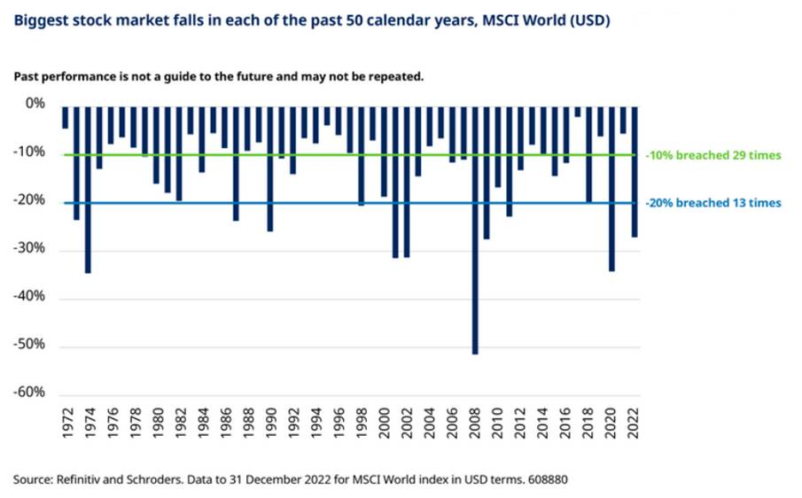
- In approximately half of the past 50 years markets fell by at least 10%.
- In a quarter of the past 50 years markets fell by at least 20%.

In conclusion, different risks attach to both cash and stocks and shares. Cash is far from a risk-free asset: even at today’s best available savings rates, deposits are likely to lose real value. And, as our data shows, cash can deliver real losses over longer periods too, including the past two decades. But shares also carry risk, especially when held for shorter periods.

*Source: Bank of England, two-year fixed rate cash ISA, change from 30 April 2022 (1.19%) to 30 April 2023 (4.12%). ISA deposits from BoE Money & Credit tables. Data issued June 2023.

