Does your family structure change how you draft your will?

Sanlam Trust

From the Kolisis to the van Jaarsvelds, South Africa boasts beautiful families of all shapes and sizes. Whether it’s you and your partner, you two plus a few, you plus a fur-child, or just you, Moremadi Mabule, Head of Sales: Beneficiary Fund at Sanlam Trust, says it’s important to have a signed will so that your final wishes are known, and your family is fairly provided for.

“There is a mistaken belief that wills are only necessary for people with lots of assets. If you have a minor child (under 18 years), pets, a car or house, savings or investments of any size, cryptocurrency, photos or music in the cloud, or sentimental items such as jewellery or art – even if they are not very valuable – then you need a will,” says Mabule. A recent Sanlam survey of digitally active, working South Africans found that 98% of people had one or more of these assets, but 45% don't have a will.

If one considers the full population, about 80% of South Africans don’t have a will. “Many see it as a complex and expensive process, but it isn’t! The process of drafting a will is always the same, but there are subtle nuances to consider, depending on your unique family structure. It’s also vital to keep your will current, changing it whenever there’s a major life event, like marriage, divorce, the birth of a child, the death of a beneficiary, or a change in financial circumstances,” explains Mabule.

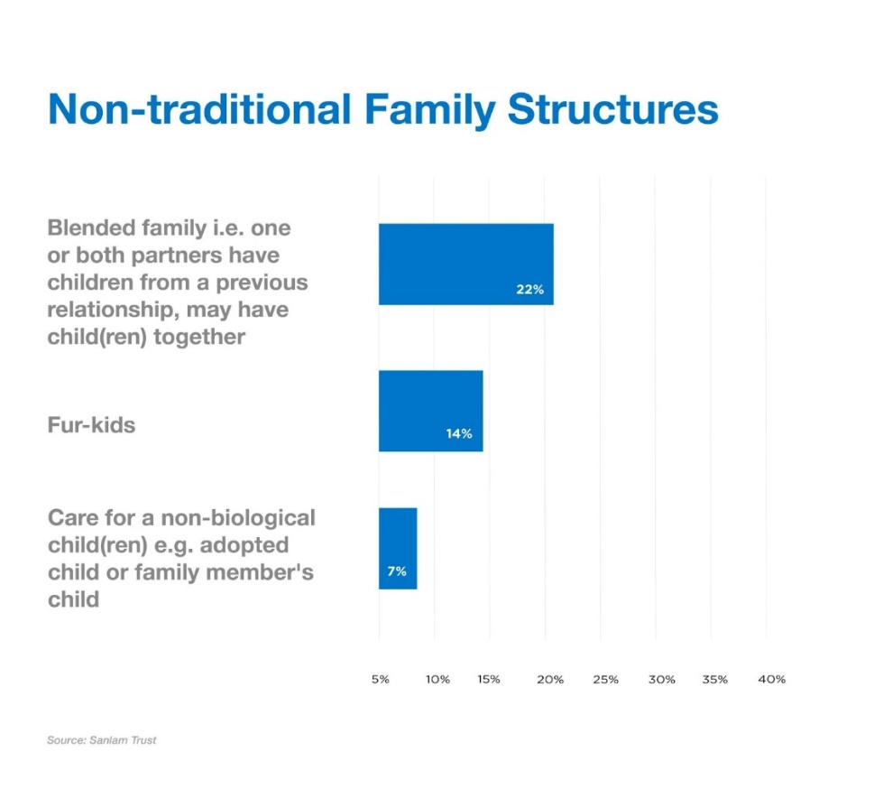

The basics of drafting a will:

A valid will needs to be in writing and signed in front of and by two competent witnesses who do not stand to inherit from the estate. Everyone can exercise freedom of testation – decide who inherits what from their estate - so long as their wishes are ethical and legal. Mabule says, “You can download templates online. Sanlam has a selection of free will templates, tailored to suit specific family structures.”

Mabule stresses the necessity of working with a professional such as a lawyer, wills consultant or financial adviser if your needs are more complex, “It’s easy to forget something important, such as the nomination of an executor or guardian. They will ensure your wishes are comprehensively covered and can help with more complex requests, such as setting up a testamentary trust for minors.”

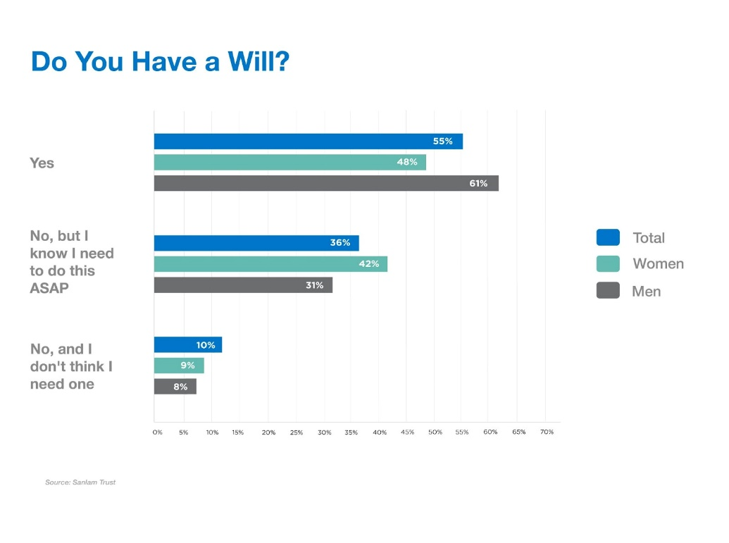

Death can have an expensive price tag

Sanlam Trust found that over 40% of the deceased estates it administers have insufficient cash to cover all debts, costs, cash bequests and taxes payable during one’s lifetime, and income tax, capital gains tax and estate duty upon death. This can have serious consequences for loved ones left behind. Planning for these costs through a policy such as the Sanlam Legacy Plan, can alleviate these extra financial stresses.

South Africa’s rainbow nation of families: Will nuances to consider

Blended family: 22% of survey respondents belong to this group and should consider the following:

- The divorce settlements: Often, partners come from previous relationships that ended in divorce. It’s important to know what’s in the divorce settlement(s) and how that affects a new marriage.
- Marital regime: Are you married in or out of community of property? If out of community, did you include the accrual system in your ante-nuptial contract? Who owns which assets?
- Beneficiaries: Stepchildren do not stand to inherit unless you stipulate as such or adopt them as your children. You need to be explicit with your wording, so there’s no confusion. If your stepchildren are excluded from your estate inheritance, but they can prove they were financially dependent on you, they can claim from your pension fund.

Adopted children:

- Adopted children have the same rights as biological children. Should you die without a will, they’ll be regarded as your children, in the intestate process.

Divorce:

- If you have a joint will, or a will that nominates your ex-spouse to inherit, you have 90 days after your divorce to amend this. Otherwise, your ex- spouse still stands to inherit.

A very special pet:

14% of respondents didn’t have children, but they had fur-kids. Leaving everything to a beloved pet is complicated. If you want to make provision for a fur-kid, you need to consider:
- Who will look after your pet? Are they going to take your animal in, as its ‘guardian’? Or is the expectation that the person will move into your home to care for your fur-kid there? If so, have you left sufficient funds for rates, taxes and the upkeep of the family in your estate? Will the ‘guardian’ inherit your house (you cannot leave this to your pet) or will the property go into a trust? You need to be clear in your will and financially provide for this, for the duration of your pet’s life.

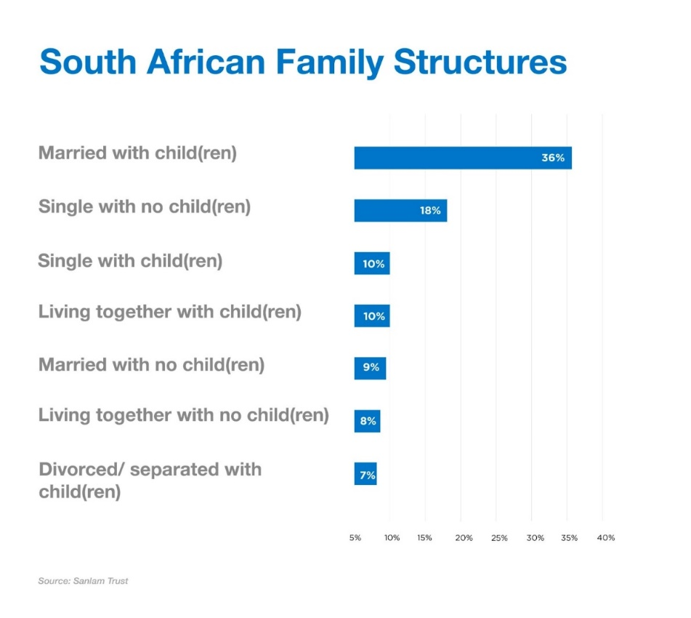

Married:

- It’s best to still have separate wills to ensure each of your final wishes are carried out.
- Whether you are married under the Marriage Act (monogamous marriages for opposite-sex couples) or the Civil Union Act (monogamous partnerships for same- or opposite-sex couples), your marital regime plays a massive role. If you’re married out of community of property, with exclusion of accrual for example, you can exercise freedom of testation and leave everything to your children. However, your spouse can still claim from the estate in terms of the Intestate Succession Act and Maintenance of the Surviving Spouse Act.

Unmarried with a life partner:

- Strictly speaking there’s no such thing as a ‘common-law spouse’ in South Africa, either in opposite- or same-sex partnerships. New legislation may soon pass enabling an unmarried life partner to claim from a partner’s estate, through the Intestate Succession Act and Maintenance of the Surviving Spouse Act and recent court decisions have granted certain rights to life partners that they did not previously enjoy. This can seriously delay the winding up of an estate, so it’s much kinder and fairer to include a partner in your planning.
- According to the Sanlam survey, 18% of people were living with a partner and 10% had children with their unmarried partner. It’s important to plan together and make sure each partner is provided for. You can stipulate your partner as the main beneficiary or make your children your beneficiaries and plan for your partner elsewhere, through life cover, for example.

Providing for parents and other extended family members:

- If you die without a will, your parents, siblings and other family members have no maintenance claim from your estate. However, if they can prove their financial dependence on you, they could claim from your pension.
- It’s best to stipulate whether you want to continue supporting family members (in addition to your children and spouse), through explicit wording in your will.

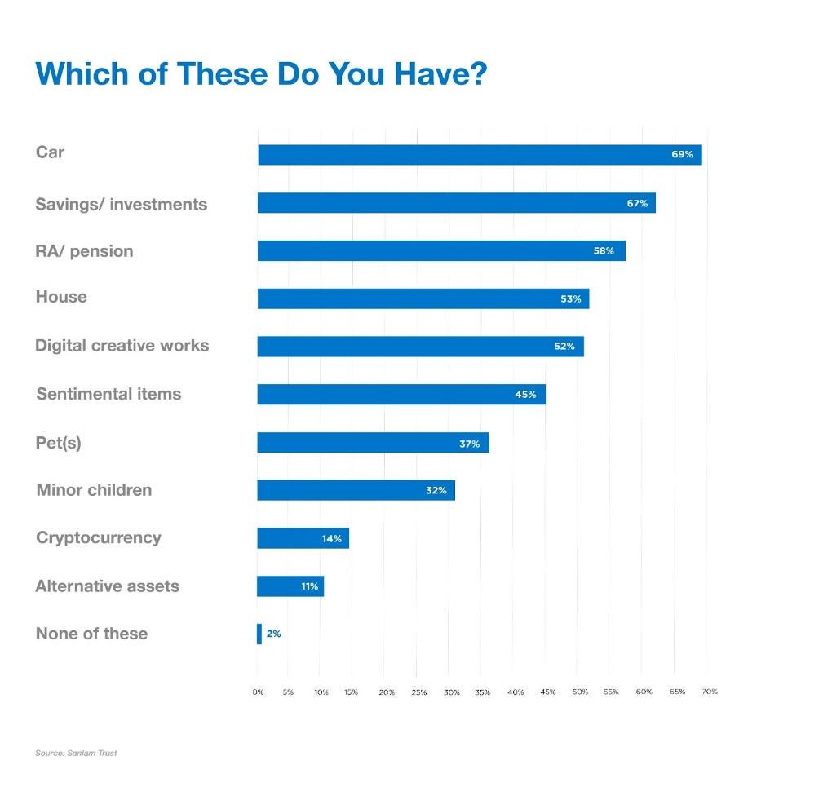

Polygamy and polyandry:

Providing for multiple partners is complex and needs to be rigorously planned for.
- If you die without a will, your estate will be divided between your partners (and your children), according to your marital regimes.
- If you draft a will, you can exercise freedom of testation over your share of the estate, however, the marital regime for each relationship will play a major role in how the estate is divided.
- The default regime is IN community of property.

Mabule concludes, “A will is the best way to ensure your final wishes are known and your family is fairly provided for. Work with a financial adviser, wills consultant or lawyer to plan your estate holistically and comprehensively so you can live confidently knowing that your affairs will be properly managed, and your beneficiaries taken care of.”

