On bonds and bananas

Old Mutual Wealth Investment Strategist, Izak Odendaal

In 1978, a time of globally high inflation, an American economics professor Alfred Kahn annoyed his boss by noting that a failure to get inflation under control would lead to a deep depression. Kahn’s boss at the time happened to be US President Jimmy Carter. Carter was not amused, and instructed Hahn never to use that word, or ‘recession’ ever again. Kahn, however, was a stickler for plain speaking and was not amused either. At the next press briefing, he used the word ‘banana’ instead of ‘recession’, saying that the US was “in danger of having the worst banana in 45 years”. When the banana industry objected to this terminology, he started using the word ‘kumquat’.

Out of the blue
The point is not that politicians like to put a fig leaf on bad news – we all know they do – but rather that recessions scare people, and understandably as people lose their jobs and businesses go bankrupt. Economies recover in aggregate, but for individuals, these blows can cause lasting damage. But another key reason why recessions are scary is simply that they usually seem to arrive out of the blue. Despite protestations to the contrary, the economics profession has a bad track record of forecasting recessions.

In fact, it can be difficult to even know that a recession is underway. It is usually only with the benefit of hindsight that we know a recession started here and ended there. For instance, the widely-used definition of two consecutive negative quarters of real gross domestic product is problematic for several reasons, but one of them is that the data is released with a long lag.

In the US, the official definition of a recession is set by a committee of experts at the National Bureau for Economic Research and pithily summarised as “a significant decline in economic activity that is spread across the economy and lasts more than a few months”. Sometimes this is called the three Ps – a profound, pervasive and persistent decline in activity. But the NBER Business Cycle Dating Committee only designates recessions long after they have ended, never mind started.

Shocks and seeds
Recessions can be caused by outside shocks, as we saw in early 2020. But usually, the seeds of the recession are sown during the expansion. Households and businesses project the good times deep into the future. They gradually overextend themselves, debt levels rise, sometimes imports rise too much, inflation picks up speed, and the central bank hikes rates in response. One unpredictable day, it is just all too much, and things go pear-shaped.

Companies see pressures on margins, and start cutting back on inventories, staff and expansion plans in order to protect the bottom line. What is rational for one company to do, causes a recession when many companies do it.

As households start seeing job losses around them, they reduce unnecessary purchases, pay off debt and save more. What is a perfectly sensible decision for an individual household to make, cascades into a slump when many households do it.

The cherry on the top is that banks often compound this situation. When times are good, they open the credit taps. When conditions turn, they tighten lending standards and reduce the flow of credit just when the economy requires the opposite.

This process then usually ends through some combination of policy intervention such as interest rate cuts, things becoming cheap enough for bargain hunters to step in, write-downs and write-offs that are painful but free up space on balance sheets, and simply the passage of time that allows for excess inventories to be worked through. Recessions do not last forever, and equity markets usually turn before the economy does.

US matters more
US recessions matter more than any, not just because the US is still the world’s biggest economy, but because of its outsized impact on global financial markets. There is a clear pattern that past global equity bear markets coincide with US recessions (1987 was the notable exception). In recessions, share prices fall because company profits fall. This is compounded by the fact that many investors scramble for cash to make ends meet, and they end up selling what they can – liquid listed equities – not necessarily what they would like to. And of course, the fact that it is all unexpected is what really upsets the apple cart.

Chart 1: Bear markets and recessions

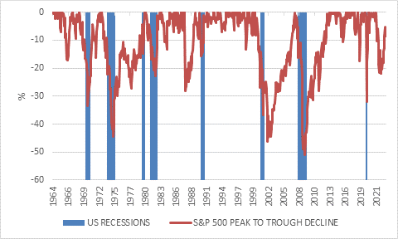
Source: Refinitiv Datastream

Outside the US, the financial shock of a US recession is usually intensified by the fact that capital flees towards safe havens, with America at the top of the list. That this is ironic does not make it less true. Therefore, a US recession is associated with falling currencies and other financial dislocations in other countries.

Just peachy
The good news, then, is that the consensus view among economists that US is on the cusp of a recession is fading. At the start of the year, it was widely believed that the US would go into recession following the Federal Reserve’s rapid rate hikes. Instead, things have been peachy and US growth surprisingly resilient. The most anticipated recession in recent US history might not happen after all, perhaps because it was so widely expected. Its economy has so far shrugged off the impact of higher rates, partly because so many borrowers fixed rates before they went up, while the decline in inflation boosted real incomes. The current comparison with China is apples and oranges. China was expected to have the strong post-Covid rebound, but instead its economy is sputtering. While the American central bank has been hiking rates, its Chinese counterpart has been cutting.

Chart 2: 10-year local currency government bond yields, %
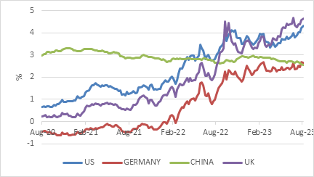
Source: Refinitiv Datastream

The divergent performance of the two superpower economies – against expectations – is the big story of 2023. The big story of the past few weeks is a further jump in US and other developed market bond yields. As chart 2 shows, the benchmark 10-year US government bond yield rose from 3.7% mid-July to 4.2%, the highest level since 2007. China’s equivalent yield has gone the other direction, reflecting its weaker economic outlook.

Chart 3: US real yields and market-based inflation expectation, %
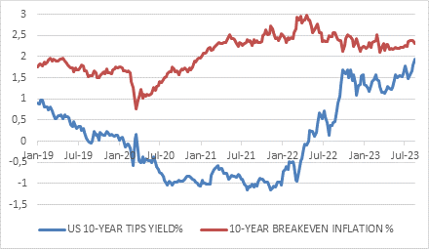
Source: Refinitiv Datastream

The increase in US bond yields has been caused by expectations of higher real interest rates, not fears of rising inflation. As chart 3 shows, the real yield (the yield on inflation-protected bonds or TIPS) has been grinding higher, breakeven inflation rates remain broadly unchanged. This makes sense, since inflation has been declining, not rising. But the question remains whether it will decline far enough and stay down. While the US economy keeps ticking along, creating jobs and generating real wage gains for workers, the Federal Reserve is likely to err on the side of keeping rates high to ensure inflation continues moving in the right direction. They might even hike again, but that this not the main point. The point is that there is unlikely to be a pivot to lower rates any time soon. This was the message from Fed Chair Jerome Powell in a much-anticipated speech at the annual Jackson Hole central banking symposium, who welcomed the progress on lower inflation, but warned that it was still too high, and that the Fed was “attentive to signs that the economy may not be cooling as expected." The Fed, he concluded, would “keep at it until the job is done".

All this is good news in so far as it reflects that ongoing economic resilience. But ultimately, higher borrowing costs must weigh on the economy. While many households and companies have fixed rates, not all do. At the margin, any new borrowing or rolling over of maturing debt is now done at much higher rates. For instance, the average 30-year mortgage rate is now 7.3%, the highest level since 2000. Home affordability is at record lows.

The seeds of the next downturn have therefore been planted, and higher interest rates are giving them plenty of water and sunshine.

The rise in bond yield has inflicted capital losses on bondholders, since yields and prices move in opposite directions. However, at multi-year highs across the curve, yields are increasingly attractive. It also has implications for the stock market from three angles, and it’s no surprise that equities declined this month. Firstly, future profits discounted to the present are smaller when interest rates are higher. Secondly, profit growth is likely to slow as interest rates increasingly weigh on economic activity and raise the cost of borrowing for firms. Thirdly, there is the surprise factor we alluded to upfront. The more the current resilience leads to expectations of better growth, the more there is room for disappointment. The more economists remove recession risk from their forecasts, the nastier the surprise when it arrives.

We’ve seen something like this in China, where the economy has disappointed the lofty expectations of a reopening boom at the start of the year. This episode might even challenge the traditional definition of a recession. The economy is unlikely to experience a broad-based contraction in income and spending, and indeed Chinese growth rates are boomy compared to South Africa. But inside China it will feel recessionary. Consumer confidence is already so low that the government has stopped publishing the survey. The assumption of rapid economic growth built into the expectations of so many businesses and households – particularly when it relates to the property sector – is being shattered. This is a psychological shock as much as a financial one and results in an increase in precautionary saving and a focus on paying off debt. Once again, this is perfectly sensible for individual households or firms to do, but if everyone does it simultaneously, the economy falls into the kumquat zone.

There is still a widespread expectation that a big stimulus effort is coming, but so far, the intervention from Beijing has been minimal. Rate cuts have been very small relative to the scale of the problem, presumably because authorities prize a stable currency and lower rates would see capital flight in search of higher returns elsewhere. It would also squeeze bank profitability at a time when banks might need to absorb some of the losses coming out of the property sector.

Mixing it together
Clearly, there is a lot going on and much uncertainty. What can we make of this from an investment point of view? It is important to have a view on the state of the economy and the trends that influence it. However, it is risky to base an investment strategy on a forecast of the future when the business cycle is so unpredictable. Things can and will turn out differently than expected. When life gives you lemons, you need to be able to make lemonade.

Instead, there are three tools we can deploy: valuation, diversification, and patience.

On the valuation side, the key is to tilt away from things that are expensive and towards things that are cheap. Cheaper assets don’t escape panicked sell-offs, but there is less room for disappointment if bad news is already priced in. And if things really get hazy and uncertain, valuation is one thing to hold on to.

Closely linked to valuation is patience, since whatever view you take on the economy and the market, it will not necessarily play out immediately. An unloved asset can stay unloved for a long time before the market finally recognises its worth. Moreover, any equity current exposure in your portfolio is not there to perform today or tomorrow, but to do so over several years.

Finally, diversification means including a broad range of asset classes that perform differently at different points of the business cycle. The exact mix will depend on the investment goals and time horizon, but the principle remains crucial. The future is unpredictable, so don’t put all the fruit in one bowl.

