Glass half full

Old Mutual Wealth Investment Strategist, Izak Odendaal

The last few weeks have seen mixed news on the South African economy. As usual there is a lot to worry about, but there are also reasons to be a bit more upbeat. Is the glass half full or half empty?

Faster growth
To start off with, the economy grew more than expected in the second quarter. Stats SA data on real gross domestic product (GDP), the broadest measure of economic activity, showed growth of 0.6% between the first and second quarters. The official numbers are no longer annualised, but if they were, it would amount to 2.4%. This was better than expected and shows an acceleration in growth from the first quarter despite the ongoing headwinds of loadshedding, logistical bottlenecks, high interest rates and lower commodity prices.

Particularly encouraging is the strong increase in fixed investment, albeit from a low base. Fixed investment spending grew 3.9% in the quarter (not annualised), accelerating steadily in the past few quarters. Most of this increase comes from the machinery and equipment category, probably largely related to investment in alternative sources of electricity.

Chart 1: Fixed investment spending (real gross fixed capital formation)
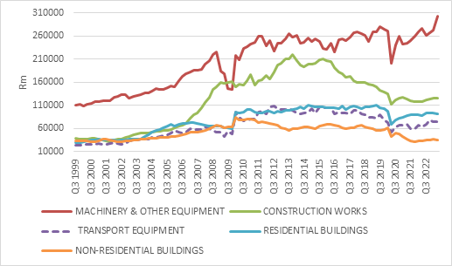

Source: Stats SA

Overall fixed investment spending remains too low to sustain rapid growth. It should be around 30% of GDP, but in South Africa it’s only 15%. Public sector investment spending has slumped due to financial constraints, while private sector investment has been held back by a pervasive lack of confidence, regulatory hurdles, high cost of capital but also, to an extent, a lack of obvious opportunities. The best opportunities lie in upgrading the country’s deteriorating infrastructure, but much of this is monopolised by the public sector. Allowing the private sector to get more involved in water, electricity, rail, ports, roads and so on will not only unlock billions in new investment spending but will also facilitate broader economic activity.

This penny is starting to drop in government circles, partly because the scale of the crisis is now too big to ignore. Because loadshedding affects everybody, businesses small and large, households rich and poor, the electricity sector has already been opened to private investment and the results are there to see. The other infrastructural crises are not necessarily as visible to ordinary people (i.e. voters) and policy reform has been slower. But it is happening. On Friday the government published a draft bill to allow changes to the ownership structure of State-Owned Enterprises, improve governance and ultimately allow for increased private participation.

Deficit
Despite economic growth picking up in the second quarter, the budget deficit, the gap between government spending revenue, has widened more than expected. For the first four months of the fiscal year that runs from April to March, the budget deficit is R191 billion. Over the same period last year, it was only R118 billion. This means there will not be a feel-good Medium-Term Budget this year.

The February Budget Speech projected a R280 billion budget deficit this year, or 4% of GDP, entirely made up of interest payments. In other words, the aim was to a achieve a ‘primary surplus’, where non-interest spending would be smaller than revenues. A primary surplus is the first step to stabilising government debt levels, but it looks like a stretch on the current trajectory. Corporate tax revenues in particular are lagging far behind expectations as loadshedding, and logistical problems have eaten into profitability.

To get the fiscal outlook back on track – achieving a primary surplus – requires tough trade-offs. Taxes won’t necessarily rise, but tax relief should not be expected. Most of the work will have to come from reducing and reprioritising spending again. This is complicated by the fact that it is an election year, but fortunately, South Africa does not have a history of election-driven fiscal cycles like we see in many other countries.

For instance, Mexico’s new budget plan shows the 2024 deficit jumping sharply from 3.3% to 4.9% of GDP according to Reuters, the largest level since 1998. This is largely due to increased social spending and high-profile infrastructure projects ahead of presidential elections.

But no incumbent government wants to do unpopular things heading into an election, suggesting that the biggest changes will probably be in the outer years of the fiscal projection, an element off kicking the can down the road. There have been reports of large-scale cuts to spending programmes and even whole government departments, but we’ll have to wait for formal announcements.

What is clear is that the fiscal problems, like the crises elsewhere, present both a threat and an opportunity. In this case, the opportunity to right-size government to be fit for purpose. Blindly cutting spending across the board is not good for service delivery or the economy. No one can argue that nurses and policemen should bear the brunt of the country’s fiscal headaches, but similarly no one can claim that government is currently optimally structured. Ideally, politicians will always do the most sensible thing, but in reality, tough decisions are usually only made when they experience a sense of crisis – and realise that change is less painful than not changing. In life as in politics, one often needs to hit rock bottom before tough decisions are made and things start improving.

Bad news
One piece of unambiguously near-term bad news is the jump in the global oil price. From $74 dollars per barrel at the start of July, the price of Brent crude has risen to $92. Some say we are heading for triple digits. Itis hard to tell, since the oil price seems to be driven more by geopolitics – Saudi Arabia and Russia cutting back production – than by strong demand.

Chart 2: Brent crude oil price
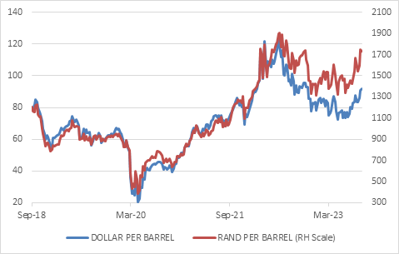

Source: Refinitiv Datastream

In South Africa, this is further compounded by the rand’s weakness against the dollar. Retail fuel prices are set to rise sharply in October, having already increased in September and August too. This is a fresh blow to consumers and business.

The impact is threefold. Firstly, companies and households will see a knock to their real incomes, as they have to spend more on fuel and less on everything else. Of course, these days fuel is used not just for driving but also running generators. That includes Eskom, which runs two diesel-powered plants.

Secondly, in South Africa, as well as in other countries, headline inflation rates will rise somewhat in the months ahead as the year-on-year change in fuel prices moves from negative to somewhat positive. This is unwelcome, but does not necessarily change the picture for monetary policy. Central banks tend to look through volatile food and fuel price movements, paying much closer attention to whether these higher costs are passed on to the prices of other items. For instance, do trucking companies raise their prices to compensate for more expensive diesel? Do the wholesalers then raise their prices to make up for higher transport costs, and do retailers do the same in response to higher wholesale prices? Do workers then demand higher wages, which would in turn force more price increases as companies protect margins? It is these ‘second round’ effects that concern central bankers. They can do nothing about the price of fuel, but they can lower overall demand with higher interest rates to contain second-round effects.

Thirdly, since South Africa imports most of its fuel, its trade balance comes under pressure. To simplify somewhat, South Africa must earn the dollars needed to buy fuel by selling into global markets. If export revenues are not enough, we need to sell bonds or equities to foreign investors. If they don’t want to buy – and they haven’t been eager buyers of late – the currency usually weakens until exports are more competitively priced or capital flows improve. Higher interest rates are another way to attract foreign capital. Therefore, a deficit on the current account is normally seen as being a risk factor for the rand, and that is why the Reserve Bank pays close attention to it.

The current account deficit has already widened to 2.3% of GDP in second quarter, having spent most of the past three years in unusual surplus territory thanks to the commodity boom. But with export commodity prices having returned to pre-Covid levels broadly speaking, export values are not much higher than import values. Export volumes are off course severely constrained by Transnet inefficiencies as discussed above.

Despite the softer rand, higher petrol price and wider current account deficit, the Reserve Bank is unlikely to increase the repo rate this week, but these factors do mean that the bar to cutting rates is higher. At 8.25%, the repo rate is already much higher than inflation of 4.7% and therefore well in restrictive territory, meaning that it is acting to cool demand in the economy. Higher rates are not needed.

Great expectations
Importantly, inflation expectations as measured by the Bureau for Economic Research’s quarterly survey have declined meaningfully from the recent peak, suggesting that household, unions and businesses do not expect accelerating inflation. This matters since it can influence long-term price-setting behaviour. If people believe inflation will rise, they tend to act accordingly, and it ends up rising.

Chart 3: Expected future inflation
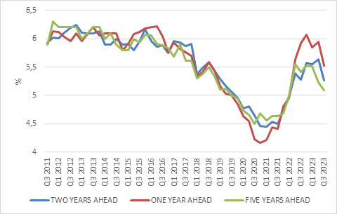

Source: Bureau for Economic Research survey

The global backdrop also matters. It increasingly appears that the international hiking cycle has run its course. The European Central Bank hiked last week but indicated that rates are now sufficiently restrictive. The US Federal Reserve is expected to remain on hold this week. The focus is shifting from how high rates will go to how long they will remain high.

All in all, it means the worst is probably over in terms of local interest rates. This is good news for beleaguered consumers.

So, is the glass half empty or half full? It depends of course. Relative to the growth the country needs to create jobs and improve the quality of life of all South Africans, the economy is underperforming, and will continue to do so. Relative to the widely-held notion that South Africa is collapsing into a failed state, things are in fact a lot better. The economy is still growing, investment levels are rising, policy is moving in the right direction and the interest rate and inflation shocks are behind us. This should be sufficient to ensure decent returns from already-cheap South African bonds, equities and listed property.

