Red Dragon Blues

Old Mutual Wealth Investment Strategist, Izak Odendaal

What is going in China? The world’s second largest economy seems to be spluttering as the post-lockdown rebound fades. The contrast with China’s great geostrategic rival, the US, is also painful. At a time when the relationship between the two superpowers is seemingly deteriorating, the unexpected strength of the American economy compared to the surprising weakness in China must be a sore point in Beijing.
Indeed, the China-US tensions are probably contributing to the weakness in China to the extent that Western firms are redirecting supply chains and trade in high-tech items like semiconductors is restricted. However, most of China’s problems are home-grown, summarised by veteran economist and China-watcher George Magnus as “excessive debt, low productivity, a flawed real estate market, weak income and consumption, poor demographics, highly regressive taxes, and a political governance structure that is controlling and generally hostile to entrepreneurship”.
Low inflation
Evidence of a spluttering economy is not just soft GDP growth, falling imports or subdued consumption. It is also in the fact that inflation is very low when it is still very high elsewhere. Last week saw markets cheering a US core inflation print that declined to a still high 4.7%. China’s core inflation is less than 1%, while headline inflation was slightly negative in July.
Chart 1: Core consumer inflation in China and the US
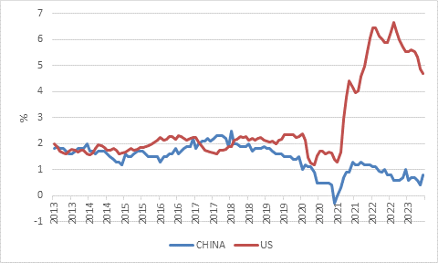
Source: Refinitiv Datastream

Now, it must be said that current Chinese GDP growth of around 3% to 4% is not to be sneezed at. South Africa can only dream of growing at such a pace, but in the Chinese context, it will feel recessionary. Even with an ageing population, the country must still absorb millions of young people leaving school and university every year. It is not creating enough jobs for them, or at least not the types of jobs they want to do. Youth unemployment has increased sharply and is now at 21% and gathering a lot of attention. President Xi has instructed young people to “eat bitterness” and find low-paying jobs. As a youth he was exiled to a far-flung rural area during the Cultural Revolution and knows hardship first hand. The current generation has grown up expecting to have interesting and rewarding jobs, however, and spend a lot of time and money to get the necessary qualifications.
Debt and demographics
Slower growth, even at 3%, also means China’s massive debt pile starts looking wobbly. High debt levels are usually not a problem as long as borrowers remain liquid, have solid income growth and interest rates remain well behaved. Chinese borrowers now face declining income growth, and while domestic interest rates have fallen and are likely to decline further, a meaningful portion of corporate debt was borrowed internationally in dollars at interest rates that have jumped.
Chart 2: Private debt excluding the financial sector, % of GDP
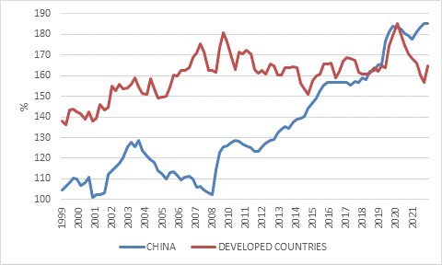
Bank for International Settlements
Chart 2 shows how total private debt (corporate and household) shot up over the past two decades and is now above that of the average developed economy. It makes sense that debt increased from a low level as the economy built up its productive capacity and households started owning property for the first time. It doesn’t make sense for China to have a higher debt level relative to the size of its economy than developed countries when its per capita income level is only a quarter ($11,000 in constant 2010 dollars, compared to the OECD average of $38,000).

With China’s population ageing and its labour force shrinking, future economic growth will have to be driven by productivity enhancements. It has proven itself to be a leader in certain industries, especially renewable energy and electric vehicles. But it is an open question whether rates of innovation can be sustained if the heavy hand of the state seems to be getting heavier and access to cutting-edge global technology is restricted.
Confidence crushed
Beijing’s official response to the current economic soft patch is that it will take time for things to return to normal after Covid. Fair enough. However, the cautious behaviour of households and businesses does not just relate to the experience of harsh lockdowns but that the entire regulatory environment has become more uncertain over the past five or so years, with important, job-creating sectors including technology and private education experiencing sudden and far-reaching rule changes. Sentiment is so weak that the national statistics agency has not released its monthly consumer confidence survey since April.
Property implosion
In no sector did the rule changes have as much of an impact as property. When the “three red lines” policy was adopted in 2020, the aim was to prevent excess leverage among property developers (the three lines refer to the debt to equity, cash and assets ratios). But this quickly resulted in overstretched developers struggling to fund the completion of projects, which meant buyers were waiting longer to take ownership of units they were already paying mortgages on. This in turn has drastically reduced both demand for new homes and new building activity. Prices are falling, thereby stripping the allure of an asset that is widely assumed to rise in value. Property is by far the biggest store of wealth for Chinese households, and therefore they are all feeling poorer and less bullish.
During the week, Country Garden, China’s biggest remaining private property developer missed $22 million in interest payments on dollar bonds. It has another $1 billion in bond payments due in the next few weeks. Like other developers, it relies heavily on buyers prepaying for units. Its liabilities of $200 billion are therefore not only outstanding bonds and bank loans, but also pre-sold units. Without sales, it lacks the funds to keep going, but its sales are down three quarters from 2021 levels, the Financial Times reports, in line with other large private developers. Only state-owned developers are seeing some sales growth, as buyers perceive these to be safer.
Property has been a key growth engine for the economy, accounting by some estimates to an unprecedented quarter of economic activity. Even at the height of the US housing bubble and all the sub-prime shenanigans, the property sector was never such a large share of the US economy. So as two decades of real estate overexuberance unwinds, China will have to find other growth engines, or accept slower growth. In the past, exports would have been the obvious choice and it has managed to rapidly become the world’s biggest exporter of electric vehicles in the past two years. However, China’s overall exports are already so large that it triggered a global backlash of trade wars and a reshoring trend. Coming off a high base, meaningful overall future export growth seems unlikely. A weaker currency is also not necessarily the answer. While it may boost exports somewhat, it also raises the debt burden of companies that borrowed internationally.
Targeted stimulus
This leaves two other avenues. Either the government must stimulate the economy, or household spending must rise. On the face of it, the national government has room to fund stimulus given its low debt-to-GDP ratio of 21%. However, the local government sector is already highly indebted while also facing the loss of income from land sales. The broader government balance sheet is therefore not in great shape and Beijing has resisted the “wall of money” stimulus approach that many investors seem to hope for. Instead, authorities have focused on targeted interventions and regulatory tweaks. These will help on the margin, but seem unlikely to address the core problems.
In most other large economies, household consumption is around two-thirds of GDP. In China it is 38%. Conversely, investment makes up a massive 42% of GDP. No other country comes close today and there are few historical parallels. A high investment rate made sense when the country was underdeveloped and catching up with the rest of the world. But today, it is increasingly wasteful and unnecessary, causing higher debt levels while contributing less and less to incremental economic growth.
Chinese household consumption is such a low share of GDP that it can only go up. This implies that even as overall GDP growth slows in the years ahead, household spending growth will be faster than that. But growth in commodity-intensive investment sectors such as real estate and infrastructure must by definition be much slower than overall GDP growth for this to happen.
Raising household consumption can only be done through a higher share of national income (or more debt), which in turn implies that the government and corporate sectors should get a smaller share, for instance through tax reforms, a better safety net and higher wages. However, there are practical and political constraints to achieving, which always seems odd given that it is a communist country. Reform is hard in all countries since there are winners and losers whenever policies change. While it is often assumed that authoritarian states are better at making tough choices, this isn’t always the case. Authoritarian leaders don’t fear losing votes, but they do fear the entire system crashing down if even small concessions are made.
In a nutshell, the development model that gave the country unprecedented economic growth over the past three decades has run out of road. What exactly lies ahead is uncertain, but it is likely to involve less emphasis on raw growth numbers and more on the quality of economic growth. None of this means that China will become less assertive on the international stage. On the contrary, it seems less focused on the performance of the economy and more on national security concerns.
Chart 3: Chinese equity prices and earnings
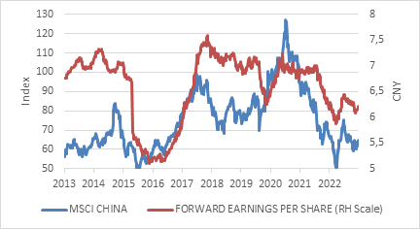
Source: Refinitiv Datastream
Lost decade
There is still much in China for investors to get excited about, but clearly also much cause for concern. Over the past decade, it has been a case of more risk, less return. Earnings for the companies in the MSCI China Index (which includes onshore and Hong Kong-listed firms) are lower than ten years ago. No wonder that share prices have gone nowhere. The sluggish earnings delivery and outlook also means the stock market is not as cheap at an index level as one might expect, trading at 10 times forward earnings. Unlike in the rest of the world, however, Chinese interest rates are falling which should lower the ratings hurdle on equities. Nonetheless, despite individual success stories, Chinese companies collectively have not managed to turn rapid economic growth into meaningful returns for shareholders. Investors deciding whether this picture will change also need to ask if state involvement in the economy will lessen, corporate governance improve and the rule of law advance.
Chart 4: China iron ore import volumes
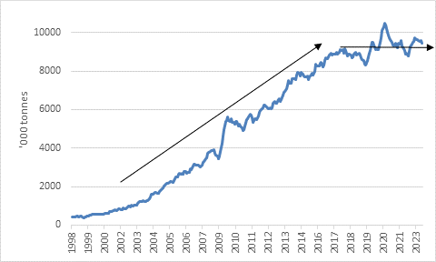
Source: Refinitiv Datastream
Risk and opportunity
None of this is necessarily good news for South Africans, though risk and opportunity are often two sides of the same coin. Firstly, trouble in China is bound to reflect negatively on sentiment towards emerging markets, which will impact local financial markets. The rand’s sudden weakness in the past two weeks is probably due in part to global investors becoming more skittish on emerging markets and commodity producers. Secondly, China is a major trading partner and buyer of South African commodities. A less-commodity intensive growth model seems likely, and indeed we’ve already seen import volumes of iron ore for instance flatlining in recent years as chart 4 shows. This is not to say that prices for industrial metals will collapse as other factors are also at play, namely the supply situation and demand from other areas such as green energy. But it is always a headwind for any sector if the major consumer is not growing demand anymore. South Africa should therefore use its membership of BRICS to diversify its exports to China and attract more Chinese tourists. Thirdly, some shares on the JSE are heavily exposed to China. The miners face potentially challenging times, as noted above, but the likes of Richemont and Naspers tap into the Chinese consumer market where the outlook is much better.
Regardless of whether you are an investor in China or not, it is so important that you cannot ignore what is happening there.

