Dollars and sense, and other laments

Old Mutual Wealth Investment Strategist, Izak Odendaal

“Reports of my death are an exaggeration,” the writer Mark Twain told a reporter after rumours of illness and an untimely demise surfaced. The same is true for the US dollar, which is quite frankly in rude health today even though ‘de-dollarisation’ is one of the buzzwords of the past two years.

In thinking about the dollar, it is important to distinguish between cyclical and structural issues. Cyclically, the greenback has rallied in recent weeks, and is back near 20-year highs on a trade-weighted basis. Against individual currencies, the dollar rallied from $1.12 euro in early July to $1.05 at the end of last week. Meanwhile, the yen fell to the symbolically important JPY150 per dollar level, before apparently triggering an intervention by the Japanese government. The Chinese yuan is hovering at a multi-year low at CNY7.3 per dollar.

This is largely a function of interest rate expectations. The gap between US interest rates on the one hand, and those of Europe, Japan, China and other major economies on the other hand, seems unlikely to close in the short term. Indeed, it might be widening as the US economy is clearly in better shape than its counterparts elsewhere. Friday’s blockbuster jobs numbers show that US employers still have strong demand for workers.

Chart 1: Yield differences and the dollar

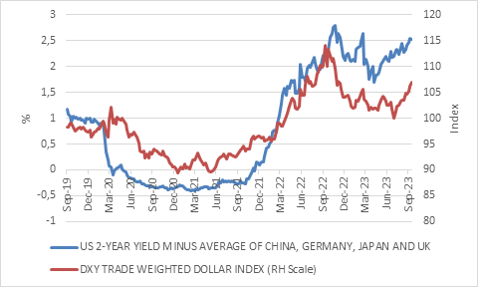

Source: LSEG Datastream

While the Federal Reserve seems unlikely to raise its policy rates further, it is likely to keep rates elevated for some time, a view the market is increasingly embracing. This has resulted in renewed upward pressure on market-based interest rates - government and corporate bond yields. US 10-year yield trades at 4.7%, and the two-year yield at 5%. Chart 1 shows the gap between the latter, and the average of the yield on equivalent of Chinese, Japanese, German and British bonds.

Chart 2 puts the trade-weighted dollar in a longer-term perspective, while also adjusting for inflation rates in the US and its trading partners. This gives a better sense of how the exchange rate impacts relative competitiveness. At the end of September, the real trade-weighted exchange rate was in the 91st percentile of monthly data since 1971 when the link with gold was broken. In other words, it has only been stronger 9% of the time in the past 52 years, mostly in the mid-1980s.

Chart 2: Real trade-weighted US dollar

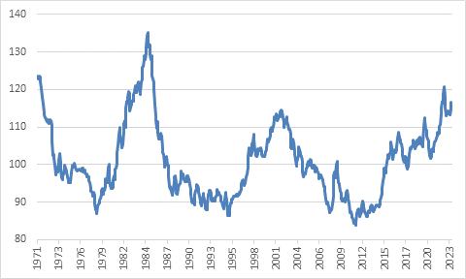

Source: LSEG Datastream

Not good news
A strong dollar is rarely good news for the rest of the world, and indeed episodes of dollar strength are associated with stress, particularly in developing countries, while periods of strong global growth have coincided with a weaker dollar.

However, for all the benefits of convenience the dollar system confers, it comes with major drawbacks which sit outside of geopolitics and are squarely in financial and monetary territory. “The dollar is our currency but your problem” is the famous line from former US Treasury Secretary John Connally. And we are seeing the problem right under our noses.

Put simply, when the Fed hikes rates, almost everyone else must follow, because in the dollar-based solar system, the Fed is at the centre and US rates exert a sun-like gravitational. A rising dollar means falling currencies across the world, putting upward pressure on inflation and interest rates, even in countries where weak economic conditions require lower interest rates.

South Africa is a case in point. The rand fell to R19.33 to the dollar last week, and this will give Reserve Bank policymakers sleepless nights. While further rate hikes are still unlikely, it also means interest rate cuts can be ruled out, even as we see evidence of high rates hurting the economy in the form of a rapid deceleration of credit growth.

For other countries, it is not the price but the quantity that is the big problem. When the dollar is strong it is by implication scarce, and many developing countries run short of the dollars needed to import necessities and also service dollar-denominated debts. Indeed, most sovereign debt defaults – where governments cannot honour their debt obligations – happens when they’ve borrowed in dollars but don’t earn enough hard currency to service the debt. No surprises that we’ve seen a string of defaults - Zambia, Ghana, Sri Lanka, Argentina - in the strong dollar environment of the past year.

A decisive weaker turn in the dollar will probably require a pivot in US interest rate expectations. When the Fed is ready to cut rates, the dollar is likely to recede from current elevated levels. Far from being the calamity that some claim, a weaker dollar would be good news for the global economy. But it looks like we’ll have to wait some time to get it.

Still dominance
Turning to the structural or long-term side of the story, the “death of the dollar” theme has been around for decades, but this hardy perennial got a boost from the imposition of sanctions against Russia which many say amounts to a weaponisation of the dollar. In other words, the argument goes, rather than being a tool for commerce and finance, it is now a tool for geopolitics, which will ultimately undermine its special role as global reserve currency.

The recent hoopla over a potential BRICS currency falls into the category. It is an idea that appeals to politicians who for obvious reasons do not like dependence on another country’s currency, particularly not if that country is your opponent. Some countries are taking steps to reduce the use of the dollar, but we are nowhere near a point where we can talk about a new world order for global currencies. Some steps also go the other direction. The leading candidate in the Argentinian presidential election wants to ditch the peso and adopt the dollar.

The dollar was bought or sold in about 88% of foreign exchange transactions according to the latest Bank for International Settlements survey, a number that has barely budged over the years. Meanwhile, International Monetary Fund data shows that while the dollar’s share of foreign exchange reserves has declined by about 10 percentage points to 59% over the past 20 years, it is still much larger than the share of global trade of the US. Moreover, the gains over this period largely come from currencies of US allies – mostly the euro, and also the Australian and Canadian dollars. These countries’ central banks have dollar swap lines with the US Fed, and in a pinch, will benefit from a backstop of dollar liquidity.

Similarly, the dollar’s share of global bank loans, financial market trading, and trade invoicing remains very high and stable. A recent Federal Reserve research paper put currencies’ share across four of these measures (forex reserves, forex transaction volumes, foreign currency debt issuance, and cross-border banking liabilities) together in an index. As chart 3 shows, the US dollar is dominant across these important dimensions, and the picture hasn’t changed much over time. The yuan’s share remains surprisingly small given that China is the biggest exporter on earth, and the second largest economy overall.

Chart 3: Index of international currency usage
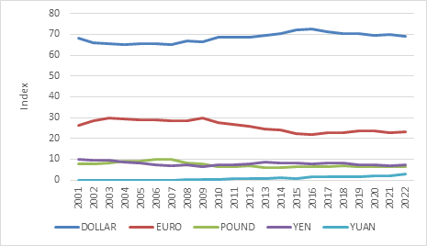

Source: US Federal Reserve

There are several reasons for this, but it includes an ambivalence on the part of the Chinese government to promote the yuan (also known as the renminbi) as an alternative to the dollar. The biggest problem is that China maintains capital controls and the yuan is not fully convertible. So Chinese government and corporates continue to make heavy use of the dollar. Most of the Belt and Road loans China made to other developing countries is denominated in dollars, for instance.

Meanwhile the simplest explanation for the dollar’s continued dominance is not American geopolitical clout, but rather the convenience of having a single currency that is accepted across the world. This is a convenience Chinese firms also benefit from. As economist Charles Kindleberger pointed out many years ago, it is like the English language, which allows people with different home languages to communicate with one another. The more people who speak English globally, the more valuable speaking English becomes to each individual speaker - a pure network effect.

English is not the global lingua franca because it is inherently better than other languages. But the dollar has some important intrinsic characteristics that go beyond mere convenience, namely the size and liquidity of US markets, overseen by trusted US legal and regulatory institutions. Any country with a large trade surplus like Saudi Arabia can park that excess money in US markets without any hassles. Yes, Saudi Arabia is starting to sell oil denominated in yuan, but its exports to China exceeded imports from China by $30 billion last year. If all that trade were denominated and settled in yuan, Saudi Arabia would have billions of extra yuan it would need to find a home for. Chinese markets, subject to Chinese laws and regulations that foreign investors generally have less confidence in, cannot necessarily absorb those flows efficiently.

And when there is anxiety, investors still flee to the dollar. That hasn’t changed at all.

So, dollar dominance does not seem to be going anywhere in a hurry, but there certainly are attempts to chip away at it. De-dollarisation is therefore best thought of as a gradual process, not an event. The high and rising level of US government debt might eventually erode the trust foreigners have in the dollar, but there is a huge amount of trust left to erode, while indebtedness is not a uniquely US phenomenon. There are simply no obvious alternatives. The list of countries with AAA ratings is short and includes minnows like Finland and the Netherlands, markets that are not big enough to be substitutes for the US.

And while the US does benefit from the dollar’s dominance, the advantage is often overstated. As noted at the top, it is not as if the US government always has lower borrowing costs than other countries with smaller currencies.

Rands and sense
Where does this leave us at the southern tip of Africa? A strong dollar usually means a weak rand. A weak rand makes imports more expensive, but that doesn’t always result in higher consumer inflation rate, since the latter depends on the extent to which firms pass on higher import prices. A weaker rand means exporters can earn more, but it does little to raise export volumes. Crucially, South Africa has relatively little foreign borrowing, particularly on the part of government. The country’s overall foreign assets exceed foreign liabilities – it has a positive net international investment position meaning that – when the rand weakens, it helps the national balance sheet. We see this in investor portfolios too, namely that a weaker rand tends to raise returns due to the boost it gives returns of offshore investments. Again, this increase tends to be bigger than the impact on domestic inflation, so it is a boost to real returns.

However, while the dollar’s structural position remains broadly intact, its cyclical strength is just that: cyclical. At some point, it is bound to retreat again and give other currencies, including the rand, room to run. Investors should always avoid one-way bets in their portfolios, and this includes bets that the rand will only ever weaken. In this vein, we’ll end with another Twain quote: “There are two times in a man’s life when he should not speculate: when he can’t afford it, and when he can.”

