Rates getting real
Old Mutual Wealth Investment Strategist, Izak Odendaal
September was a rough month for global investors with bonds and equities selling off. On the one hand, this is not unusual as September returns are on average negative for global equities. It is not clear why this is, nor is it a good enough reason to trade in and out of the market (as the old aphorism “sell in May and go away” would suggest). Bonds, however, do not normally fall in September and typically rally when stocks are under pressure. This time, however, there is a clear reason for the weakness across both asset classes. The common factor is that global markets seem to have finally come round to the higher-for-longer interest rate view that I’ve written about here for some time.

As per usual, it is US economic and policy developments and associated market response that set the tone for the rest of the world. The Federal Reserve kept rates unchanged at its September meeting as widely expected, but its projections for the next year or two is what caused the big moves. Every quarter, Fed officials anonymously provide their individual forecasts of growth, unemployment, inflation and interest rates, and these are summarised on the so-called dot plot. And while these forecasts must be taken with a pinch of salt since we don’t know how much conviction each official attaches to their projection, they are still instructive. As summarised in Chart 1, the September dot plot showed an improved growth and unemployment outlook while the inflation outlook still shows a gradual decline. This is all good news and means the good people at the Fed view a soft landing as more probable. But it also made it clear that interest rates will remain elevated for longer and even rise a little bit more from current levels (though that is unlikely).

Chart 1: Median dot plot forecasts at the June and September FOMC meetings
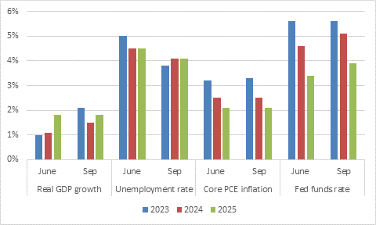
Source: Federal Reserve Board

The result was another sharp upward move in bond yields. Now talking about the bond market is bound to glaze over many eyes, but it contains an astonishing amount of information about how investors view the world. It also tends to spill over to other asset classes, since it impacts borrowing costs for companies and governments and competes with other asset classes for capital. So bear with me while we talk bonds for a minute.

Firstly, when yields rise, prices fall. Investors still get paid the interest attached to the bond, but its paper value has dropped. Secondly, in the more sophisticated markets, bond yields can be decomposed into underlying drivers namely expected future inflation and real (or inflation-protected) yields. Chart 2 shows the US example. ‘Breakeven inflation’ is the difference between nominal and real yields, the latter is the yield on Treasury Inflation Protected Securities or TIPS (in South Africa we call them inflation-linked bonds or ILBs).

Chart 2: US 10-year nominal and real yields
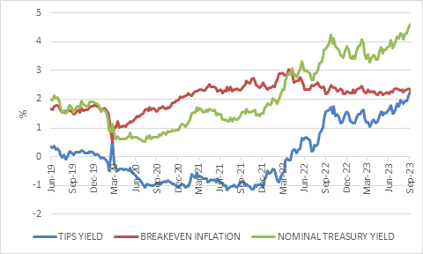
Source: LSEG Datastream

The 10-year Treasury yield bottomed out below 1% in late 2020. Its increase since then was initially driven by rising inflation expectations. Breakeven inflation rose from 1% to 3% as the world found itself short of all kinds of things, from oil to food to gym equipment and prices surged. It is only from early 2022 onwards that real yields started rising in earnest, as it became clear that the Fed would be hiking rates to combat inflation. The most recent increase in yields, however, has clearly not coincided with rising inflation expectations. In fact, even the recent surge in the oil price has not had a meaningful impact on breakeven inflation.

The market is not worried about inflation. The jump in real yields (TIPS) reflects the expectation that the Fed will keep its policy interest rates high for an extended period.

Chart 3: 10-year developed market government bond yields
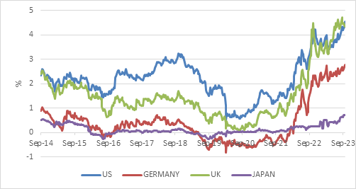
Source: LSEG Datastream

Chart 3 shows that rising bond yields are not just a US-phenomenon, though Japan’s 10-year yield is of course capped by Bank of Japan intervention. Worryingly for the likes of Germany, bond yields are rising despite the deterioration in its growth outlook. Bonds are usually a great recession hedge and tend to rally when the economy cools (yields fall) as the market prices in central bank cuts. But now, even as the German economy is sagging, it must contend with higher borrowing costs.

In the US, the situation is not as tragic, but there is still the hint of irony. Stronger-than-expected growth is leading to higher real yields, but this latest jump in yields will put renewed pressure on economic growth if it is sustained. Mortgage rates, for instance, have jumped to 7.5% and buying a house is now less affordable since at any point since the early 1980s. Central bankers simply call this a “tightening of financial conditions”. In other words, it is not just about one specific interest rate going up, but the broad impact of the financial system on the economy, including the willingness to lend and borrow. As the Fed’s forecasts discussed above show, there is still plenty of support in the US economy. However, at the margin, things are weakening, and the renewed tightening of financial conditions don’t help. A looming federal government shutdown is also not helpful, but historically has had a bigger political than economic impact.

Taking stock
For stocks, it’s a double whammy. Higher borrowing costs impact the bottom line, even if it takes time to do so (depending on how much debt a company has and over what term). The same is also true for each company’s customers. But higher borrowing costs also mean the asset class competes with bonds and cash for the marginal investor’s dollar. Gone are the days of TINA – there is no alternative (to equities).

The MSCI All Country World Index lost 4% in September, but it is still in solid positive territory year to date. The growing soft-landing narrative and AI excitement have boosted stocks this year, but it has also been an extremely concentrated rally. The US S&P 500 has returned 13% this year, but the equal weighted version of the index – where each of the 500 shares has a 0.2% weight – has only returned 1%.

Global sovereign bonds lost 3.5% in September, as measured by the FTSE World Government Bond Index. Unlike equities, bonds have had a torrid time this year, barely rebounding from last year’s record sell-off. Global bonds have delivered a negative return for the first nine months of the year. However, since the best predictor of the longer-term return from bonds is the starting yield, investors can now look forward to a better return in the years ahead. Similarly, dollar cash yields are now above 5%.

It is also notable that the dollar has resumed its upward march, as the stronger relative performance of the US economy means European, Japanese, and Chinese interest rates are not going to catch up with America any time soon. The trade-weighted dollar index has risen 6% since mid-July.

Chart 4: Trade weighted dollar index and rand-dollar exchange rate
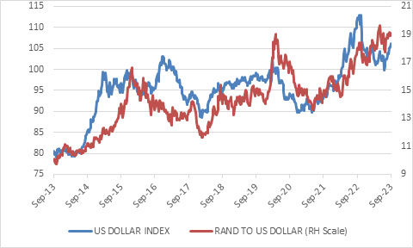
Source: LSEG Datastream

Not spared
South African markets were not spared the global sell-off, and rarely are. Local bond yields also rose, not just following international yields higher, but also because of the deterioration in the budget since the start of the year.

The South African 10-year bond yield kicked up from 10.3% to 11% during the month, before retracing a bit. The 20-year bond yield surged to 13%, even higher than during the 2020 Covid crash. Fortunately, at these high yields, investors get a lot of protection from high interest payments that can offset price declines.

Therefore, despite the All Bond index suffering a 2% loss in the month, it is still clinging to a positive return for the first three quarters of the year.

The FTSE/Capped SWIX Index fell 2.9% in the month, wiping out its gains for the year. Apart from local headwinds, the JSE is also directly exposed to China and the struggles there. However, it does look like economic activity is stabilising somewhat outside the property sector. On the other hand, the JSE also has a large rand-hedge component, and with the local currency hovering around R19 to the dollar, this cushions the blow somewhat.

Terrible twins
The bigger problem is that South Africa’s ‘twin deficit’ – the current account deficit and the budget deficit – is widening again. The current account deficit hit 2.3% of GDP in the second quarter, having been in surplus for most of the prior three years. The budget deficit is also bigger, despite the February Budget promising that it would be narrowing.

Twin deficits are problematic because they rely on the proverbial kindness of strangers – foreign capital flows. But in a world of rising bond yields, there is a lot of competition for that capital. As the September Monetary Policy Committee statement noted, “tighter global financial conditions are likely to persist, raising the risk profile of economies needing foreign capital.”

South Africa is one of those countries, and the implication – although not expressly voiced in the statement – is that local interest rates will also need to remain higher for longer despite the impact on the local economy. Already, credit growth has halved since the start of the year to only 4.8% year-on-year in August. The expected inflation trajectory is also not a source of concern though there is no room for complacency given the 30% jump in the rand oil price since the start of July. Some of the country’s biggest medical aid schemes have also announced big premium increases, affecting a substantial portion of the CPI basket (about 8%).

The bottom line is that the global environment has turned hostile for South Africa, with tighter financial conditions and softer export commodity prices and a higher oil price. But we have also scored own goals. Loadshedding has been worse this year than any previous year, the country’s railways only carry a fraction of their historical freight volumes, and its biggest city and industrial heartland faces water shortages despite having full dams.

Some of these problems can and are being fixed by allowing for greater private sector participation in sectors previously monopolised by the state. Others can only be addressed by a government that is now facing budget cuts across the board, potentially further reducing already-stretched capacity. However, these kinds of crisis moments often provide the best opportunities for meaningful change. When the status quo is a worse alternative than reform, politicians start acting and we’ve seen evidence of this already.

In summary, it is still a tricky environment for investors, and we should expect volatility to remain a feature of the markets landscape. Fortunately, the cost of sitting out this volatility (or diversifying against it) has gone down as interest rates have moved up. It also provides a better outlook for investors who need income. But don’t forget that the best long-term growth has always come from equities, especially when they are bought at sensible valuations. Outside of a handful very large US stocks – the ones that dominate the benchmarks and grab the headlines – equity valuations are reasonable across the world and cheap in places like South Africa.

