Balancing risk and return on S.A. government bonds

Sean Neethling, Head of Investments at Morningstar South Africa

Current market sentiment towards SA government bonds is especially negative. Both local and foreign investors are becoming increasingly concerned about the debt hangover effects and higher borrowing costs arising from continued fiscal slippage on an already bloated balance sheet. Ahead of the 2024 National Election, there is also the potential risk of increased populism affecting more disciplined and pragmatic management of government spending.

Restoring investor confidence

All eyes will be on the medium-term budget policy statement (MTBPS) in November where a widening deficit (driven by lower-than-expected tax revenues) is likely to be highlighted. Market participants will be looking for an explicit commitment to cost containment measures to control a public sector wage bill that continues to be funded from increasingly expensive debt without the requisite productivity gains. In an especially uncertain environment, government will be under increased pressure to improve transparency and present a credible strategy to address both short and longer-term challenges to the country’s balance sheet.

Given the deteriorating fiscal outlook, it’s essential for investors to have a forward-looking risk management framework to monitor the investment thesis for S.A. government bonds and track developments relative to expectations.

Balancing risk and return

The role of professional investors is not to avoid risk but to manage it in a way that provides clients with the best opportunity to achieve their long-term investment objectives. What matters most is that risk can be understood, priced, and most importantly, controlled and mitigated through asset allocation and portfolio construction. The principle is that the whole (portfolio) is greater than the sum of the parts (individual assets). The application of this framework in the context of S.A. government bonds is explained further below.

- Understanding fundamental risks
The South African fiscus is under pressure due to both global cyclical as well as domestic structural constraints. The short-term pressure on the fiscus is mostly attributable to lower global commodity prices feeding into lower-than-expected tax collection from mining companies. In the absence of domestic consumption growth, the country is particularly reliant on commodity exports and more specifically on infrastructure spending in China.

Rand depreciation should be net positive for exports but with low levels of demand and deflation in China the outlook remains relatively uncertain. Low growth and a downturn in the commodity cycle have especially pronounced effects on the fundamentals of the bond market since government needs to increase borrowing to fund the budget deficit.

The leading structural detractor to domestic growth is South Africa’s unreliable power supply as lower energy availability and unplanned outages continue to push the country towards higher stages of loadshedding. S.A. corporates are relatively cash-flush but are unlikely to allocate capital to new projects in an environment where government policy and regulation is unclear, consumer spending is under pressure, and the outlook for the global economy remains uncertain.

Relatively weak fiscal and balance sheet management is part of our base case assumption given how government has historically issued debt and allocated capital. While the recent decline is concerning it is not outside the normal range of outcomes we have considered as part of the investment thesis for S.A. government bonds.

Our process specifically looks for evidence of material changes to our base case assumptions that could either fully or partially impair the investment thesis. More specifically, we consider the rate at which direct and indirect balance sheet debt increases, the underlying term and structure of those obligations, as well as potential bailouts of value-destructive state-owned enterprises (SOEs) and parastatals.

We also assess potential contingent risks that could detract from the investment thesis. This includes nationalisation of strategically important sectors, policy reforms affecting the independence of decision-making by the South African Reserve Bank (SARB), abandoning of inflation targeting as a dedicated policy, or any actions that potentially lead to increased risk of international sanctions. Our current assessment is that these are all low probability events but we continue to monitor developments as data emerges.

- Pricing investment risk
Fixed income should not be expected to be the driver of portfolio returns. Equities are usually priced with an embedded premium over government bonds that compensate investors for taking on incrementally higher levels of risk. There are however occasions when bonds are priced to deliver higher returns. On a risk-for-reward basis, this is relatively unusual. Bonds pay contractual cash flows effectively underwritten by the government whereas equity cash flows are relatively more volatile.

The graph below shows an implied equity risk premium that is based on the excess real return that S.A. equities are expected to deliver over S.A. bonds.
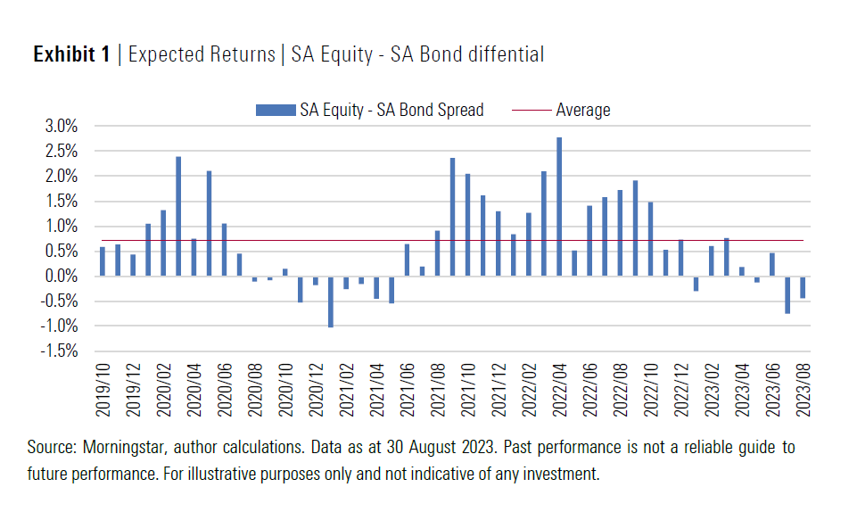

S.A. equities are expected to deliver higher real returns so the spread over S.A. bonds is normally positive. While the differential was mostly below average last year, it turned negative in June 2023 suggesting that bonds are especially attractively priced.

On a relative value basis, S.A. bonds present a more compelling opportunity than S.A. Equities and are priced for outcomes comparable to the COVID-19 market sell-off in 2020. This supports the absolute value argument we highlighted in a recent article “Disentangling risks in SA government bonds”, where the asset class was shown to be priced for expected real returns in excess of 5%.

- Managing Portfolios
Unfortunately, S.A. equities do not provide any meaningful downside protection to mitigate exposure to S.A. bonds. Both asset classes are significantly affected by currency movements, particularly where bouts of global risk-off sentiment result in foreign investors being net sellers of emerging markets like South Africa.

S.A. cash does, however, provide a less correlated payoff profile when compared to S.A. bonds and can diversify portfolio risk when managed appropriately at different stages of the market cycle.

The graph below shows the rolling 12-month correlation between S.A. bonds and cash since 2015. It can be seen that cash is negatively correlated with bonds over certain periods but also shows periods where the correlation is strongly positive. Over the whole period, the correlation is close to zero which suggests that cash is potentially a good diversifier when combined with bonds in multi-asset and income solutions.
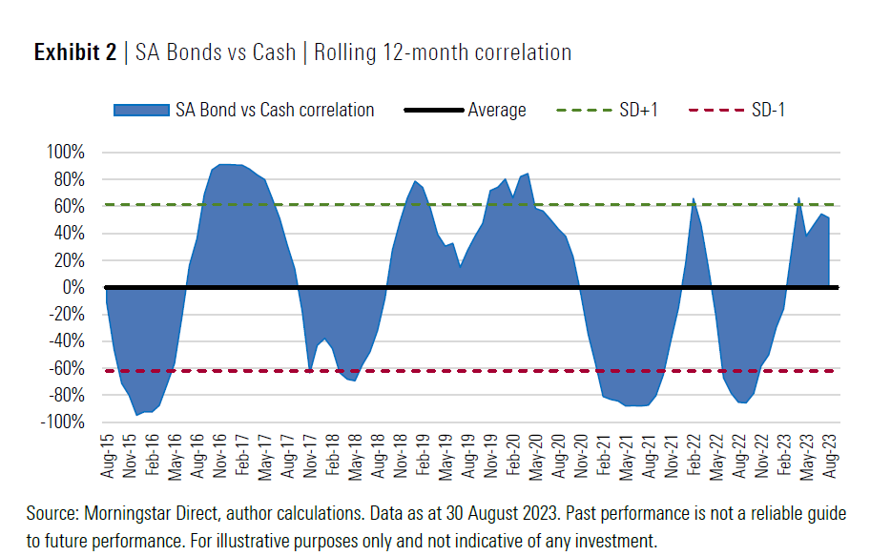

The combination of short-term cash with longer-term bonds results in a so-called barbell strategy being implemented across portfolios with higher fixed income allocations. This approach allows clients to benefit from the higher yield available on longer maturity bonds while mitigating interest rate and drawdown risk through allocations to shorter-term cash instruments.

Cash has the advantage of carrying negligible duration as well as providing liquidity that can more readily be deployed when shifts in capital markets allow for opportunistic allocations. Increased cash rates (relative to historical averages) make this strategy attractive in the current environment.

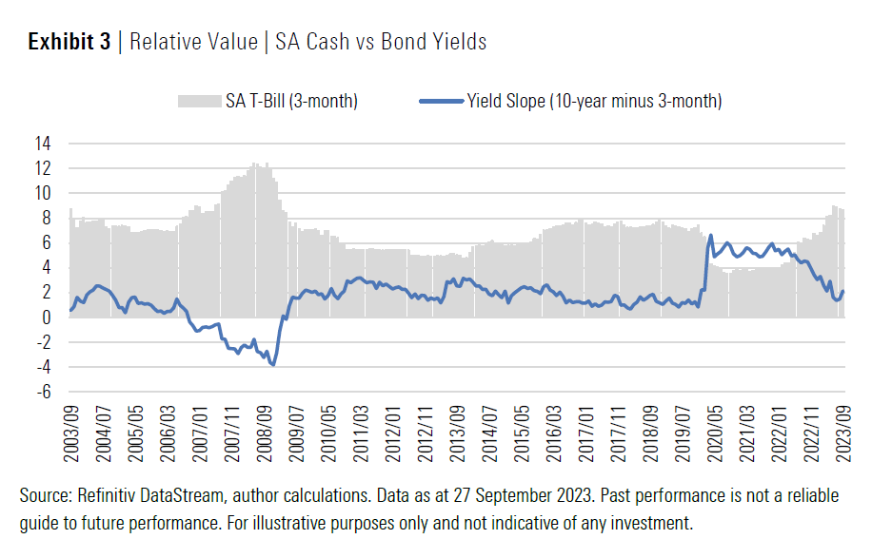

The graph above shows cash proxied by a three-month Treasury Bill. Rates have increased substantially since late 2021 and are currently at the highest levels since the financial crisis in 2008. The declining slope of the yield curve also shows that the higher interest rate environment has resulted in cash becoming increasingly attractive relative to bonds.

In conclusion

Navigating the uncertainties of both domestic and global capital markets requires a disciplined investment and risk management process in the current environment.

While investors are being adequately compensated for the fundamental risks to S.A. government bonds, exposure needs to be managed through sensible asset allocation and portfolio diversification.

Income and multi-asset portfolios that combine short-term cash with longer-term bonds allow clients to benefit from elevated yields while mitigating interest rate risk and improving liquidity. Sizing positions appropriately in portfolios is especially important to limit drawdowns if sentiment continues to be especially negative and provide upside participation when market sentiment turns positive.

Morningstar Investment Management’s local rand-denominated portfolios are currently marginally overweight S.A. government bonds whilst also maintaining healthy allocations to cash and cash-equivalent exposure.

