Scratching below the surface of tobacco companies
By Philip Short*
Consumers’ first thoughts on tobacco companies are generally “unhealthy; addictive; money machines”. As an investor, one thinks “over reaching regulation; a dying industry; money machines”. Unenviable characteristics that one would prefer to avoid… except that money machine trait. That sounds interesting enough for us to scratch below the surface.
Regulation
Regulation is the biggest red flag when looking to invest in tobacco companies. Regulators dictate what products tobacco companies may and may not sell, and governments can increase taxes on tobacco products to the point where they become unaffordable. One of the more stringent regulators is the US Food and Drug Administration (FDA). This is a cause of concern for British American Tobacco (BATS) investors because the FDA has flexed their muscle over the tobacco companies of late, and forty per cent of BAT’s revenue is derived from the US.
How did the US become such a large percentage of BATS’ revenue? BATS used to own 42% of Reynolds American Inc. (the vehicle through which it had exposure to the US), and bought the remaining 58% in 2017. Why? The US still has a long runway of pricing power. Looking at where a box of cigarettes is sold worldwide in US$ versus GDP/capita, one can see that affordability still has far to go in the US.

Additionally, BAT’s operating profit margins are higher in the US at 54% versus the 44% average for the Group. While traditional smoking product volumes, i.e. combustibles, are expected to decrease, the favorable pricing environment will more than offset this for at least the medium term (5+ years), resulting in a positive price/mix.
However, we’d would like to see something more tangible, beyond the medium term that the combustible portfolio currently offers. What happens one day when combustible prices are too high and unaffordable, and volumes too low? How far will regulation go? How are tobacco companies positioning themselves for this?
Next Generation Products
The effects of regulation, and the unquestionable evidence of the harm that combustible products inflict upon users, has pushed tobacco companies towards Next Generation Products (NGPs).
BATS and Philip Morros International (PMI) are leading the way when it comes to reduced risk products (RRP); products that studies have shown to be less harmful than combustibles. The global set of RRP include the following:
- Vapour, or E-cigarettes: vaping simulates smoking by creating an aerosol that appears like a vapour and contains nicotine, although no tobacco. It does not contain the harmful tar associated with cigarettes, but does contain other chemicals.
- Tobacco Heated Products (THPs): a tobacco stick that is inserted into a heating device which brings the temperature of the stick to just below burning point. Compared with cigarettes, THPs deliver up to 83% of nicotine while reducing levels of harmful toxicants by at least 62%, and particulate matter by at least 75%. (https://tobaccocontrol.bmj.com/content/28/5/582)
- Modern Oral: a small pouch filled with nicotine, water and flavorings (no tobacco), placed between the upper lip and gum, where the nicotine and flavors are released over 20-30 minutes.
BAT reported Group revenue growth of 4.4% over the first half of 2023. Traditional combustible revenue was up 1.8% while revenue from NGPs was up 29%. NGPs now makes up 12% of Group sales and this will become a greater part of the mix going forward.

Whereas combustible volumes are decreasing, the NGP category is drawing in new users, either through existing combustible smokers switching to NGPs as well as consumers who are new to the nicotine category as a whole.

Source: BATS; Kantar Group
BAT has positioned itself well in the vaping market, with a leading market share globally and in the US of 36% and 47%, respectively; North America alone has 44% revenue share of the global vaping market. Vaping is clearly a growing business. Given that existing combustible products are high margin, the question is, will the growth in NGPs be margin accretive or dilutive?
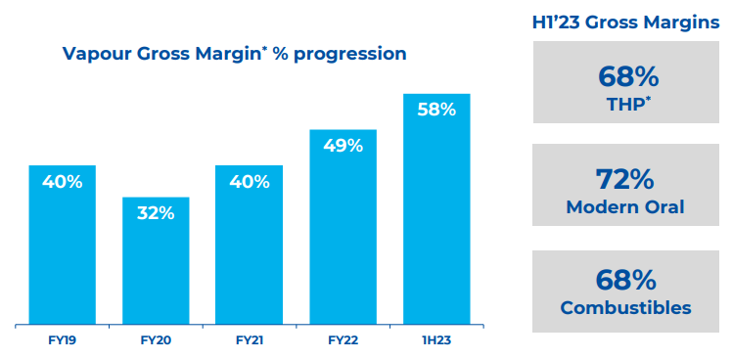
Source: BAT H1 2023 results presentation
NGPs are at, or trending towards, combustible gross margins. The dynamics in the trending margins for e-cigarettes are that you either get a refillable or a disposable product. For the refillable pods or cartridges, you first buy the e-cigarette device as a once-off (which is low margin and often subsidized by the company), and then you continuously refill the device with nicotine liquid which is higher margin. Thus, we expect vaping margins to increase further.
On an operating margin basis, there has been a significant amount of R&D going into NGPs which gets deducted from gross profit. This has resulted in the NGP portfolio being loss making at an operating profit level, to the amount of £1bn in 2020. Even so, BAT is expected to generate free cash flow of £8.6bn over its entire portfolio (combustibles plus NGPs) for FY 2023. We see sufficient runway for combustibles before the NGP portfolio takes the lead in growing cash flow for the Group.
Conclusion
Regulatory risks mean that combustible volumes will continue to decline, albeit with better pricing to offset this in the short to medium term. The FDA will move against flavors, such as menthol, in both cigarettes and e-cigarettes. This is important for BAT because 25% of group profits come from US menthol. In December 2022, the State of California banned menthol cigarettes and menthol flavoured e-cigarettes. Yet BAT managed to retain 90% of sales through menthol users switching to normal flavoured cigarettes and e-cigarettes, as well as some consumers buying menthol from neighboring states.
BAT currently trades on a rolling forward P/E and EV/EBITDA of 6.7x and 6.9x respectively, and a dividend yield of 9.4%, with annualized earnings expected to grow in the mid to high single digits over the next 3+ years. Taking the worst-case scenario and assuming every US state bans every menthol product, and that every menthol user quits nicotine completely (combustible and vaping), then BAT will trade on a still reasonable 8.9x PE and a 7.1% dividend, assuming the share price stays constant.
BAT is moving away from being a tobacco company to more of a nicotine company. The transformation to a less harmful product portfolio which has a longer growth runway should lead to a less regulated sector in time – and it will still be a money-making machine.
Ends
*Philip Short is a senior equity analyst at Flagship Asset Management.

