Is the global goods cycle about to turn?

David Rees, Senior Emerging Markets Economist at Schroders

An upturn in the global goods cycle has historically been a positive catalyst for some downtrodden markets such as EM equities and commodities.
A feature of the unusual global economic cycle in the post-pandemic era is that the world has been full of surprises as activity has become less synchronised. At the country level, China is only just coming out of its zero-Covid policy. Meanwhile, other emerging markets (EM) are about to start cutting interest rates as inflation subsides, whereas many developed markets (DM) are still tightening policy in the fight against inflation.
There has also been a major divergence at the sector level, where services have been performing strongly, while the goods side of the global economy has been weak. The goods side of the global economy fared well during the initial phase of the Covid-19 pandemic as healthcare requirements and lockdowns concentrated demand into the sector. However, it has lagged behind as economies have reopened and demand has rebalanced towards services, turbo-charged by large fiscal stimulus.
Indeed, according to data compiled by the Netherlands Bureau for Economic Policy Analysis (known as the CPB), global industrial production has been largely stagnant since the end of 2021 and has been in recession in advanced economies since the third quarter of last year. EM have fared a bit better, but only really because of mini-booms in output around lockdowns in China.
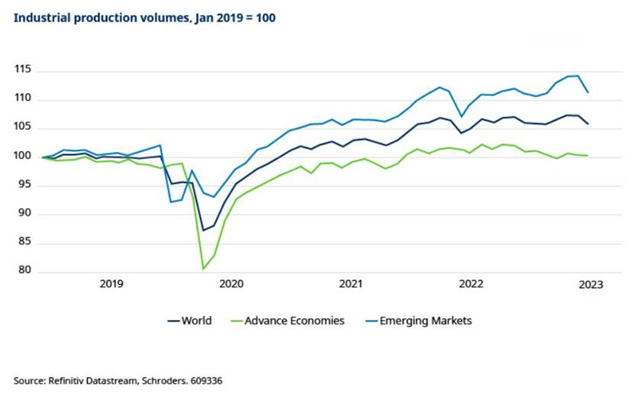
Looking ahead, though, there are tentative signs that another economic surprise is in the pipeline amid mounting evidence that the goods side of the global economy may be about to stage a recovery. Certainly, the fact that South Korea’s exports, which are a good indication of global trade conditions, have returned to growth in volumes terms has flown under the radar.
It is also worth noting that manufacturing in Asia ex-China and in the advanced economies has inched back to growth on a seasonally-adjusted, three month/three month basis.
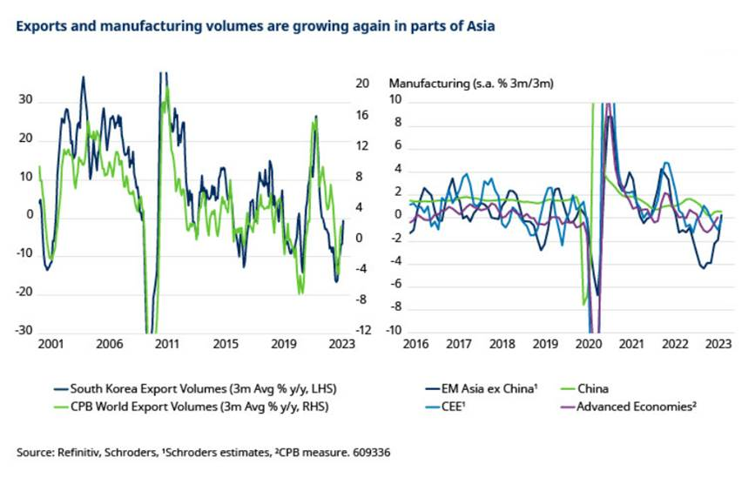
Meanwhile, global monetary indicators also suggest that the goods sector is near a turning point. While the relationship between global real M1 and S&P’s global manufacturing PMI is not perfect, it has historically been a useful guide to turning points.
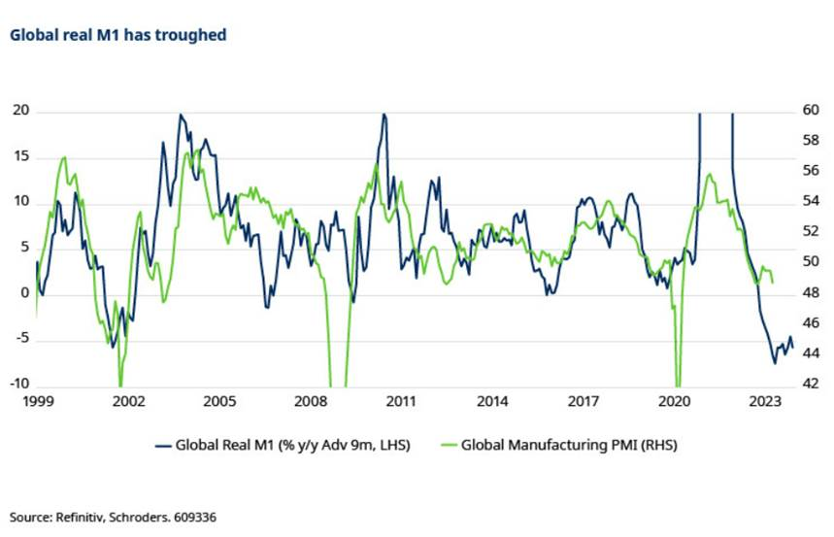
Real M1 clearly substantially overshot to the upside during the initial phase of the pandemic and is likely to have conversely undershot as the huge injection of stimulus unwound in year-on-year terms. But it has stabilised and started to turn up, which has historically heralded an improvement in manufacturing conditions.
Furthermore, outside of Europe, while noisy, the new orders to inventories ratios of major manufacturing PMIs published by S&P Global appear to have turned the corner. While the new orders minus inventories series for the ISM Manufacturing Index also suggests that something is afoot. And some market-based indicators also point in the same direction.
For example, the ratio of the consumer discretionary to staples sectors of the US equity market also imply a rebound to above 50 in the ISM Manufacturing Index in the months ahead.
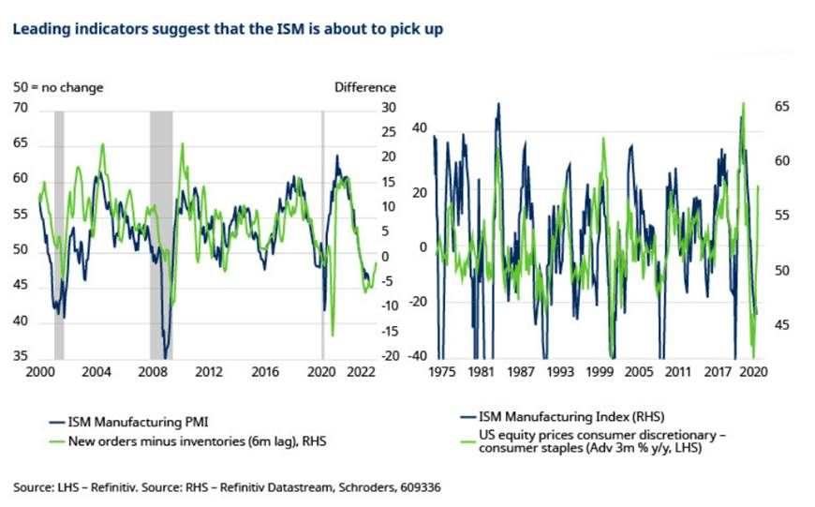
It is early days, and our baseline view is that DM will slide into recession later this year, led by the US. The prospect of recession, at a time when inventories are not particularly low, is an obvious argument against a strong rebound in the goods sector given that there would normally need to be an increase in final demand.
However, our work on regime shift has highlighted that firms may start to transition from “just in time" stock management to “just in case”, which could support inventory building.
Either way, these trends clearly warrant close attention given that an upturn in the global goods cycle has historically been a positive catalyst for some downtrodden markets such as EM equities and commodities.
