Is El Niño’s economic impact being underestimated?
David Rees, Senior Emerging Markets Economist at Schroders
We think that the increased likelihood of the “El Niño” weather pattern poses a stagflationary risk for emerging markets because of its potentially large impact on food prices.
A key plank of our view on emerging markets (EM) is that steep declines in inflation, in part due to a reversal of food price pressures, would allow central banks to start cutting interest rates this year, brightening the outlook for economic growth in 2024.
Incoming data have so far suggested that this view is playing out. Inflation surprise indices have fallen as CPI rates have started to decline. A reversal of energy inflation has so far done the heavy lifting, but food inflation has now clearly begun to roll over, while core price pressures are also starting to fade. Against this backdrop, falling survey measures of inflation suggest that it won’t be long until an EM easing cycle gets underway.

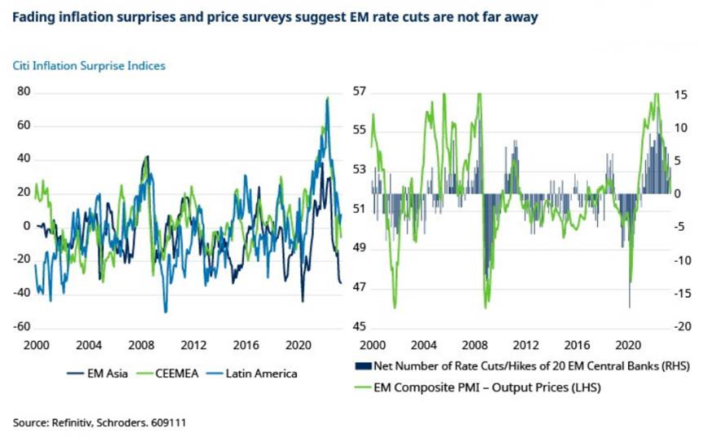
Some EM central banks, such as in Uruguay, Vietnam and Hungary, have already made tentative steps into easing mode. Falling inflation and slowly shifting central bank rhetoric suggests it won’t be long until Brazil starts to cut rates and others in Latin America are likely to follow suit before the year is out.
What is El Niño and how likely is it?
Looking ahead, though, the increasing likelihood of El Niño this winter is an emerging threat to our view.
According to the National Oceanic and Atmospheric Administration of the US Department of Commerce, El Niño is more than 90% likely in the 2023-24 northern hemisphere winter.
It is a periodic weather pattern typically observed every two to seven years, where a warming of sea waters in the Pacific Ocean disrupts the climate, affecting rainfall across different continents particularly in the southern hemisphere. South Africa is already experiencing some extreme weather conditions and the onset of El Nino is likely to exacerbate these issues in the months ahead, with higher winter rainfall giving way to a hotter and drier summer. The shift in weather conditions is also likely to affect the supply of food both at the local and global level that could push prices significantly higher. While leading indicators imply that food inflation in South Africa should still fall significantly in the near term, the effects of El Nino could cause it to rebound in 2024, leaving the SARB (South African Reserve Bank) with less room to lower interest rates.
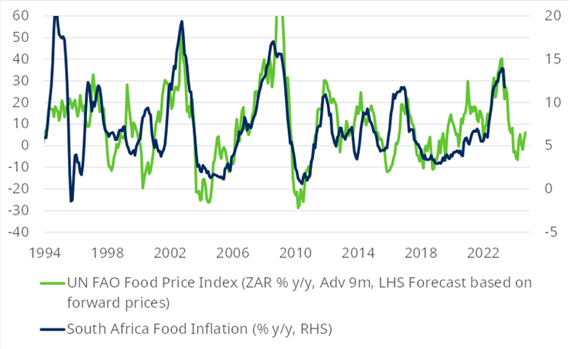
While the impact of El Niño can vary, and much also depends on the strength of the weather pattern, in general it leads to drier conditions in parts of Latin America such as northern Brazil and Colombia, Australia, India and Southern Africa. By contrast, there tends to be greater rainfall in more southerly parts of Latin America, the US and East Africa.
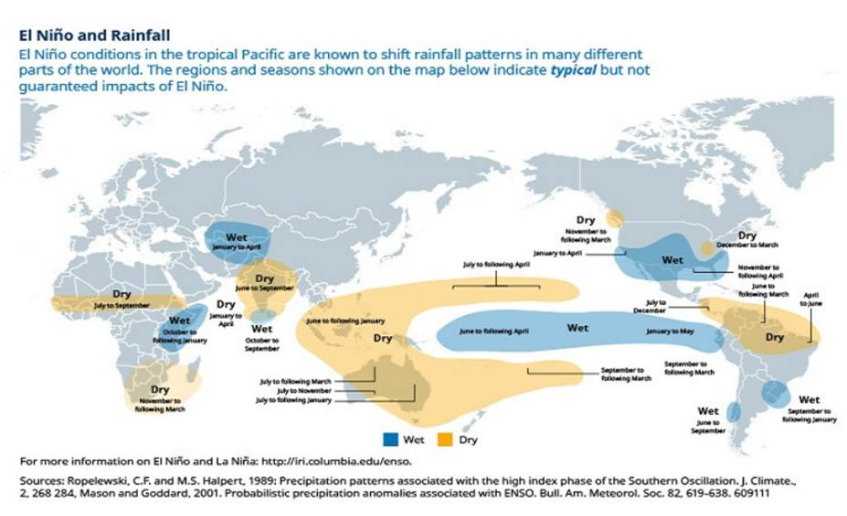
How El Niño can affect economies
There are several direct and indirect ways that El Niño can impact EM economic activity.
There are already reports that low rainfall has caused the level of the Panama Canal to fall, forcing ships to carry lighter loads to avoid running aground. At the margin that could cause some disruption to supply chains, which caused goods price inflation to balloon during the Covid-19 pandemic.
El Niño is also expected to impact the supply side of the global commodities market. There are already reports of heavy rain disrupting copper mining in Chile. However, in Asia, drier weather and shorter monsoon seasons can actually be positive for the extraction of other metals and ores such as bauxite, nickel and tin. (reference)
EL Niño may also exacerbate natural disasters, which have had an increasingly devasting impact on global activity and insurance markets in recent years. Many parts of Asia including China and India have already been suffering heatwaves, and drier conditions due to El Niño would add to the risk of drought and wild fires, which have been increasingly prevalent in recent years due to climate change. Heavy rainfall can lead to flooding and landslides.
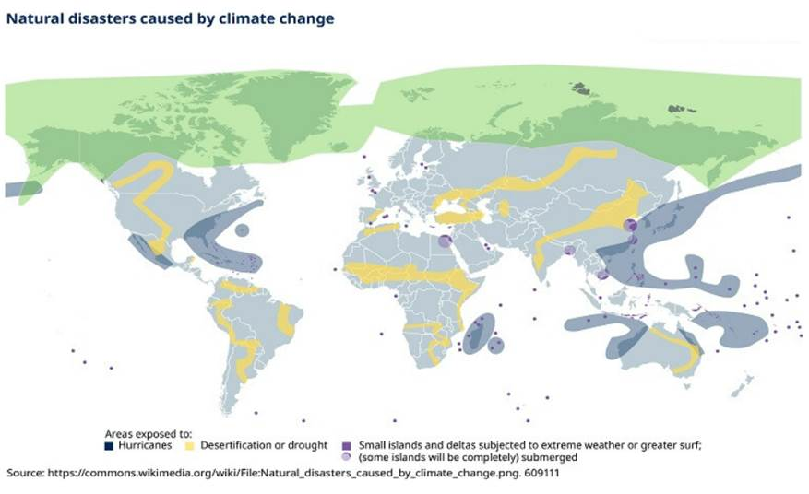
Drier conditions also affect energy generation in those countries, notably in Latin American countries such as Brazil, Colombia and Venezuela, that tend to rely heavily on hydroelectric power generation. That can lead to power shortages, pushing up prices and stifling activity.
Hydroelectric generation may be disrupted in parts of EM that rely on it heavily.
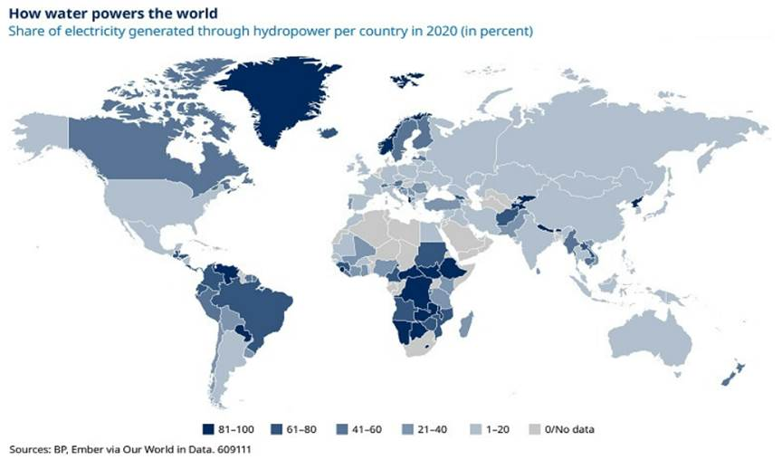https://www.statista.com/chart/28032/share-of-electricity-generated-through-hydropower-per-country/
The effect on food prices
Meanwhile, changes in weather conditions are a clear threat to agricultural output. Drought conditions can stunt production, while excessive rain can also cause problems if it washes crops away. All other things equal, disruption to agricultural output would cause food prices to climb.
At first sight there does not appear to be much relationship between the risk of El Niño and global food prices. For example, the Oceanic Niño Index (ONI) produced by the National Oceanic and Atmospheric Administration of the US Department of Commerce, which measures changes in water temperatures in the Pacific Ocean, bears virtually no resemblance to movements in global food prices. An ONI score of 0.5 is consistent with weak El Niño conditions, 1 moderate, 1.5 strong and 2 very strong. As the chart shows, spikes in the ONI, representing more severe El Niño conditions, have only occasionally been accompanied by significant increases in global food prices. More recently, while the ONI score has picked up, food prices have been heading in the opposite direction in year-on-year terms.
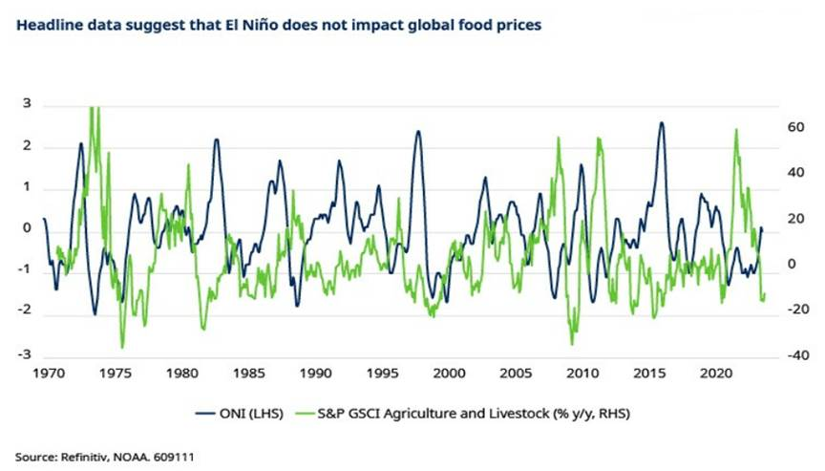
That being said, it’s worth bearing in mind that weather conditions and expectations for supply are only one factor that drive food global prices. Expectations for demand, along with production costs – notably energy – are equally, if not more important. This explains why there has historically been a close correlation between movements in global oil and food prices. Higher energy prices often reflect improved sentiment about future economic growth (and thus demand for food) and directly increase the cost of production in the agriculture sector. The opposite is also true for lower energy prices.
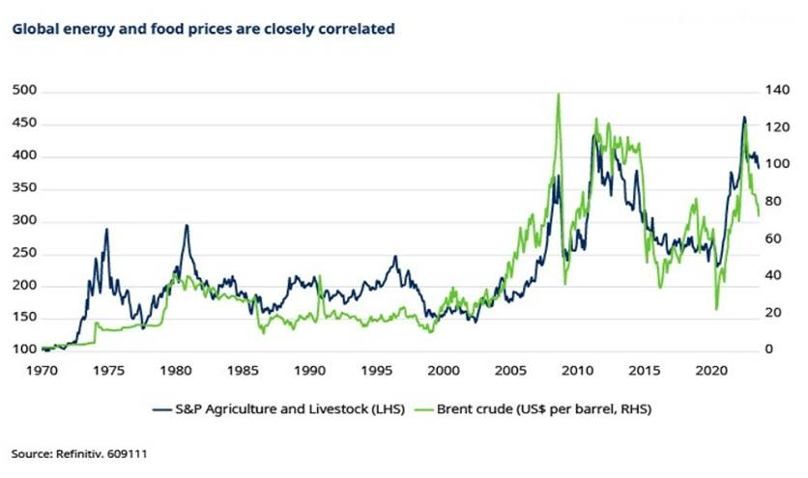
An obvious recent example of this was seen when food prices spiked in the wake of Russia’s invasion of Ukraine. While higher food prices were in part due to concerns about the loss of supply of exports of wheat and other products from the region, much of the impact was due to higher energy prices as sanctions on Russian exports turned the global oil and gas market upside down. That increased the cost of producing food, and also forced up the prices of fertiliser. Energy prices have more recently declined, reflecting downbeat sentiment about the global economic outlook, weighing on food prices.
Accordingly, it makes sense to try and eliminate the impact of changes in the cost of energy on food prices. And by doing that we find that there is a better relationship between measures of the likelihood of El Niño such as the ONI and movements in food prices that are not due to energy. On the face of it, this suggests that the increasing likelihood of El Niño has begun to affect food prices, and that they trade roughly in line with a “moderate” weather pattern.
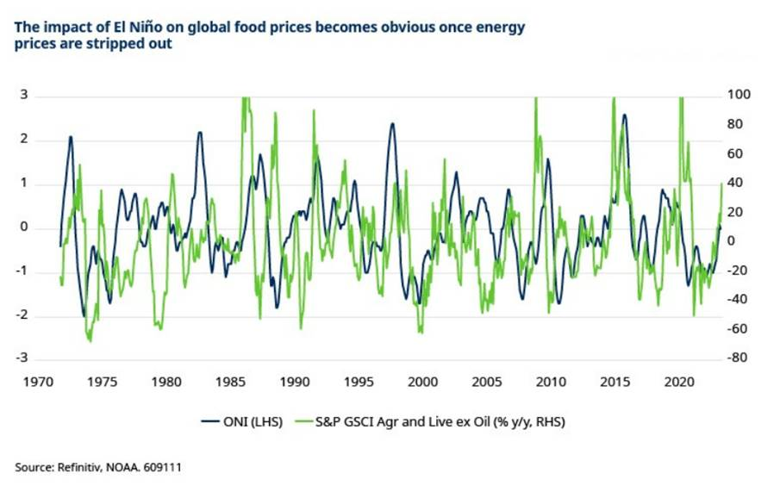
Using this relationship as a guide, we can think about what might happen to food prices in the event of more severe El Niño conditions. Keeping oil prices stable, this suggests that in the end of a strong El Niño the S&P GSCI agriculture and livestock indeed might be around 40% higher from current levels around the turn of the year, while a very strong El Niño could lift prices by more than 50%. Feeding these figures into our inflation models, it seems that while a moderate El Niño would not significantly alter the outlook for inflation, anything more severe would be worrisome. Indeed, it is feasible that, after steep declines into year-end, average EM food inflation could quickly rebound into double-digits during 2024.
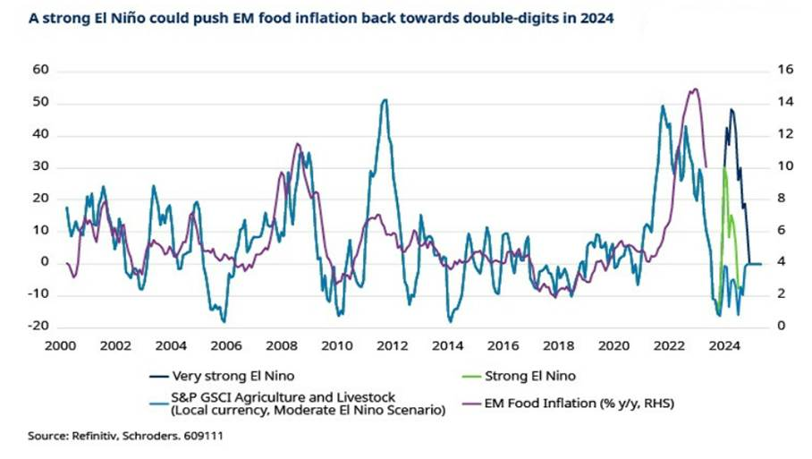
All other things equal, higher food inflation would put a renewed squeeze on real incomes to the detriment of non-food goods, and leave less room for central banks to lower interest rates. As such, El Niño is a stagflationary risk to EM forecasts.
Which economies would be most impacted?
That being said, the impact of any disruption to agricultural output and prices would be felt unevenly across EM. After all, poorer countries rely more heavily on agricultural output for local sustenance and economic growth. Higher food prices and shortages of goods can have a devastating impact on poorer EMs and even be the trigger for social unrest.
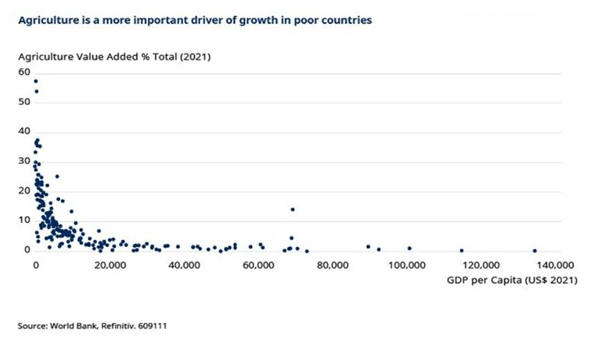
Meanwhile, those EM economies that are major net exporters of food can suffer from a loss of export revenues if production losses are worse than any increases in prices.
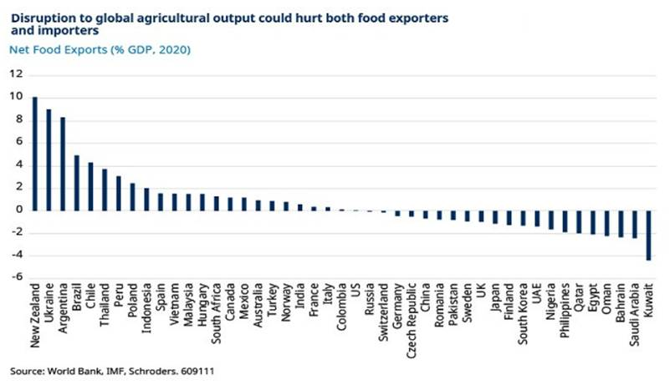
For example, in Brazil net food exports are equivalent to around 5% of GDP and it is notable that swings in the ONI have become well-correlated with GDP growth. This would suggest that while bumper agricultural output ensured that Brazil’s economy grew more quickly than expected in the first of 2023, that support may go into reverse in the months ahead if El Niño conditions intensify.
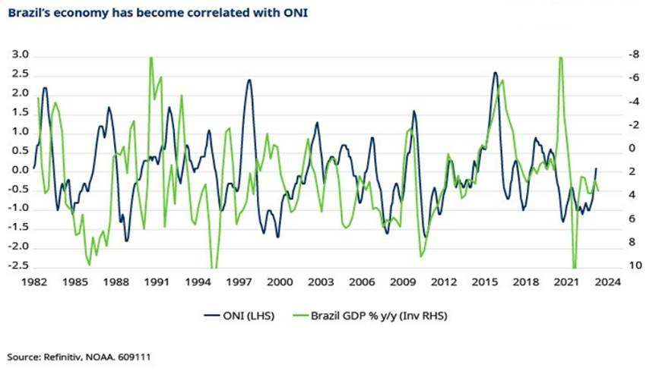
Meanwhile, net importers of food will face higher prices and face the choice of funding wider trade deficits or cutting back imports of other goods, requiring a reduction in domestic demand and therefore overall GDP growth. Food inflation would also increase.
However, the impact on inflation would be felt unevenly across EM. After all, food accounts for a varying proportion of consumption in different countries. For example, whereas food accounts for about half of the CPI basket in India, the weight is much lower in other EMs.
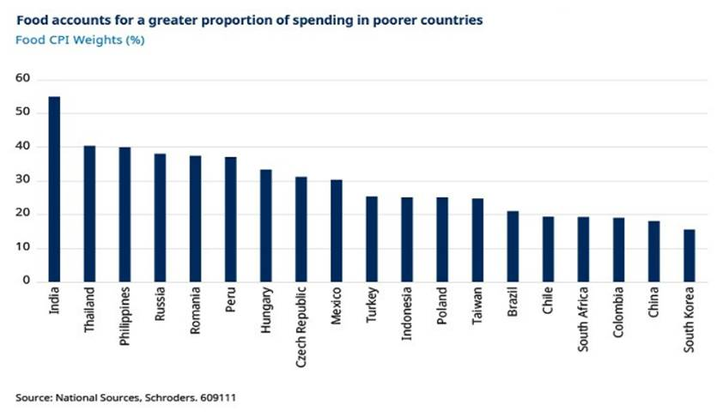
The vast majority of EM central banks are now priced to significantly cut interest rates in the year to come. Indeed Brazil, Colombia and Chile, three economies directly impacted by El Niño, are priced to cut policy rates by 350-600bp over the next 12 months – meaning that relatively strong El Niño events could have some impact on financial markets. After all, unlike in developed markets where policymakers tend to look through commodity effects and concentrate on core inflation, EM central banks have historically been sensitive to movements in food inflation.
One way to think about where the vulnerabilities lie is to consider what markets are expecting in terms of real policy rates. The chart below gives an approximation of where real policy rates will be in a year’s time by subtracting a rolling 12-month forward consensus forecast for headline inflation from the market-implied policy rate for various EMs.
Expectations for positive real rates gives central banks in Latin America some room for manoeuvre. The greater vulnerabilities appear to be in Central and Eastern European (CEE), where food is a large share of CPI baskets and markets appear to be priced for negative real rates. And India, where food is around half of the CPI basket and drought conditions would raise major question marks overs the ability of its large agriculture sector to produce enough food.
