Silver Linings Playbook

Old Mutual Wealth Investment Strategist, Izak Odendaal

A mystery explosion caused death and mayhem in the Johannesburg CBD last week, and much head-scratching. However, it was otherwise mostly a good news week in South Africa.
Starting with inflation, data from Stats SA showed that the pace of increase in consumer prices slowed to 5.4% year-on-year in June. This is down from a peak of 7.8% in July 2022, meaning that the worst is behind us. Notably, food inflation has eased from 14% to 11%, while annual fuel inflation fell from 56% to -8%. These are typically the items people notice most since they are regular purchases. Many people equate food and fuel inflation with inflation. Therefore, the relief is great.
However, while important, food and fuel make up less than 20% of the overall consumer price index. Excluding these items, yields the so-called core inflation rate.
Chart 1: Inflation in South Africa
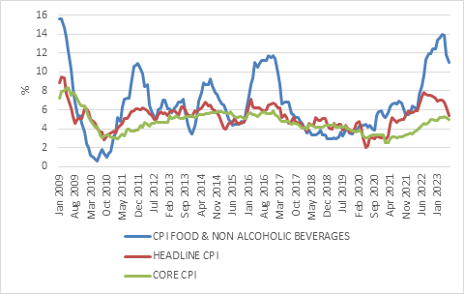
Source: Refinitiv Datastream
Core inflation is useful to economists, investors and policymakers as a better indicator of underlying or persistent inflation. Admittedly it does little to assuage other people’s money anxieties to tell them that “inflation is low apart from the items whose prices are high.” But there are times when food and fuel inflation is negative, and then core inflation can give comfort that the economy is not about to fall into a deflationary trap.

Core inflation was 5% in June, a touch lower than the recent peak of 5.3%. It remains relatively elevated and is likely to be somewhat sticky on the way down. In other words, while the worst is over, it is not necessarily the case that inflation will cease to be a concern.
Food for thought
A worrying recent development is the 10% jump in global wheat prices following Russia’s withdrawal from the agreement to allow Ukrainian grain to be shipped through the Black Sea. However, so far, the increase is small compared to the 70% spike after Russia first invaded Ukraine in March 2022. As with the oil market, it does appear that grain markets have largely lost interest in the war. Traded wheat (and oil) prices are still lower than they were a year ago.
Chart 2: Global wheat and oil prices, $
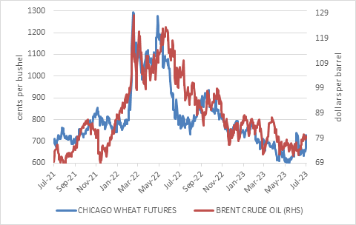
Source: Refinitiv Datastream
The bigger worry for food prices, however, is the emerging El Nino phenomenon, which tends to be associated with drought conditions in South Africa and many other countries, and upward pressure on food prices.
Speaking of Russia, the announcement that Vladimir Putin will not be attending the BRICS summit in Sandton next month is also good news. It means there will be no further complications to the delicate relationship with the US as it decides on renewing South Africa’s benefits under the African Growth and Opportunities Act (AGOA).
Rates relief
The next bit of good news – or just relief – came when the South African Reserve Bank’s Monetary Policy Committee (MPC) left the repo rate unchanged at 8.25%. Though it was a close call with a 3/2 split on the Committee, it was the right decision. Inflation is declining locally while global factors have also eased up recently, while rates are already deep in restrictive territory.
The MPC statement highlighted that there are still risk factors that can push inflation in the wrong direction. Loadshedding is one, insofar as firms pass on the costs of running generators, while the rand’s vulnerability to sudden declines given the country’s international funding needs and tight global financial conditions is another.
The Bank also wants to lower inflation expectations on a sustained basis. The theory is simply that if people expect that inflation will be high, they alter their economic behaviour such that it becomes a self-fulfilling prophecy. In practice however, inflation expectations as measured by surveys tend to largely reflect people’s recent experience. It is often more of a lagging than a leading indicator. The Bureau for Economic Research surveys consumers, trade unions and businesses on their expectations of future inflation. The composite number for the coming 12 months increased to 6% in the second quarter, but the five years-ahead number declined to 5.2%.
Either way, expectations play an important role in the MPC’s decision-making, as noted in its statement that its restrictive policy stance “aims to anchor inflation expectations more firmly around the midpoint of the target band and to increase confidence of attaining the inflation target sustainably over time.”
Though inflation is back within the Reserve Bank’s 3% to 6% target range, it is important to remember that the Bank targets the midpoint (4.5%) these days, and simply being below 6% is not enough reason for it to declare victory. Like other central banks, it will want to have a high degree of certainty that inflation will remain on target over the medium term. The Governor, Lesetja Kganyago, has also repeatedly stated his preference for an explicitly lower inflation target, but this is the government’s decision and is unlikely to happen any time soon. Nonetheless, nothing stops the Bank from implicitly targeting the 3% lower end of the range.
This suggests that South Africa is heading for a period of positive real short-term rates. The Bank forecasts inflation of 6% this year, 5% next year and 4.5% in 2025. By the fourth quarter of this year, inflation is expected to be 5.3%, implying a 3% real repo rate.
Chart 3: Repo rate, %
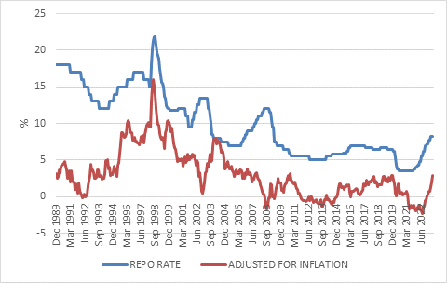
Source: SA Reserve Bank
While the MPC left the door open to further tightening if conditions warrant, things will have to go badly wrong either domestically or in global financial markets. The next move in rates is therefore very likely to be down, but probably only early next year. Borrowers will have to continue penny pinching, but savers and conservative investors will have reason to smile.
Unblocking growth
The Bank upgraded its 2023 economic growth forecast very slightly to 0.4%, but the medium growth outlook remains tepid at 1%. The MPC statement notes that an “improvement in logistics and a sustained reduction in load-shedding, or greater energy supply from alternative sources, would significantly increase growth.” Therefore, the announcement that ICTSI from the Philippines is the preferred bidder to partner with Transnet to expand and run Terminal 2 of the Durban port for 25 years is notable.
It will see foreign capital and expertise injected to upgrade and improve the running of the terminal, responsible for almost half of container trade in and out of South Africa. This is an important milestone for Southern Africa’s busiest port, unfortunately ranked near the bottom in terms of efficiency by World Bank comparisons. But it is also an important milestone for the broader agenda of economic reform and raising private sector involvement in key network industries. Expect to see more of these announcements in the future, better sooner than later.
The other major challenge remains electricity supply. While loadshedding remains a feature of daily life, it has generally been less intense than in April and May when the country was regularly on stages four to six, and certainly better than expectations for sustained stage seven and eight loadshedding in the depths of winter. It is hard to say why this is exactly. However, what we do know is that private investment in electricity generation continues to grow rapidly, and we will solve loadshedding one solar panel at a time.
Fixing energy and logistics is crucial for improving the growth prospects of the country and improving its fiscal situation. Faster growth in tax revenues is needed to stabilise debt levels. Unfortunately, the opposite has happened this year, with tax revenues undershooting as economic growth has disappointed. Therefore, unlike in developed countries where bond markets react directly to the slightest changes in central bank policy, in South Africa it is fiscal policy that drives the markets. Bond yields remain extremely elevated, well above any reasonable expectation of where inflation will be over the next decade, reflecting investor anxieties over the sustainability of government debt.
Chart 4: South African 10-year government bond yield, %
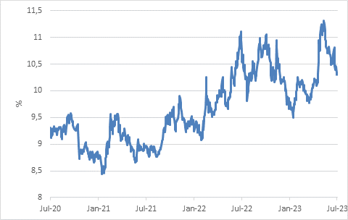
Source: Refinitiv Datastream
On the bright side
Nonetheless, there is a touch more optimism on South African markets. The rand seems to have stabilised around R18 to the dollar, while bond yields have pulled back in the past few weeks. Local equities are enjoying a good month and are still positive year-to-date. The global climate plays a big role, however, and always influences South African assets. Hopes of a soft landing in developed markets have risen, with inflation receding somewhat while economic growth – particularly the labour market – remains resilient. The weakness in China’s economy is also spurring optimism that Beijing will launch a big stimulus package. On both counts there is reason for caution. That the US and other developed economies have shrugged off the impact of rate hikes may simply be because it always takes time for this impact to be felt. We also know that employment is a lagging indicator, historically the one of last variables to turn after a hiking cycle. The leading indicators continue to point south.
Meanwhile, Chinese authorities are less focused on raw economic growth numbers. They are focused on reducing debt, not increasing it, and addressing some of the overcapacity that exists. Geostrategic considerations also loom larger than whether consumers are spending or not. In the struggling property market, the emphasis is on completing half-finished developments where buyers have already put money down, rather than spurring new building activity. Residential construction, an outsized portion of the economy, looks set to continue shrinking.
In summary, there are more silver linings around the dark clouds these days. The investing playbook continues to be one of not betting on a single outcome – good or bad – but rather to position portfolios for when things go off script through proper diversification. If the past three years has taught us anything, it is expecting the unexpected.

