Rand Mayday

Old Mutual Wealth Investment Strategist, Izak Odendaal

May has not been kind to the rand. The beleaguered South African currency is down sharply against the US dollar this month, hitting a new record low along the way. In fact, 2023 in its entirety has been unkind to the rand, and it has lost ground against the pound and euro too.

This is not good, but for some perspective consider what happened this month 25 years ago. Indonesian president Suharto was forced to stepped down after 30 years in power on 21 May 1998, as widespread rioting followed a catastrophic currency collapse. Like many East Asian currencies in the 1990s, the rupiah was pegged against the dollar. Across the region, this encouraged lots of cheap but ultimately unsustainable borrowing in dollars. When Thai authorities eventually ran out of hard currency to maintain the peg in July 1997, it triggered a financial crisis that would knock over other countries in the region like dominoes and ultimately destabilise markets as far away as Russia. The Indonesian rupiah lost 80% of its value against the dollar in the 12 months prior to Suharto’s resignation (the already-weak rouble would slump 70% in the following 12 months). Chaos in the financial market spilled over into the streets.

Managed currencies have the great benefit of stability, allowing businesses to make decisions about future cross-border activity with relative ease. But over time, the exchange rate can become unrealistically strong or weak relative to the underlying economic reality. Imbalances build up. The experience in most developing countries is that the currency ends up too strong, encouraging excessive imports and foreign borrowing. Ultimately, the country runs out of the foreign exchange reserves needed to keep the currency pegged, forcing the government to adjust the exchange rate. People wake up one morning to hear that the currency has fallen by 20% or 30% overnight. In the case of Indonesia, the declines were much worse.

Prior to the early 1980s, the rand was also pegged against the pound and later the dollar with the exchange rate determined by the government. The rand was also periodically devalued, for instance in 1975, when it was devalued by 21% over a weekend in September.

Chart 1: 50 years of the rand’s volatility
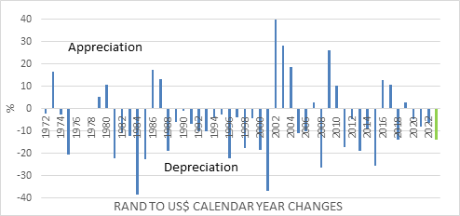
Source: Refinitiv Datastream

After 1981, it was left to the market to determine the exchange rate, though it would only be until 1995 that the system of parallel currencies (the financial and commercial rand) used to manage capital controls was finally abolished. Foreigners investing in South African markets had to use the financial rand, and it often traded at a large discount to the commercial rand.

Almost as soon as the rand became free-floating currency, it came under pressure from the strong US dollar of the early 1980s, and it would experience several other episodes of sharp depreciation in the years ahead, as has been the case again recently. (A devaluation is a deliberate change in the exchange rate of a managed or pegged currency, while a depreciation is a market-determined decline of one currency against another.)

This included a 30% decline against the dollar during the Asian Financial Crisis. A big fall, but still mild relative to what the East Asian currencies and the Russian rouble were experiencing. The Reserve Bank desperately tried to stop the tide by hiking the prime rate to 25%, but also through selling forward billions of dollars it did not have. It was a largely futile exercise that can best be described as whistling against the wind. It would be the last time the Reserve Bank would try to intervene directly to prop up the currency. Indonesia too learned lessons and is today considered one of the more stable and attractive emerging markets. The rupiah has outperformed the rand in recent years but has still not escaped the big emerging market sell-offs as chart 2 clearly shows.

Chart 2: A proper blow-out
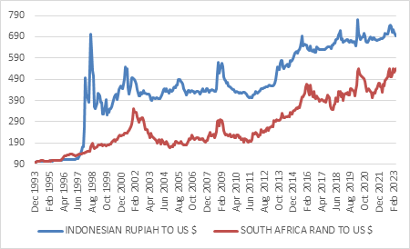
Source: Refinitiv Datastream

So today we have a currency that trades completely freely at the whim of the market and can be very volatile as a result. As a reminder, it was ranked as the 18th most traded currency in 2022 by the Bank of International Settlements (BIS), ahead of the currencies of larger economies like Brazil, Poland and Thailand.

As an aside, the BIS’ triennial survey also shows no change in the US dollar’s absolutely dominant role in global currency markets, with the dollar being part of 88% of traded currency pairs. In the giant forex market – whose $7.5 trillion daily turnover dwarfs other markets, such as oil’s roughly $10 billion – the dollar is still the undisputed king.

What is the point? The rand has a history of big blow-outs, but these are also never as catastrophic as what some other countries have experienced. This is largely because we’ve never had the same build-up of major imbalances in the domestic economy.

The benefit of the rand’s famous volatility is that it discourages reckless foreign borrowing and overreliance on imports. Everyone knows they can get their fingers burnt, whereas a managed exchange rate usually lulls people into a false sense of security. Moreover, with a sophisticated domestic financial system, foreign borrowing is rarely necessary. The Reserve Bank oversees this system as a regulator, but also provides a credibility with sound monetary policy. It will almost certainly raise interest rates this week, and possibly by 50 basis points. Unfortunately, credibility doesn’t always come cheap.

These are key strengths that act as a bulwark against the kind of financial implosion suffered in Latin America in the 1980s and early 1990s, East Asia and Russia in the late 1990s, and now again in Argentina, where the currency has lost 95% of its value over the past five years and where annual inflation is running in triple digits. Turkey’s lira has lost 77% over the same period, and while not all the associated chickens have come home to roost yet, they are surely on the way especially now that it seems that President Erdogan will win re-election and maintain his unorthodox economic policies.

Pros and cons
Many people believe the rand to be the share price of the country, and therefore its depreciation is seen as an outright negative. But this view is wrong on two counts. Firstly, an exchange rate is not a share price but a ratio of two currencies. Therefore, there are always two moving parts that influence it. In the case of the rand-dollar exchange rate, it is both the rand and the dollar that matter. Secondly, exchange rate shifts rebalance income and activity in an economy. A weak currency boosts the income of locals earned from exports or foreign investments. It makes imports more expensive, which hurts consumers but helps businesses that compete against imported goods and services. It also makes the country more attractive for tourists. On the negative side, a weaker currency puts upward pressure on inflation and interest rates. A currency can also be too strong for the domestic economy, making it uncompetitive in global markets.

Can the rand recover from these levels? History suggests yes. The biggest declines in the currency – 1984, 2001, 2008, 2015, 2020 –coincided with global conditions turning negative for emerging markets. A strong dollar, falling commodity prices and a financial crisis – or some combination of the three – is toxic to the rand. 2023 has been rather unique in that the rand has weakened while our peer group has mostly gained against the US dollar. The increased severity of loadshedding is probably a big factor, and now Eskom has explicitly warned of Stage 8 during the winter.

Each of these blow-out episodes was followed by a recovery when global conditions turned positive. Even in 1986, the rand rallied as the dollar retreated from elevated levels, despite the fallout from the Rubicon Speech, the debt standstill and increased global sanctions.

For the rand to recover from current bombed-out levels would therefore require some good news on the electricity front but also largely depend on whether the dollar once again retreats from its globally strong dollar position. Since 1970, the dollar has only been stronger on a real trade weighted basis 13% of the time. Further sustained dollar weakness will require a further closing in the expected interest rate gap between the US Federal Reserve and other major currencies, and probably outright cutting by the Fed.

Chart 3: Real trade-weighted US dollar index
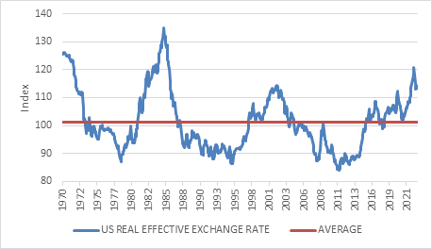
Source: Refinitiv Datastream

Strategy and tactics
What to make of all this in the context of portfolio management? The rand lost on average 7% a year against the dollar over the past four decades. Around this steady weakening trend, there were several periods where it appreciated. Chart 4 shows that the rand depreciated over most rolling three-year periods, since 1980, but several were positive. Not surprisingly, the weakest periods were followed by the strongest, as the market corrected its overshoot. This is the dilemma for South African investors. On average the rand will be a tailwind to offshore investments, but it can be a headwind for uncomfortably long periods.

Chart 4: Rolling 3-year changes in the rand-dollar exchange rate %
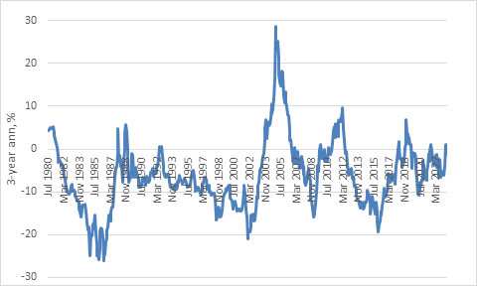

Therefore, it is important to be clear about time horizons. If you are concerned about what happens in the next three years, then there is a good chance the rand will be stronger than it is today. This suggests tactically reducing offshore exposure or employing a currency hedge on a portion of that exposure. On a longer-term horizon, it is a different story. The rand could rally sharply over the next three years but still end up at R28 per dollar ten years later if it resumes its historic depreciating trend. This is not a forecast, simply a reasonable assumption unless South Africa fundamentally restructures its economy. Again, it does not imply that the country is falling apart, rather that the exchange rate is doing what it needs to compensate for the relative lack of competitiveness. And of course, there will be ongoing cycles around this trend.

It is also very important to consider what you are buying offshore. Given high domestic interest rates, the rand would have to fall by unrealistically large amounts for global cash to outperform local cash over time. The same is true for bonds. For equities, the story is different. Equities should always have a much longer investment horizon, with shorter-term currency fluctuations less relevant. The key factor is always valuations. A weak currency is unlikely to bail you out if you bought into an expensive overseas market. If you sold cheap rands to buy expensive dollar equities, it can be a double whammy as the rand recovers and the equities underperform. This was the experience of the early 2000s that burnt so many fingers and put many people off offshore investing for a decade or more.

Looking at the world today, the US large cap equity still looks on the expensive side, after more than a decade of outperforming non-US equities. The better value appears to lie in the latter.

This too shall pass
To conclude, the rand is on the back foot and there is no sign of immediate improvement, especially not while global markets are increasingly on edge over the US debt ceiling. This too, however, shall pass. The rand should recover to more reasonable levels. This presents opportunities and risks to investment portfolios that should be approached in a sober and considered fashion. A knee-jerk reaction to recent events is unlikely to serve any investor well.

