A hop, a skip, a jump, and a cut
Old Mutual Wealth Investment Strategist, Izak Odendaal
It was a busy week for the world’s four most important central banks. By implication, it was also a busy time for the world’s traders, economists, fund managers and market commentators. What have we learned?
A hawkish skip
The big daddy of central banks is of course the US Federal Reserve, or Fed, whose policy interest rate is the base rate from which pretty much all other financial assets across the world are priced directly or indirectly. Its Federal Open Markets Committee (FOMC) kept rates unchanged in line with market expectations. However, it signalled further hikes would likely be needed, unless incoming data shows a softening in inflation and the economic outlook. The pause at last week’s meeting is therefore probably a skip, not a stop.
Chart 1: Dot plot projections
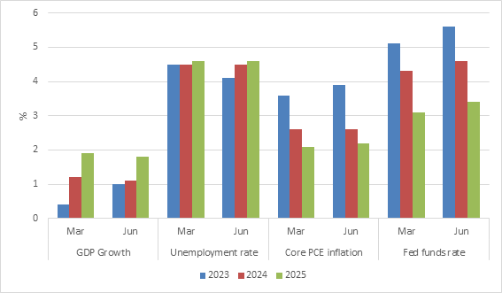
Source: US Federal Reserve
Every quarter, the independent forecasts of officials from the Fed system are plotted on an anonymous summary known as the ‘dot plot’. It shows that most officials think rates will need to increase by at least 50 basis points from current levels spread over any of this year’s four remaining meetings. Officials also marked up their near-term outlook for growth and inflation, while trimming the unemployment outlook compared to the March dot plot. However, the forecasts still show an economy that is estimated to slow from current levels, while unemployment is expected to rise from 3.7% in May to 4.1% at year-end.

US economic data has been solid of late, despite the 500 basis point cumulative rate increase over the past 18 months. Consumer spending remains strong, supported by excess savings, plentiful jobs, and decent wage gains. But there is little harm in the Fed skipping a meeting to assess the lay of the land, especially since interest rates always work with a lag. Though interest rates have risen sharply, the cycle only started 18 months ago.
Inflation is coming down, but this progress doesn’t mean its mission accomplished. Headline inflation declined to 4% in May from a 40-year high of 9.1% in October last year. This is a big improvement and also improves people’s real incomes. However, having more than halved, it would need to halve again to get to 2%, the Fed’s target. This will be tougher. Moreover, core inflation, which excludes volatile food and fuel prices, remains sticky at an annual rate of around 5%. This should also decline given that the large rental component in CPI lags market rental growth by several months, and the latter has cooled decisively. But even so, the path down to 2% is long and uncertain as inflation in other service components remains elevated. The Fed may or may not decide to raise rates further, but they certainly are not going to cut any time soon. We’re still in a higher-for-longer interest rate environment.
It is not clear that the stock market is getting the message, perhaps because it is so love-struck by artificial intelligence that it refuses to acknowledge reality. It is true that a better economic performance in recent months means a somewhat better earnings outlook, but most of the returns form the year have come from a rerating. Investors are prepared to pay more for each dollar’s worth of earnings generated. This doesn’t make a huge amount of sense in an environment as uncertain as the present. A soft landing where growth slows without crashing and inflation cools without the Fed having to bludgeon it into submission is plausible, but not the only scenario. This is not what the bond market is pricing in, with short-term yields exceeding long-term yields by the most in four decades. This so-called yield curve inversion has historically been a good recession warning.
Chart 2: US government bond yields
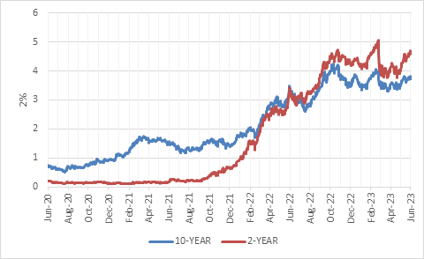
Source: Refinitiv Datastream
Jump
The European Central Bank (ECB) ploughed ahead with rate increases, taking its deposit rate to 3.5%, the highest level in 22 years. Rates have jumped by 400 basis points this cycle. Recent economic data has disappointed in Europe, and the ECB cut its growth forecast for the next three years, but inflation is still running hot. In fact, inflation is only expected to return to target by 2025. Therefore, another 25-basis-point hike is likely next month.

Chart 3: Policy interest rates
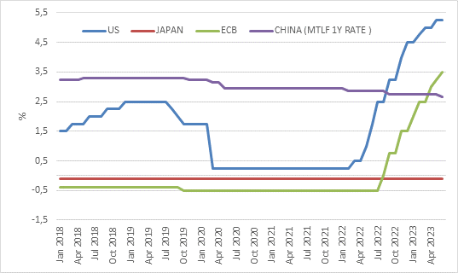
Source: Refinitiv Datastream

As in the US, there is a strong demand for workers and unemployment is at a record low in the Eurozone. This results in upward pressure on wages, with pay per employee in the Eurozone rising by 5.2% year-on-year in the first quarter. The ECB is worried this will put upward pressure on inflation as workers have more money to spend. Moreover, as companies’ wage bills rise, they might have to raise prices to maintain margins, a so-called wage price spiral. This is a worry for central banks on both sides of the Atlantic and the English Channel. Wage growth has been particularly strong in the UK and the Bank of England is also likely to hike this week, not for the last time.
Hopping along
The inflation surge of the past two years was global in nature, but there are two important exceptions. The one is China, where inflation never jumped, and which we’ll discuss below. The other is Japan, where a bit of inflation is welcome after years of very low to negative inflation. In fact, some staples in a Japanese grocery basket saw price increases for the first time in a generation. And while the rest of the world is worried inflation might not fall fast enough, in Japan the question is whether it will stick around, injecting a bit of oomph in an economy long thought of as moribund. Core inflation was 3.4% in April, above the 2% inflation target.
But the Bank of Japan expects it to decline later this year and remains the last central bank to maintain negative short-term interest rate. It is also the only major central bank controlling long-term bond yields. For now, the Bank of Japan is sticking to its ultra-accommodative stance. One of the consequences has been a very weak yen.
Nonetheless, there is a renewed sense of optimism in Japan that has seen its equity market soar. The Nikkei 225 hit fresh 30-year highs, though the August 1990 peak of the 1980s bubble still remains out of reach. Investors are excited not just because of a new-found dynamism, but also because there seems to be genuine improvements in corporate governance and a greater focus on shareholder – instead of management – returns. The growing competition between China and the US may also play into Japan’s favour as it is a staunch American ally and could benefit from companies redirecting activities form China.
Chart 4: Nikkei 225 equity index in yen
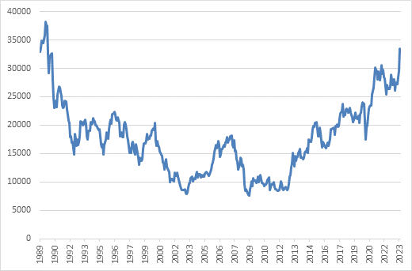
Source: Refinitiv Datastream
Cutting
Which brings us to China itself. The People’s Bank of China (PBOC) is an outlier in two ways. For one, it is not an independent institution like its global peers. It is very much an arm of the state. But it is also in a very different cyclical moment compared to others, and perhaps, a structural one too. As noted, it is the only major economy where consumer inflation did not jump and remains low. Headline inflation was a mere 0.2% in May, and core inflation 0.6%. The post-lockdown rebound has disappointed across a broad range of economic variables, from retail sales to fixed investment and credit growth. In particular, the massive property sector still struggles.
The PBOC cut two of its benchmark interest rates, the short-term reverse repo rate and the medium-term lending facility rate, last week by 0.1% each. These are unlikely to be the last policy moves from the PBOC, but support is also expected to come from elsewhere in Beijing. China’s problem is not just low consumer confidence coming out of the long Covid lockdowns and increased hostility with the West. It also faces a bursting property bubble. Cutting rates typically does not help much in such a scenario. More direct support for the property sector is needed, as well as for local governments who derived much of their income from selling land to developers. This will likely include regulatory easing and financial injections.
There are obvious parallels with Japan’s long deflationary experience, notably the property bubble, excessive leverage, and an ageing population. But there are important differences too, in particular the Chinese government’s strong grip on the banking sector and broader economy which means it can better navigate these currents, at least in the short term. In the longer term, state control is likely to result in a less productive and dynamic economy. Moreover, the fact that Japan went through the deflationary ‘lost decade’ gives China and the rest of the world important lessons on what to do and not do in terms of policy interventions. Nonetheless, it would be naïve to think that China can return to the heady 6%-plus growth numbers of yesteryear on a sustained basis. The property market can be stabilised, but it won’t be an engine of growth. More likely, growth rates in the 2% to 4% range will be the new normal in the years ahead.
Back home
What does this mean for the SA Reserve Bank (SARB) and local interest rates? The SARB’s next Monetary Policy Committee meeting is in July, so it will have the benefit of more data and time to read the tea leaves. It will also have CPI data up to June, which should show a meaningful decline in headline inflation (the rand oil price is 30% lower than a year ago). The stabilisation of the rand after the May slump will be important if sustained. The SARB’s inflation forecast at the last MPC meeting was based on an exchange rate of R18.60 per dollar.
Global interest rate shifts impact the SARB’s decisions in three important ways. Firstly, it sets the tone. If the synchronised global hiking cycle is still underway, it is hard for the central bank from a small, open, savings-poor economy not to follow suit or at least maintain a hawkish tone. Not doing so risks capital flight. Secondly, relative interest rate changes between the major economies influence exchange rates. If the dollar strengthens against the euro and yen, it tends to strengthen against the rand too and vice versa. Thirdly, to the extent that higher rates slow global economic growth, South Africa is likely to be negatively impacted by lower export volumes, fewer foreign tourists, and weaker commodity prices. The latter are of course particularly sensitive to Chinese demand and have fallen a lot. As much as South Africans tend to navel gaze about domestic challenges, the global environment is always more important to local financial markets.

