A Rorschach economy
Old Mutual Wealth Investment Strategist, Izak Odendaal
In 1921, a Swiss psychologist named Hermann Rorschach published a test where patients’ responses to ten inkblots were recorded and analysed. He died soon thereafter and never saw his images and associated test system become widely used and well known, but also controversial among psychologists. The popular understanding of the Rorschach test – that everyone sees different things in the inkblots, and that what you see says a lot about you – is obviously oversimplified. But it is a useful analogy. Often, judgement is in the eye of the beholder. This is clearly the case in art and aesthetics but can also be the case in economics and investing.
At the best of times, the global economy has many, many moving parts, which makes it difficult to get a precise handle on where things stand and where they are headed. It is even more difficult now, given the massive and still-lingering disruption of the pandemic and associated policy intervention. Moreover, most of the data on economic activity, inflation, spending and so on is produced with a lag of a month or longer. It is also subject to revision. And this data itself also reflects what happened several months ago. In the case of inflation, for instance, headline numbers compare prices in one month with the same month a year prior. Policy changes and external shocks take time to filter through the economy, affecting different sectors at different speeds. And then, of course, tastes and preferences also change.
Therefore, sometimes different people can look at the same set of economic numbers and have different conclusions. Are things really good or really bad? It depends where you look and who you ask. And from a financial markets point of view, it is not just about whether things are good or bad, but how good or bad things are relative to what was expected.
Surprised
Surprise indices are a good way of illustrating this. They show how incoming economic data compares with the consensus expectations. In other words, whether the data is better or worse than expected. Chart 1 shows the US, Europe and China, the three biggest economies.
Chart 1: Economic Surprise Indices
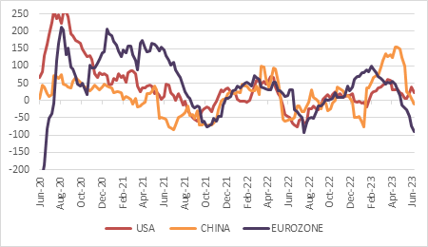
Source: Citigroup, Refinitiv Datastream
American data has mostly been coming in better than expected of late, in defiance of the widespread expectations of an imminent recession. Chinese data initially surprised to the upside as the economy reopened from lockdowns late last year, but recent data has disappointed. In contrast to the elevated and sticky inflation in most parts of the world, China’s core inflation fell further in May, down to only 0.6%. Meanwhile, data from the Eurozone has missed expectations by an increasingly wide margin and show that the bloc was in a technical recession in the first quarter, after two consecutive negative quarters.
What explains the perky US data and what does it mean for the Federal Reserve meeting this week?
Since the US economy is dominated by consumer spending, that is the obvious place to look. Indeed, the entire global economy is dominated by US consumer spending. It is about as big in dollar terms as the whole Chinese economy.
Estimates vary, but US households still have between $500 billion and $1 trillion in excess savings accumulated during the lockdowns when spending was artificially depressed, and incomes boosted by government stimulus cheques. This is not evenly distributed, however. Lower income households ran through their excess savings long ago and are battling in the face of still-high inflation.
The demand for workers remains remarkably strong. There are more job openings than unemployed persons. In May, the economy was still adding jobs at an annual pace of 2%, while wages (depending on how you measure it) was growing by 4% to 5%. This adds up to 6% to 7% annual growth in total worker incomes. Add in a bit of borrowing or a reduction in savings and there is enough ammunition for consumer spending to continue growing at a rapid clip.

Another surprise, perhaps, is the unusual behaviour in the housing market. Because most mortgages have fixed interest rates, anyone who bought a home before 2022 will be extremely reluctant to sell and buy elsewhere today since it means losing a sub-3% mortgage rate in exchange for one that is 6%-plus. As a result, there are very few existing homes on the market for sale. Buyers are forced into the market for new homes and this is stimulating activity there despite the high interest rates. Homebuilder shares are up 25% this year.
That is not to say everything is hunky-dory. As is the case in China and Europe, the American manufacturing sector is under pressure, while the commercial real estate market looks increasingly creaky, buckling under the weight of office vacancies, high interest rates and banks reluctant to roll over loans.
So following our pop-psychology approach, do we see a healthy picture or a worrying one? Both. The stronger the US economy is now, the less likely inflation is going to decline from current levels of around 5% to 2%, the Fed’s target.
A pause or a skip?
Therefore, to obsess over whether the Fed will pause its rate hiking cycle this week, or merely skip over a meeting until July is somewhat missing the point. It is worth pointing out that both Australia and Canada unexpectedly resumed hiking last week after a brief pause due to persistent inflationary pressure. In the case of the Fed, we may be at the end of the hiking cycle or near the end. But we are clearly still a long way from cutting. Sustained higher interest rates will eventually slow the economy.
The big risk is that the Fed reads the inkblots all wrong and keeps rates high even as the pressure on the economy becomes unbearable. Given the lags involved in the data and also in how interest rates affect economic activity, this is a realistic fear. Past interest rate cycles across the world almost always end abruptly when central banks realise they’ve overdone things.
Which brings us to the stock market, which is also experiencing a Rorschach moment. The S&P 500 is now almost 20% above its October 2022 low. According to some, this means it is a new bull market. However, a 20% rise from the bottom seems an arbitrary definition. Others say it is only a bull market when the index has regained its previous peak. But that would be too late for most investors. You need to get in much earlier than that. What previous bull markets have in common is that they start in climates of extreme uncertainty and when the economic news is still pretty dire. Indeed, the economy is often still in recession. However, they’ve also historically started when the Fed is cutting rates, not while it is still hiking and when bond yields are falling.
Chart 2: S&P 500 and 2-year US government bond yield
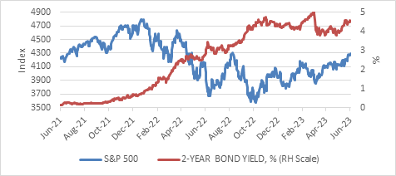
Source: Refinitiv Datastream
The fact that so much of the market rally has been driven by a handful of technology shares presents another inkblot test. Some argue that market breadth is important, others say that returns are always generated by a small group of shares.
Ditto for the excitement around artificial intelligence (AI). It is too big a topic to cover here, but just remember that even if it is a transformative technology, as the internet was, it is not certain who will capture the profits, which is what investors ultimately care about. Put differently, it might be that the users of AI benefit more than the companies supplying the hardware and software.
Stagnant
South Africa has long been an inkblot society of sorts. People tend to be very optimistic or very pessimistic, with little middle ground. As this is a Rugby World Cup year, we’ll probably see emotions swinging even more wildly between overconfidence and despair (and hopefully, ultimately, joy).
Viewed objectively, the local economy is underperforming its potential and barely growing. It expanded by 0.4% quarter-on-quarter in the first quarter and while it avoided a technical recession, it is only slightly above the pre-Covid level in real terms. Confidence in the economy and the country’s leadership languishes, with the latest BER Business Confidence Index falling 9 points to 27 in the second quarter.
Economic growth estimates for the year from credible forecasters between -0.2% and 1.2%. The IMF’s forecast is 0.1%. This amounts to stagnation.
Still, whether this is a good or bad outcome depends on your perspective. Given the needs of the economy to generate jobs and provide a better life for the poor, it is a very disappointing outcome. But if you are in the camp that sees the country as a failed state, stagnation is not a bad result. Failed states collapse, they don’t merely tread water. Given all the challenges the economy faces, treading water might actually be doing well. Moreover, this reflects the current state of affairs. Our job as investors is to look ahead.
Darkest before dawn?
Eskom’s loadshedding is the economy’s biggest challenge, followed by the growing nightmare that is Transnet’s rail performance. No surprises that two monopoly state-owned enterprises are causing so much damage. On the electricity side, things could get worse before they get better as demand spikes in winter. But heading into summer and into 2024, Eskom’s performance can improve as Koeberg and Kusile return to action and private projects come on stream. A new survey by Eskom and solar and wind industry bodies shows a massive pipeline of 18GW in renewable projects in “advanced stages” of development, with a further 21GW under development and 27GW at “early stages” of development. Eskom’s total installed capacity is 44GW, only half of which is currently available.
Private participation in electricity is far advanced compared to rail, where the process is only now getting underway. But here too there is some movement – excuse the pun – and momentum especially since it forms one of the three workstreams agreed to between the country’s business leaders and President Ramaphosa, where big business will provide technical and financial support to key interventions. The other two areas are electricity (no surprise) and crime. Whether this will work is also a Rorschach test of sorts. Some are already writing the initiative off as a gimmick, others see the possibility of real improvement, especially given its narrow focus on the economy’s biggest problems.
Chart 3: Equity and bond yields, %
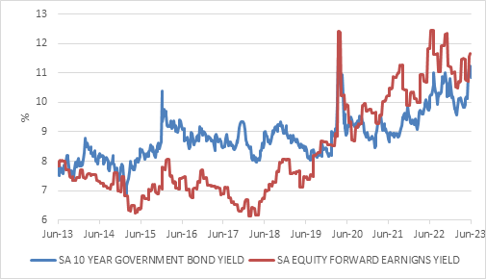
Source: Refinitiv Datastream

While global markets struggle to price the ambiguity of the current moment, local markets lack similar doubt. The outlook embedded in local bonds, equities and the currency is bleak. Chart 3 shows bond and equity earnings yields at levels approaching March 2020, reflecting fears of a similar shutdown. While the rand has recovered somewhat over the past week, it too is still trading at near-record lows. Its improvement from R19.80 to R18.75 per dollar does illustrate that you don’t need good news for markets to rally. You just need the news to be better than feared.

