Till Debt Do Us Part

Old Mutual Wealth Investment Strategist Izak Odendaal

Ratings agency Fitch stripped the US of its coveted AAA credit rating last week, throwing the proverbial cat among the market pigeons. Global equities sold off, but after a strong run, a pull-back is normal and shouldn’t be of much concern by itself. More notably, the yield on US government bonds (Treasuries, or sometimes spelled Treasurys) rose, implying falling bond prices. The increase in bond yields, which takes the 10-year yield back to the highest level in this cycle, probably has less to do with the Fitch announcement and more with the ongoing resilience in the US economy implying a higher-for-longer interest rate environment.

The ratings downgrade is unlikely to affect the role of Treasuries as the bedrock of the global financial system, acting as the reference rate, the most trusted form of collateral, and the ultimate safe haven, or as a Financial Times journalist put it well this week, the financial world’s “bomb shelter.”

Credit ratings agencies rarely tell the market what it doesn’t know already, and the factors that go into a ratings decisions are usually known and discounted. Ratings agencies make periodic announcements, but the market rates in real time.

Chart 1: US 10-year Treasury yield %
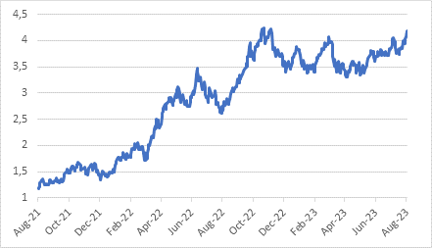
Source: Refinitiv Datastream

Nonetheless, there are real questions about the long-term fiscal trajectory of the US and other developed countries.

Fitch’s decision to strip the US of its AAA credit rating was a surprise and criticised by many prominent commentators as it comes at a time when US growth is strong. This means the government’s fiscal position and creditworthiness should be improving. In very simple terms, when nominal economic growth exceeds the cost of borrowing, a country should be able to manage its fiscal situation. Nominal growth delivers the increases in tax revenues needed to service debt. If it grows faster than the rate at which debt compounds, there shouldn’t be a problem. This is very much the case in the US, where annual nominal GDP growth was 6.2% in the second quarter compared to a 10-year government bond yield of 4%. It is not the case in South Africa, however. The 10-year bond yield is 11% and the economy is only growing 5% in nominal terms. Hence the junk-status credit rating on SA government bonds and the massive risk premium built into bond yields. Unfortunately, this can become self-fulfilling. The government borrows at these high yields, meaning a growing share of the budget goes to interest payments. But the more the market worries about the creditworthiness of the SA government, the higher it will push bond yields, in turn worsening the government’s creditworthiness.

The US does not face this situation, nor does any major developed economy. US yields have jumped, but this is because of monetary policy, not fiscal policy (again, unlike South Africa where the reverse is true). In other words, US yields are largely reflecting higher interest rates, not fiscal fears. The so-called term premium – the compensation investors demand for the risk of holding long-term bonds – is negative by most estimates.

Chart 2: Debt-to-GDP ratios for selected developed economies, %
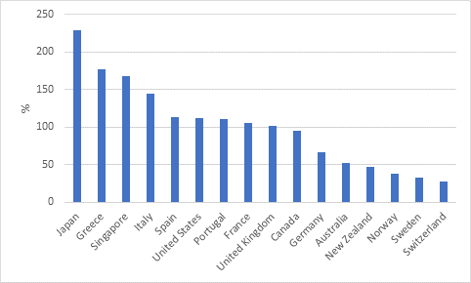
Source: Bank for International Settlements

Erosion of governance
Fitch’s reasoning centres on the budgeting process and “erosion of governance” more than the actual fiscal position of the US government. This follows the recent debt ceiling standoff. An increasingly divided political scene in the US means such episodes are likely to become more common. Fitch believes, probably correctly, that the budgeting process could fall hostage to politics again. Political divisions also make it difficult to see how some of the longer-term fiscal challenges can be tackled in a pragmatic way. Next year’s election is heading for a rematch of 2020’s Trump versus Biden contest, but even more bitter and contentious.

S&P similarly downgraded the US government in 2011 following the debt ceiling standoff that year. The immediate response was for yields to fall. Ironically, the very asset that was downgraded, rallied, since investors fled to the bomb shelter. It was a different point of the cycle however, with investors fearing a double-dip recession. The Fed’s interest rates were at zero and it was still swelling its balance sheet. Today it is selling bonds and has jacked rates up to 5.5%.

Debt sustainability
Thinking about future debt sustainability, goes beyond the size of debt pile (the stock). Other considerations include how fast it is growing (the flow), which will be a function of prevailing interest rates and current borrowing needs. Interest rates have risen sharply over the past year, but that is mostly only applicable to new debt. Most government bonds have fixed interest rates, meaning it is the lender, not the borrower that takes on the interest rate risk. When debt is linked to a specific asset (such as a mortgage tied to a property) the value of the asset matters, but that is not relevant when we’re talking about general government debt. Crucial, as noted above, is the pace of income growth, since debt is serviced out of income. Current income growth is still pretty strong in the US.

The worry is that credible forecasts show persistent deficits in the years ahead. The Congressional Budget Office (CBO) is an official non-partisan institution that models fiscal policy in the US, and its projections make for sober reading. Deficits are expected to average 6% of GDP over the 10-year forecast horizon. It is not as if the US lacks the resources to narrow the deficit, the gap between tax revenue and spending. During the Clinton years, the US managed to run a budget surplus. But the political will is missing today.

Chart 3: US budget deficit ratio with projection
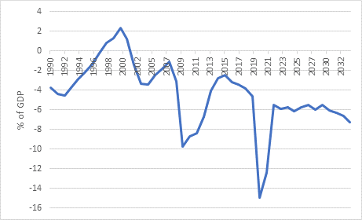
Source: Congressional Budget Office

If the US was an emerging market, or a country like Greece trapped in an exchange rate straitjacket, its bonds would be crashing based on such projections. But it is not. The US issues the world’s reserve currency, and demand for Treasuries remains robust. It won’t necessarily enjoy that advantage forever. Investors might get cold feet, though it is impossible to say when. Like most of these cases, the timing probably follows Hemmingway’s “gradually then suddenly” description. There will have to be an alternative, however. Today there is none.

The remaining AAA countries are all relatively small (the likes of Norway, Switzerland, Australia, and Canada) and unable to absorb the world’s excess savings. Germany is a big economy, but its unwillingness to borrow (as an aside, the word for debt in German is the same as for ‘guilt’) means it doesn’t have a large bond market.

US borrowing reflects domestic political choices but is also the mirror image of the world’s demand for safe and liquid fixed income assets. If that was not the case, bond yields would be much higher. They’ve increased over the past year but are not high by historical standards. So, while the US government has borrowed $24 trillion ($46 trillion in ten years’ time, according to the CBO), the flipside is that it supplied the world with $24 trillion of highly liquid assets.

China has the world’s second largest bond market, and would be the natural competitor to the US, except that it doesn’t allow free capital flows and the rule of law is weak. Despite political gridlock, global investors still believe they will get fair treatment in the eyes of US courts should any disputes arise. That is not the case in China.

Some will argue that the alternative is gold or crypto, but these are also small markets, and volatile asset classes. They might have a role to play in diversifying portfolios, but cannot fulfil the same function as Treasuries in the global financial system. So, it looks like the status quo – worrying about US debt but not doing much about it – will remain for some time, as has been the case for years.

One also hears the argument that the US government will try to inflate away the value of its debt, and it is true that inflation will reduce the real debt burden. But the experience of the past decade has shown how difficult inflation is to control. It cannot simply be conjured into existence, or wished away once it arrives. The problem is also that interest rates will rise with inflation, as we’ve seen over the past two years, potentially increasing instead of decreasing the debt burden.

The combination of higher debt levels and rising interest rates means the US government now spends around $1 trillion on interest payments, but relative to the size of the economy, that is neither large nor historically significant. In contrast, South Africa already spends 4% of national income (GDP) on debt service costs. In both cases, however, the number is rising.

Chart 4: Government interest payments % of GDP
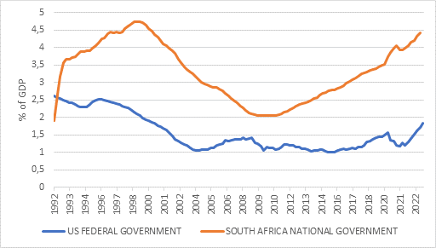
Source: Refinitiv Datastream

In the meantime, the rise in US bond yields and outlook for interest rates remains the key thing investors should pay attention to, more so than longer-term fiscal worries. Many economists are abandoning their US recession forecasts based on the solid backward-looking data. However, the longer the strength persists, the greater the upward pressure on interest rates which will eventually squeeze the economy and cause collateral damage in other markets such as our poor volatile rand. Fortunately, these same higher interest rates also provide investors with more tools to diversify portfolios.

