Opportunities in the chaos

Old Mutual Wealth Investment Strategist, Izak Odendaal

“May you live in interesting times,” is supposedly an ancient Chinese curse. Times have certainly been interesting, so perhaps we are cursed. However, like many such expressions, it is probably apocryphal. According to Wikipedia, the closest Chinese saying on this topic is: "Better to be a dog in times of tranquillity than a human in times of chaos."

Tranquillity is not what the past three years have offered us. And the last few weeks have seen moments of chaos, particularly in local markets.

Ceiling lifted
But let’s start with a bit of good news. The US Congress raised the debt ceiling for two years until after the next election. The agreement comes with only minimal spending cuts. The US federal government can now resume normal borrowing and spending activities. This removes two tail risks for the US economy, and by implication, global markets. The first is that there will be no default on US government debt. This is hugely important since it could’ve been catastrophic, as these bonds are the bedrock of global finance. The second is that deep spending cuts are not part of the latest deal, unlike in 2011. Those cuts contributed to a much slower economic recovery from the Great Recession.

However, since US fiscal policy will only tighten marginally, monetary policy might have to do more. This is because there is still plenty of evidence of inflationary pressures in an economy that is still chugging along, despite areas of weakness.

Most notably, US consumer spending remains solid. Jobs are still plentiful (there were 10 million job openings in April, 1.8 for every unemployed person). Many households still have some savings from the lockdown days to draw on. And most homeowners aren’t affected by higher interest rates since their mortgage rates are fixed.

Chart 1: US job openings and unemployment
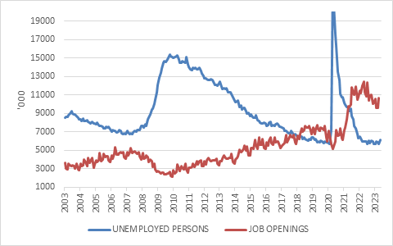

Source: Refinitiv Datastream

Some areas are struggling, however. Activity levels in the housing market are markedly lower as higher interest rates scare off new buyers. The manufacturing sector has an inventory hangover after booming in 2021 and 2022. So far, recent bank failures have not had a major impact on credit extension, but it is still early days. Faced with higher funding costs, banks can be expected to pull back on lending.

But consumer spending is the ultimate engine of the US economy, and it is still doing fine. The problem is that this can put sustained upward pressure on services inflation.

So, while there is still a good chance that the Federal Reserve pauses at its June meeting to survey the economic landscape, there is also a good chance it continues raising rates thereafter. At any rate, the detail of where and when exactly rates settle is less relevant than the fact that interest rates have jumped considerably over the past 18 months and are likely to stay at levels that squeezes the economy. The question is just how slowly or rapidly it will be.

Fizzling fast
The contrast with China is stark. China’s reopening seems to be fizzling fast. Data from the world’s number two economy has largely disappointed. Activity has certainly picked up as the Covid lockdowns ended, but it doesn’t look like the boom the market expected. Maybe it is still too early, but there are also bigger structural problems at play, notably the shaky property market, excess leverage, and high and rising youth unemployment. While the rest of the world is still battling the inflation dragon, the Chinese dragon is struggling to get up. Headline inflation was 0.1% year-on-year in April and core inflation 0.7%. The same numbers for the USA were 4.9% and 4.7% respectively.

So, while the US could see continued policy tightening, China is likely to see further easing. The disappointing Chinese reopening has weighed on commodity prices, but also blurs the outlook for Europe, particularly Germany, given its reliance on exporting to China.

Divergence
If we then look at equity market performance, we get a striking divergence too. At a headline level, the US S&P 500 returned 9.6% in the first five months of the year, while the MSCI China Index delivered a mirror image -9% in dollars.

But one also needs to look closer at the S&P 500. Most of its year-to-date returns come from a handful of mega-cap tech stocks, seemingly because of the growing optimism over breakthroughs in artificial intelligence (AI), as demonstrated by ChatGPT. Notably, the market value of Nvidia, who makes the specialised microchips needed for AI processes, has reached $1 trillion. Five years ago, it was worth less than $200 billion (This was still a big number. The total market value of all South African listed companies is around $400 billion.)

But the rest of the US market is treading water. The S&P 500 is weighted by market value, so bigger companies contribute more to performance. Give equal weights to each of the 500 companies, and the index is in negative territory.

Chart 2: S&P 500 Composite and Equal Weighted indices
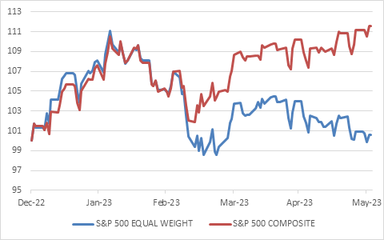

Source: Refinitiv Datastream

This has led to a big debate about market breadth, with many arguing that a healthy market is a broad one, where most shares are advancing, while a narrow market is shaky. There is some truth to this, but over time index returns are usually driven by only a handful of big winners. While a bit extreme, the current episode is not that unusual.

What is more interesting is to ask why the market is so narrow? If most shares are moving sideways or down, it probably reflects investors’ nervousness related to the current economic and profit outlook. This is not all bad. We’d rather want the market to be realistic about future prospects than be caught off guard by an economic slowdown.

Tough times
For South Africans, May was a tough month. South African nominal bonds experienced one of the worst monthly returns since the inception of the All Bond Index in 2000, losing 4.8%. Only December 2001 (rand slump), March 2020 (Covid) and December 2015 (Nenegate) saw bigger monthly declines, while March 2013 (Fed taper tantrum) was similar. This pulled 2023 returns into negative territory (-2.7%) while 12-month returns are now flat. However, bear in mind that bond returns can bounce back relatively quickly when starting yields are as high as they are. This is because interest income offsets price movements. In contrast, when global bonds sold-off heavily last year, they did so from a starting point where yields were very low. There was no cushion.

Chart 3: Monthly South African bond returns, %
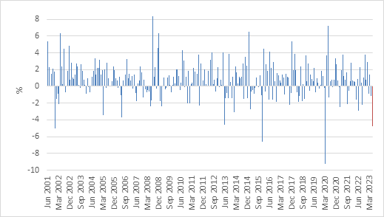

Source: Refinitiv Datastream

The rand also endured one of the worst months in the past three decades. It lost 7.8% against the US dollar in May and hit a record monthly close of R19.82. The rand rallied a bit after Congress lifted the debt ceiling deal. The last thing the struggling local currency needed was a big global risk event.

There is a silver lining here of course. The rand has lost 26% of its value against the dollar over the 12 months to end May, boosting the returns of global assets from the point of view of South African investors.

With this comes a risk. If the rand retraces, which it has historically done after a big blow-out, those same global assets could come under pressure, particularly global cash and bonds. Even a 10% gain in the rand from current bombed-out levels would wipe returns from dollar or sterling cash. Investors need to think carefully about how they approach this.

Equities also battled. The FTSE/JSE Capped SWIX lost 5.8% in the month, wiping out year-to-date returns. It is easy to blame the overall negative sentiment towards South Africa. But commodity prices have also been weak, weighing on resource shares despite the weak rand. China’s fizzling market has weighed on Naspers. In other words, some of the big rand hedges on the JSE haven’t come to the party.

If the JSE was cheap before, it is even cheaper. The same is true of the bonds. Given that the Reserve Bank remains committed to keeping inflation in check – at the risk of tipping the local consumer over the edge – the real yields available across the bond curve are extremely attractive. And one doesn’t need to be a hero at the long end of the curve where volatility is usually the greatest. While a 20-year bond now offers almost 13%, 2-year bonds yield 9%.

Chart 3: South African government bond yields, %
Source: Refinitiv Datastream

While May’s market chaos hit local asset classes hard, some perspective is useful. At the end of the month, year-to-date returns for the average retail South African balanced fund (ASISA Multi-Asset High Equity category) were still positive at 6%, according to Morningstar data. The four-year annual return was 8.7%. Considering what the world and South Africa have been through over this period – pandemic, recession, war, inflation shock, interest rate surge, loadshedding and more – it really is a solid result, beating cash and inflation by almost 4%. Diversification across asset classes has worked well. At points during this period, local assets outperformed, and at other times, including this year, global assets have outperformed. And given where valuations are, there is reason to be optimistic about future returns. It will just require patience and a balanced approach, since we are likely to experience chaos as much as tranquillity in the years ahead. Bottom line: stay the course, even during interesting times.

