Barbenheimer meets the markets

Old Mutual Wealth Investment Strategist, Izak Odendaal

For the first time in many years, there is genuine excitement at movie theatres with the simultaneous release of two very different movies – Barbie and Oppenheimer. Collectively, the biggest cinematic event since Covid shut the screens has become known as ‘Barbenheimer’. Barbie needs no introduction, being the best-selling doll of all time, though it is interesting that her creator, Ruth Handler, thought she would survive only one typical three-year toy cycle. That was more than 60 years ago. Oppenheimer is a film about the life of Robert Oppenheimer, the physicist who played a leading role in the Manhattan Project to develop the first atomic bombs. His work ushered in the nuclear age, but he also eventually became a vocal proponent of arms control.
If nothing else, the box-office boom points to consumers – particularly American consumers – being willing and able to spend on entertainment. Big-name pop stars are performing to sell crowds and sports stadiums are full. And why not? Inflation is falling and real wage growth rising, and there is a stock market rally to boot.
Interestingly, the Barbenheimer excitement comes against the backdrop of a strike by Hollywood actors and writers, with one of the sticking points being future remuneration of the creative class in a world where artificial intelligence (AI) is increasingly likely to script and produce entertainment. Will we need human writers and performers at all? The answers are intriguing and scary, and of course the question can be posed for a broad range of industries, including our own. Oppenheimer himself unleashed forces he probably did not anticipate – the nuclear arms race continues to this day – and it is no coincidence that the Pulitzer-prizewinning biography on which the movie is based is titled American Prometheus. AI may or may not be another form of playing with fire.
In the meantime, however, the big focus area is still monetary policy.
Rates still rising
Jerome Powell is not Robert Oppenheimer. He doesn’t design weapons of mass destruction, and in general is a much greyer character than the charismatic and polymathic Oppenheimer. But there are two loose similarities. In the financial world, Powell, as head of the US Federal Reserve, wields atomic power. When the Federal Reserve raises interest rates, the entire global financial system must adjust. When the Fed raises rates too high or cuts them too low, major economic dislocations are felt in the US and across the world.
Secondly, Oppenheimer achieved a superhuman feat in building a workable nuclear bomb in the space of just over two years, overcoming a range of engineering and logistical problems. Powell’s interest rate cycle was not difficult to do in any technical sense, but still moved at incredible speed. At the start of 2022, the fed funds rate target range was 0% to 0.25% (unlike most other central banks, the Fed’s policy rate is set as a range). Following last week’s hike, it was 5.25% to 5.5%.
Given the speed and scope of this hiking cycle, with rates now higher than at any point in the past 22 years, it is remarkable that the US economy is as resilient as it is. As noted, US consumers are still spending and having a good time as if rates are still low. US economic growth accelerated in the second quarter, with real GDP growth rising to 2.5%.
It is also notable that inflation declined as much as it did, without requiring a rise in unemployment or what economists call ‘slack’. When overall demand is high relative to supply, there is little slack and price dislocations can become self-fulfilling inflation. Firms and workers have pricing power and can protect margins and real purchasing power, respectively. The general thinking in economics has been that reducing inflation requires increased slack of which higher unemployment is a component. And yet, while US inflation (as measured by the Fed’s preferred indicator, PCE) fell to 3% in June and 4.1% excluding fuel and food while unemployment remains at 3.6% in the US, near record lows.

Chart 1: US inflation and unemployment

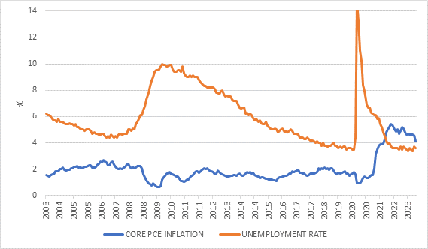
Source: Refinitiv Datastream
Debate
Needless to say, there is a huge debate among economists whether we’ve seen an “immaculate” disinflation – disinflation without the pain – with the inflation spike simply a transitory impact of Covid-related disruptions. But it is also too early to declare with certainty that inflation is gone for good.
How do we square this circle? Remember that, unlike the physics Oppenheimer knew and worked with, economics is the study of human activities and behaviours, and unpredictable things happen. Yes, there are broad economic laws that apply in most circumstances, but there are always interesting exceptions to how reality plays out relative to theory. This is true at the best of times, but the Covid pandemic completely distorted economies and the fall-out continues to evolve in unexpected ways. On top of this, the war in Ukraine has seen commodity prices go haywire, while the changing geopolitical backdrop adds uncertainty everywhere.
Also remember, that while nuclear fission (fusion in the case of the later weapons) occurs in microseconds following the detonation of the bomb, monetary policy works with long and variable lags. It is still too early to judge the full impact of the hiking cycle.
Jerome Powell himself noted at the most-meeting press conference:
“What we see are those pieces of the [disinflationary] puzzle coming together and we’re seeing evidence of those things now. But I would say what our eyes are telling us is policy has not been restrictive enough for long enough to have its full desired effects…We think the process still probably has a long way to go.”
He also noted that if US growth remains relatively strong, there is the possibility that inflation could gather speed again, or at the very least refuse to fall much. After all, while inflation has fallen a lot, it is not near the Fed’s target yet. Strong wage growth means households can still spend and put upward pressure on prices. The US employment cost index, the broadest measure of worker income growth including wages, bonuses and benefits, was 4.5% higher in the second quarter from a year ago.
Powell gave no guidance to future interest rate decisions. The next meeting is in September and Fed officials will have a lot of data on inflation and the labour market to analyse. While there is a good chance we’ve reached the end of the hiking cycle, there is no indication that the Fed is going to cut rates soon. In fact, the more the optimism of a soft-landing grows, the less likely rate cuts seem, since it will then take a recession for the Fed to ease policy. It is still a higher-for-longer rate environment.
Chart 2: Policy interest rates, %

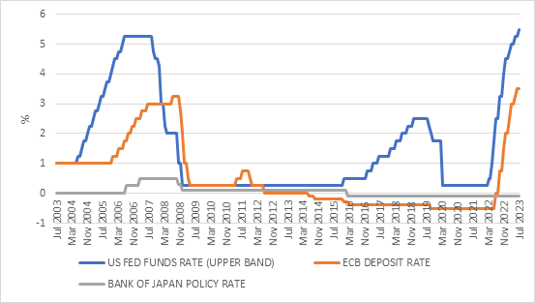
Source: Refinitiv Datastream
In Europe, economic growth has already slowed this year. In simple terms, the Eurozone economy appears to be much more interest rate-sensitive than the US economy and the European Central Bank’s (ECB’s)hikes seem to be biting earlier. (Europe’s manufacturing sector is also bigger than the US and global manufacturing is struggling). Nonetheless, the ECB still raised rates last week. As in the US, it is also concerned by continued tightness in the labour market – despite slower growth, unemployment is still at a record low – and ongoing wage growth putting upward pressure on inflation. The ECB is also therefore not going to be in any hurry to cut rates, even though it too is probably at or near the end of the hiking cycle.
Rounding up a busy week for monetary policy, the Bank of Japan kept its policy interest rate unchanged at -0.1%, but surprised the market by widening the band at which it allows the 10-year government bond yield to trade. This is seen as a prelude to policy tightening in the only major economy apart from China not to have done so.
B.A.R.B.I.E
None of the above seems to scare off the equity market. It is no longer simply AI excitement, as European equities are also stronger, despite the slowdown there, while the rally has broadened out in the US beyond big tech. However, the S&P 500 is still more concentrated than at anytime since the dotcom bubble.
Even in South Africa, despite the loadshedding hammer blows to the economy and declines in key commodity prices, the market has held up reasonably well.

Global equity markets are increasingly pricing in a soft landing, driven largely by multiple expansion (rising price: earnings ratios) and not stronger earnings. This is normal in the early stages of an economic recovery and bull market, but unusual given that rates are still rising and show no sign of falling.
Chart 3: Equities in 2023, US$
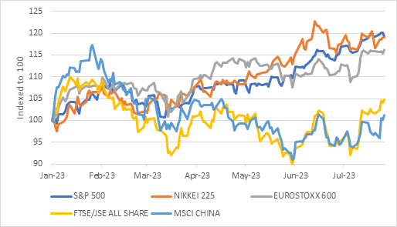
Source: Refinitiv Datastream
While an equity rally is a gift horse you definitely don’t want to look in the mouth, there is reason to be cautious about the outlook and not be overweight in equity allocations.
The reality is that we’ve gone from TINA - There Is No Alternative (to equities) - to BARBIE. Bonds Are Really Back in Earnest in this higher interest rate environment. And while Barbie the doll has always been very popular and certainly does not need a movie to sell more toys, for bonds, particularly short-dated bonds and cash, this is a radical change from the decade before the pandemic.
It is easy to forget that trillions of dollars of bonds from Europe and Japan traded on negative yields, offering a guaranteed nominal negative return. US bond yields were positive in nominal terms, but cash yields were barely above zero.
South African investors need not necessarily be too excited about this, since we’ve always had elevated bond and cash yields, even more so today with real long-bond yields in the 5%-plus territory and real cash yields of 3%. Global fixed income allocations do offer a source of return diversification, but rand volatility can easily offset that. Indeed, the rand is 6% stronger this month, enough to offset a year’s return from US cash. Finding ways of hedging rand volatility is therefore crucial when South Africans allocate to global fixed income allocation. Where South African investors should pay very close attention to global fixed income yields is precisely in the competition to equities it offers other investors globally and the pressure it can place on equity valuations, but they are clearly not doing so yet.
Uncertainty and principles
Finally, at risk of stretching the Oppenheimer metaphor too far, one of his friends and collaborators before the war was Werner Heisenberg, famed for the Heisenberg Uncertainty Principle. The principle states that we cannot know both the position and speed of a particle with perfect accuracy, since the more you know about its speed, the less you know about its position and vice versa. Something similar is at work in investments, but with risk and return. The more you try to control risk, the more potential return you give up. The more return you want, the more risk you will have to take on. But, as noted above, physics analogies quickly break down since human emotions quickly get in the way. When investors get excited about future returns, they tend to push the valuations of popular assets to levels where future returns are impaired. Buying expensive assets therefore messes with your return outlook, which is itself a source of risk. The reverse is also true, and unloved, unpopular assets are generally much less risky than assumed, provided one has the patience. And in an uncertain world where we can control very little, we can control how patient we are.

