China’s recovery may be bumpy, but the focus should be on long-term growth drivers

Ninety One

China’s economic recovery may be uneven, but we would argue that investors should bring their attention back to the country’s long-term growth drivers. Here are four engines of growth that will propel the Chinese economy in the years ahead.

Wenchang Ma, 4Factor Portfolio Manager, Ninety One
The reopening of China sparked a wave of positive market sentiment as investors anticipated a robust economic recovery. But over the last few months, we’ve seen optimism waxing and waning due to a fixation on short-term demand and growth dynamics. China’s recovery may be uneven, but we would argue that investors should bring their attention back to the country’s long-term growth drivers.

Consumption market expected to almost double by 2030
The first important growth driver is China’s expanding consumption market. There are already 140 million Chinese households that have an annual disposable income exceeding US$25 000, and this middle-class cohort is expected to grow to 380 million households by 2035. That translates to almost one billion people who will be seeking better quality products and services and a wider array of lifestyle experiences. As a result, China’s total consumption market, which is sitting just under US$10 trillion today, is expected to nearly double by 2030 to reach close to US$19 trillion. That is basically the size of the US consumption market today. So in the race to tap into this opportunity, leading domestic companies are increasingly gaining market share in a variety of consumption industries, which include beer, dairy products, textiles, sportswear and home appliances.

Figure 1: China is among the fastest growing consumption markets globally
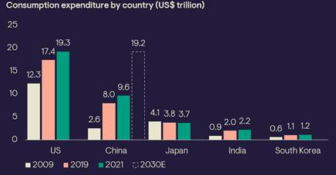Source: Euromonitor (July 2022), World Bank, Morgan Stanley Research, Ninety One, 31 May 2023.

Forging a path towards technology self-sufficiency
The next growth driver is China’s strong pursuit of technology innovation. Over the last few years, China has played catch-up with the major economies in terms of research and development (R&D) spend as a percent of GDP. The country is already spending more on R&D than most European countries, and it leads the world in the number of patent filings. Since 2020, China accounts for about a quarter of global patent applications. The large domestic market and supportive industrial policies provide a favourable background for technology innovation. This is enabling companies to achieve economies of scale and greater efficiencies, allowing them to compete in global markets.

Figure 2: China leads in international patent filings
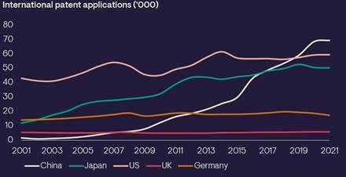Source: WIPO statistics database, 2022.

Global leader in renewable energy expansion
The third important driver for long-term growth is China’s commitment to the energy transition. As the world’s largest emitter, the country has pledged to reach peak carbon by 2030 and carbon neutrality by 2060. We are already seeing signs that coal within the energy mix is starting to decline, and renewable energy is increasing. Over time, renewable energy is expected to dominate China’s power mix. When I visited South Africa earlier this year, I kept hearing the word “load-shedding”. Although we don’t use this term in China, we also experience something similar occasionally on a regional level – loosely translated as peak load staggering or peak load rationing. The way the Chinese government manages the situation is to first safeguard households’ usage of electricity, while high power users such as factories are expected to rotate their operations during peak times.

Of course, in the longer term, we need solutions. We have already seen significant investment being poured into developing renewable energy generation, power networks and energy storage capabilities. Policymakers also carefully consider the synergies of different types of renewable energy to address grid issues. For example, China has already constructed the world’s largest pump storage hydro power plant and is building others, which should help improve the reliability of power generation and the resilience of the grid. We expect an increasing number of investments in support of China’s energy transition over the next few decades.

Figure 3: China’s power capacity mix will be dominated by renewable energy
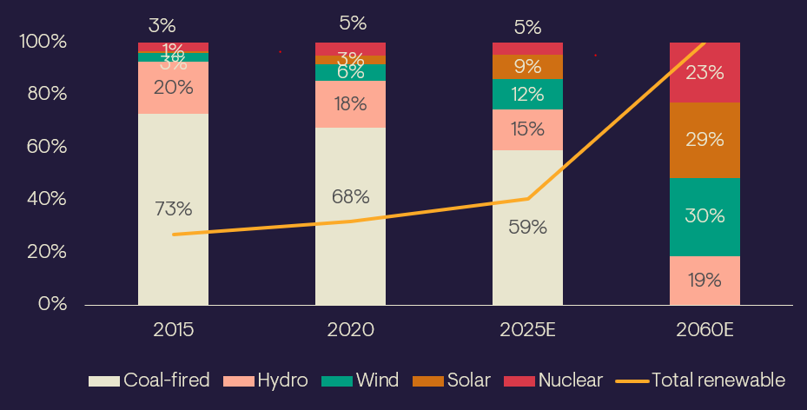
Source: China Electricity Council (2015),J.P. Morgan estimates (2020-2025), Tsinghua University (2060 forecast), May 2023.

State-owned enterprises doubling profits
Another key engine of growth is the state-owned enterprises (SOEs) sector, which accounts for nearly half of the market cap of all Chinese equities (onshore and offshore). SOEs dominate strategic areas such as financials, energy, real estate, materials and capital goods. Government reform initiatives over the last few years have delivered strong efficiency improvements, generating opportunities for investors.

Supply side reform since 2015 has effectively helped to increase the return on equity (ROE) of listed SOE companies in China. Although these SOE companies have been growing at a slower pace compared to their private-owned enterprise peers, their net profit still managed to double over a period of 10 years. The introduction of performance metrics such as ROEs and cash-flow ratios is a positive development and should help to maximise the efficiency of SOEs. Greater transparency and accountability are also in the interest of shareholders as they promote better corporate governance.

The Chinese government is consistently reforming SOE companies, to boost the productivity of this important asset to help address the country’s pressing socio-economic issues. Well-run and profitable SOEs can provide the government with much-needed fiscal relief and bolster economic growth.

In conclusion
China is going through structural changes. The country is entering an era of slower but more sustainable growth, powered by a growing middle-income population, a strong push for technology innovation, the pursuit of the energy transition and consistent reform of SOEs. China’s equity market is the second largest globally and is too big to ignore. We believe disciplined, bottom-up stock selection, focusing on fundamental analysis underpinned by local expertise, is the best approach to unearth investment opportunities.

