Where to save your savings – A practical look at the products available

Francis Marais, Product Director at Morningstar Investment Management SA

South Africans are lucky to have a wide variety of savings and investment options available to achieve their diverse financial goals. This may be for long-term wealth creation, medium-term goals (like saving for a deposit on a house) or short-term emergency funds that need to be available immediately.

Before we take a practical look at the various choices or products available through which to save and grow wealth, it’s important to take note of some initial considerations:

- Consideration 1: Your time horizon
The first consideration is the time horizon of your goal and ensuring it matches the product you ultimately choose. Just as it makes no sense to have your short-term emergency funds stuck in your retirement annuity (RA) it similarly doesn’t make sense to have your long-term savings sitting in cash in your bank’s saving account. As things currently stand, South Africans are also mostly encouraged to save for the long term via different tax incentives.
- Consideration 2: Tax benefits and trade-offs
This brings us to our second consideration which is the different tax benefits available via the different products on offer. It is important to be aware of the unique benefits and trade⁻offs each product offers. The rule of thumb is generally to maximise risk-adjusted returns net of fees, and after-tax (within your unique preferences and requirements). Actively engaging with one’s financial adviser is, therefore, not only needed but vitally important.
With these basic considerations established, let’s delve a bit deeper into some of popular product options South African investors have access to.
Pre-retirement savings via a Retirement Annuity (RA) or an Employer’s Provident and Pension Funds.
For most South Africans, saving towards retirement is still by far the most popular way to build long-term wealth.
The benefits of saving via these products, include:
- Immediate tax benefits as the amount saved gets deducted from your annual taxable income (thereby reducing your taxable income).
- From a longer-term perspective all income and capital gains generated are tax free, so your net investment returns can compound far quicker.
- In addition, these pre-retirement products also offer various estate planning benefits which your financial adviser will be able to elaborate more on.
At retirement, the majority of your wealth accumulated in your RA or Pension fund must be used to buy an annuity (adhering to the two-thirds rule¹). Post-retirement income withdrawn is, however, subject to income tax. In addition, these RA’s and pension funds need to be Regulation 28 compliant, which limits the exposure to asset classes such as equities, property and total offshore investments.
Recent changes to Regulation 28, including the ability to invest far larger portions offshore (45%) and the inclusion of alternative investments (such as hedge funds, infrastructure, unlisted debt and private equity) have largely addressed previous concerns such as limiting the amount of risk and diversification and therefore the potential return opportunities available.
These products are suited for investors with longer time horizons and offer very little liquidity, although with the proposed two-pot system² a portion of your savings will be available for short-term emergencies.
Tax free savings accounts (TFSA)
Tax free savings products were introduced in South Africa in March 2015³ and are relatively new to South Africa. It is an additional savings product South African investors can utilize to build wealth.
The benefits of saving via a TFSA, include:
- All returns (both income, including dividends and capital in nature) are tax free and investors therefore benefit from the compounding benefits, like in an RA or a pension fund.
- Although amounts saved towards a TFSA, aren’t deductible from your annual taxable income, the amounts withdrawn from a TFSA won’t be subjected to income tax.
- The product offers a wide range of investment choices such as unit trusts, fixed deposits and real estate investment trusts (REITs) without any limitations placed on allocations to certain asset classes or offshore investing.
Unit trusts with performance fees⁴ aren’t allowed and hence investments such as hedge funds will typically be limited. In addition, you are only allowed to invest R36 000 on an annual basis with a lifetime limitation of R500 000⁵.
Investors don’t face any liquidity constraints and your savings are generally available, although withdrawals don’t repair your lifetime limitation, i.e., once money is invested into your TFSA it counts towards your lifetime limitation, and once withdrawn, your lifetime limit will forever decrease by this amount. So, in a sense, it does serve as a disincentive to withdraw money from your TFSA over the short term. In addition, the tax savings benefits only really start compounding over the long term.
Tax relief now or tax relief later: RA or TFSA?
In an ideal world, you should take advantage of both products’ characteristics and have both as part of a holistic portfolio, as both allow for a powerful compounding effect of tax-free investment returns, which will lead to meaningful outcomes from a wealth creation perspective. However, in practice, this might not always be possible, and you might need to choose between either one or the other, at least initially.
What should you then consider when choosing between the two?
- Besides the differences already mentioned above, a TFSA doesn’t offer any immediate tax benefits (the contributions aren’t tax deductible), but similarly amounts withdrawn from your TFSA aren’t taxable.
- While an RA does offer some immediate tax benefits, amounts withdrawn from your living annuity are susceptible to the normal income tax tables.
- One might therefore be tempted to conclude that there is little difference then between the final outcomes, but this might not be correct as the RA’s tax treatments aren’t symmetrical.
- Let’s illustrate this with an example:
- Let’s assume you are a 45-year-old earning R1 300 000 per annum. According to the 2024 South African Revenue Service (SARS) tax tables this places you in the 41% marginal tax bracket, i.e., all income earned above R857 900 is taxed at a marginal tax rate of 41%.
- If you were to save your full R350 000* into your RA, your taxable income decreases to R950 000, which then results in a total tax payable of R289 019 (before your annual rebate of R17 235). Importantly the full R350 000 that was deducted from your annual income meant that you were essentially saving at 41%, i.e., your highest marginal tax rate.
- Now let us assume a different investor, aged 66, that is withdrawing an annual income out of his investment-linked living annuity (ILLA) of R1 300 000. This investor’s annual income tax is R432 519 (before his annual rebate of R26 679).
This equates to an average tax rate of 33.27%. Why is this? When withdrawing money from your ILLA, your lowest marginal income tax buckets are filled up first, i.e., the 18%, then the 26%, then the 31% and so forth.
This example should illustrate that money going into a RA or pension fund “reduces” your most expensive income buckets first, i.e., 45%, 41%, 39% etc., but when money starts flowing out of your ILLA it’s the opposite and you fill up your least expensive tax buckets first, i.e., 18%, 26%, 31% etc. There is therefore a slight asymmetry, and you don’t pay the same levels of taxes when withdrawing income from your ILLA as you save when contributing to a RA.
One could therefore argue that this is an additional tax benefit the RA has over the TFSA, especially for those with higher marginal tax rates. For lower marginal taxpayers, the opposite might be true and here it could make sense to first fully utilise your annual TFSA contribution and as your marginal tax rate increase, you start contributing towards your RA.
It goes without saying that if you are a higher marginal taxpayer and you already contribute a sizeable amount towards your RA but still don’t have a TFSA it might be a good idea to start taking advantage of your annual contributions to a TFSA as soon as possible.
Another important consideration is disallowed contributions (to your RA’s and/or Pension Fund). These are contributions made above the annual contribution limit of the lesser of R350 000 or 27.5% of your income or remuneration. Any disallowed contributions will further reduce future tax payable on the income withdrawn from an investor’s annuity until they are depleted.
Endowments
The endowment offers investors another vehicle to build long-term wealth, but it’s not necessarily for everyone.
Investments inside an endowment are taxed at 30% on all income declared within the policy (except for dividend payments that will continue to be withheld at 20%), with a maximum capital gains tax of 12%. This is therefore a product that would work well for more affluent investors with marginal tax rates above 30%, i.e., those individuals earning more than R370 500 a year.
The benefits of saving via an endowment, include:
- From an investment perspective an endowment offers a lot of choice in terms of underlying investments and there are no asset class or foreign investment limitations.
- The first five years are normally what is known as the restricted period but after this initial term, unlimited withdrawals, that are also tax free, are available.
- Other additional benefits would include estate planning benefits (saving on executor’s fees), the ability to add beneficiaries, insolvency protection (after three years) and a simplified tax process as this is taken care of within the endowment on behalf of the investor.
Endowments, therefore, offer a very useful alternative for building wealth via discretionary savings.
Discretionary Savings
A discretionary savings account offers no tax benefits, and all returns are subject to tax whether that is income tax (interest or rental), dividend withholding tax or capital gains tax. There are no restrictions such as the maximum investable amounts (TFSA), liquidity (RA), choice (TFSA) and asset allocation (RA) or restricted terms (endowment).
These accounts typically take the form of savings accounts, money market accounts and fixed[1]term savings accounts. A normal investment account can be useful to house your emergency cash funds (subject to your annual interest exemption of R23 800 for those persons under the age of 65 and R34 500 for those 65 years and older) or for longer term buy and hold investments where the tax would be primarily capital (max 18%, min 7.2%) or dividend (20%) in nature, or as an addition to the various other savings products.
How do you know what’s right for you?
It is easy to see that all the different options offer some unique benefits and have quite specific characteristics and choosing an optimal mix might be tricky. In addition, there are always trade-offs.
For instance, the graph below illustrates one of many ways to interpret the differences.
- Investor A has a low marginal tax rate and only recently started working. This client might choose to first build up some emergency cash in a discretionary investment account, while slowly starting to invest in a TFSA.
- Investor B on the other hand, is an experienced executive earning in excess of R2 million per annum. Here his optimal choice might lie between his pension and RA as well as an endowment.
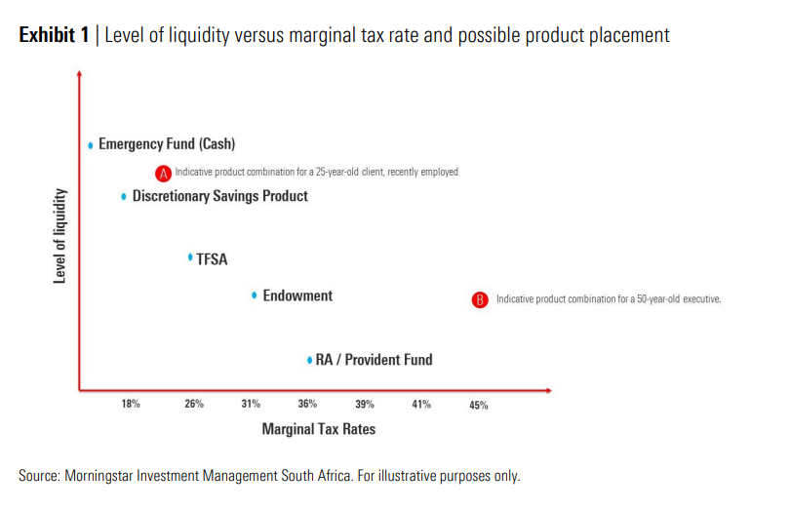
In conclusion
It is clear that South Africans have a wide variety of potential products available to assist them with investing their hard-earned savings optimally and in the most tax and liquidity efficient manner.
Indeed, South Africans are actively encouraged by these different products to save for the long term. But as is so often the case, with lots of choices, one can easily feel overwhelmed and default into not making any decision at all.
Some of these products are quite unique with very specific benefits and characteristics and engaging with one’s financial adviser to choose the most optimal mix is crucial as each person has a unique set of needs and circumstances. This will not only help with clarifying some of the complexity, but it will almost definitely lead to superior long-term outcomes for clients and their savings.
Sources
¹ For more information see”Guide on the benefits of lump sum benefits”
² For more information see: “Draft legislation for the ‘two pot’ retirement system”
³ Dailymaverick(2023), retrieved from Five things you should know about Tax-Free Savings Accounts(dailymaverick.co.za)
⁴ National treasury (2017), retrieved from JSE Service Hotline 3617 BDA-Media Statement Tax Free Savings Accounts( Attachment).pdf
⁵ SARS, retrieved from Tax Free Investments| South African revenue Service (sars.gov.za)

