Regime shift: central banks will prioritise inflation over growth

Azad Zangana, Senior European Economist and Strategist at Schroders

Inflationary pressures mean monetary policy must be tighter and more restrictive than it has been in the recent past. Higher for longer interest rates will be an important feature of a new regime in policy and market behaviour.

2022 was a landmark year for monetary policy. For some time, central banks had blamed rising headline inflation on a series of shocks: post-Covid supply chain issues, along with higher food and energy prices related to the war in Ukraine. These factors were seen as transient, and so policymakers felt that tightening monetary policy would not have much impact. However, it became apparent that these temporary cost increases had triggered pressures elsewhere, and that they had spread to other parts of the economy. Suddenly, inflation in services sectors was rising sharply, with wage growth being a major contributor.
Central banks acknowledged that the external shocks could no longer be looked at in isolation. These shocks, they came to understand, should be viewed in the context of wider changes in the global economy which had occurred over a much longer period of time. Past circumstances which had helped contain wages, the cost of imported goods, and energy prices, say, could no longer be relied on in the future. Gradually, policymakers accepted we’re in a new regime of supply side shortages and more frequent price increases.
Certainly, the pandemic had a profound impact on labour markets, especially where governments had not stepped in to protect jobs. For example in the US, the unemployment rate rose from 3.5% in February 2020 to 14.7% in just two months. As the economy re-opened, generous government aid and the movement in jobs made it very difficult for companies to hire people back and to respond to pent up demand. This helped return the unemployment rate to pre-pandemic levels by mid 2022, and drove wage growth up.
Total private sector average hourly earnings reached 5.3% in 2022, which remains the highest reading since the series began in 2008. The same series for the production only sectors has a longer history, and on this measure, earnings growth in 2021 reached 6.4% - the most elevated since 1981.
Increase in long-term sickness means labour shortages and wage pressures are likely to persist
Missing workers, however, are exacerbating the situation. Since the pandemic, the labour force participation rate has fallen back in both the US and UK. In the latter, some 650,000 workers have left the workforce, mostly due to long-term sickness. Optimists believe some of these workers could return, but it’s looking less and less likely as time passes.
In December 2022, there were 11 million unfilled job vacancies in the US, with only 5.7 million unemployed people (chart 1). That means there were 1.9 unfilled jobs chasing every unemployed person. Even if the labour market were to match every unemployed individual by geography and skill-set, there would still be a severe shortage of staff. And economics dictates that where demand exceeds supply, prices, or in this case wages, must rise. This is partly why those who have moved jobs in the past year have achieved significantly higher pay increases than those that have remained in their current job for over a year. Companies are having to outbid each other to attract staff. Although, it is worth mentioning that pay growth for both groups is currently elevated (chart 2).
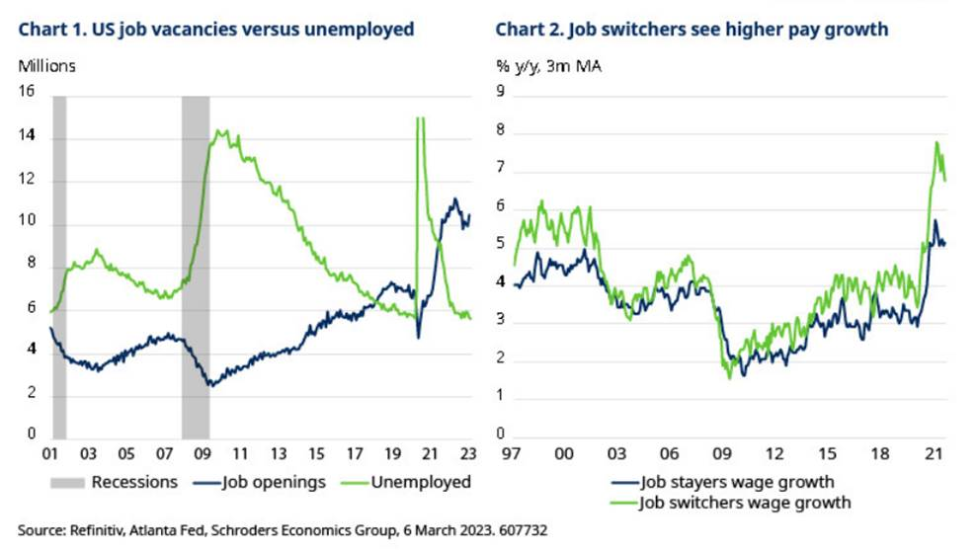
The shortage of workers has not only helped empower employees to demand higher pay awards, but also dissuade companies from firing staff, even when businesses need to cut costs. Higher pay growth all-round means that if companies let staff go, but then decide to fill those positions again, they would face significantly higher payrolls. Holding on to staff may be the better option.
Staff hoarding in itself re-enforces the strength of labour markets, which in turn has supported demand, enabling larger increases in prices and inflation. Labour hoarding may only prove to be temporary, but the “great retirement” and the increase in long-term sickness means shortages are likely to persist. This is another element of the regime shift.
As inflation continued to spread, so did fears of a repeat of the late 1970s and early 1980s, where inflation across much of the developed world spiralled out of control. Similar to recent events, the 1970s and early 1980s also featured energy crises which triggered many of the problems that followed. It was the unhinging of inflation expectations, however, that led to workers demanding and achieving much higher pay increases, even after inflation fell back. A wage-inflation spiral followed as the cost of those pay increases had to be passed on to consumers in the form of price rises, and so the cycle continued. It took multiple rounds of tightening of monetary policy, and even double-digit interest rates before prices eventually returned to lower, more normal levels.There are many parallels between this latest bout of inflation and past ones. The historical comparison of real interest rates in the US, UK and Germany is most stark. As a result of high inflation and low nominal rates, real interest rates have not only been very negative, but even more negative in Germany and the US than during the high inflation era. The UK is the exception, although real rates are still very much in the same ballpark to those seen in the 1970s and 1980s, see chart 3.
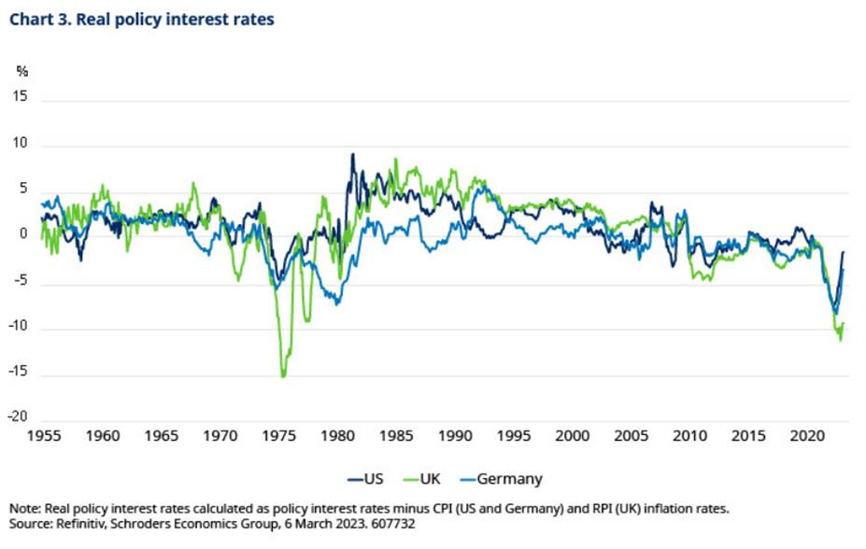
Central banks are keen not to repeat the same mistakes, and so they began to respond last year, initially by halting quantitative easing, but then moving to quickly raise interest rates. The US federal funds rate rose nine-fold to 4.5% (upper band or target range) in 2022 - a blistering pace of hikes. All three of the US Federal Reserve (Fed), European Central Bank (ECB) and Bank of England (BoE) resorted to raising rates by 75 basis point (bps) at a time, highlighting the urgency in tightening policy. For the Fed, these were the biggest single moves since 1994 and it was something the BoE had not enacted at a single meeting of its Monetary Policy Committee since 1989. The ECB had never previously increased rates in such increments. All three have continued to tighten policy in 2023, although markets expect interest rates to reach their terminal rates in coming months (chart 4). Importantly though, money markets are not pricing a fall in interest rates back to the lows seen before the pandemic.
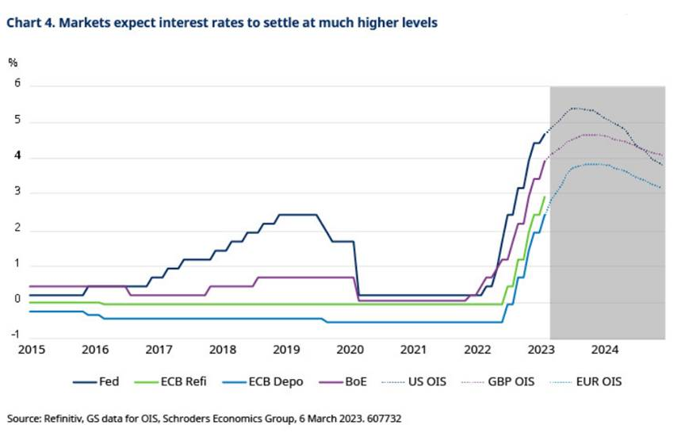
It is becoming clear that the trade-off between growth and inflation has worsened, making the decision for policymakers far more difficult than in the past. This is one of the new macroeconomic trends we are observing, amid a new shift for financial markets.
The globalisation dividend is coming to an end
Even beyond this current economic cycle, structural inflation pressures are emerging, which are likely to change the battle for central banks. For the past two decades, central banks have struggled to push inflation rates up to their respective targets, with deflation fears dominating the balance of risk during the “lowflation” period since the global financial crisis. Looking ahead, central banks are now more likely to struggle to avoid inflation from overshooting those targets.
Even before the pandemic, the productivity gains from globalisation were being called into question. Since the 1970s, advanced economies have enjoyed falling production costs and lower inflation thanks to profound changes to supply chains. Improved trade and technology, but also improved accessibility and infrastructure in emerging markets meant that manufacturers could shift more of their complex production to parts of the world where cheaper labour was available. While global trade between countries that have a competitive advantage is nothing new, outsourcing and offshoring in particular was a major change.
Early examples of production shifting to lower cost countries include General Electric outsourcing production to new factories built in the 1960s in Mexico. There are also countless other examples such as the exodus of low value-added textiles production, leaving the UK and southern Europe for India and South East Asia. These shifts helped boost the share of global exports of many of the emerging markets as shown in chart 5. China’s entry to the World Trade Organization in 2001 helped it catch up with other emerging markets in capturing a growing segment of world exports and really embedded the globalised model of extended supply chains, or global value chains.
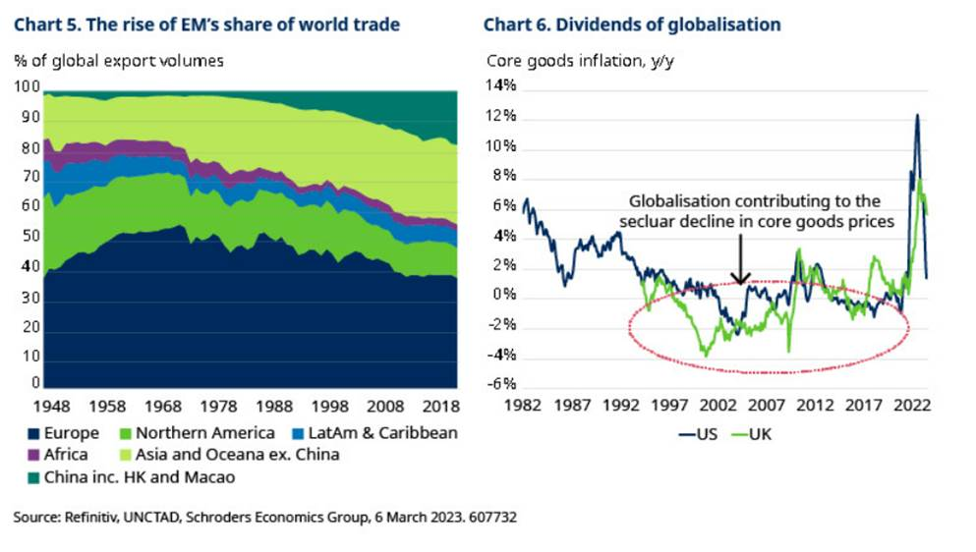
For advanced economies, although many jobs were lost to the globalisation process, the benefit of cheaper products helped boost disposable incomes. The extent of the lower prices can be seen in chart 6, which shows core goods inflation (excluding food and energy products) for the US and UK. Both experienced a significant decline through the 1980s (which was a high inflation period), and eventually core goods prices disinflation from the early 1990s. The two decades which followed were distinct for a lack of inflation. This was helped, of course, by falling prices of imported goods, but also by the impact of globalisation on wages whereby the global supply of labour increased significantly. Governments responded with labour market reforms that introduced additional flexibility.
Active labour market policy including adult training, and linking benefit payments to work helped increase the incentives for the unemployed to return to work. The trade unions, which were instrumental during the high-inflation regime, slowly lost their power, leading to a dramatic fall in the share of wage settlements covered by collective bargaining.
For central banks, the improved trade-off between inflation and growth had snuck up on them. Initially, policymakers celebrated, declaring victory over the high-inflation regime that had dogged economies over the previous decade. But they soon became concerned as inflation started to persistently undershoot their targets. They initially responded by cutting interest rates to lower and lower levels, causing bonds yields to fall on a secular basis.
It was only with the benefit of hindsight that policymakers about a decade later recognised that a structural break had occurred. The benefits of globalisation had wider consequences beyond the profits of firms and the location of jobs. It had created an unprecedented dynamic.
Speaking in 2004, former governor of the Bank of England Mervyn King described the previous 10 years as ‘…a non-inflationary consistently expansionary – or “nice” – decade; a period in which growth was above trend, unemployment fell steadily, and inflation remained stable. The ups and downs of the economy were much smaller in the nice decade than in any previous historical period.’ (Eden Project speech - 12 October 2004).
The internet revolution aided the nice decade, which we argue continued well after King’s speech. The introduction of e-commerce, along with the gains in efficiencies and productivity resulted in better management of economic resources. By exuding disinflationary dynamics, these changes ensured inflation pressures remained well contained as activity grew and economies expanded. The combination of international and domestic disinflationary pressures meant that there was room for more domestic inflation and growth in most economies, which allowed policymakers to lower interest rates even further as time went on.
In closing his speech and answering the question as to whether the nice decade would last, King concluded that ‘…the combination of low and stable inflation and continuously falling unemployment must come to an end at some point…’. This reflected his concern that with little spare capacity, the trade-off between growth and inflation was becoming more difficult. ‘The nice decade we might expect to be followed by the “not-so-bad” [not of the same order but also desirable] decade.’ Yes, central bankers had more time on their hands back then.
The new world order will result in disruption and higher costs
The gains from globalisation appeared to have peaked by around the start of the new millennium (see previous chart 6). But in recent years, new forces have emerged to stall the progress of world trade, and in some cases even reverse it. Driven by a decoupling of the US and China, the ensuing new world order is challenging globalisation (as we will explore in part 3 of the regime shift series). It is encouraging multi-national companies to re-shore, or near-shore overseas production as well as redirect investment into other “friendly” lower risk countries, so-called “friend-shoring”.
Geopolitical tensions have been rising for some time between the China and the West, but in particular the US, especially under the Trump administration. Accusations of excessive protectionism and the theft of intellectual property eventually led to tariffs and other trade barriers in 2018 and 2019. An agreement between China and the US was reached in 2020 in that tariffs would be reduced if China imported a certain amount of goods from the US. The trade relationship was sullied, however, leaving a precarious outlook for the new administration of Joe Biden.
Anti-China sentiment is one of the few issues that unites US voters. This encouraged President Biden to not only maintain most of the Trump-era tariffs, but to go further by restricting certain exports, banning investments into Chinese companies, and even sanctioning many companies. The US has effectively cut China off from accessing (and consuming) US technology, which is forcing the country to build its own basic technological infrastructure, separate from that being used elsewhere in the world. The importance of China, especially for Asia could cause further divisions and trade conflicts with the West.
These politically-driven restrictions have forced many companies to re-think and even change their plans for operating in China and with Chinese companies. The losers are obviously Chinese companies, but also US investors, who are missing out on profitable investment opportunities. Ultimately US consumers, who will now pay a higher price for goods and services they consume, will lose out too. The winners will be those competing companies and countries to which trade will be diverted to.
The Covid pandemic also highlighted the fragility of supply chains, and the danger of having too much production concentrated in a particular country or region. Companies are more likely to consider “acts of God” in their risk planning, and seek to diversify their supply chains. On a risk-adjusted basis, this makes economic sense. However, shifting manufacturing locations, setting up new factories, and potentially even contributing to the creation of infrastructure all adds to costs, and inflation.
Europe and the war in Ukraine has been a prime example of political risk re-shaping the economic and trade landscape. A significant proportion of European energy needs were met by Russian oil and gas (chart 7). Many EU member states began to voluntarily cease Russian energy imports shortly after the invasion of Ukraine in early 2022. This occurred before a more explicit stop to exports from Russia began at the end of the summer. While some Russian energy is still clearly making its way to Europe via third countries, Europe is planning ahead, and signing long-term energy trade agreements with alternative partners.
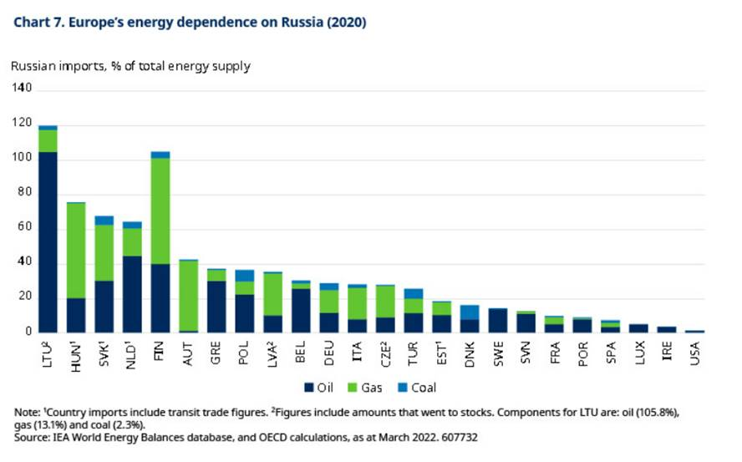
Russia has found other customers for the majority of its energy, circumventing the sanctions placed on it. India and China appear to be the main beneficiaries, although this has added to the tensions between the West and China mentioned earlier.
Ultimately, though politically more acceptable, the new sources of energy, especially being imported in the form of liquified natural gas (LNG), is far more expensive. This will maintain much higher energy costs for firms and households for years to come.
Decarbonisation and greenflation
In response to the energy crisis, European politicians are accelerating the transition to renewable energy. Even before the war, global governments had recognised the need to make more progress towards net-zero emissions, and had made significant strides in agreeing various climate change initiatives. These include both initiatives to support the growth of companies specialising in providing clean energy, but also measures that raise the costs of carbon based energy, so to incentivise a switch. These trends are only likely to accelerate. Meanwhile, companies are also making great efforts, investing considerable resources to change behaviours and clean up supply chains.
Decarbonisation is yet another structural shift which is set to accelerate in the coming years. Although the cost of producing renewable energy is falling sharply, the cost of replacing carbon based energy will raise energy inflation for many years to come. In turn, the cost of manufacturing goods, transportation, home energy and in many more areas is set to rise, adding to yet further inflation pressures. Not only will there be associated investment costs, but also regulatory costs designed to shift incentives. We discuss the likely impact in greater depth in part 5 of the regime shift series.
Summary and conclusions
- Central banks have probably already done enough to lower inflation in the near-term, but there has been a regime shift in the trade-off between growth and inflation.
- The global economy is likely to continue to face cyclical inflation and ongoing labour shortages, pushing labour costs higher. The global economy must also learn to cope with rising structural inflation associated with political fragmentation and the response to the new world order. Deglobalisation has put an end to the globalisation dividend and so there is less room for domestic inflation pressures as there was in the past.
- Commendable as it may be, decarbonisation, and the transition to a more sustainable economy is likely to be a very inflationary trend.
- Structurally higher inflation means that monetary policy must remain tighter and more restrictive than before the pandemic if central banks are to meet their obligations to maintain price stability. The regime shift will result in higher interest rates for longer, and a reduction in global liquidity.
- Higher interest rates will have significant consequences for investors and financial markets. From the implications for asset valuations, to the additional volatility that will be introduced. Investors will have to adapt to a world where the “Fed put” cannot be relied on to bail-out risk assets. The era of free money has come to an end.

