Whatever happened to the US recession?

Keith Wade, Chief Economist & Strategist at Schroders

We see recession as being delayed rather than dodged.
The US continued to grow at the end of last year and appears to have started 2023 on a firm note. Economists are now pushing out or cancelling a US recession which was expected only a few weeks ago. So, why has the US defied the sceptics and remained resilient in the face of significant monetary tightening?
The failure of Silicon Valley Bank (SVB) has complicated the picture and will result in some tightening of financial conditions and caution on the part of investors. Our view is that this will dampen growth, but at this stage does not appear to be sufficiently systemic to cause a more general credit crunch and a recession. The situation is fluid, as the Federal Reserve (Fed) raised the key Fed funds rate at its latest meeting by 25 basis points (bps) to 5% on its upper bound as expected.
Consequently, in this note we take a broader look at the factors behind the recent US resilience. Our long held view had been that the shock delivered to the economy over the past year from higher energy prices, alongside rising wage costs and interest payments, would weaken demand and cause the corporate sector to retrench.
There have been some signs of this in sectors such as technology, which has been cutting jobs after expanding rapidly during the pandemic lockdowns. A process which may accelerate in the wake of the failure of SVB. However, we have not seen widespread layoffs across the economy, or much of an increase in unemployment which remains close to record lows.
Companies continue to report shortages of workers and job openings are buoyant with nearly two vacancies for every unemployed person. The labour market has not cracked as expected.
Companies have passed on rising costs to maintain their margins
Listening to companies in the recent earnings season provides an explanation as to how they have withstood the shock to their cost base. It is clear that there is still pricing power with firms able to pass on higher costs into prices such that the squeeze on profit margins has yet to materialise. This is borne out by the macro-economic data which shows prices rising faster than unit wage costs in the business sector. Profit margins have been maintained and cashflow continues to exceed expenditure in the corporate sector (chart 1).
Against this backdrop firms have not been under financial pressure to restructure and cut jobs. As a consequence inflation is still a problem as costs have been passed through into consumer prices.
Chart 1. US corporate sector remains cash rich

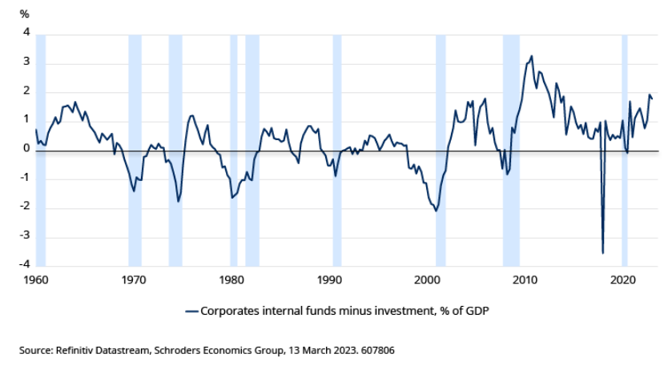
From this perspective the source of the resilience in growth, inflation and corporate earnings lies in the buoyancy of underlying demand which has remained strong enough to absorb higher prices.
Release of pent-up demand as pandemic savings run down
Focusing on the consumer, the rise in inflation has clearly taken a toll on spending power amid widespread media coverage of a cost of living crisis. Yet, despite the pressure on lower income households, real consumer spending for the US increased in 2022. Breaking this down, if we look at the rise in spending in the US last year we see that consumer demand was supported by running down savings, rather than spending out of current income.
Real personal disposable income fell 2.3% over the year (Q4 2021 to Q4 2022), but real consumer spending rose 1.9% over the same period as households reduced their savings rate from 7.3% of disposable income to 2.9% (see chart 2).
Chart 2. US consumer spending drivers – real income and savings rates
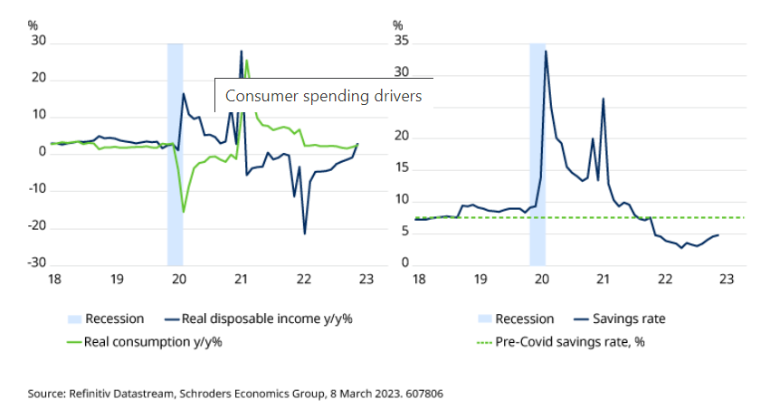
The reduction in household savings reflects the use of funds built up during the pandemic when spending was constrained. We estimate that households went into last year with $2.4 trillion “excess” savings based on pre-pandemic trends. During 2022 around $800 billion was used to support consumption on our calculations, equivalent to the decline in the savings rate, leaving an excess of $1.6 trillion. The fall in savings can also be seen in the sharp decline in the M2 measure of money supply as households withdrew bank deposits. On this basis we would argue that the source of consumer resilience lies in the unspent “excess” savings from the pandemic and as the largest component of GDP this explains much of the broader strength of the economy.
Looking ahead, judging the path of consumer spending means assessing the speed with which households will run down their remaining $1.6 trillion of excess savings. There is no easy answer as much will depend on household perceptions of the future and the extent to which spending on areas such as travel catches up after being curtailed during the pandemic. Furthermore, there are questions over the distribution of those savings with much being concentrated amongst the higher income groups (who were fortunate enough to be able to work through the pandemic). These groups may choose to permanently save some of the excess for the future.
Overall, we expect the excess to be run down at a similar rate to 2022 and consequently we would see another year where households keep their savings rate below normal as this comes through. Recent data shows the savings rate beginning to pick up from its lowest levels for more than a decade, indicating that the impulse from excess savings, or pent-up demand, is now stabilising.
As a result, consumption in 2023 will be entirely dependent on any growth in real income. We believe this will be modestly positive as, although inflation is currently high at 6% and running above wage and salary growth, consumer price increases are expected to moderate as we move through the year. Increases in benefits, pensions and the minimum wage will also help, but real income growth is not expected to be much above 1% in 2023 particularly if, as expected, unemployment increases.
Potential for considerable demand slowdown
Consumption growth of 1% would represent a considerable slowdown in demand, putting pressure on company pricing power and squeezing profit margins and cashflow. Companies should then react by cutting jobs, thus pushing up unemployment. This in turn would feed back into slower consumption as households become more cautious. In our view these second round effects would trigger further weakness in spending and tip the economy into a sharper slowdown later in 2023. The starting point though would be a slowdown in consumer demand as pent-up demand fades.
In our view, the ability of consumers and firms to withstand the energy and wage shocks helps explain much of the resilience in the economy. This does not mean that monetary policy has stopped working. Policy always works with long lags and the speed with which interest rates have been increased from near zero to current levels means that policy has not been restrictive for that long. Higher interest rates are working to slow the economy, but as always take time to feed through into economic behaviour. An example of this can be found in the housing sector.
One of the most interest rate sensitive sectors, housing has experienced a significant slowdown in starts as mortgage rates have risen. However, so far employment in construction has been resilient and continued to rise in 2023.
The weather may be a factor here with a mild Q1 allowing activity to continue at unseasonal levels. Looking at previous cycles though it can be seen that there is a lag of just over a year between peaks and troughs in housing starts and construction employment. On this basis the current resilience is not unusual and construction employment should be declining later in 2023 as the fall in starts means workers are not re-employed as they complete existing homes (chart 3).
Chart 3. Housing starts signal fall in employment
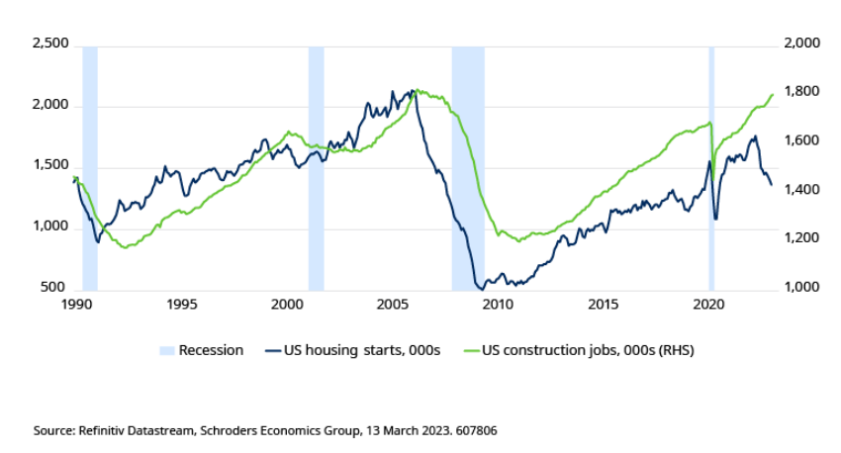
On this basis we see the recession as being delayed rather than dodged. Should consumer demand cool as expected this is likely to be in the second half of the year, if not later. An easing of policy or Fed pivot, is then likely to follow from the Fed.

