Why there is good reason to be positive on South Africa

Andrew Rymer, CFA - Senior Strategist, Strategic Research Unit at Schroders, and Robert Davy - Emerging Market Equities Fund Manager

South Africa is beset by long-term and near-term challenges, most notably an ongoing power crisis, but we think that it’s not all doom and gloom for investors in the country.
South Africa’s economy faces an array of structural challenges, and the need for reform is as urgent as ever. The power crisis is becoming increasingly severe, with loadshedding, or electricity rationing, at record levels. Going into the southern hemisphere winter, when demand rises, power pressures could hit a new high.
Added to the long-term structural issues is the slowing cyclical picture for the economy. Commodity prices are falling as the external environment deteriorates, while domestic demand remains weak, hampered by power shortages and rising inflation and interest rates. Against this backdrop, companies across a range of sectors have announced earnings downgrades.
One of your authors (Robert) was in South Africa to meet with companies in March and felt that the mood was as pessimistic as he can remember in several decades of visiting the country. Despite this gloomy backdrop, we think there is good reason to be positive towards South Africa.
Look through the weak 2023 growth outlook
GDP growth for Q4 2022, released in March, slowed more sharply than expected to 0.9% year-on-year (y/y). On a quarter-on-quarter basis, GDP was down -1.3%. The increase in blackouts through the period, as the electricity situation deteriorated, weighed on broad activity. Last year was the worst on record for loadshedding in South Africa and it may have been even more severe in Q1 of this year.
GDP growth expectations for this year are now sub 1%, with power set to remain a constraint on activity. The higher interest burden for households, following 18 months of policy tightening, is weighing on consumption. Meanwhile the commodity price outlook has weakened as the global growth outlook has moderated. The outlook into 2024 and 2025 looks more optimistic though, amid signs of improvement on the horizon for electricity supply, and as the global economy is expected to recover.
Inflation ticked up slightly to 7.0% y/y in February. Although it has been trending down, it remains above the central bank’s target range of 3-6%. South Africa’s Reserve Bank has lifted the policy rate by a total of 4.25 percentage points to 7.75% since the end of November 2021. The 50bps hike in March surprised the market, but the hiking cycle appears to be peaking. Inflation should resume its move lower in the coming months as base effects ease. A fall in food price inflation would also be beneficial.
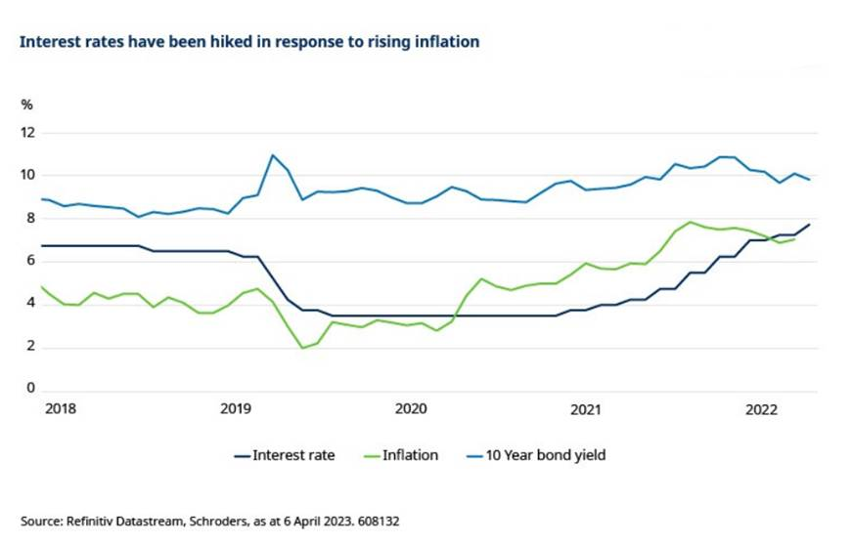
South Africa has enjoyed an improvement in the terms of trade as a result of higher commodity prices since 2020. This has driven the current account from a deficit to surplus in 2022 and helped tax revenues, which was supportive of the fiscal accounts. However, with the global economic cycle fading and commodity prices deteriorating, these factors are reversing. The current account is expected to move to a deficit of around -1% this year. Against this backdrop, the rand has depreciated by around 5% against the US dollar year-to-date, as at 5 April.
On the fiscal side, February’s National Budget was relatively positively received in that it showed signs of a longer-term commitment to fiscal consolidation. It also included a reasonable three-year debt relief plan for the state-owned electricity company Eskom. South Africa’s debt-to-GDP ratio has climbed to around 70%, and the budget projects this to peak in 2025/6 at almost 74%. This is because Eskom debt is added over three years; excluding Eskom debt, it believes the ratio has already peaked. After a forecast balanced primary account for the tax year 2022/23, primary surpluses of 1% and rising are projected for the following years. Although this is positive, the tax and expenditure figures may yet prove optimistic. Indeed, the recent two-year public-sector wage agreement with a 3.3% first year rise is above the 1.6% assumed in the National Budget.
Long term structural challenges
The most evident challenge facing South Africa is the lack of power, which has led to severe load shedding. Ultimately, this is just one facet of a broader collapse in various state capabilities that accelerated under the Zuma administration, and has so far not been halted by President Ramaphosa.
Transnet, a rail freight and logistics operator, is another state-owned enterprise (SOE) with debt issues. The company plays a crucial role in transporting commodities such as iron ore and coal for export, but capacity has been declining due to factors including ageing infrastructure, inefficiencies, and vandalism. The volume of goods moved by rail is down by 30% since 2021.
Transnet’s operational issues have created bottlenecks in various natural resources supply chains, with stocks building at mines. Exports have fallen and the opportunity cost for businesses and the public purse has been significant, with capacity constraints coming at a time of high international prices. Some supply chains have switched from rail to trucks, but this has only added pressure on the road infrastructure.
Other utilities are also in difficulty, with around 37% of municipal water supply lost. In Northern Cape, the private sector had to participate, otherwise mines and mining towns would not have received water supply.
Is the power crisis peaking?
In various areas where the state capability is no longer functioning, the private sector is stepping in with investment to fulfil the role. This process takes time though, in part as it is political, and in many cases has not happened until the SOE operations are in dire straits. For example, in the electricity sector, Eskom’s energy availability factor was 85% in 2011, but was down to 57% in 2022.
President Ramaphosa responded to the energy crisis last year by scrapping licence requirements for private power generators over 100 megawatts. Anecdotally, almost every South African company Robert met with was investing in power. The government also announced plans to double the renewable energy procurement.
The 2023 National Budget delivered a relief plan for Eskom of ZAR 254 billion. It is conditional on Eskom working with the private sector to support the running of its power plants and transmission network. This is a positive milestone and should enable the company to focus on transmission, which is a key bottleneck, in return for taking over debt. These reforms are clearly positive in the long term, but it will take time for private capacity to get up and running.
The power crisis is therefore likely to persist through 2023, particularly in the southern hemisphere winter. However, moving into 2024 the picture is brighter, as more private power comes online. Furthermore, two relative new Eskom units which have so far not functioned at full capacity should be back online. The combination of these factors should enable load shedding to ease by 2025.
Politics poses a medium-term risk
President Ramaphosa has enacted reforms since his election in 2019, but the pace of change has been slower than hoped, not just in addressing power issues but also in areas such as combatting corruption. The National Prosecuting Authority (NPA) was hollowed out by former President Zuma and, despite a new head being appointed, has yet to prove itself. No-one highlighted by the now Chief Justice Zondo and his Commission of Inquiry into Allegations of State Capture is in jail. Ex President Zuma remains free and the Gupta brothers recently avoided extradition from the UAE. Earlier this year, the departing CEO of Eskom highlighted that high levels of corruption and the criminal syndicates remain major challenges.
That said, there has been some uptick in reforms in the past two years. In addition to the regulatory changes for private power generation, some SOE issues have been addressed, including the sale of a 51% stake in South African Airways, and the separation of the Ports Authority from Transnet.
Ramaphosa performed well in the African National Congress (ANC) National Elective Conference in December and secured another term as party leader. The 80-member National Elective Committee (NEC) also looks to have a greater proportion of Ramaphosa allies. On paper this could bode well for a faster reform pace, but optimism is dampened somewhat by other factors which could demand a more cautious approach.
There is medium term risk stemming from a general election, expected in the second quarter of 2024. Ramaphosa’s ANC party received 58% of the vote in the last election in 2019. If its share falls significantly below 50% it may need to form a coalition with another smaller party, raising uncertainty over the direction of future government policy.
Meanwhile, the president still faces investigations from the tax authority and a specialist economic crime unit of the South African police, known as the Hawks. These are focused on allegations of a cover-up relating to the theft of foreign currency from his private game ranch. Earlier this year the Public Protector, an anti-corruption watchdog, cleared Ramaphosa in a preliminary investigation.
What do valuations look like?
On a combined valuation basis, South Africa is cheap relative to history on a Z-score basis, which measures how far valuations are from their historical mean. The market is cheap on a trailing price-earnings, price-book and a dividend yield z-score basis. On a forward price-earnings the market is close to its historical average.
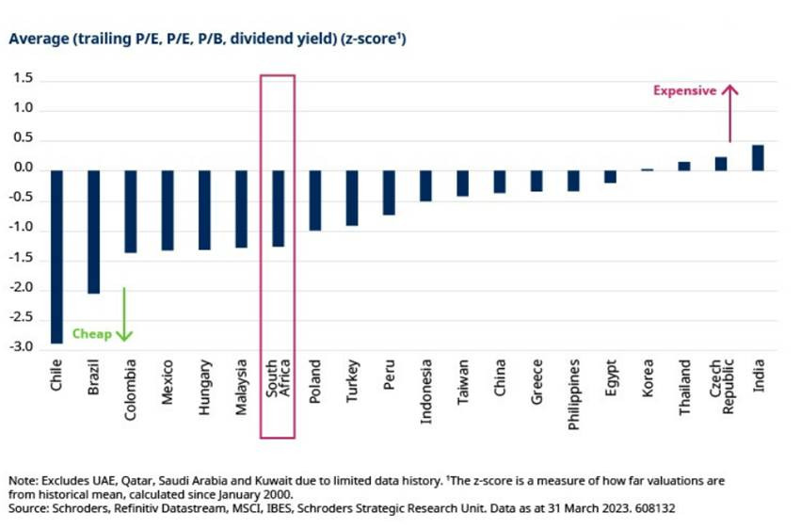
The South African rand is also cheap relative to history, and among the cheapest in wider emerging markets. The currency is around 30% below its historical average since January 1995 on a real exchange rate basis, and 13% on a last five-year basis.
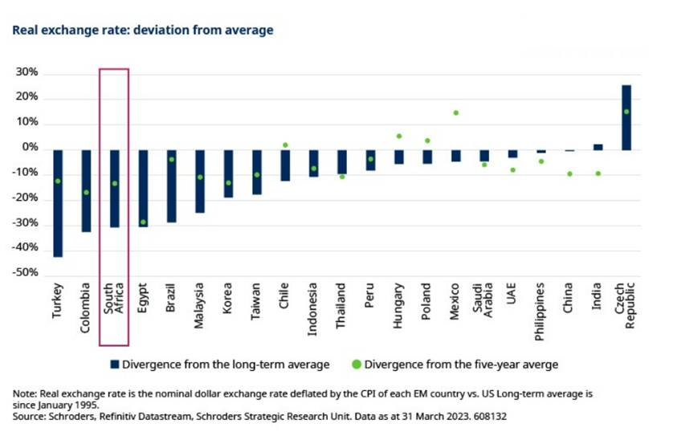
Our view on South Africa
The need for broader structural reform in South Africa persists. Reform progress under President Ramaphosa has been incrementally positive, if slow.
In the near term, the main risk is from further power sector stress and the wider ramifications for the economy and corporate earnings. Signs of a potential easing in the power crisis are on the horizon, but uncertainty remains, and this is a story for 2024 onwards. Eskom has already warned of severe shortfalls in power generation for the next 12 months. Politics presents some medium-term risk due to elections in 2024.
The involvement of the private sector in the power sector is encouraging and raises the prospect of a resolution to the crisis in the coming years. The strength of the private sector in South Africa should not be underestimated and has the capability to help resolve some of the structural issues.
Market sentiment has become very pessimistic, and earnings have been revised down. This is now reflected in attractive equity market valuations, and the currency is cheap leading us to hold a favourable investment view. The South African equity market offers a diverse opportunity set, and we continue to find a range of well-run companies with strong management teams.

