Does it make sense to ditch the 2% inflation target?
George Brown, Economist at Schroders
Investors are beginning to question whether central banks should set their sights higher.
Since the advent of inflation targeting in the 1990s, advanced economies have coalesced around a common 2% goal. In the intervening decades, central banks have largely achieved low and stable inflation. But this has been turned on its head in recent years as inflation has soared to the highest seen for a generation.
This has ignited a debate over whether policymakers should ditch the ubiquitous 2% target and instead set their sights on higher inflation.
Proponents of a 3% or even 4% inflation target argue it would entail higher nominal rates. Higher nominal rates would diminish the risk of central banks being constrained by the effective lower bound, or “ELB”, as they would have more room to reduce borrowing costs when faced with an economic downturn. It is a seemingly simple solution to the issue that has plagued policymakers in the years following the Global Financial Crisis.
But it brings about problems of its own. One is whether inflation will even be able to converge to the higher target.
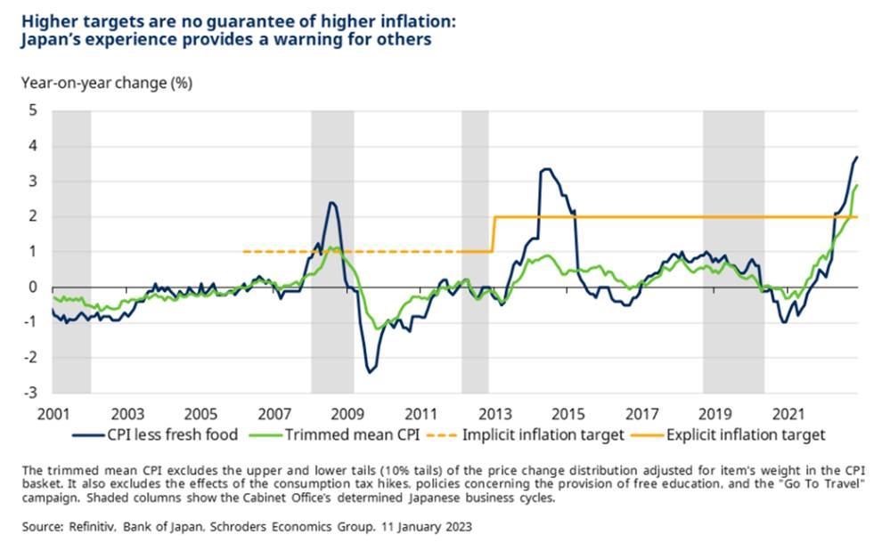
It is a challenge the Bank of Japan knows all too well. 10 years ago, it raised its inflation target from 1% to 2% in a bid to overcome chronic deflation. And to help inflation along its way, it initiated colossal quantitative easing which has seen its balance sheet swell from 30% to 130% of GDP. Safe to say, it did not work. Barring a tax hike in 2014, inflation stayed stubbornly subdued, at least until the recent global renaissance.
And while Japan’s economy is somewhat unique, its peers struggled with persistent inflation undershoots over the same period. One factor was the financial crisis, which opened up an G7 output gap of 5.8% of GDP which took several years to narrow. Another has been globalisation, especially following China’s accession to the World Trade Organisation in 2001. As has technological innovation and disruption, such as smart phones and subscription services.
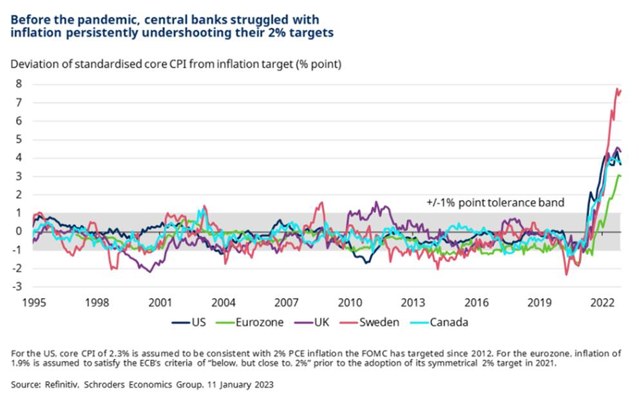
Some of these disinflationary trends can be expected to head into reverse. We may be in a regime shift to a less globalised world, with security and proximity prioritised over the efficiency and cost considerations which have characterised the globalised model of extended supply chains in recent decades. This shift could result in more stagflation pushing up inflation and slowing global growth.
One aspect of this shift might be “fiscal activism”, a potential implication of which might be central bank inflation targets increased, or independence rescinded. Governments seem likely to become more fiscally generous after voter expectations have changed due to pandemic support schemes. Fiscal activism could be another potential source of upward pressure on inflation in the near to medium-term.
Pathways to more active fiscal policy might include governments changing the central banking system to manage the impact of additional spending. A scenario where regulation is used to direct funds into the bond market, combined with changes in the mandate of central banks to tolerate greater inflation is not inconceivable, should we see big changes in political priorities as a result of populism, say.
However, it remains to be seen if any of our predictions come to pass. Not to mention whether we have correctly gauged what the net impact will be. And it is uncertain how other factors might play out. There is, for instance, a debate about whether population ageing will ultimately be inflationary or deflationary. Also, technological disruption could act as a headwind to inflation, such as if generative artificial intelligence (AI) leads to a widespread displacement of workers.
It is also questionable whether higher inflation ought to be tolerated unless anaemic productivity growth can be improved. Most empirical studies find a negative correlation between the two, but moving into a higher inflation regime might help to spur business investment. But if productivity remains low and other countries don’t also raise their inflation targets, there will be a gradual erosion of competitiveness and a deterioration in living standards.
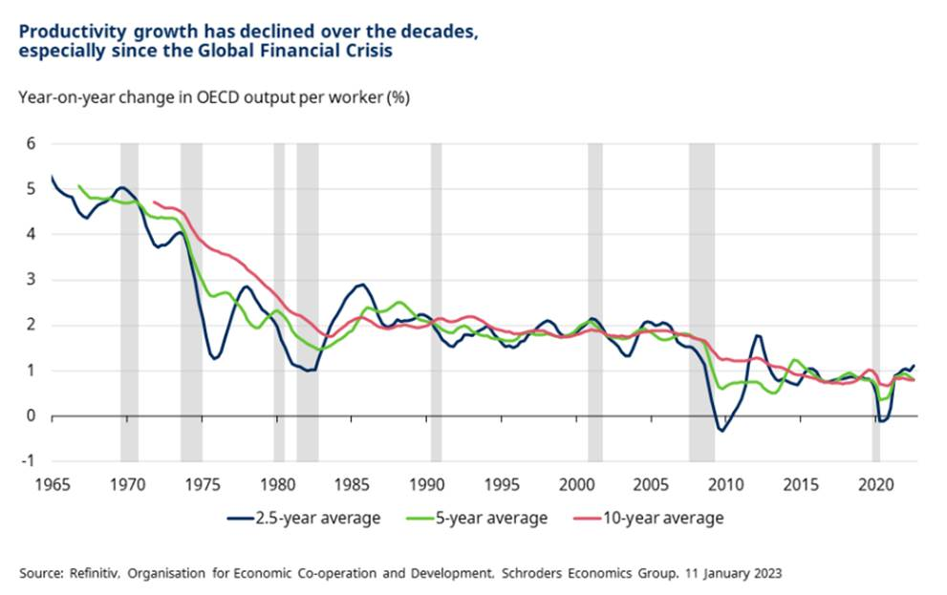
Raising the inflation target also risks damaging the credibility of central banks. Particularly the Federal Reserve and the European Central Bank (ECB), whose recent policy reviews indicated a willingness to tolerate inflation overshoots after years of it being below 2%. For then perform a volte-face and raise their targets amidst high inflation could give the impression they are not in control and risk de-anchoring inflation expectations beyond the new higher target.
This is a very slippery slope. Particularly as employee bargaining power is high and ought to remain so in the face of ageing populations, anti-immigration sentiment and reshoring efforts. Firms might therefore have little choice but to grant worker demands to be compensated for higher inflation. Unless productivity growth can keep pace, this risks causing a wage-price spiral would have to be arrested by aggressive Volcker-style policy tightening by central banks.
So whilst inflation looks set to be structurally higher this decade than the last, this is far from guaranteed. And if this is the case, supply side reforms are likely to be needed to accommodate it, or else competitiveness and living standards could suffer. Also, central banks first need to achieve their existing objectives in a sustainable manner to ensure credibility. Until these criteria are satisfied, it is premature to talk about ditching the 2% inflation target.

