What does recession mean for your portfolio?

Kondi Nkosi, Country Head at Schroders South Africa

With the US economy looking more resilient than many had anticipated, the recent turmoil in the banking sector has added fuel to the debate on whether there is going to be a soft landing or a recession.
We’re on the side of the latter and still expect a recession is going to happen this year given the sheer pace of policy tightening by the Federal Reserve (Fed).
With this in mind, how should investors position their portfolios to seek shelter from the impending recessionary storm? Although every recession is unique and there is no guarantee that history is to be repeated, it is useful to understand how different asset classes have behaved during past downturns.
Recessions can be defined by two consecutive quarters of negative real GDP growth or in terms of the economic cycle, but here we simply look at US recessions officially dated by the NBER (National Bureau of Economic Research).
Safety first - but don’t miss the re-rating in the market
Recessions are often characterised by a slump in growth and a fall in inflation, which spurs policymakers to ease monetary or fiscal policy, or often both. Investors have typically sought the safety of government bonds and to some extent corporate bonds (chart 1). The US dollar has also benefitted from its perceived safe-haven status during recessions, particularly when the rest of the world has been weaker than the US economy . In comparison, equities and commodities get hit hard by the collapse in economic activity.
More generally, the performance of risk assets has been even worse during recessions over the last 30 years due to the heavy losses incurred during the Global Financial Crisis.
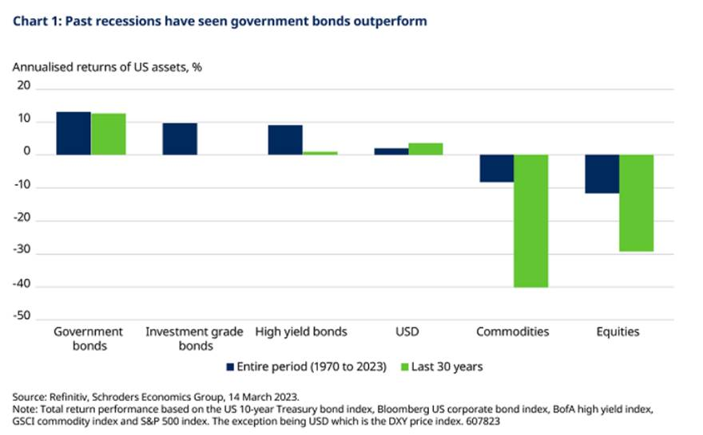
While US stocks have nearly always hit rock bottom during recessions, they have rebounded strongly towards the end of the period (chart 2). The recovery in equities is driven by the combination of cheap equity valuations and expectations of future improvements in economic activity and corporate earnings thanks to policy easing by the Fed. By simply looking at the poor returns experienced during past recessions, investors should be mindful of missing out on the re-rating of the market. This is also relevant to investing in equity sectors and styles during recessions, which is discussed next.
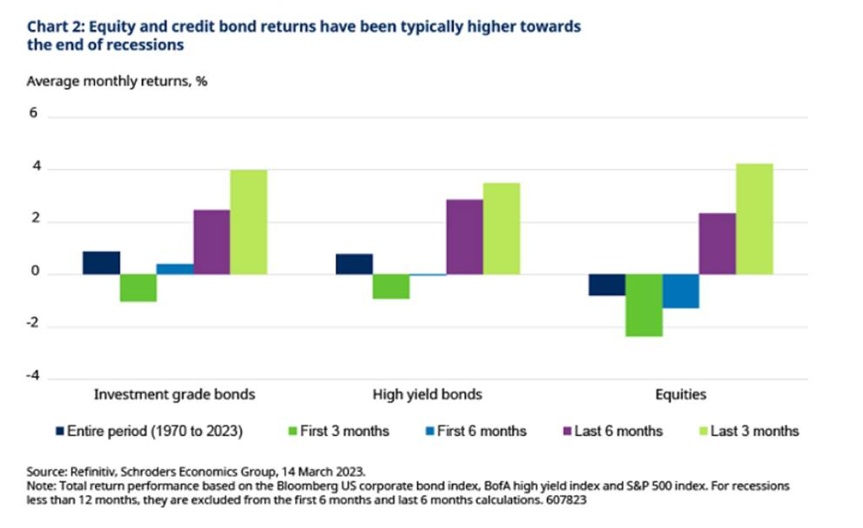
How have equity sectors performed during previous recessions?
With equities typically in the red during recessions, the more defensive sectors in the US such as consumer staples and health care have on average delivered the strongest returns (chart 3). This is because investors have looked for companies that offer superior profitability and robust balance sheets during times of economic stress. Instead, the more cyclical areas of the market such as financials and industrials have tended to be the worst performers.
Note there is no hard and fast rule in defining sectors as being defensive or cyclical. Defensive sectors generally have a lower beta relative to the market, such as consumer staples, health care, utilities, and real estate. In comparison, cyclical sectors typically have a higher beta relative to the market such as industrials, energy, financials, technology (tech), materials, consumer discretionary and communication services.
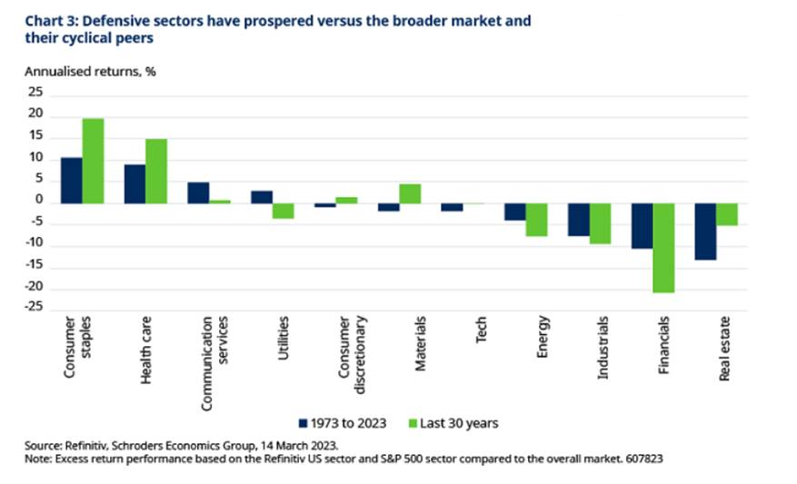
That said, some of the worst sector underperformers during recessions such as real estate and financials have recovered strongly towards the end of the recession (table 1). For financials, particularly the banks, they make profits from lending at a higher rate than they pay interest to depositors (known as the net interest income). So, the net interest income earned by banks rises as interest rates increases. While cuts in interest rates during recessions undermines their profitability, the loosening of policy eventually leads to the re-steepening of the yield curve and an improvement in their net interest income. Consequently, we see a rebound in performance of financials towards the end of the recession.
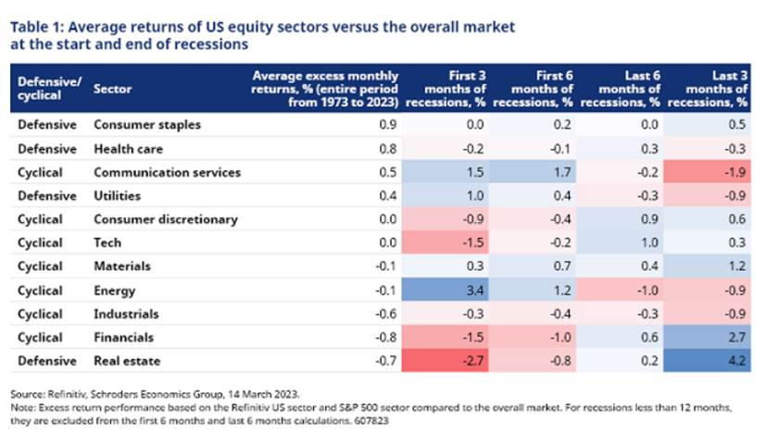
Even the performance of some of the more rate-sensitive cyclical sectors, such as consumer discretionary and tech, have come back before the recession has concluded. Like the re-rating of the equity market prior to the end of the recession, these cyclical sectors have benefitted from the market discounting a recovery in economic activity and corporate earnings.
In comparison, defensive sectors such as utilities have tended to make robust gains at the start of the recession, but losses towards the end of the recession. Despite being considered a cyclical sector, the performance of the communication services sector has also exhibited this pattern during recessions. This is because prior to 2018, this sector was categorised as a defensive sector know as ‘telecommunications’.
Defensive equity styles have been the winners - but don’t ignore small caps
During previous recessions, the more defensive strategies have been the style winners (table 2). It seems that investors have looked for shelter in quality stocks that have strong balance sheets and stable cashflow. At the same time, they have invested in the minimum volatility strategy as these stocks have lower risk than the broader market. For more information on the definitions of the different equity styles used in our analysis, please refer to table 3.
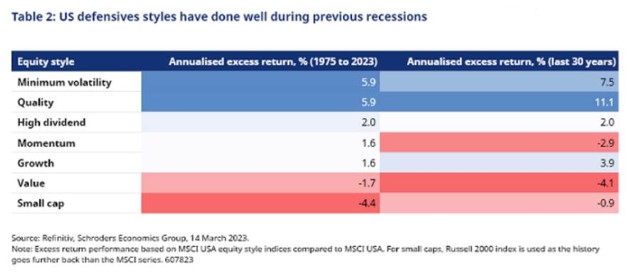
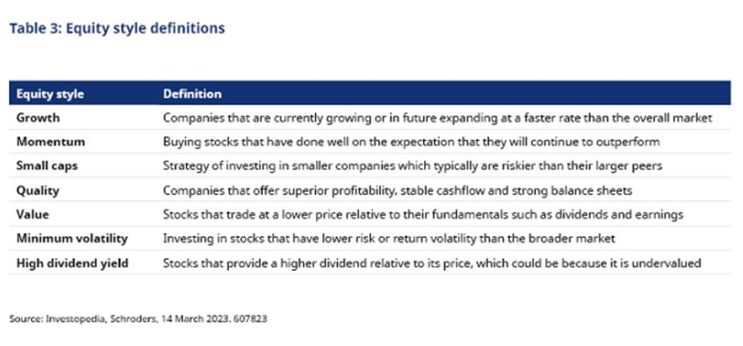
Meanwhile, the growth style has delivered stronger gains during recessions over the last 30 years given the increased dominance of tech stocks in the index. These companies tend to generate a large proportion of their earnings in the future, so interest rate cuts means that their future cash flows are being discounted at a lower rate.
By contrast the worst style performers have been small cap and value stocks. The value style gets hit by the fall in interest rates as they are positively correlated with higher government bond yields. Although small caps generally deliver negative returns during recessions, they re-rate strongly towards the end of it (table 4). It seems that investors start to discount the recovery in corporate profitability of the smaller companies, as they are more likely to benefit from looser monetary policy than their larger peers.
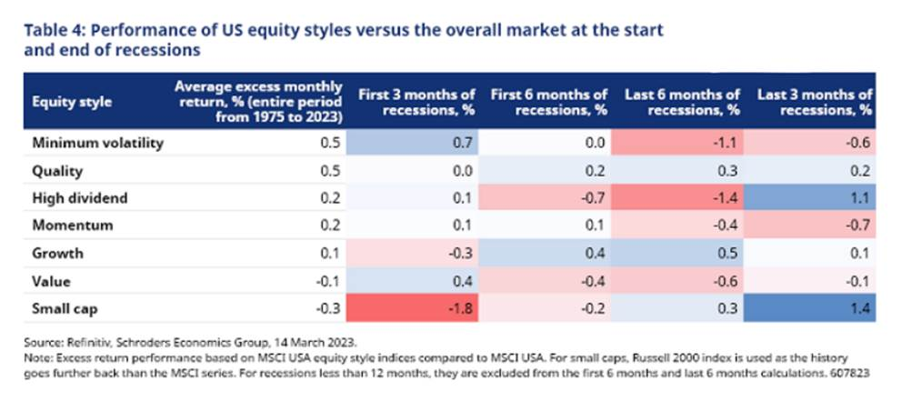
Commodities don’t do well in recessions
Commodities typically get weighed down during recessions with the worst performing sectors being energy and industrial metals as they are most sensitive to changes in economic growth (chart 4). These sectors make up a significant proportion of the commodity basket which mean they drag down the overall index during recessions.
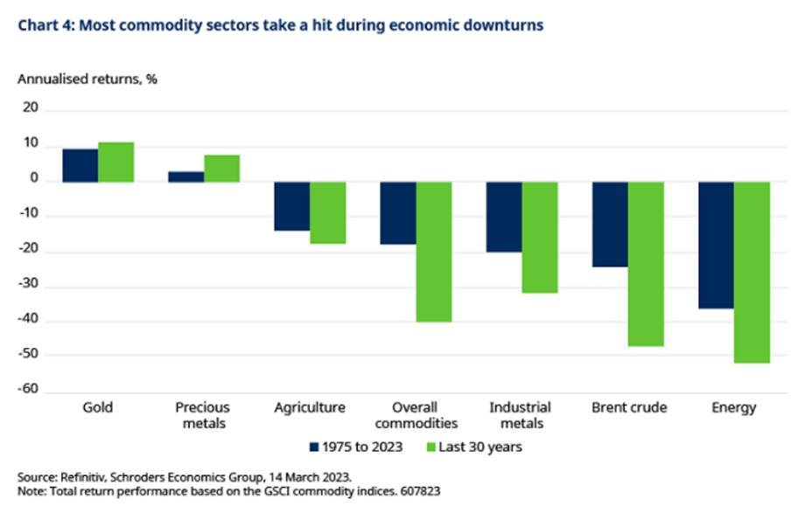
By contrast, gold has tended to shine during recessions as investors have reached for their safe-haven status. At the same time, the loosening of monetary policy and lower real interest rates has typically supported gold prices during economic downturns. Although there is a balancing act with a stronger US dollar during recessions.
It is worth highlighting that these results have been based on past US recessions and have not taken into consideration China, which is the world’s biggest commodities consumer. For instance, China accounts for half of the world’s copper consumption and is ranked as the second largest consumer of oil.
With the US expected to go into recession later this year, growth in China is likely to rebound strongly due to the lifting of zero-Covid policy restrictions. The recovery in China is expected to be skewed to services, which may be more supportive of the energy sector and offset some of the potential drag from an US recession.
Conclusion
Government bonds and to some extent credit bonds have typically done well during recessions, while commodity and equity prices have been hit hard. Defensive equity sectors and styles have also been performance winners. But investors should be mindful of missing out on the rebound of the stock market and certain equity styles and sectors towards the end of the recession. With the Fed easing policy during economic downturns, this eventually lifts expectations of a recovery in the economy and corporate earnings.
Commodities, particularly industrial metals and energy, have generally done poorly during past recessions. But gold has benefited from safe-haven flows. That said, this lesson from history does not consider the impact of China, which is expected to grow strongly this year. So, the recession playbook for commodities could be different this time around.
While there is no guarantee on the timing of the recession, we expect this to occur during the second half of this year. This would likely set the stage for investors to naturally seek defensive assets first when investing in the initial months of the recession. But they should not ignore the pocket of opportunities that emerge as the market re-rates and prepares to move to the next phase of the cycle.

