Bank stability Q&A: one month on from turmoil, what next?

Schroders
As more details emerge of the pace of withdrawals that triggered crises for Silicon Valley Bank and Credit Suisse, our investment experts assess the longer-term outlook for banks
In mid-March, the failure of three mid-sized US banks – most notably Silicon Valley Bank (SVB) – caused turmoil across global stock markets. Bank shares fell sharply.
Nervousness was not confined to the US, with investors soon focusing on perceived weak spots in other regions. A week after the failure of Silicon Valley Bank, the Swiss authorities brokered a deal that would see UBS take over troubled rival Credit Suisse. Like SVB, Credit Suisse had also been experiencing high levels of outflows: CHF61.2 billion ($68.6 billion), according to its recent Q1 results.
Yet that period of extreme market stress in March has proved short-lived. Bank shares, as measured by the MSCI World banks sub-index, have recovered off their March lows and returned to where they were at the start of the year.
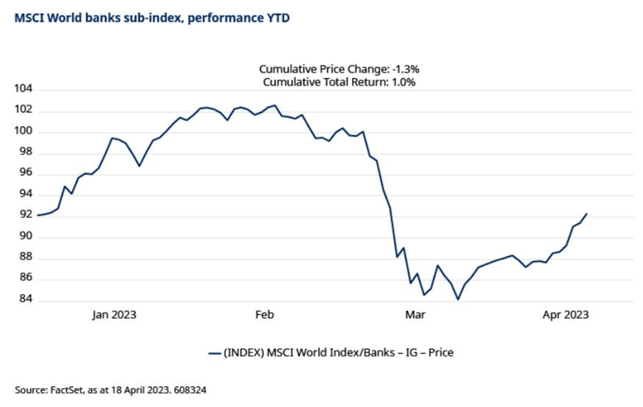
Does that mean the problems facing banks are over? We asked our banking sector experts how they view the sector now.
Do other banks face the same problems as SVB?
Harold Thomas, Credit Analyst, US banks, said: “Banks in general have a similar duration mismatch as SVB, as their investments are generally longer than their deposits. As interest rates rise, especially at the pace we have seen over the past year, the value of those investments - regardless of the quality – declines, while the deposits remain available to be withdrawn at any time. The largest banks maintain significant liquidity cushions to manage this duration mismatch and generally have long-standing, complex customer relationships.
“SVB’s problem, however, was specific to its franchise. Its client base was highly concentrated in the tech start-up sector. These clients started withdrawing their deposits at the same time, causing a vicious feedback loop. SVB was forced to liquidate underwater securities that it wouldn’t normally have to liquidate, creating a classic run on the bank.”
Grant Toch, Equity Analyst, US small and mid-sized banks, said: ”The US banking system no longer has a liquidity issue. Thanks to the Federal Reserve and Federal Home Loan Bank System, the sector is extremely liquid. The only question that remains for banks is the price to access that liquidity and the impact that access will have on earnings.”
How is the situation different for banks in Japan and Europe?
Kazuko Yabutani, Equity Analyst, Japanese banks, said: “Japanese banks operate with a very ‘sticky’ deposit base – customers do not tend to move their money around. They are also under tight regulation so their capital position is solid. Unlike in the US, there is no relaxing of the regulations by bank size.”
Nor do pan-European banks face the same situation as SVB, according to Justin Bisseker, Equity Analyst, European banks. “The kind of interest rate risk being taken by SVB wouldn’t be possible under UK or European regulations. As regards Credit Suisse, its problem was the interplay of a poor risk management culture, ongoing senior management turnover, a lack of credibility on restructuring, and – most crucially – a collapse in client and depositor confidence. No other bank I cover is facing this situation.”
Will bank regulation tighten up in the wake of the SVB failure?
US
The regulation of US banks changed in 2018, after lobbying from the banks, so that mid-sized and small banks were not subject to the same liquidity and capital requirements as large banks.
Harold Thomas said: “We do believe regulations will be more aggressive for smaller US banks – down to the $100 billion level - and force better risk management processes regarding liquidity and interest rate risk. This may include the issue of additional debt to protect taxpayers. For the smaller and less diversified banks, this will negatively impact profitability.”
Europe
In Europe, regulations around liquidity and capital are already tighter than the US, but there could still be some changes to come, according to Justin Bisseker.
“In Europe, one possibility is that deposit insurance levels could be increased, which will mean higher contribution costs for banks. The Bank of England’s governor has already mooted the idea of beefing up the bank deposit protection scheme, including potentially raising the £85,000 limit on protect deposits. The speed with which both SVB and Credit Suisse lost deposits may also mean that banks are forced to hold more high quality liquid assets (i.e. assets which can be easily and immediately converted into cash at little or no loss of value).”
What are the implications of the Swiss authorities’ decision to impose losses on AT1 (additional tier 1) bond holders, while equity holders were paid CHF3 billion?
A highly controversial aspect of UBS’s takeover of Credit Suisse was that holders of Credit Suisse’s AT1 bonds lost CHF15.8 billion, while shareholders received CHF3 billion in stock. The standard hierarchy would see equity investments classed as secondary to bonds.
Robert Kendrick, Credit Analyst, fixed income, said: “That decision makes it harder and more expensive for any bank to issue AT1 securities. Regulators in the EU and UK (and Singapore) have made statements to indicate they wouldn’t have imposed losses in the same way. Even so, investors won’t be able to forget that these securities have very investor-unfriendly idiosyncratic features that could be used to their detriment.”
Rising interest rates were a problem for SVB. How will they affect Japanese banks, where rates have not yet risen?
Rising interest rates had a negative impact on SVB in two ways. Firstly, they led to reduced funding being available for SVB’s tech sector customers, who then rushed to withdraw their deposits. Secondly, the rapid withdrawal of deposits meant SVB had to sell its fixed income securities at a time when they had fallen in value.
While interest rates have risen sharply in the US and Europe, they have not yet done so in Japan.
Kazuko Yabutani said: “Japanese banks and life insurers have been buying non-Japanese securities, including US Treasuries, given the negative interest rate environment in Japan. However, exposure to “held-to-maturity” (HTM) securities is limited.”
HTM securities do not have to be assessed at their current market value and SVB’s large holding of these was part of its downfall.
“If long-term interest rates go up in Japan, then we would expect regional banks to see some unrealised losses on their bond portfolios, as they tend to hold Japanese government bonds with longer maturities. It’s less of an issue for the major banks.
“But if the negative interest rate policy is lifted and policy rates rise so that the short-term prime rate (STPR) goes up, then the positive impact will be higher at regional banks. This is because housing loans will automatically re-price and STPR-linked loans to SMEs (small- and medium-sized enterprises) can be re-priced. Because deposits are sticky, banks won't need to raise deposit rates at the same pace as loan rates, so banks can finally benefit from holding deposits. This would have a greater positive impact on the earnings of regional banks, given they are largely Japan-only operators. But it’s not my view that such a scenario is on its way.”
Short-term prime lending rates refer to the minimum rate of interest applied to loans of less than one year. These are charged by financial institutions on loans to firms with high ratings in their sectors.
What are the major risks now facing banks?
Grant Toch said: “For many years now, central bank policy around the world – in the form of ultra-low interest rates – has obscured the cost of capital and incentivised misallocation of capital. We’re now seeing that unwind and risks are manifesting in many different areas.”
Harold Thomas said: “Credit risk is the largest risk looming for the banking system as the benign environment we have seen over the past decade comes to an end. We are keenly focused on commercial real estate, auto lending and credit cards. The latter two are highly correlated with unemployment as pandemic-era savings rates return to more normal levels.
“Despite disclosure from the banks not being great, we are also watching any indirect impact any developments in the non-bank financial markets have on the banking system.”
Robert Kendrick said: “In Europe the main risks are the same as they were before the SVB/Credit Suisse events: higher loan losses as a result of an economic downturn, plus a reversal of the benefits the recent rate hikes have given them. Commercial real estate is a key risk factor, given rising borrowing costs and falling property valuations. We’ve been working to ensure we fully understand the exposures the banks we are invested in have to this sector.”
Kazuko Yabutani said: “In Japan, controlling losses on the bond portfolio remains the key challenge. Banks have been selling unprofitable bonds by realising losses and adding higher-yielding bonds. They have already made good progress so unrealised losses have shrunk. The question is how much more needs to be done. Meanwhile, the termination of Covid support loans might result in rising credit costs at weaker, smaller regional banks but I don't expect that to be a serious problem for the whole sector.”
Are the risks factored in to valuations?
On the credit front, Harold Thomas said: “Despite the recent events, the largest banks in the system are still sitting on very healthy capital and liquidity metrics and run very diverse franchises. Spreads (the yield differential between corporate bonds and Treasuries of similar maturities) have tightened compared to their mid 2022 levels, but still provide fairly decent relative value compared to industrials when adjusted for duration (sensitivity to interest rates).”
Credit from European banks also looks attractive, according to our experts.
Robert Kendrick said: “Given the lack of direct read-across (between US and European banks) and the strong level of capital going into the downturn, we think spreads are very attractive for European banks right now.”
From an equity perspective, Justin Bisseker said: “European banks are trading at extremely cheap valuations, implying around 40% upside to their 20-year average. And bear in mind that the last 20 years has hardly been a bullish backdrop for banks”.
It is the same story in Japan as well. Kazuko Yabutani said: “Japanese banks are very lowly valued. We think the risks are already more than reflected in valuations. Arguably they are sitting on too much capital but ironically that is probably a good thing if the market is very concerned about SVB and Credit Suisse.”
Kevin Murphy, Fund Manager, Equity Value said: “From a value investor’s point of view, current valuations more than compensate for the risks inherent within the bank stocks. The zero-rate environment forced many of these businesses to restructure. And after a decade of cost-cutting they are much leaner today than they were in the wake of the crisis.”
Which banks represent the best investments?
While valuations may look enticing across the banking sector as a whole, our experts still favour being selective.
Justin Bisseker said: “With valuations so cheap across the pan-European banking sector, there is little point chasing the riskier banks now.
“Barring a very sharp macro downturn and/or a collapse in core inflation, the rate environment for banks will be significantly more positive than has been the case for over a decade. While regulation may be tightened in some areas, this will be manageable and nothing like the headwind to performance seen since the Global Financial Crisis. In addition, in Europe we’re likely to see very material shareholder distributions in the coming years in the form of both share buybacks and dividends.”
Value investor Kevin Murphy said: “Now that interest rates have risen, banks are beneficiaries of operational and financial gearing where increased revenues run through directly to profitability. However, the market remains concerned that a deterioration in economic conditions will lead to loan losses eating away at these profits. That is a valid concern. Our focus therefore is on owning the banks that have high levels of tier 1 capital and strong balance sheets that can absorb potential losses.”
Credit analyst Harold Thomas said: “For the larger US banks, the increased regulation for the system as a whole doesn’t impact our investment thesis. From a credit perspective, I favour the largest and most diverse banks from an assets, revenue, geographic and deposit franchise standpoint.”
Understanding a bank’s culture, as well as its financial metrics, is also important according to credit analyst Grant Toch.
“I cover the US small and mid-sized banks, which have really been at the eye of the storm. The next months will clearly be difficult for the sector. The current quarter results will show only a partial effect of what’s happened with SVB and banks will likely come under stress in terms of their funding costs. Guidance provided during the Q1 2023 reporting season will provide us with a much clearer picture as to the extent to which the banking crisis will impact results through the remainder of 2023.
“There is no such thing as a 100% safe bank. Any bank can be subject to a run if depositors panic, and money moves very fast in this era of digital banking. But our job is to assess and manage the risk. A key thing to look for is a diversified deposit base. Prudent growth is another.
“Management teams are crucial too. Many of the best-run banks today have management teams who steered their institutions through the turmoil of 2008, or who learned from that experience. Understanding management’s proclivity for taking risk is essential for investing in banks.”
Important Information
For professional investors and advisers only. The material is not suitable for retail clients. We define "Professional Investors" as those who have the appropriate expertise and knowledge e.g. asset managers, distributors and financial intermediaries.
Any reference to sectors/countries/stocks/securities are for illustrative purposes only and not a recommendation to buy or sell any financial instrument/securities or adopt any investment strategy.
Reliance should not be placed on any views or information in the material when taking individual investment and/or strategic decisions.
Past Performance is not a guide to future performance and may not be repeated. The value of investments and the income from them may go down as well as up and investors may not get back the amounts originally invested. Exchange rate changes may cause the value of investments to fall as well as rise.
The views and opinions contained herein are those of the individuals to whom they are attributed and may not necessarily represent views expressed or reflected in other Schroders communications, strategies or funds.
Information herein is believed to be reliable but Schroders does not warrant its completeness or accuracy.
Issued in March 2023 by Schroders Investment Management Ltd registration number: 01893220 (Incorporated in England and Wales) which is authorised and regulated in the UK by the Financial Conduct Authority and an authorised financial services provider in South Africa FSP No: 48998

