Is the 60/40 portfolio dead?

Michael Devereux, Multi Asset Portfolio Manager at Schroders

The idea behind the 60/40 portfolio, which is made up of 60% equities and 40% bonds, relies on the negative correlation between equities and bonds. In others words, if the equity component of the portfolio does poorly, these losses would be offset by gains from the bond component, and vice-versa.
However, the correlation between equities and bonds turned positive in 2022 which meant that the 60/40 didn’t provide the protection it has been known for since the 1990s. Instead, as equities fell over the year, so did bonds. A portfolio made up of 60% US equities and 40% long-term US government bonds, fell 17% last year (Fig. 1), underperforming both South African and US inflation by roughly 21.6%.
Fig. 1
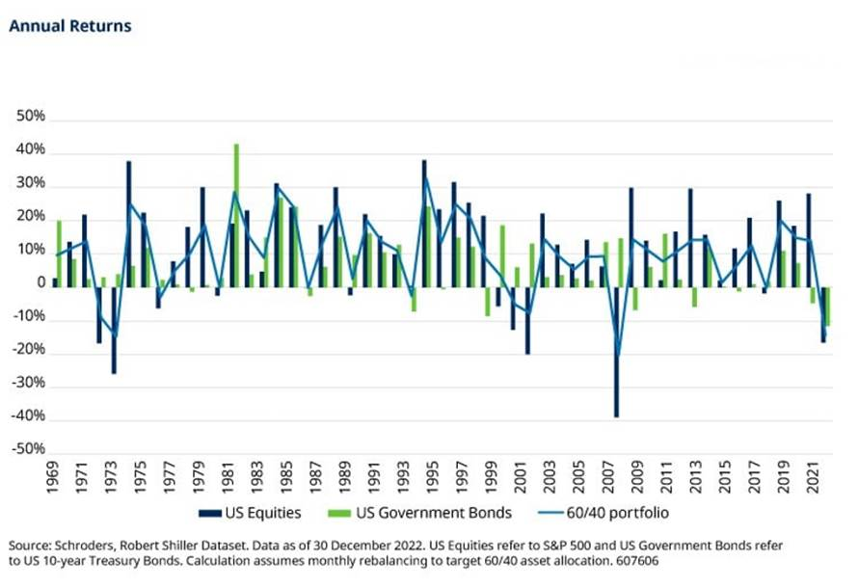
So is it all over for the 60/40 portfolio? Here’s why we don’t think so.
Firstly, looking back at history, it’s highly unusual to see significant drawdowns in the 60/40 happening in two consecutive years. Indeed, we’re already seeing the 60/40 bounce back after a strongly negative year in 2022.
Secondly, the growth and inflation environment looks relatively favourable. There are signs that global growth is heading for a soft, rather than a hard or ‘no’, landing. A soft landing is characterised by slowing inflation and lower growth that is cushioned by a factor such as excess savings or government support.
Indeed, global growth has been better than expected so far. Growth estimates have been revised higher in many cases around the world. (Fig. 2).
Fig. 2
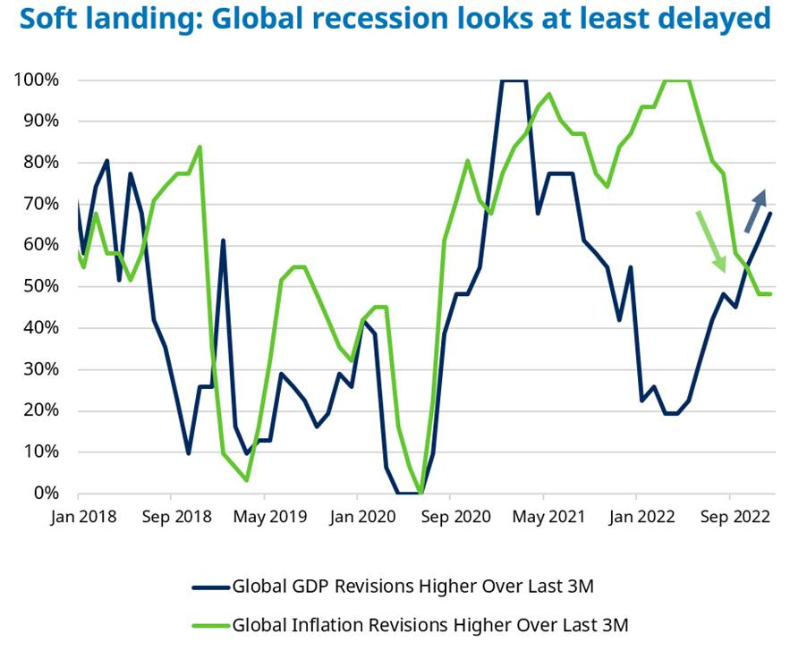
Source: Refinitiv Eikon, Consensus Economics, 14 March 2023.
While inflation estimates appear to have peaked, year-on-year, global inflation has been trending downward and we expect this to continue, especially in the US and Europe, until at least the second half of the year.
All in all, it feels like 2023 should be a more ‘normal’ year in terms of growth and inflation. In this environment, the equity-bond correlation should go back to a negative relationship which means bonds can once again play their diversifying role when combined with equities (Fig. 3).
Fig. 3
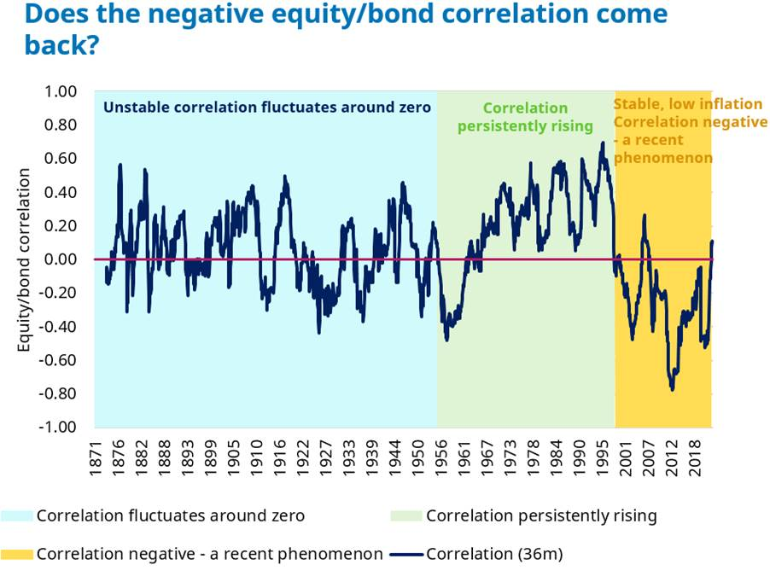
Source: Schroders, Robert Shiller Dataset, data as of 30 December 2022. US Equities refer to S&P 500 and US Government Bonds refer to US 10-year Treasury Bonds.
Looking more closely at the outlook for equities this year, from a fundamental perspective, the picture doesn’t look great, not least because earnings are deteriorating. Earnings growth was very strong in 2022, but that bar is getting harder to surpass. We’re seeing a year-on-year slowdown in earnings, revenue and profit margins, albeit from high levels.
Of course, that doesn’t mean there are no equity opportunities. There is still hidden treasure to be found underneath the surface. For example, valuations in Europe, the UK, China, Japan and emerging markets are attractive compared to history, while the US remains expensive.
Commodities and currencies are often overlooked but we think they could offer good opportunities this year especially for diversification – commodities have nicely performed ahead of equity and bonds last year, whilst EM currencies have also shown greater resilience in last year’s downturn.
Digging deeper into bonds, it’s clear that higher interest rates have attracted yield-hungry global investors, even in South Africa.
But if we’re right about inflation slowing, rates will come down too, boosting the prices of bonds (because there is an inverse relationship between bond yields and prices). We think this is especially going to be the case in emerging markets – emerging market debt is one of our preferred areas of the market at this point in time.
Overall then, we are looking for a more “normal” year where both growth and inflation fall from peak levels. This is an ideal environment for the 60/40 equity and bond portfolio to regain its poise once more, with our outlook suggesting opportunities beneath the surface in both asset classes. The case for commodities and currencies also seems more relevant than ever in adding value to a multi-asset portfolio today.

