Sanlam Corporate and Simeka Consultants and Actuaries weigh in on the Budget Speech

Sanlam

Contributors:
Carien Veenstra – Senior Legal Advisor, Sanlam Corporate
PG Marais – Legal Advisor, Sanlam Corporate
Anita Roodman - Senior Manager: Legal and technical, Simeka Consultants and Actuaries
William Donachie - Legal and Technical Specialist
David Gluckman – Chairman, Sanlam Umbrella Fund
Danie van Zyl – Head of Smoothed Bonus Centre of Excellence, Sanlam Corporate: Investments
Dirk Oosthuizen – Head: Research and Development, Simeka Consultants and Actuaries
- Introduction
Tax revenue collections for 2022/23 are expected to total R1.69 trillion. This exceeds the 2022 Budget estimate by R93.7 billion, and the 2022 Medium-term Budget Policy Statement (‘MTBPS’) estimate by R10.3 billion. Over the medium-term, revenue projections are R6 billion higher than the estimates of the 2022 MTBPS. As a result, there are no major tax proposals in this budget.
The 2023 Budget provides tax relief totalling R13 billion to support the clean energy transition, increase electricity supply and limit the impact of consistently high fuel prices. In addition, the budget provides inflation-related adjustments to the personal income tax tables, the retirement tax tables, transfer duties and excise duties for alcohol and tobacco. R4 billion in relief is provided for households that install solar panels, R5 billion is provided to companies through an expansion of the renewable energy incentive and there is no increase in the fuel levies, resulting in R4 billion in tax foregone.
- Proposals affecting the retirement fund industry
  - Adjustment of retirement tax tables
As part of the periodic reviews of monetary values in tax tables, the brackets for retirement fund lump sum benefits and retirement fund lump sum withdrawal benefits will be adjusted upwards by 10% to compensate for inflation. This means that the tax-free amount that can be withdrawn at retirement increases from R500 000 to R550 000.
The rates shown in tables 4.8 and 4.9 below are effective from 1 March 2023:
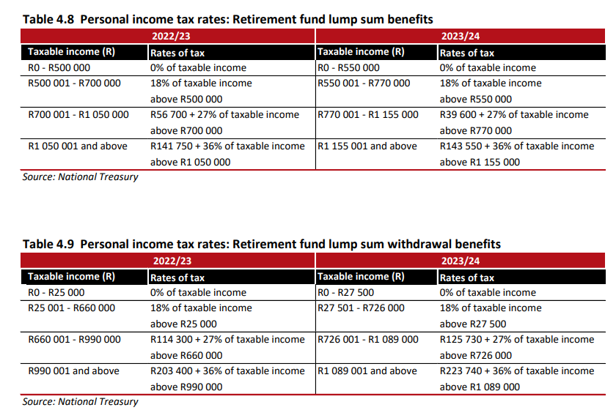
Comment: This adjustment is welcomed, as the last adjustment was made during the 2014 Budget speech. It is important to note that any previous withdrawals will be taken into account for purposes of calculating the tax-free portion of the lump sum withdrawal or retirement benefit (i.e., it is cumulative).
  - Two-pot retirement system
Following extensive public consultation, the first phase of legislative amendments to the retirement system is due to take effect on 1 March 2024. The intent of these amendments is to enable pre-retirement access to a portion of a member’s retirement assets, while preserving the remainder for retirement. Retirement fund contributions will remain deductible up to R350 000 per year or 27.5% of taxable income per year – whichever is lower. Permissible withdrawals from funds accrued before 1 March 2024 will be taxed according to the lump sum tables. Withdrawals from the savings pot before retirement will be taxed at marginal rates. On retirement, any remaining amounts in the savings pot will be taxed according to the retirement lump sum table.
Four areas require additional work: a proposal for seed capital, legislative mechanisms to include defined benefit funds in an equitable manner, legacy retirement annuity funds and withdrawals from the retirement portion if one is retrenched and has no alternative source of income. The first three matters will be clarified in forthcoming draft legislation. The final matter will be reviewed as a second phase of implementation.
Comment: The targeted implementation date of 1 March 2024 will be extremely challenging unless the design of the two-pot system is finalised in the very near future.
  - Third-party data and personal income tax administration reform
The pay-as-you-earn (PAYE) and personal income tax administration reform announced in the 2020 Budget has given pensioners the option to agree to more accurate PAYE withholding rates to take account of multiple sources of income, as well as enabling 2.9 million individual taxpayers to be automatically assessed without the need to file personal income tax returns. The reform will continue over the medium term with a view to reducing the administrative burden for employers, payroll administrators and SARS, as well as individual salaried taxpayers. Work has commenced, in consultation with employers and representative organisations, to provide employer and employee data on a monthly basis in a fully automated fashion. Over time, the need for employer PAYE annual reconciliation is expected to fall away, and the reform will be extended to third-party data providers.
  - Clarifying the amount of employer contribution to a retirement fund to be deductible
Section 11F(4) of the Income Tax Act deems an employer contribution to a retirement fund as a contribution made by the employee, and it is calculated as the amount equal to the cash equivalent of the value of the taxable benefit. However, there is no requirement that the calculated cash equivalent be included in the employee’s income, as is the case in sections 6A and 6B of the Act. This is against the policy rationale of the Act’s provisions. To address this, it is proposed that the Act be amended to require that the cash equivalent of the taxable benefit for employer retirement fund contributions be included in an employee’s income before a tax deduction is allowed.
  - Transfers between retirement funds by members who are 55 years or older
In 2022, changes were made to the Income Tax Act to allow for tax-neutral transfers between retirement funds by members who are 55 years or older in instances where transfers of retirement interests in relation to a member who has reached normal retirement age but has not yet opted to retire. It has come to Government’s attention that there are some instances of active contributing pension and provident fund members who have reached retirement age and been subjected to involuntary transfers to another pension or provident fund may still be subject to tax. To address this, it is proposed that members of pension or provident funds who have reached the normal retirement age as stipulated in the rules of that fund but have not yet opted to retire must, as part of the involuntary transfer, be able to have their retirement interest transferred from a less restrictive to a more restrictive retirement fund without incurring a tax liability. The value of the retirement interest, including any growth thereon, will remain ring-fenced and preserved in the receiving pension or provident fund until the member elects to retire from that fund. This means that these members will not be entitled to the payment of a withdrawal benefit in respect of the amount transferred.
Comment: This is an issue that has been raised by the retirement fund industry for a number of years. Addressing the anomaly in this regard would be welcomed.
  - Auto enrolment
In 2023, National Treasury will finalise policy proposals on how to expand the participation and coverage of all formal and informal workers in a retirement fund without excessively burdening their disposable income. These proposals build on National Treasury’s December 2021 paper entitled Encouraging South African Households to Save More for Retirement. Consideration will be given to a voluntary and flexible savings scheme for informal workers.
  - Governance
Legislative amendments to improve governance of retirement funds – particularly commercial umbrella funds – will be published in 2023 and tabled in Parliament thereafter.
  - Unclaimed assets
In September 2022, building on joint work with National Treasury, the Financial Sector Conduct Authority (FSCA) published a discussion paper on the nearly R90 billion of unclaimed assets across the financial sector. One recommendation it put forward is to establish a fund into which all unclaimed assets must be transferred and managed. Alternatively, unclaimed assets can be transferred into the National Revenue Fund for the same purpose. Further consultation on the FSCA recommendations will take place in 2023. A final paper will be published in 2024.
  - Apportioning the tax-free investment contribution limitation and limiting the retirement funds contributions deduction when an individual ceases to be a tax resident
In 2022, the Income Tax Act was amended to provide that, when an individual ceases to be a South African tax resident, the annual interest exemption applicable to individuals in terms of section 10(1)(i) is apportioned and the capital gains tax annual exclusion applicable to individuals in terms of paragraph 5(1) of the Eighth Schedule to the Act is limited. To ensure there is alignment with the Act’s other provisions for individuals ceasing to be tax residents, it is proposed that further changes be made to section 12T(4)(a) to apportion the tax-free investment contribution limitation and section 11F(2)(a) to apportion the annual limit on the deduction of the retirement fund contributions.
- Other matters of interest
  - Conduct of Financial Institutions Bill
National Treasury has revised the Conduct of Financial Institutions Bill based on feedback from stakeholders. The Bill is expected to be tabled in Parliament in early 2023. It will introduce a new legal framework for the regulation and supervision of the conduct of financial institutions, which will shift away from the institutional form to an activity-based licensing approach.
Comment: The Conduct of Financial Institutions Bill will introduce several amendments to the Pension Funds Act and will have far-reaching implications for retirement funds and retirement fund administrators.
  - Transformation and financial inclusion
The FSCA published its draft transformation strategy for the financial sector in 2022. In the first phase of implementation, the FSCA will engage with industry and other stakeholders on the current legal landscape governing transformation. In the second phase, it will set and supervise specific licensing and regulatory requirements for financial institutions in line with the relevant legislation. The FSCA has committed to
following a proportionate approach that will not unduly burden small businesses. The final strategy will be published by March 2023.
  - Financial education policy
In 2023, National Treasury will publish a consumer financial education policy document for public comment. This policy document addresses consumer protection in the financial sector in the context of financial inclusion and transformation.
  - Tax administration
Aligning tax registration requirements for non-resident employers
It has been noted that non-resident employers may not have representative employers in South Africa for purposes of employees’ tax. They are, as a result, not liable to deduct or withhold tax from the remuneration that is paid to their employees who render services in South Africa. Nevertheless, given that they pay remuneration, they are required to register with SARS as employers. They are liable for skills development levies and unemployment insurance contributions, which many pay. It is proposed that the various provisions be aligned to ensure consistency.
  - Combating financial crimes and illicit activities
Since 2003 South Africa has been a member of the Financial Action Task Force (FATF), which sets global standards to combat money laundering and the financing of terrorism across national borders.
The FATF’s most recent mutual evaluation of South Africa identified a number of deficiencies in its legislative framework and implementation. Government is working to rectify these shortcomings. At its February 2023 plenary, the FATF will pronounce on South Africa’s progress and the extent to which it will face enhanced monitoring, including possible grey listing.
Comment: The efforts to prevent grey listing are bound to lead to a considerable additional administrative and compliance burden being placed on the financial services industry and payroll administrators.
- Personal income tax
  - Income tax brackets
The personal income tax tables are reviewed annually to ensure that inflation does not automatically push personal income taxpayers into higher tax brackets. The 2023/24 tax brackets will be adjusted in line with the expected inflation rate of 4.9%.
As a result, the annual tax-free threshold for a person under the age of 65 will increase from R91 250 to R95 750. Relief mainly benefits middle-income households.
The brackets have been adjusted as follows:
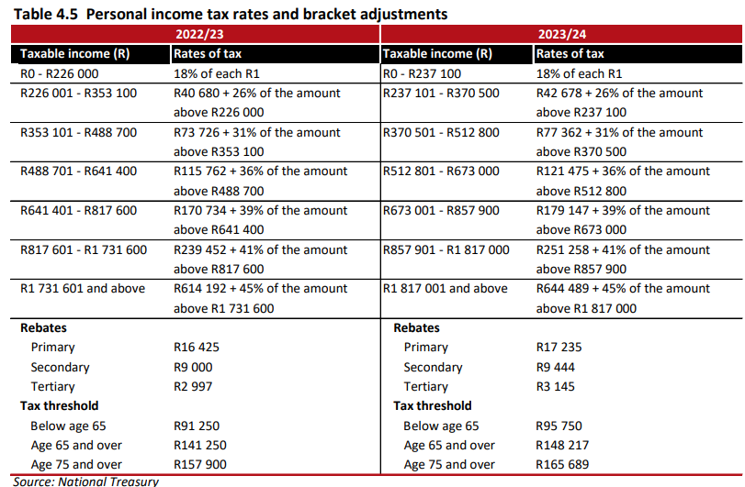
  - Medical tax credits
Medical tax credits will increase from R347 to R364 per month for the first two members, and from R234 to R246 per month for additional members.
  - Social grants
The old age and disability grants increase by R90 on 1 April 2023 and a further R10 on 1 October 2023. The result is a total increase to R2090.
The COVID-19 social relief of distress grant of R350 per month will be extended for a year until 31 March 2024. Government is still considering alternative options to provide appropriate social protection for the working-age population that can replace or complement the current grant.
Social grants will increase in line with inflation, as per the table below:
