Is South Africa investable?

Old Mutual Wealth Investment Strategist, Izak Odendaal

For the last year or so, following regulatory crackdowns, Covid lockdowns, slowing growth and growing strategic competition with the West, many investment commentators have posed the question “Is China investable?” This question can just as easily be asked of South Africa, not only by foreign investors, but by locals too.
Investors are always told to leave their emotions aside when thinking about their money. This is hard at the best of times but particularly difficult when things around you literally seem to be falling apart. How can you invest in a country where there is no reliable electricity, crime and corruption seems to be out of control and dodging potholes has become an essential skill?
Meanwhile, the only growth industry, apart from installing inverters, appears to be commentors warning that we are on the precipice, peering over the edge, at a tipping point – insert your metaphor of choice.
To take the emotion out of it – or at least try to – let’s not think like South Africans, but like New Yorkers. Picture a fund manager on Wall Street. How would they approach this question?
The first consideration for our hypothetical New Yorker has nothing at all to do with South Africa. It is about the global investment landscape, dominated of course by the US and American monetary policy. When US interest rates rise, as they’ve done sharply over the last year, every single asset class on earth has to reprice directly or indirectly. This is because of the singular role of the dollar in global finance, with US interest rates simply begin the cost of borrowing dollars.
This global landscape, which includes growth prospects in the major economies – US, China, Europe, Japan – will determine how much risk our investor is willing to take, and what the split between bonds and equites will be, for instance. It will also influence how much emerging market exposure our New Yorker will take on.
Typically, capital flows to emerging markets (EM) when risk appetite is strong, US rates are low and growth prospects solid. Clearly, the global backdrop of late has been exactly the opposite as interest rates have increased across the developed world, risk aversion has been high and growth has been under pressure, firstly due to Covid (with lockdowns in China only ending recently) and then the war in Ukraine causing energy and food prices to spike.
The combination of these factors has also led to a very strong dollar. When the dollar is strong, it tends to depress economic activity in emerging markets, but it also depresses returns for our friend in New York who must translate local currency returns generated outside America back into dollars. If the dollar gains against the yen, for instance, Japanese returns decline from the point of view of American shareholders. In contrast, a weaker dollar will boost those returns (This is of course the opposite effect that South African investors experience. When the dollar is strong and the rand weak, our global investment returns are boosted).
To the moon
Only now do we get to South Africa. SA asset classes are a small subset of emerging markets (EM) which is a small subset of global markets. Chart one presents a simplified version of this picture. What matters is therefore how EM are placed within the global context, and then how SA is placed in the EM context. Too many local investors start by thinking about South Africa in isolation. This is a bit like the pre-Copernican view of the earth as the centre of the universe. Instead, the earth is a small planet in a solar system dominated by a massive sun. Global markets (US markets to be more accurate) are the sun, EM revolve around it and South Africa is a moon that orbit around planet EM.
To put some numbers to it, South Africa’s weight in the MSCI Emerging Markets Index is now barely 4%, down from 7% largely due to China’s increased importance. In the overall MSCI All Country World Index, our global equity benchmark, SA’s weight is less than 1%. The US is at a sun-like 60%.
Chart 1: Simplified picture of the investment universe
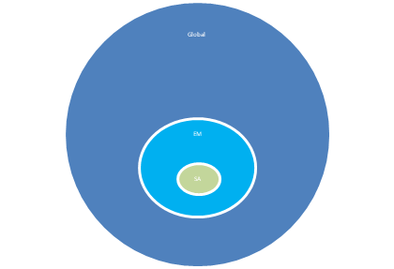
Source: Old Mutual Multi-Managers
Therefore, our Wall Streeter will compare SA with other developing economies, not developed countries. We can compare South Africa with New Zealand, Australia or the UK when it comes to rugby, but when it comes to investing, our peers are the likes of Brazil, Mexico, and Indonesia.

This is where things get interesting. Such a comparison will incorporate several metrics, but the following are particularly important:
- Economic growth outlook
- Rule of law and protection of property rights
- Corruption
- Macroeconomic and financial stability
- Political stability
- Government debt
- Valuation of bonds, equities, and currency.

How does South Africa stack up?
On economic growth we lag the likes of fast-growing India and Indonesia, but our recent experience and outlook is very similar to Brazil and Mexico as chart 2 shows. We are not a fast-growing economy, and have never been, being heavily reliant on mining exports and capital imports. Instead, our growth history has been one of pedestrian expansion interspersed with commodity-linked booms. Recently, infrastructure bottlenecks have become major constraints. Where South Africa’s economy is unique, unfortunately, is in its structurally high levels of unemployment. While the average across developing economies is for around 60% of working age people to employed, it is only 40% in the case of South Africa.
Chart 2: Real economic growth rates of selected emerging markets
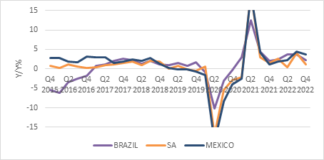
Source: Refinitiv Datastream
Rule of law comparisons published by global think tanks put South Africa towards the higher end of our peer group, but clearly lower than developed countries. Here is a simple thought experiment to gauge rule of law: can a foreigner expect to successfully sue a government in one of its own courts? This is certainly the case in South Africa, but definitely not in China or Russia, and also doubtful in several other developing countries.

Global corruption comparisons suggest the problem is worse in places like Brazil, India, Argentina, though SA itself obviously lags the likes of Australia and Canada. On crime, we are certainly one of the worst in our peer group when looking at murders per capita, for instance, though many countries in Latin America struggle with deeply entrenched cartels.
Chart 2: World Bank Governance indicators for selected emerging markets, 2021
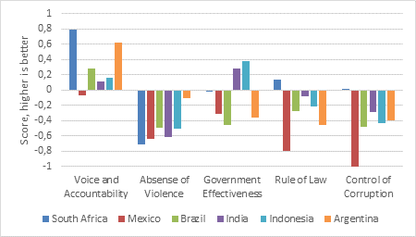
Source: World Bank
On macroeconomic and financial stability, South Africa compares relatively well. South Africa has never experienced hyperinflation, for instance, where as recently as the 1990s many emerging markets struggled with three- or four-digit inflation rates. This is crucial because financial stability means we have large and liquid capital markets and solid banks. These are also well regulated, with a conservative and credible central bank overseeing the financial system and setting interest rates.
South Africa’s recent grey listing does not contradict this picture. Rather, several of our peer countries could well end up on the Financial Action Task Force’s grey list too, as the international community takes a tougher stance on illicit cross-border financial flows. There is a similar concerted worldwide effort to combat tax evasion.
A tell-tale sign of financial instability is when locals do not want to use their local currency at home, fearing that it will rapidly lose value. Instead, they prefer hard currency, particularly US dollars, even for day-to-day activities. While the rand is volatile in global forex markets, and inflation does erode the purchasing power of the rand over time, there is no sign of South Africans preferring to buy groceries in dollars or pounds rather than rands. Yet in a place like Argentina, an otherwise sophisticated economy, dollars are widely used because there is little trust in local financial institutions, the government and the peso as a currency.
South Africa does have a higher government debt-to-GDP ratio than other emerging markets except for India and Brazil. India has the benefit of rapid economic growth which means it can probably sustain higher debt levels. SA doesn’t have that luxury, but it does have the benefit of being able to borrow in the local market in rands, as discussed above. This limits default risk as most debt defaults in developing countries happen when countries borrow in a hard currency that they can only earn through exports. However, since our government borrows at some of the highest interest rates in our peer group, the debt service burden is growing rapidly and spending reductions are needed to stabilise debt levels.
Finally, politics. South Africa is at a notable juncture in its political history, as three-decade long dominance of the ANC fades and it’s unclear what comes next. Coalition governments at municipal level have not inspired confidence. However, political uncertainty is a standard feature of emerging markets and is certainly not unusually high in South Africa where there is a track record of free and fair elections since 1994. While many investors are taking a wait-and-see approach ahead of next year’s election, there is likely to be broad economic policy continuity regardless of the outcome.
Extreme political risk – invasion by a foreign power, a military coup, or the ouster of the government through a mass revolt – is low. Though South Africa experiences regular, sometimes violent protests, the chance of an Arab Spring-type uprising is limited because of the multiple democratic avenues people have for expressing their very real frustrations. Why attempt to overthrow the government, when it can be voted out of office in a free and fair election?
On balance then, within the EM world, South Africa should rank somewhere in the middle, perhaps towards to higher end of the scale.
So why have global investors shunned South African bonds and equities? Again, outflows from South African bond and equity markets should first and foremost be seen in the context of outflows from EM in general. Sometimes having liquid markets counts against us. It is often easier for investors to sell South African assets. But even within EM, investors are underweight South Africa. It is probably the disappointing growth story that is the biggest factor. Global investors will need to see traction on the growth reforms before getting excited about SA again.
It does mean though, that SA assets are cheap even in the EM context. Bonds and equities have derated relative to other EM countries over the past eight or so years.
Global portfolios for South Africans
Where does this leave the seemingly never-ending SA versus offshore debate? Simply put, we should forget the either/or mentality and focus on building global portfolios for South Africans. What does this mean? It means that we should access all the wonderful investment opportunities the wide world offers, including the best of South Africa, but take into consideration local regulations, tax rules and the fact that investors ultimately have to spend their returns in rands.

For instance, local investors will almost always favour local over global cash, since they expect a stable return from it, whereas overseas cash measured in rands can be up 30% in one year but down 20% in another as the currency moves around. The limited yield on global fixed income does not nearly compensate for the currency volatility. Since equities are a long-term asset to begin with, short-term currency volatility is going to play less of a role when looking at returns over the appropriate five-to-10-year periods.
Chart 4: Rolling 12-month US cash returns in rand
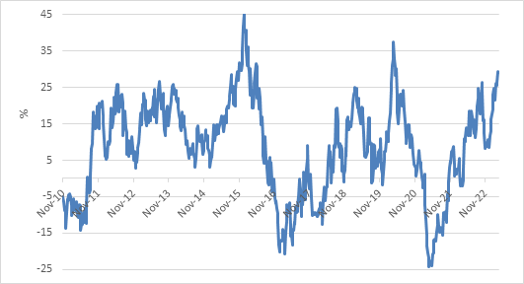
Source: Refinitiv Datastream
Is 45 the new 30?
The recent Regulation 28 changes mean that even retirement funds can have substantial global exposure without forgoing the considerable tax advantages. Most large local institutional investors have not taken up the full 45% global allowance, and it makes sense for now, since that would require selling relatively cheap domestic assets. But over time, the 45% is likely to become the new 30% and the name of the game will be far greater and smarter integration of local and global within asset classes.
In conclusion, South Africa is not uninvestable. It has plenty of problems for sure, but also lots of unmet potential. However, it is and always will be a tiny corner of the investment universe. The challenge for investors is to get the right allocation that balances risk and reward in the context of a globally diversified portfolio and their unique needs.

