The Big Budget Themes
Old Mutual Wealth Investment Strategist Izak Odendaal
Most people think of the Budget as a speech, but it is actually a 280-page document containing eight chapters, six addenda and three explanatory memoranda. In the legal-technical sense, it is also a set of bills tabled for Parliament to approve. It contains a bewildering array of numbers, tables, and charts, denoted in millions, billons and even trillions. There are projections, actuals, ratios, and percentages in spades, some of it in calendar years, and the rest in fiscal years. Eyes glaze over a few pages in and it is easy to get lost, distracted or confused.
So, unless you are a fiscal policy connoisseur, it is useful to step back and focus on four overarching themes.
Get growth going
Firstly, the economy generates the money that government spends on social grants, education, health and so on. The starting point for the Budget is therefore a projection of economic growth, on which assumptions about tax revenue growth can be based. These forecasts must be sensible if the Budget is to have any credibility. Treasury expects real economic growth of 0.9% this year, 1.5% in 2024 and 1.8% in 2025. These are broadly in line with the forecasts of private sector economists.
However, clearly the Budget and government policy more broadly influence economic growth. If government can take steps to boost the economy, it can earn more taxes and service its debts with greater ease. The 2023 Budget puts the fragile state of the economy front and centre, highlighting the devasting toll of loadshedding and a crumbling logistics network, both due to inefficient State-Owned Enterprises.
The emphasis on reforms to raise South Africa’s growth potential permeates the Budget documents, and this is important. Treasury has taken a much more active role in these reforms in recent years through Operation Vulindlela and this is starting to bear fruit. But other government departments continue to let the side down through inadequate implementation. For instance, though the increasing negative economic impact of organised crime was highlighted, and the budget allocation to fighting crime was increased, it is ultimately SAPS that has to catch the crooks.
The biggest and most immediate challenge is loadshedding. Hence the most notable attempt to support economic growth in the short term is the tax breaks for rooftop solar installation, with businesses being able to reduce taxable income by 125% of the cost of solar panels. Financial directors across the country have probably been very busy over the past few days doing the numbers and placing orders. The incentive for households is less generous, being capped at R15,000, but can help persuade a few undecided homeowners. Unfortunately, there was no detail on feed in tariffs that will allow households and firms to sell excess power into the grid.

The debt relief for Eskom was the other headline-grabbing announcement and was widely expected, though it was eventually somewhat overshadowed by CEO Andre de Ruyter’s dramatic exit. In a nutshell, government will take over Eskom’s interest and capital repayment commitments over the next three years to the tune of R186 billion, and thereafter absorb R70 billion of Eskom’s debt directly. This will substantially improve the beleaguered utility’s cash flow position and allow it to invest in its transmission and distribution network. The lack of grid capacity currently limits the roll-out of renewable power plants in the solar and wind-rich Northern and Eastern Cape.
The debt relief only helps Eskom’s financial situation. There is still a long way to go in fixing the operational and governance side of things. While Treasury has attached strict conditions to the Eskom support, there is the risk that it becomes yet another cook in a crowded kitchen now that a minister for electricity is also set to be appointed.
Fiscal consolidation commitment remains
Secondly, the commitment to fiscal consolidation remains. Treasury understands that government borrowing was getting out of hand, and that associated interest payments are squeezing out other important spending areas. By next year, almost 20 cents of each tax rand will go towards interest payments. And since all this borrowing undermines government’s creditworthiness, it pays a higher rate of interest compared to peers. This, in turn, means the debt burden is compounding faster than the ability to service the debt, which further lowers government’s creditworthiness. A vicious cycle if ever there was one.
Chart 1: Decomposing the Budget Deficit
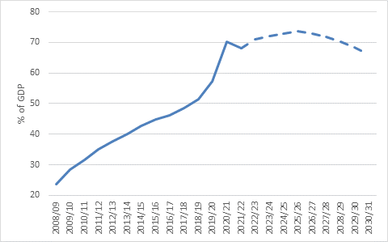
Source: National Treasury
The first step to putting government finances on a sounder footing is to reduce the amount of current borrowing. A different way of saying this is that the budget deficit, the difference between tax revenues and spending, must be closed. This implies that taxes must go up or spending down, or some combination of the two. Narrowing the deficit requires tough choices and is never politically popular. And yet, a year before a crucial election, this is exactly what Treasury is doing. Rather than vote-grabbing giveaways, we get sombre discipline.
The government will run a primary surplus this year, meaning that non-interest spending will be below revenues for the first time since 2008. The surplus is projected to rise over the medium term such that the overall deficit is made up entirely of interest payments. This will allow for the debt-to-GDP ratio to peak at 73.6% in the 2025/26 fiscal year.
Chart 2: Government Gross Debt-to-GDP ratio
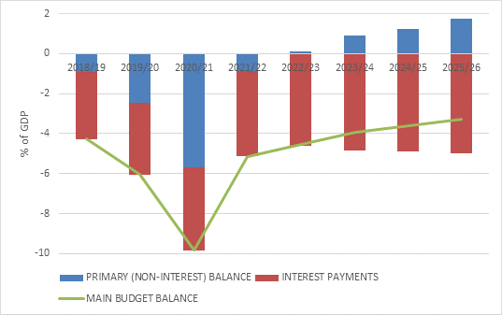
Source: National Treasury
Several commentators have already questioned whether the projected numbers can be achieved, especially since bruising public sector wage negotiations still lie ahead. However, the exact details are less important than the intent and direction of travel.
The wage settlement is very likely to be higher than Treasury expects, but it has already made great strides in reducing the overall growth in the wage bill compared to pre-2019 trends and is likely to accommodate it without deviating too much from the current fiscal framework, for instance by reducing headcount. The same is true for other forms of spending. In other words, despite a looming election, government is committed to getting its debt under control, accepting short-term pain for long-term gain. This should be comforting for investors.
Keeping the Golden Goose alive
The third overarching, though implicit, theme is that Treasury is mindful of not taxing the economy, particularly the middle class, to death.
There have been strong calls for the implementation of a basic income grant, and while it would be life-changing for recipients, there is no money to fund it. Taxpayers would have to be squeezed more, to the point where it becomes unproductive. Skilled workers are in demand globally and can leave. Wealthy investors can already move their money overseas. A million people, mostly domestic workers, are employed directly by households and could see their jobs put at risk. In all likelihood, then, instead of the basic income grant, we are likely to see a continuation of the R350 per month Covid SDR grant that is currently set to expire next year. This would have to be funded partly from the contingency reserve.
So, despite the many competing spending priorities, no new tax increases were tabled apart from the usual sin tax increases on tobacco products and alcoholic beverages. Rather, the focus at SARS has been rebuilding internal capacity to increase compliance with existing taxes, and this seems to be working well.
It is also important to remember that the sin taxes are not percentage-based taxes. If the price of a pair of shoes rises, the VAT payable rises automatically since it is 15% of the purchase price. Excise duties, the fuel levy and the RAF levy are nominal amounts and are increased manually every year to keep pace with inflation.
In a period of high inflation, the easiest thing for Treasury to do would be to let inflation push people into higher tax brackets, thereby quietly creaming off a few extra rands. Instead, the Treasury will raise the tax brackets by 4.9% and thereby forego R15 billion rand in personal tax revenue. This is the largest amount of ‘fiscal drag’ relief since 1998.
From an investment point of view, taxes can have a meaningful impact on returns. Investors will therefore welcome the absence of any changes to dividend and capital gains tax rates, as well as the higher exemption for interest income.
Overall, tax revenue as a share of GDP is set to remain around 28% over the medium term, which puts us on the high side compared to other developing economies, but low compared to most rich nations.
The how
The fourth overarching theme is one that doesn’t nearly get enough attention, and that is the prudent way in which Treasury manages debt. Yes, there is too much debt, but how the debt is structured matters, as is the way that borrowers engage with lenders.

Treasury has always kept foreign currency borrowing low, and it will continue to be around 10% of the total. While it might be able to get lower interest rates abroad, it would have to take on the associated exchange rate risk. If the rand weakens, which it often does, foreign debt becomes more costly to service. Borrowing in foreign currency is the Achilles’ heel of so many developing economies. When exchange rates move or when hard currency becomes scarce, a debt crisis can very quickly ensue – we are currently witnessing it again in Ghana. This risk is low in South Africa’s case, since debt is largely raised in the local market in local currency.
Treasury also tries to spread the debt out across different maturities, so that it doesn’t face the problem of a large portion of debt maturing at once, a moment that might coincide with market stress where lenders demand much higher rates for rolling over the maturing bonds.
Wisely, Treasury also didn’t assume that the commodity price windfall of the past two years will persist and just as well, since these prices are now normalising following the disruptions of the pandemic and then the war in Ukraine.
Chart 3: US$ Price index of South Africa’s main commodity exports
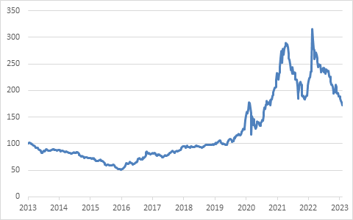
Source: Refinitiv Datastream
The transparency of the budget process is also crucial. There are many risks to the projections as discussed above, but they are known risks since the Budget provides so much detail. And the whole exercise is repeated in October when the mini-Budget (MTBPS) updates the numbers based on the latest available information. In between, Treasury publishes monthly data on government revenue and spending so investors know exactly what is going on.

Infamously, the Eurozone debt crisis was sparked in 2010 when the new Greek Prime Minister revealed that his predecessors had concealed vast amounts of debt, and that the budget deficit would in fact be more than double than previously thought. Markets were understandably spooked. In contrast, ours is a known set of problems.
The orderly South African budgeting process also stands in contrast to the potential chaos of a failure to lift the US debt ceiling. Congress authorises spending but approves the associated borrowing separately and now refuses to do so. It is a shambolic way of running the finances of the world’s richest and most powerful nations, with potential reverberations across global markets.
What are the investment implications?
The asset class most impacted by the Budget is bonds, since it is the bond market that must fund government’s borrowing, and by implication it is the bond market that the government must keep happy.
South African bonds de-rated meaningfully from its peer group during the Zuma years, and unfortunately, rebuilding credibility takes much longer than losing it. The market will need to see meaningful progress on economic reforms, faster growth, and evidence that government is sticking to its fiscal consolidation promise before getting excited. The same is true of the ratings agencies. All this takes place in a challenging global environment where bond yields have not yet stabilised as central banks continue to hike rates. While global growth is expected to be better this year than was previously thought, it will still be slower than last year.
Nonetheless, the 2023 Budget should put a floor under the bond market’s rating and is another important step towards winning back the market’s trust. South African bonds should continue to deliver decent real returns, not because the prices are going to rally meaningfully, but rather because the yield is well above inflation, with inflation itself likely to be reasonably well behaved over the medium term.

