March Madness

Izak Odendaal, Investment Strategist at Old Mutual Wealth

Fifteen years ago, in March 2008, a storied name in US banking failed. The government-backed sale of Bear Sterns to rival JP Morgan was seen at the time as putting a floor under the growing credit crunch and markets rallied. As we now know, the orderly unwinding of Bear Sterns would be followed six months later by the chaotic collapse of Lehman Brothers and a scary new phase of the Global Financial Crisis.

The scars of this crisis largely informed how bank executives, investors and regulators have thought about things in subsequent years, right up to the recent wobbles. With that comes a tendency to fight the last war, comparing the current crisis with the past one. The good news is that current stress in the banking system is nothing at all like in 2008. But that doesn’t mean the current episode can’t end up causing damage. So, we need to ask ourselves four key questions, acknowledging that the situation is uncertain and fluid: To what extent are we dealing with a few bad apples versus a systemic problem? What is the likely spill-over to the broader financial system and economy? What does it mean for policy? And how can it affect the South African financial sector specifically?

Reckless safety
Firstly, banking crises are usually caused when the chickens of reckless lending come home to roost. Typically, though not always, there is a property boom, and banks overextend themselves lending to overextended households chasing house prices higher. When the music stops, there is trouble all around. This time, lending has been subdued and American household finances have generally been in good shape. Rather, Silicon Valley Bank and others got into trouble by putting too much money into safe, boring government bonds.

US bank deposits surged from $13 trillion to $18 trillion in 2020 and 2021 (they’ve declined somewhat since, as money market funds offer better yields). Banks needed to do something with all this cash, and with limited demand for loans, increased holdings of government securities that offered higher yields.

The problem is that those securities fell sharply as the Federal Reserve hiked interest rates. The same is true in other jurisdictions. This means that hundreds of billions of dollars in unrealised losses sit on balance sheets across the US banking sector. They don’t have to account for losses, however, if those bonds are held to maturity. But if a bank is a forced seller of those bonds to meet customer withdrawals, it must crystalise those losses and raise fresh capital. Across the banking system, customers have been withdrawing funds in favour of higher yielding options (deposit rates have not increased as much as Fed policy rates).

Chart 1: Unrealised losses and gains in US banks
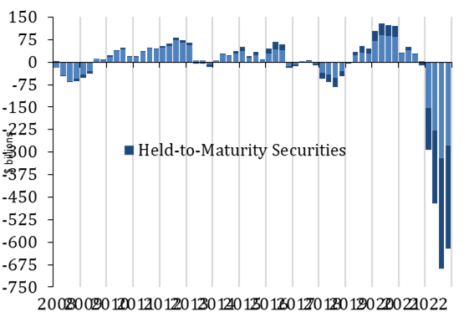
Source: Federal Deposit Insurance Corporation

This is where some banks are much more vulnerable than others. Silicon Valley Bank (SVB) had particularly high holdings of long-dated fixed-rate bonds and did not hedge the interest rate risk. The unrealised losses on those bonds when rates shot up was enough to potentially wipe out capital. It was the one bank that could not afford depositors asking for their money back. Unfortunately, it had a very concentrated depositor base in the tech sector, with many of its clients belonging to the same social and business networks, backed by the same handful of venture capital firms. US bank deposits are insured up to $250,000, but 97% of SVB deposits were above this threshold, meaning depositors were potentially skittish.

What ensued was a classic bank run. The more depositors feared they might lose money and then withdraw funds, the closer they push the bank towards failure in a self-fulfilling prophecy.

Now banks are inherently fragile. The business model is absorbing liquidity and maturity mismatches and making a profit from them. The trick is to manage those risks carefully, which SVB did not do well. Being a smaller bank (but not small, being the 16th largest in the US), it was also subject to less regulatory oversight than the megabanks like Citigroup and JPMorgan. This leniency to smaller banks is very likely to change.

The problem with bank runs is that they are rarely contained to a single bank. US authorities therefore stepped in quickly and forcefully, promising to guarantee all depositors, not just those insured by the FDIC. The Federal Reserve also set up a facility where banks can borrow against their bond holdings at face value, not the depressed market values. It might reasonably be asked why governments are so quick to prop up banks, but would happily let industrial or retail companies fail. The reason is that while banks are profit-making institutions, they also perform a vital social function of providing credit, guarding savings and facilitating transactions. The aim of authorities is to protect depositors and sustain responsible credit relationships, meaning that shareholders and some bondholders are usually wiped out in a bank rescue. But authorities will usually make the distinction between a bank with a liquidity problem (not enough cash on hand to meet requirements) and one that is fundamentally insolvent. Propping up the latter is throwing good money after bad.

Bank fears go global
The actions of US authorities should have been enough to prevent contagion and financial market turbulence, at least in the US. However, in situations like these, the market has a habit of sniffing out weakness elsewhere. European bank shares also came under huge selling pressure, notably Credit Suisse, long the problem child among global banks with a string of scandals and bad decisions long predating the current panic. As in America, Swiss authorities stepped in to support Credit Suisse. However, this was not enough to calm markets and by the weekend, they engineered a sale to rival UBS, bringing an end to the 167-year-old bank’s existence as a standalone entity. This prevents a disorderly collapse, but since big losses have been imposed on shareholders and some bondholders, investors in other banks still appear nervous.

Chart 2: Datastream bank share price indices, locals
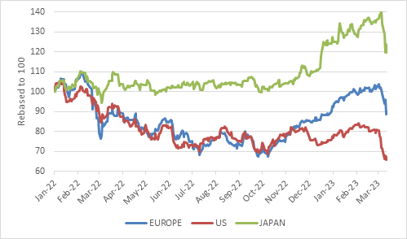
Refinitiv Datastream

Still fighting inflation
The underlying problem, of course, is that all of this is happening against the backdrop of still-high inflation in the US, Europe and elsewhere. Higher rates caused the SVB failure, but rates will probably have to increase further. US consumer price inflation was 6% in February, and 5.5% excluding food and fuel. This is lower than previous months, but not low. The labour market also remains unbalanced, with demand for workers far outstripping supply. This is putting upward pressure on wages and, eventually, inflation.

The Fed and its peer central banks are therefore in the unenvious position of having to fight fires on two fronts, banking sector stress and inflation. They have the tools to both, but the messaging is very tricky.

Whereas some commentators argued that the Fed should be cutting, and money markets quickly discounted an end to Fed hikes, the central bank is still likely to raise rates this week and beyond. The European Central Bank is similarly also still in hiking mode. It hiked rates by 50 basis points last week, despite the turmoil in financial markets.

Chart 3: Policy interest rates, %
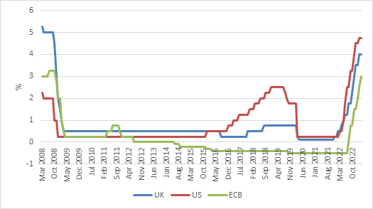
Source: Refinitiv Datastream

As for the broader economy, banking crises tend to cause long-term damage, hence the urgency of preventing them. Indeed, banking crises often cause “lost decades”. However, this is usually because of the ballooning debt that preceded the crisis. After the crisis, banks, businesses and households alike sit with impaired balance sheets that take years to repair. The current episode was not associated with rapid growth in borrowing, but rather a rapid increase in deposits that speaks to underlying health in the private sector.

Nonetheless, banks are likely to become more conservative in lending practices in the near term, thereby weighing on business activity. This is true in the US and Europe, and possibly beyond. This will do some of the central banks’ inflation fighting work for them, potentially limiting the extent of further rate increases.

Back home
South Africa has had its share of bank failures, most notably the small bank crisis of 2002 (when household names such as Saambou and Board of Executors disappeared) and more recently, the 2014 collapse of African Bank (which specialised in unsecured lending to low-income households).

However, today local banks are tightly regulated and well capitalised under the watchful eye of the Reserve Bank. There certainly has been no boom in lending given the depressed local economy and the big banks have all reported solid results.

Interest rates increased modestly in South Africa compared to developed countries and local banks have long operated in a higher interest rate environment. In fact, over three years, the SA All Bond Index has delivered an annualised return of 9% in rand, compared to a -4% return in dollars on the FTSE US Government Bond Index. The dollar return on the All Bond is also positive, but of course it is the local currency return that matters for banks’ accounting purposes. The 10-year plus maturity index of US government bonds has lost 9% per year over the past three years.

Chart 4: Three-year rolling bond returns, local currency
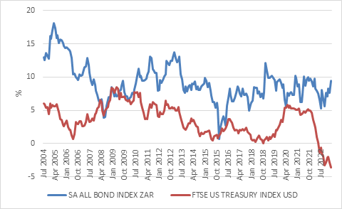
Source: Refinitiv Datastream

But while South African banks are not directly vulnerable to the kinds of stress experienced elsewhere (there are plenty of homegrown headaches), local markets do not escape global sell offs. The JSE fell in sympathy with global equities last week, and the flight to safety that boosted global bonds also benefited local bonds. If global markets regain composure, local shares are likely to follow suit.

When rates rise rapidly
The final point is that when interest rates jump far and fast, things break. Unexpected skeletons start tumbling out. This is particularly the case when rates rise off extremely low levels. There have already been a few examples, including the UK pension fund hedging blow-up last year.

A long period of low interest rates can convince people to take risks they would not do otherwise, especially if they think rates will remain low. We don’t know from which closet the next skeleton will fall. A good place to start looking is those areas of the market that experienced rapid growth as SVB did, as well as the venture capital funds that channelled deposits into it. Nonetheless, one advantage of the recent turmoil is that complacency is being wrung out of the system, though it is clearly a painful process. What emerges is hopefully stronger and more resilient (and better regulated). It is not the end of capitalism as some have suggested.

Risk is being reassessed as lessons are learned. For example, ratings agency Fitch cut the rating of First Republic Bank, another regional US lender, from A- to BB (junk status) because its deposit concentration is “now viewed as a ratings weakness”. Several of the largest US banks together placed $30 billion at First Republic to stabilise its depositor base, reminiscent of the 1998 collective bail-out of Long Term Capital Management.

The other benefit of higher rates is simply that there are now attractive opportunities in global fixed income for the first time in 15 years (the last time rates were this high, Bear Sterns was still a going concern).

Given the tremendous uncertainty and fluidity of the current situation, it is dangerous to make definitive statements about what will or won’t happen. We know from history that banking crises, if left to run, can cause great anxiety on markets and do real damage to economic activity. But authorities have learned hard lessons from this history and don’t seem likely to let this happen. The second important lesson from history is that markets do go through these periods of turmoil and extremely negative sentiment where fundamentals get thrown out the window in the scramble for safety. These are difficult times to stomach for all concerned, but also create opportunities to buy bargains or just rebalance. It is always useful to have liquid assets around to be able to do so. When others are forced sellers, don’t join if you don’t have to.

