More banks and central banks

Old Mutual Wealth Investment Strategist, Izak Odendaal

It is May, but it feels a bit like March again. US banks are teetering, the Federal Reserve and European Central Bank (ECB) are hiking interest rates, and South Africa is still experiencing loadshedding. The last point should surprise no one, but the first is unsettling.
First Republic Bank never fully recovered from the March banking panic and was seized by US authorities and sold to JPMorgan recently. That made it the third US bank to fail this year, and like the other two, a household name for all the wrong reasons. Like the other two – SVB and Signature – it suffered big losses on its holdings of government bonds as interest rates rose. This would not normally be a train smash if customers did not withdraw deposits en masse. Unfortunately, that is exactly what happened. A combination of higher yields on offer in money market funds and elsewhere and jitters over the safety of banks meant rapid deposit loss. Regulators and bankers are also belatedly discovering that technology is changing the dynamic of the classic bank run. Customers do not physically have to run to the bank. They can do it very quickly electronically. Moreover, rumours of bad bank health can spread much quicker on social media than on the street.
Unfortunately, First Republic’s sale did not reassure investors. Other regional banks have also seen share prices crash, notably PacWest and Western Alliance, even though they do not seem to have faced the same kind of deposit flight. Unlike for other businesses, when a bank’s share price slumps, it almost invariably leads to a sale or closure as it becomes near impossible to raise capital. Even if a bank is not necessarily in financial trouble, a loss of confidence is a death knell. Therefore, when it comes to bank closures, it is unlikely the First Republic will be the last.
Again, there are three important questions to ask: what does this mean for the broader health of the financial system? What is the impact on the real economy? And what is the impact on monetary policy?
Chart 1: US large and smaller bank shares
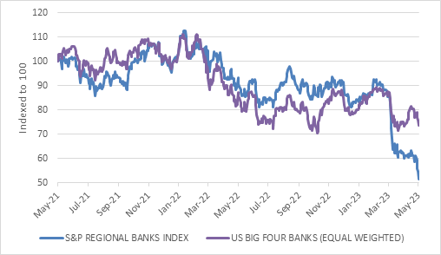
Source: Refinitiv Datastream
Big is beautiful
The good news is that the big banks are still fine and recently reported first quarter earnings to the market showing no reason for concern. They will probably gain customers through this turmoil, and the opportunity to buy smaller competitors on the cheap. For smaller banks, the turmoil could continue until there is a clear and decisive intervention from US authorities, probably including a temporary insurance for all deposits. The folks from Washington, in turn, are by now probably thoroughly fed-up with cleaning up after banks and are likely to tighten regulations and oversight considerably.
This leads us to the second question. Smaller banks are likely to substantially constrain lending activity given that many will go into survival mode. There is already some evidence of this. They will have to pay more to keep deposits - a key source of funding - and being very careful about who they lend money too. This is likely to be a headwind for economic activity even under a best-case scenario. A worst-case scenario of a rolling series of bank failures that shakes confidence even in the giant banks, would lead to a deep recession (though still not as bad as 2008 since banks were stuffed to the gills with bad loans, which is not the case today).
The main concern is the commercial property sector, where these smaller banks have been particularly active and where firms might struggle to roll maturing loans. But any firm that relies on a revolving credit line or needs to roll a loan to fund ongoing activities could find itself suddenly short of funds.
Tricky time
This makes it a tricky time for central banks. On the one hand, ensuring the stability of the financial system is the responsibility of central banks, and indeed the Fed was set up for this purpose primarily. It will therefore continue to play the lender-of-last resort role to banks who suffer from poor liquidity rather than insolvency.
On the other hand, inflation remains too high, and the Fed and other central banks are still raising interest rates. Last week, the Fed and the European Central Bank (ECB) both raised rates by 25 basis points.
However, the Fed’s hike could be the last in the current cycle while the ECB in the words of its President Christine Lagarde still has “more ground to cover”. This is because the Fed started earlier and hiked 11 times (5% in total) while the ECB has only increased rates at seven policy meetings since 2022 (3.75% in total). But it is also because the banking stress is much more severe in America. If banks decide to lend less, the outcome is basically the same as higher interest rates: credit slows.
Not that banks in Europe are lending freely. Loan growth is slowing, and the ECB’s survey of banks shows a reduced risk appetite and tightening of credit standards. The Fed’s own survey is only released this week but is likely to show the same.
Chart 2: Policy interest rates US, Europe and South Africa
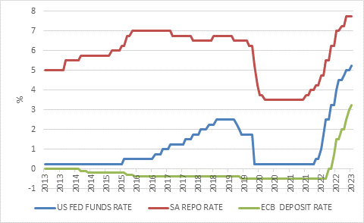
Source: Refinitiv Datastream
The Fed has an additional reason to pause and assess things. The debt ceiling debacle remains unresolved, and indications are that the US federal government will run out of money (completely artificially of course) some time in June. This means a shutdown of many government activities, and even a temporary default on some bonds.
A pause is not the same thing as a pivot, however. Fed officials remain adamant that they will keep rates at current levels until they have comfort that inflation is heading back down to the 2% target and staying there over the longer term.
There has been progress on this score, but as in Europe, not nearly enough. Core inflation, excluding volatile food and fuel prices, was 4.6% in March (according to the Fed’s preferred measure, the personal consumption expenditure deflator) and 5.6% in the eurozone.
And as in Europe, labour markets remain tight. Indeed, it is remarkable that in both economies, unemployment is lower today than when rate hikes started. In the US, it is at a 50-year low of 3.4%, and in the eurozone, a record low 6.5%. Employment growth continues at a fairly rapid clip, and wages are rising. This means consumers have the spending power that can continue to put upward pressure on prices of consumer goods and services. In addition, households in rich countries have additional firepower from savings built up during the pandemic years. In the US, this amount of excess savings is probably north of $1 trillion.
Chart 3: Unemployment in the US and Eurozone
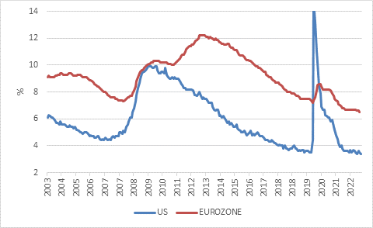
Source: Refinitiv Datastream
Demand-pull
Put differently, the supply-driven phase of the global inflation surge is mostly in the past. Energy prices are back to levels seen before the Russian invasion, and the supply-chain and logistical bottlenecks that caused goods prices to spike have mostly faded. What the developed countries are dealing with is demand-pull inflation. Hence the need to have interest rates in restrictive territory in order to cool demand and ultimately put downward pressure on inflation. Or to put it more bluntly, some people need to lose their jobs and others need to see incomes decline so that there is less spending power in the economy and prices increase at a much more sedate pace. Since a lot of economic activity is funded by banks, a contraction in bank lending can have a similar effect.
Locally
In South Africa, inflation is by and large a supply problem and not one of excess demand. Food and fuel prices are basically set in global markets, and to the extent that loadshedding is adding to consumer prices, it is also a supply problem.
Demand is not irrelevant. When consumers have spending power, it is easier for manufacturers retailers to pass on the cost of running generators. If consumers are penny-pinching, businesses must absorb most of the cost in their margins. The Reserve Bank recently estimated that loadshedding adds 0.5% to the inflation rate, assuming that firms pass on 90% of the cost of running generators. This might be a strong assumption.
Still, inflation has been higher than expected and the Reserve Bank does not like such surprises. Consumer inflation came in at 7.1% in March. As elsewhere, it is worried that consumers and firms will develop an inflationary psychology that becomes self-fulfilling. That is why central bankers always talk about the need to keep “inflation expectations” in check.
It means that the rate cycle is not necessarily done, with another increase later this month possible. However, we are certainly much closer to the end of the cycle than the beginning. As always, global conditions will matter greatly. It helps that the rand oil price fell to its lowest level since January 2022 in recent days.
Finally, it is important to repeat the often-made point that domestic banks do not face the same kinds of problems as in the US. Our banking system is concentrated and therefore tightly regulated, unlike the fragmented US system with thousands of banks and several overlapping (or not) regulators. Though our banks have increased holdings of government bonds in recent years due to attractive yields, those bonds have not lost value. Bond returns are positive over all rolling three-year periods since 2000. So that is not a concern. The bigger concern is that bad loans would rise in this tough economic climate, but banks generally make prudent provisions for that. Importantly, a spike in bad loans usually follows a period of robust lending that we haven’t had. In banking, it is the good times that normally lead to the bad times. Of course, that is why the current US banking panic is unusual. The banks got in trouble firstly for purchases of safe government bonds, not reckless lending to small businesses or individuals, and also for not paying competitive deposit rates.

Not trash
What are the portfolio implications? Firstly, things are fluid and uncertain. Sentiment often dominates fundamentals in such an environment. Remember that the biggest advantage the individual investor has over large institutions is that you decide your investment horizon. You can decide not to respond to market volatility because you don’t have clients pulling funds. You are the client! Secondly, the fundamentals are not getting better, unfortunately. Interest rates have shot up in almost all economies of note (Japan and China are the exceptions) and if history is any guide, this will cause a slowdown in economic growth. As growth slows, sentiment could worsen though the market is already pricing in a slowdown. We just don’t know if it is pricing the full extent of what will materialise. However, if markets decline, it will present a buying opportunity. When rates eventually start falling, equity markets usually do well, and the market tends to bottom before the recession ends. Finally, the good thing about high interest rates is that they can be earned as well as paid. The opportunity cost of being defensive has declined, and income options for conservative investors with shorter-term cash flow needs have increased. Over the long term, cash is never the winner. But for the time being, cash is not necessarily trash.

