Of Interest

Old Mutual Wealth Investment Strategist, Izak Odendaal

How much will higher interest rates hurt? Higher rates usually impact economic activity with a lag, so it is probably too soon to tell. In the developed economies where rates have increased dramatically from ultra-low levels, the answer so far is not much. We have seen banking turmoil, or at least in some parts of the banking sector, but little impact on employment or consumer spending. At any rate, the banking panic seems to have eased, thankfully, and casualties have been limited. At least, the acute phase appears to be over, though we might still enter a chronic phase of uncertain timing, breadth, and severity as banks cut back lending, which in turn causes some borrowers to default, inflicting losses on the banks. Consumers and corporates are also still switching deposits from smaller to larger banks and money market funds.

Big questions remain on what the ultimate impact of the rate hikes to date will be on economic growth, inflation and ultimately, financial markets. Today we’ll focus on South Africa.

Take a hike
The Reserve Bank’s Monetary Policy Committee (MPC) increased the repo rate by 50 basis points to 7.75%. This was more than expected, supported by three members against two who preferred 25 basis points. The MPC is concerned over the upside risks to inflation and downside risks to the rand. It is also particularly worried that consumer, worker and company expectations of future inflation could rise further, becoming self-fulfilling and feeding into sustained inflation above the 4.5% mid-point of the target range.

The Bank expects inflation to average 6% this year, 4.9% next year and 4.5% in 2025. Consumer inflation rose to 7% year-on-year in February, with elevated food inflation largely to blame. However, there was also a jump in core inflation, excluding food, fuel and energy prices. It rose to 5.2% year-on-year. Headline inflation should subside during the year, helped along by an 8% decline in the rand oil price in March.

The MPC hiked despite a bleak economic growth forecast. While central banks in the developed world ploughed ahead despite financial stability risks, the Reserve Bank went ahead despite the possibility of economic stagnation. Real economic growth of only 0.2% expected this year, with 1% forecast for next year and 1.1% in 2025.

Chart 1: The repo rate, %
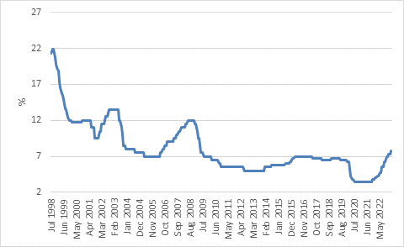
Source: SA Reserve Bank

Rampaging repo rate
The repo rate is now the highest it’s been since July 2009. Back then the MPC was cutting rates from a peak of 12% in response to the global recession. The previous peak was 13.5% in 2003, and before that 21.5% in 1998. Assuming we are at the peak in the current cycle – though the MPC gave no such signal – interest rate cycles have clearly become much milder in South Africa over the past two decades. The Reserve Bank would attribute this to the success of inflation targeting (introduced in 2000). It probably played a role, but so did an increase in global integration, lower global goods prices and greater competition domestically. Despite how much people complain about government economic policies today, it is easy to forget how tightly the economy was regulated before the 1990s, with high tariff barriers limiting global competition and strict rules about who could do what and when domestically plus price controls. For instance, until 1988, there were restrictions on what could be transported by road instead of by rail (today the pendulum has swung too far the other way, and too little is moved by rail). Similarly, agricultural food prices were controlled (on a cost-plus basis protecting margins), and production subsidised and managed by agricultural marketing boards until the early 1990s. This process of deregulation continues to this day. For instance, supermarkets can sell wine, even on Sundays now, but not beer. The Competition Act was passed in 1998 to foster greater competition between firms and penalise anti-competitive behaviour.

Having milder interest rate cycles creates more certainty for borrowers and allows them to make better long-term decisions. The risk of an interest rate shock – a massive jump in borrowing costs that renders an affordable loan suddenly unaffordable – is much less likely. Although South Africa has a deep and liquid bond market, it is dominated by the government and a few large corporates. Most private borrowing is done through banks, with a large portion of variable rate loans. Most mortgage rates, for instance, follow the Reserve Bank’s repo rate adjustments.

In contrast, in the US, most mortgage rates are fixed for the duration of the loan. This partly explains why the rapid rate increases in the US have not had much of an impact on consumer finances. Homeowners who took out a mortgage before 2022 have locked in low rates for the duration of the loan. The problem now sits with the banks, who made those long-term loans at low rates but who increasingly must pay depositors and other funders much higher rates.

Borrow low, lend high
For South African banks, the basic economics have not changed, and Governor Kganyago reiterated that there is no sign of stress in the domestic banking system. Despite repo rate hikes, the yield curve still slopes upward, which is a jargony way of saying that longer-term rates are higher than shorter-term rates. If a bank funds itself (including deposits) at a rate close to the repo rate and makes longer-term loans near the prime rate or higher-yielding longer-maturity government bond rates, there is still a decent spread to be earned.

The problem is that in the tough economic environment, the demand for long-term loans like mortgages has not been all that strong, while banks have also generally been on the conservative side in approving loans. Mortgage advances grew by 7% in February from a year ago, in line with inflation. In real terms, there has been very little growth in mortgage lending over the past decade. Indeed, adjusted for inflation, the total outstanding amount of mortgage debt is 10% below 2008 levels.

Lending unto Caesar
Notably, banks can now make almost as much lending to the government instead of households or businesses. If we assume a typical mortgage rate to be prime plus 0.5% over 20 years, that currently equates to 11.75%. A 20-year South African government bond yield is not far off at 11.5%.

Now this is not an entirely fair comparison since mortgage rates are variable while government bonds are mostly fixed, and mortgages are secured (banks can repossess a property at some cost).

But it illustrates the incredible situation that a typical household can be considered about as creditworthy as the South African government, despite all the resources at its disposal, including the powers of coercion and ability to create currency. But that is the price the South African government is paying for its squandered fiscal credibility.

The market demands a massive premium, over and above what it needs to compensate for interest rate and inflation risk in lending to the government plus some currency risk to attract foreign buyers. Until such time as there is genuine progress in putting state finances on a sound footing, this premium is likely to remain.

From the point of view of banks, it is a very profitable trade. Lending money to the government also carries a low risk-weighting in terms of capital rules and no surprises that government securities have doubled as a share of bank assets over the past decade to 7%.

For the broader economy, it is not necessarily an optimal state of affairs if banks are lending more to the government instead of the private sector. But then again, the demand for credit from the private sector has not always been there.

Doom loops
It also raises the spectre of a “doom loop” where a government default can decimate the banking system, while bank fragility can undermine the government’s ability to borrow. This was a big fear during the Eurozone fiscal crisis of 2010 to 2012, particularly in Italy where the government debt to GDP ratio was 130% (now 150%) and 10% of this debt sat on domestic banks’ balance sheets, exposed to big losses, including last year. South Africa is not in such extreme territory, but it is something to keep an eye on. This is one of the reasons why the credit ratings of banks always follow changes to the government’s rating. Even though our big banks are solid, well-run, and very profitable entities, they too carry “junk status” credit ratings. Importantly, South Africa’s bond returns have mostly been positive over the past decade apart from two big but brief drawdowns in 2015 (Nenegate) and 2020 (Covid).

Chart 2: SA and Italian rolling 3-year bond index returns %
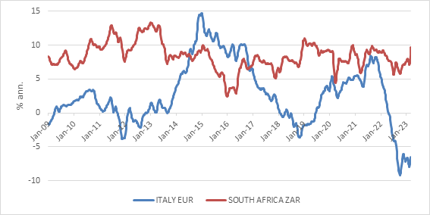
Source: Refinitiv Datastream

Nonetheless, the bigger interest rate risk to the local economy therefore does not come from monetary policy (the actions of the Reserve Bank), but rather fiscal policy.

If the government cannot stabilise its debt levels, it can one day cause damage across the economy and the financial system. Moreover, the lack of any fiscal buffers leaves the country vulnerable to external shocks, such as the pandemic of 2020 and global energy crisis of 2022.

Unlike the government, South African households have not increased borrowing faster than income growth and they can absorb the Reserve Bank’s rate hikes to an extent, especially if we are at or near the peak. The ratio of household debt to after-tax income of 62% in the fourth quarter is well below the 2008 peak of 78% and suggests that households have mostly deleveraged since then.

Households spent on average 8% of after-tax income on debt servicing in the fourth quarter. This number will rise when the latest rate hikes are taken into account. A simple calculation shows that the monthly repayment of a R1 million home loan at prime plus 0.5% increased from R8 000 to R10 800 over the past two years. This is a big squeeze on household finances at a time when wage growth has generally lagged inflation, though it is not at historically extreme levels yet.

Chart 3: South African household debt ratios
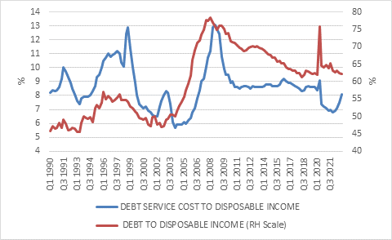
Source: Reserve Bank

Rates and returns
From an investment point of view, higher interest rates make cash more attractive. Money market yields will follow the repo rate higher and is starting to offer positive real returns. These are also more than double what a US 10-year government bond offers. One of the silver linings of the current situation is that it gives conservative investors more options.

Taking on more duration risk offers even higher yields and long bonds remain an attractive asset class considering that the Reserve Bank is determined to keep inflation in check. Inflation, after all, is a bond investor’s most common enemy. Fiscal risk, as explained above, is also an enemy, but sovereign defaults on local currency debt are extremely rare. Again, local bonds are likely to continue trading at a discount to most international peers until there is evidence of fiscal consolidation. High bond yields in turn also weigh on equity valuations, as local companies face a high cost of capital. The difference between cheap bonds and cheap equities is that bonds pay handsome interest while one often needs to wait a long time for the value in equities to be unlocked.

