In Covid’s long shadow
Izak Odendaal, Investment Strategist at Old Mutual Wealth
Three years ago, the reality of Covid shook global markets from its sanguine state. The new coronavirus that had emerged from Wuhan, China, was spreading globally, and investors began to panic, especially when Italy became the first country to institute a nationwide lockdown on the ninth of March, following earlier regional lockdowns. Over the course of the next three weeks, liquid assets across the world were dumped in a frenzied scramble for cash. Only when central banks forcefully intervened with promises of near-unlimited liquidity injections did markets stabilise. Soon, amazingly, a blistering rally was underway. Looking at a chart of global equity indices, Covid appears as a blip, although a very deep one.
Chart 1: Global equities in dollars over the past three years
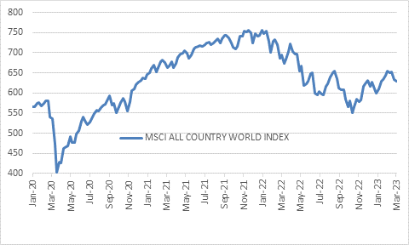
Source: Refinitiv Datastream
Not so for the real world. The impact of Covid remains and not just in the fact that more of us work remotely these days. The rapid shutdown, shift in spending patterns from services to goods, massive fiscal stimulus, near-zero interest rates and logistical logjams all contributed to an inflation surge that central banks are still trying to contain. The supply chain challenges have largely faded, but a bigger problem has emerged across the rich world: labour shortages. This is also due to Covid, at least in part. Many people have dropped out of the labour market due to the lingering impact of the disease, while others took early retirement. The pandemic has also disrupted typical migration patterns.
The net result is very low unemployment rates across the developed world, and high levels of job openings. This has put upward pressure on wages as can be expected, but not enough to keep up with inflation. Individual workers have suffered real income declines over the past year as inflation has surged. However, in aggregate, real incomes have grown since the combination of job growth and wage growth has exceeded the rise in prices. This in turn has supported consumer spending, particularly in the US. This is good news, since it means a recession is less likely for now.
But as long as consumers keep spending, there is likely to be upward pressure on inflation, particularly service inflation. Good news can be bad news.
The data from the US so far this year confirms this story: economic growth has been resilient, labour markets remain tight, consumer spending has been solid if unspectacular, and inflation is proving to be sticky on the way down.
The next few months should see declines in annual inflation rates due to base effects. Russia’s invasion of Ukraine a year ago sent food and fuel prices sharply higher. Today’s annual inflation rates are measured off that high base and will therefore decline – they could in fact show deflation in categories as most dollar energy and primary foodstuff prices are now below pre-invasion levels. But this doesn’t mean the inflation genie is back in the bottle.
The Federal Reserve’s preferred inflation measure, the core personal consumption expenditures (PCE) price index, rose 4.7% from the prior year, a faster pace than economists projected. As an aside, the data was released 30 minutes after it was announced that South Africa was on the FATF grey list. The big sell-off on that Friday afternoon was because global markets came under pressure.
Chart 2: US Core PCE inflation

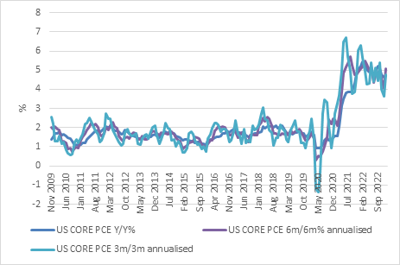
Source: Refinitiv Datastream
Chart 2 shows the PCE data over three and six-month periods alongside the usual 12-month number to account for the base effects associated with the latter. It shows a picture of still-strong inflation momentum. We know that the important rental component should ease substantially in the months ahead following the overall weaker housing market, but there are enough signs of sticky inflation elsewhere for the Fed to maintain the pressure. Indeed, outside of the interest rate-sensitive housing market, it is hard to see much of an impact of the rapid rate increases over the past year.
One explanation is simply that the economy has adapted quickly to higher rates and life goes on. The other is that since rates are still negative when adjusted for inflation (and by implication income growth), the full impact only appears when they turn positive in real terms. It could be a case of recession postponed, not avoided.
The Fed hiked its policy rate range by 25 basis points to 4.5% to 4.75% at its February meeting. Fed funds futures suggest that there are another 75 basis points to go in this cycle. That would leave the policy rate at the highest level since 2000.
The market pricing is now closer to what Fed officials were saying all along, namely that rates would have to rise further and remain elevated to ensure that inflation goes down and stays down. While January’s blistering bond and equity rally was driven by hopes of a soft landing, the more recent gyrations suggest the market is grappling with a different, higher-for-longer interest rate scenario.
The one country that grappled with Covid the longest is the place of its origin. China only recently exited Covid lockdowns and last year saw growth of only 3%, extremely slow by Chinese standards. Inflation is still low and policy support remains accommodative, in contrast to developed economies. Chinese economic data is starting to show signs of life, with a strong rebound measured by the February purchasing managers’ indices. Beijing has adopted a growth target of around 5% for 2023.
Republic of Sad Africa
South Africa was one of the most heavily impacted economies during the early months of the pandemic. The economy was fragile even before Covid hit, and then our government instituted one of the strictest lockdowns in the developing world without having the fiscal space to provide sufficient relief to businesses and households. According to the quarterly labour force survey, 1.6 million formal jobs were lost between the first quarter of 2020 and the third quarter of 2021. Although some of those jobs have been recovered, the overall level of employment remains below pre-pandemic levels, while school-leavers still expand the labour force every year. Time will tell how intensive loadshedding may disrupt this gradual recovery. Unfortunately, timely labour market data is scarce in South Africa.
Disruptions to global commodity markets worked in our favour, however. While the initial lockdowns saw commodity prices crumble – the oil price famously briefly turned negative in April 2020 - they shot up soon thereafter as the market started worrying more about supply constraints than demand. The 2022 Russian invasion of Ukraine exacerbated this. However, commodity prices have come down to earth, especially over the past few weeks. This is despite the better growth outlook for China, still the world’s biggest market for raw materials.
The surge in commodity prices bailed out the local economy by supporting the currency, the JSE and government tax revenues. Unfortunately, logistical and electricity bottlenecks limited how much the economy could benefit, but the boost was massive. This is now unwinding. The rand is under pressure, and the resources index on the JSE lost 12% in February alone, losing 16% over 12 months.
The long-term outlook for many commodities is still positive as supply remains tight. South Africa is not the only mining jurisdiction with supply-side bottlenecks, and the major miners have been very circumspect in expanding production. But this does not help in the short term.
Three years after Covid, where to next for markets? The standout feature of the current investment landscape is that interest rates are higher, not just compared to the lows of 2020, but also compared to pre-pandemic levels.
Shorter-term bond yields in the US and Europe are pushing levels last seen before 2008. Longer-dated yields have also risen, but not by as much, reflecting a view that inflation will eventually subside. This results in a “yield curve inversion” where short yields are higher than long yields. This is historically a recession indicator, though with uncertain lead times.
Chart 3: 6-month government bond yields %
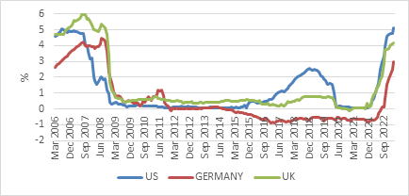
Source: Refinitiv Datastream
Either way, for the first time in many years cash and bonds in the developed world are offering attractive yields. The post-Global Financial Crisis era has been characterised by ultra-low interest rates, and the pandemic briefly intensified this. But no more.
Goodbye TINA
Over this period of low yields, it made sense to strongly favour equities over fixed income, so much so that the acronym TINA was widely used – there is no alternative to equities.
This is clearly no longer the case. Given higher fixed income yields. an equity overweight would only make sense if equities were also cheap compared to their own history. This is not the case in the US, though the air came out of the most inflated areas of the market such as tech and crypto last year. Outside the US, valuations are in line with long-term averages.
Chart 4: Forward price: earnings ratios
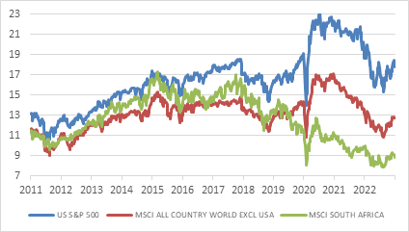
Source: Refinitiv Datastream
South African equities are cheap compared to history, though this is somewhat distorted by the high earnings base of the mining firms. However, clearly the local market derated significantly since 2015, from PE of 17 to 9, and is on the low side of its historic range. There has been a lot of bad news in South Africa, but a lot of bad news is priced in. The same is true for the local bond market, where high yields have long been a feature. However, there was a notable derating relative to other emerging markets following Nenegate. The lost credibility can only be regained when there is demonstrable progress in the structural reforms that can boost economic growth. All South African assets will continue to be influenced by global events and rise and fall with global markets, usually with greater intensity.
We are still in the early days of the post-pandemic era and might not be fully aware of some of Covid’s long-lasting economic and social changes yet. The same is true of the Ukrainian invasion, which could end up fundamentally rewriting the global geopolitical order. It certainly took time to understand how long the impact of the Global Financial Crisis would linger. However, the past three years have again reminded us how quickly markets can turn on a dime. It is either naïve or arrogant (or both) to think that you will be able to time those turning points. Hence the importance of remaining invested even when things look dire – the market can quickly turn higher when things go from terrible to just bad. But the equity market can also turn lower when too much optimism is priced in, or an external shock hits. This is where diversification is so important, and higher global yields mean the cost of having defensive offsets in a portfolio has declined significantly.

