Continue to contribute

Arno Olckers, Business Development Manager at Morningstar Management Investment SA

The impact of saving consistently through the up, down, and boring times

A sad, but harsh reality is that only 6% of South Africans can retire comfortably. “Comfortably” means that an investor retires earning 75% of their final salary in retirement, from the investments and savings put in place before their retirement. More often than not, investors only contribute the minimum percentage of their income to their retirement funding, wrongfully believing that this will provide them with an adequate amount with which to sustain their income during their retirement years. The following article considers not only the importance of saving but why doing so from an early age is so imperative.

Let’s start with the basics and why the principle of saving is so important

Savings is a simple concept – whether you are saving coins in a piggy bank, or percentages in your bank and/or investment account, it’s the principle of sticking to the habit of saving that is important. Warren Buffett’s wise words perfectly encapsulate how we should approach saving – “Do not save what is left after spending but spend what is left after saving”. It’s easy to spend money but it often leads to us not having much left to save, whereas, if you save first, you’ll spend what you have left a lot more mindfully (and cautiously).

It is important to note that, it’s the habit of saving that matters most, and less so the actual amount. Of course, the more you save the better, but getting into the habit can be the hardest part. You will be surprised how rewarding it is to see how quickly you can build up a nest egg and the incredible power of compounding.

Saving versus investing

We all want the best performing portfolio but the reality is that performance is only one of the components on the journey to wealth creation. While you can’t control how markets will perform and/or your investments, you can control the amount you save every month.

The table below shows you the end value of investing a certain percentage of your disposable income every year for 30 years.

- On the left-hand side, we show you the rate of return assumption, and at the top is the percentage you have saved of your disposable income.
- We use the assumption that the investor’s disposable income is R500 000, that it remains unchanged for 30 years and we have made no tax assumptions, to keep things simple.

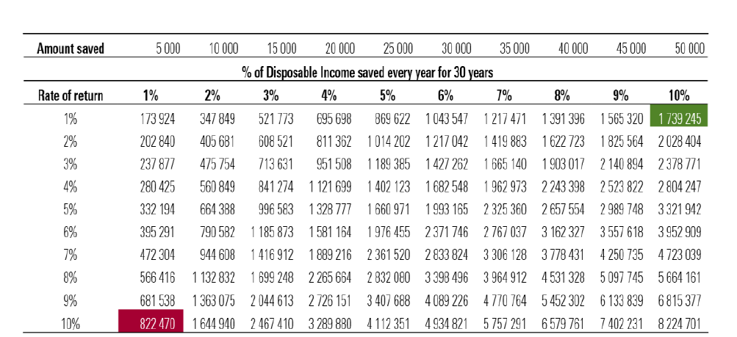
Source: Compoundadvisers.com “Why saving is more important than investing”; Adapted by Morningstar Investment Management. Data as at 28 September 2022. Note: The table assumes no taxes on investment gains and a constant disposable income of R500,000. For illustrative purposes only.

What does this teach us?
- If you generate a 10% per annum return for 30 years, but you only save 1% of your disposable income (in other words, R5000) you end up with R822 000 – displayed in the red block.
- On the other hand, looking at the top right section - if you generate an investment return of only 1% but saved 10% of your disposable income you end up with R1.7 million (as displayed in the green block).

This shows how extremely important the habit of saving is; and that you can end up with a 111% higher ending balance if you save 10% compared to saving only 1% - even though the annualised investment returns were 9% lower!

Start your savings journey as early as possible

Investors often assume that if they are starting small, they don't have enough assets to invest. But the fact is, even if you have a very small sum that you can save and invest in the market, thanks to compounding, over a long time horizon you may be able to accumulate more than the person who starts with a larger sum but waits for longer before investing.

The following example could be helpful if you are unsure how much you need to save given your current age. This does not consider the investment strategy you are in, but purely the amount that needs to be saved from your monthly income to retire comfortably at age 65. More importantly, what we illustrate here is the importance of starting your savings early.

The following assumptions have been made:
- A starting salary of R200 000 per annum (increasing by 4.5% annually)
- A growth rate on the investment of 8% and inflation of 4.5%.
- The investor’s final annual salary amounts to R1 163 272.91, meaning this investor would require an income of R872 454.68 in the first year of retirement to retire “comfortably” (which would reflect a 75% replacement ratio).

As you can see in the below graph, the later you start to invest the more you need to save per month, for example – if this investor started saving at age 25 he/she would need to save 15% per month to retire comfortably whereas if he/she started at age 50 he/she would need to save 62% per month to retire comfortably (at a 75% replacement ratio).

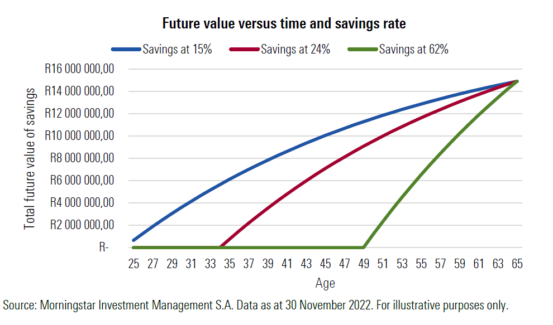

The late-start investor may be scrambling just to make a retirement plan work. People who get started earlier have a better shot at achieving shorter and intermediate-term goals along the way. The unfortunate reality is that very few people start saving early and save the correct (or rather an adequate) amount.

In closing

When thinking about your investment strategy, you want to think about the components you have control over. These components are your behaviour while being invested and the amount you save every month.

Some key points to remember:
- Start saving from an early age and take advantage of the power of compounding
- Markets do recover after market crashes and you can experience your best returns after a crash, so do not be fearful or scared while having a long-term investment strategy. Going through short-term market movements is part of your journey to wealth creation.
- Time in the market remains superior to timing the market – so remain invested for as long as possible.

