It’s all about balance

Roné Swanepoel, Business Development Manager at Morningstar Investment Management SA

Diversification doesn’t necessarily mean variety

“The most important thing you can have is a good strategic asset allocation mix. So, what an investor needs to do is have a balanced, structured portfolio – a portfolio that does well in different environments….we don’t know that we’re going to win. We have to have diversified bets.” – Ray Dalio.

We all aspire to achieve balance in many parts of our life – be it in our personal life, at work, with family time, our diet or even exercise. Similarly, the world is made up of different balancing factors needed not only for it to survive but thrive. Crops need both rain and sunshine to grow, our economy needs both buyers and sellers to thrive and we all need a good night’s rest after a hard day’s work.

In the same way the world needs and thrives on these balancing factors, so too do investments. Managing an investment portfolio is a constant balancing act, whether it be the allocation between cash and equities, local and global markets or even active and passive fund managers. History has shown us that a balanced and diversified approach to investing can help navigate turbulent markets.

Why do investors need to diversify?

The need for diversification reflects the fact that the future is uncertain. This has become particularly evident in 2022 with this year’s market environment proving unusually tough for most asset classes, both locally and globally.

The FTSE/JSE All Share Index has seen a close to 6% drop year-to-date (as of 31 October 2022) in rand, and local bonds have also generated negative performance. Globally, bonds are generating some of their deepest losses in decades.

If an investor had invested in a 60/40 portfolio consisting of equities (60%) and bonds (40%) they would have limited their losses year to date just with the help of naive diversification between the two asset classes.

If we look at the Morningstar Adventurous Portfolio, the portfolio consists of more than eight different asset classes, with the portfolio allocation consisting of –
- 4% local property
- 4% local cash
- 22% local bonds
- 34% local equities and,
- The remainder of the portfolio is invested in global equities, global bonds and global property.
An investor who invested in the Morningstar Adventurous Portfolio would have experienced a return of -0,5% highlighting the fact that smart diversification has buffered some losses on a year-to-date basis.
This negative return might not seem favourable when viewed in isolation, however, as can be seen in the graph below, given the current state of the market, the picture could have been a lot worse…

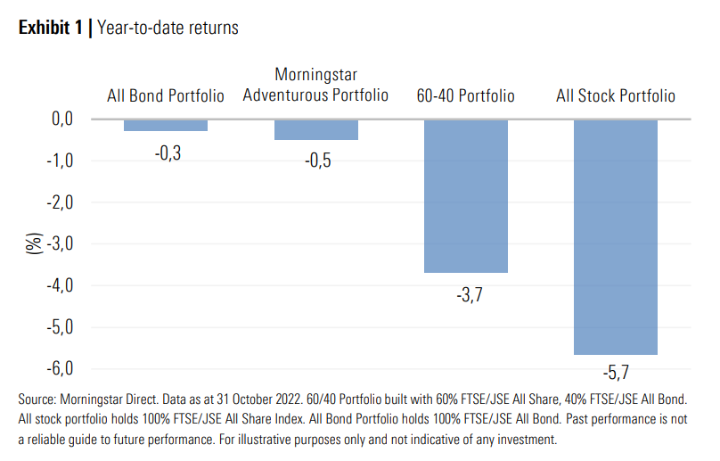

Diversification doesn’t necessarily mean variety

A strong body of research (including Vanguard’s research, “The global case for strategic asset allocation”) believes that the most important decision any investor can make is setting their asset allocation. The analysis found that more than 90% of a portfolio’s return variability over time could be explained by its asset allocation. However, it is almost impossible to pick which asset class will be next year’s winner, or in any subsequent year.

The graph below shows asset class returns on a calendar year basis. As can be seen, it is very difficult to predict which asset classes will outperform each year - just take Emerging Market equities (red line) and Global Bonds (yellow line) as an example.

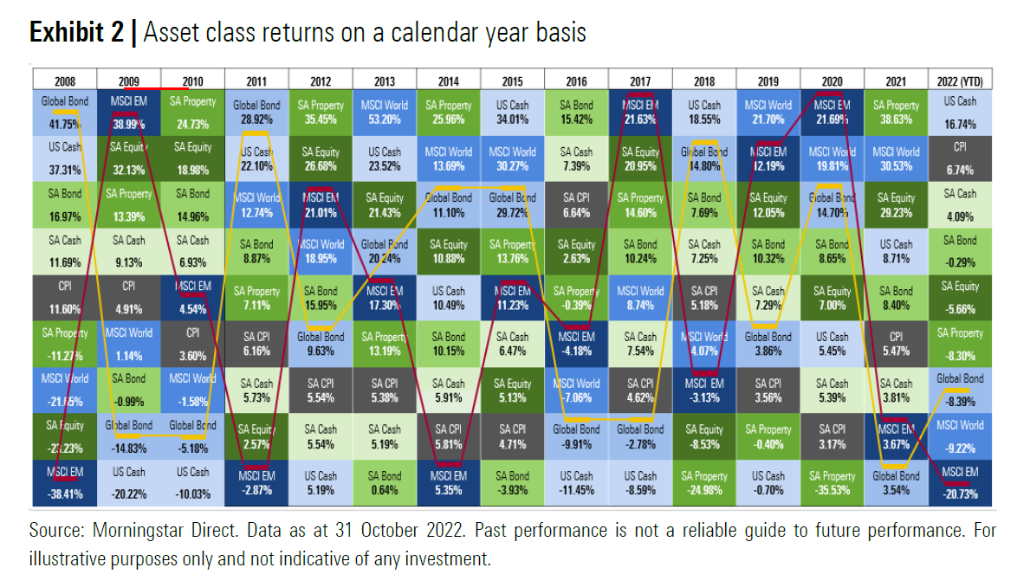

Does this mean that we should include every asset class in the investable universe in a portfolio to achieve great returns? In short, no.

Being well-diversified means that everything doesn’t move in the same direction all at once

The challenge for investors is that we typically confuse ‘diversification’ with ‘variety’. Investor Howard Marks described this problem best when he said “Intelligent diversification means not just investing in a bunch of different things, but in things that respond differently to the same factors”. This viewpoint is particularly true during times of high volatility in markets.

In the next table, we illustrate how different asset classes responded to recent crises. It illustrates the benefit of having asset classes that respond differently during turbulent times and market corrections.

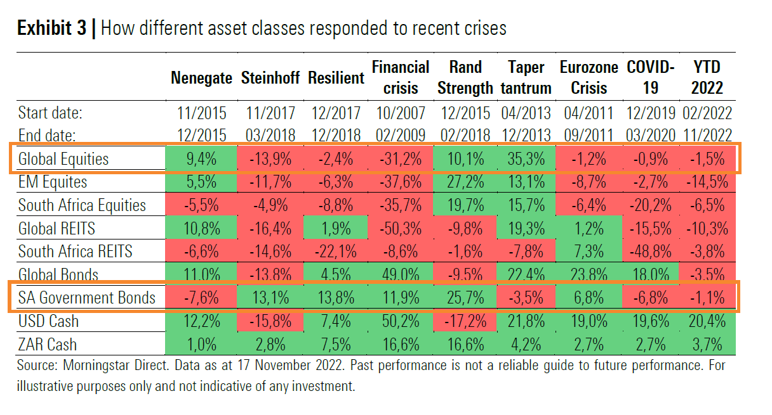

Let’s consider these examples:

- “Nenegate”:
  - The rand depreciated and local asset classes were all in negative territory.
  - The allocation to global markets held up well and the depreciation in the rand added to the performance of global assets (in rand terms), which helped to buffer the losses in the local part of investors’ portfolios.

- Steinhoff:
  - Markets sold off across the board, but an allocation to local government bonds and local cash helped buffer widespread losses.

- Covid-19 crash:
  - Global bonds acted as a buffer against losses in most asset classes.

Looking at global equities and local government bonds, these asset classes behave very differently in crises and act as great diversifiers over time. What has baffled the markets in 2022, is that there has been no place to hide – with both bonds and equity behaving out of sync and realising losses at the same time.

The need for diversification may appear obvious, but it can be challenging to implement, as the difference in the behaviour of the diversifying asset can be uncomfortable. For example, if an investor builds a portfolio primarily of equities that are typically rising in value, then the diversifying asset may be providing zero or a negative real return in some circumstances. This creates ‘line item risk’ for the investor who is usually disappointed with the specific holding performing less well than others on their statement. It is important to remember that being well-diversified means that everything does not move in the same direction all at once.

Keeping the balance

If one investment type has a long run of strong returns and another area has had poor returns, it may well flip places over the next few years. The market overreacts in rallies and sell-offs in the short run, but it does correct eventually. Rebalancing is a simple way to put that cyclical force to work to your benefit. It helps you to buy low and sell high without attempting moves due to market forecasts.

The Morningstar portfolios are rebalanced regularly to keep investors’ portfolio(s) from drifting from its tactical asset allocation percentages as markets overreact in rallies and sell-offs in the short term. Rebalancing also ensures that we continue to buy low and sell high with the aim of bolstering returns over time.

The graph below shows two identical portfolios - one that is rebalanced quarterly, and one that follows a buy-and-hold strategy. We can clearly see the value that rebalancing provides over time, with the rebalanced portfolio adding just over R350 000 in value at the end of a 15 year investment horizon.

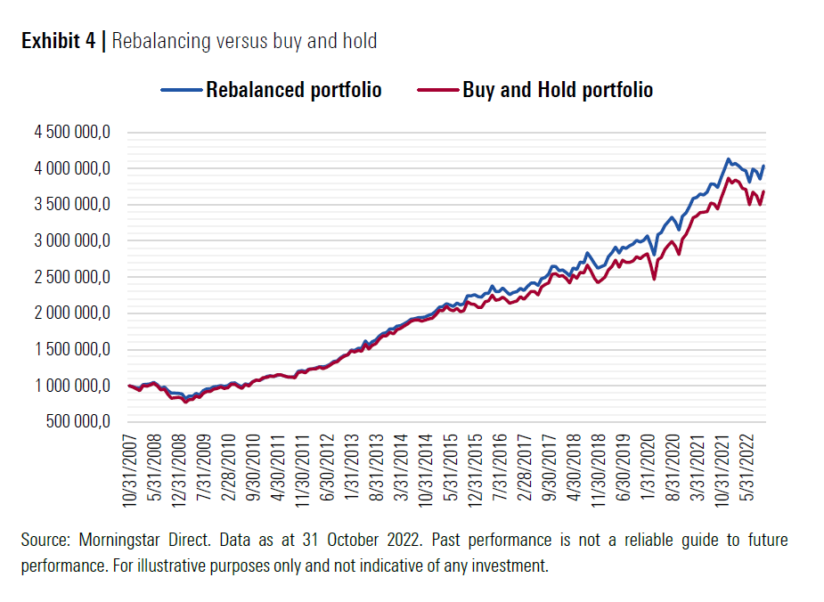

In closing

Successful diversification is dependent on both an understanding of how assets will behave in the various scenarios and the likelihood of the scenario occurring. Yet, despite this range of investment options, we need to remember that the uncertainty of the future means that we cannot hope for every outcome to reflect our expectations. Rather, we hope to use the weight of probabilities to create a return path that will help the end investor reach their goals.

At Morningstar we believe that taking a patient, long-term view helps investors ride out the market’s ups and downs and take advantage of opportunities when they arise. Powerful research is behind each decision we make, and we spend a lot of time understanding what drives each investment we analyse.

To help manage risk and deliver better returns, we make sure portfolios are smartly diversified, combining investments with different underlying drivers and keeping the balance by rebalancing client portfolios to take advantage of the cyclical force in markets.

