Navigating the uncertainties and finding the opportunities

A few reminders as we embark on another year of investing

By Roné Swanepoel, Business Development Manager at Morningstar Investment Management SA

“Investors cannot earn high returns without occasionally bearing great loss. If the investor desires safety, then he or she is doomed to receive low returns.” – William Bernstein.

2022 was a year where most investors had to stomach great losses. Looking back at 2022, most investors are likely to say “good riddance” to the year that was, for a myriad of reasons –

- The Morningstar US Market Index ended the year down 19.4% - its biggest annual loss since 2008.
- Bonds had their worst year in modern history, as the Morningstar US Core Bond Index fell by 12.9%. Prior calendar-year losses for the index had never exceeded 2%.
- Technology stocks plummeted. The Morningstar US Communication Services Index—containing tech giants such as META Platforms (Facebook’s parent company) and Alphabet (Google’s parent company) — declined by 40.9%, marking its worst loss since the start of performance history in 1998.
- The US Federal Reserve raised its benchmark federal-funds rate at its fastest pace in history, with seven interest-rate hikes through the course of the year, bringing the effective rate into the 4.25% - 4.50% range (up from zero in January). We also saw steep interest rate hikes locally.
- By the third quarter of 2022, the US dollar rose to its highest level in two decades, resulting in the weakening of most other currencies against the dollar.
- Cryptocurrencies had a painful year. Bitcoin, the largest cryptocurrency, lost over $550 billion in market capitalisation and declined by 64.7%.
- On the local front, Eskom's woes continued, as South Africa endured a total of 208 days of loadshedding in 2022.1

Due to all this turmoil, investors were desperately seeking safety and the expression “cash is king” sadly made a comeback in 2022. As we embark on 2023, investors are still grappling with a lot of uncertainties and are left wondering how to navigate the year ahead.

Here are four reminders as we embark on another year of investing…

- The stock market is not the economy

Companies listed on the stock exchange account for billions in market capitalisation, employ millions of people and are frequently reported on in the media. It is, therefore, easy to be misled into thinking that the stock market and the economy are the same and should by that logic always move in the same direction.

The stock market is forward-looking and prices of stocks/shares/bonds (any listed liquid instruments) are determined by the supply and demand of investors. Investors that are buying these instruments are expecting positive outcomes looking forward. Sellers, on the other hand, expect the price of the stocks/shares/bonds to decrease in value.

In contrast with forward-looking equity markets, the government’s gross domestic product (GDP) numbers are backwards-looking. GDP is the value of goods and services produced/rendered in a country during a certain period. It provides a snapshot of a country’s economy and it is used to estimate the size of an economy and its growth rate but has no direct relationship to the stock market.

When stock performance trends upward, we often feel like the economy is doing better. Similarly, when stock market performance trends downward, we feel like the economy is doing worse. But, the stock market and the economy are not always in sync with each other.

Equity markets generally react to changes before the economy does. This means that when economic data (positive/negative) is released, markets tend to have priced in the economic data already, as well as how that could affect companies and investors. For example, with the 2008 recession, equity markets experienced a drawdown before the economy slowed (moving downwards during October 2007), whereas the economy only slowed well into 2008.

2022 was also a good example of markets pricing in economic factors. The below chart shows the performance of local equities, bonds and cash during 2022 - a year where the news was filled with negative headlines regarding loadshedding, inflation, interest rates, geopolitical tension and recession fears.

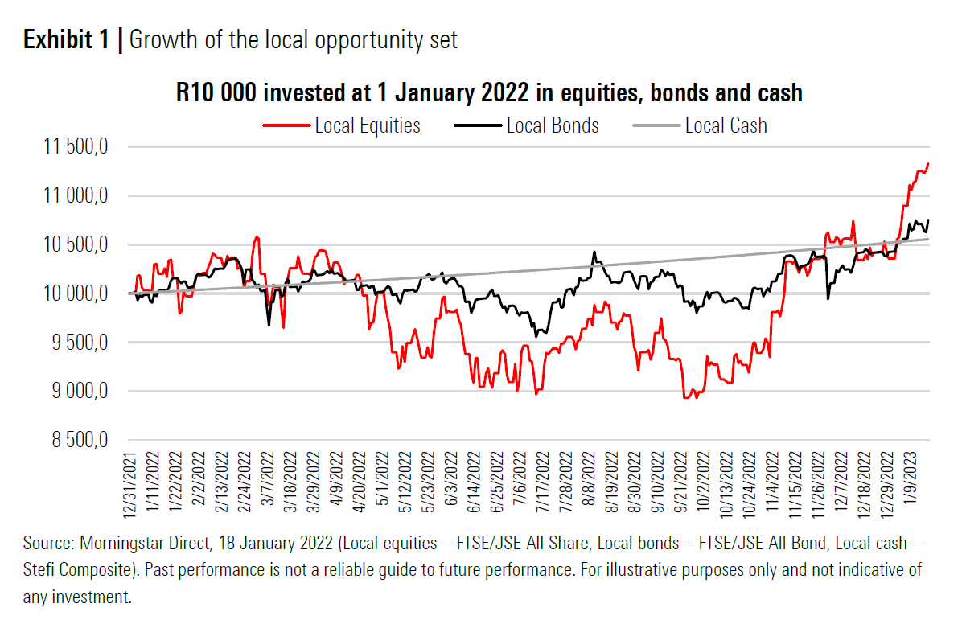

But even amid tough conditions globally and negative economic data, local equities managed to provide investors with a 13.3% return, local bonds (although volatile during 2022) are up 7.5% and cash is also up by 5.6% since 1 January 2022 to date.

- Less prediction and more preparation

Timing the economy is hard, but timing the stock market is even harder. There is certainly no shortage of things to worry about at the moment. As with all things unknown and uncertain, it is human nature to try and predict how things will pan out. Although we have no actual control over the outcome, being mentally prepared for a certain outcome brings some sort of comfort – especially when it comes to our investments. Trying to predict outcomes for life is one thing, but investors are notoriously bad at correctly predicting the markets and the subsequent impact that events might have on the value of their investments.

Market volatility is one of the few things we can predict in the investment world. We don’t know what prices are going to do next month or next year, all we know is that prices are going to move around, often more than warranted by the investment fundamentals and underlying cash flows of the asset classes.

One of the ways that we can prepare for a wide range of outcomes is by being diversified. It is important to remember that sensible diversification means not just investing in a bunch of different things, but rather investing in opportunities that respond differently to the same factors i.e. making sure to take a range of possible outcomes into account. No asset class or manager has a perfect strike rate.

In the below table, we illustrate how different asset classes responded to recent crises. It illustrates the benefit of investing in asset classes that respond differently during turbulent times and market corrections.
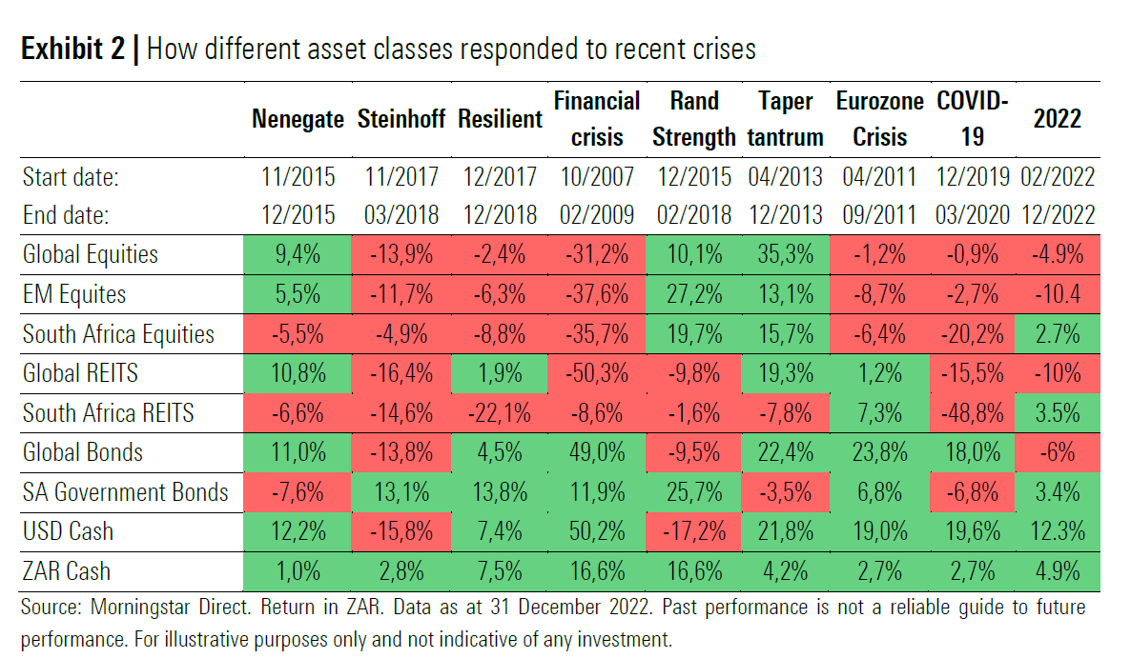

- The best investments are made when we feel the worst about investing

One part of the agreement we have with risk assets is that long-term returns should be gained in exchange for short-term risks. About one out of every 10 days, the market falls at least 1%. In 2022, we experienced 219 intraday S&P 500 moves of +/- 1% or greater, the most since 2009.

The below graph shows the worst days in the local equity market (historically), and the subsequent one-year and five-year returns from that point in the market for investors who were able to stay invested. This shows that the best days often come after the worst, and the difficult environment investors have faced in 2022 has set the scene for good future returns.

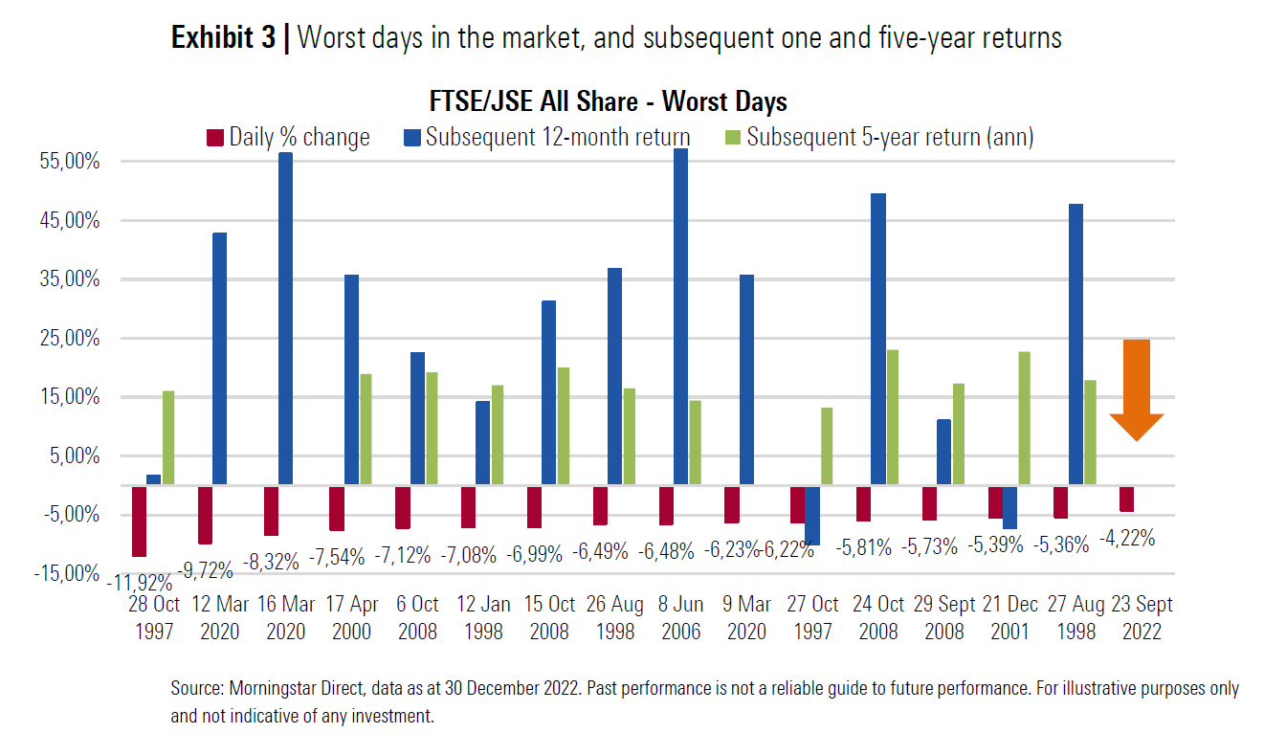

- Investing starts with you and not the markets

Investors too often redirect their attention away from the end destination of investing and focus too intensely on the short-term journey when faced with a lot of outside noise. Much like in other walks of life, we can lose focus, making us susceptible to capitulation or giving up at the moment when fortitude and determination pay off most.

We are firm believers in the importance of staying invested through market cycles, even when it feels uncomfortable. Patiently allocating to assets that will help you achieve your financial goals should remain key. If you catch yourself getting down about the state of our economy, always remember why you are investing in the first place.

Perspective is important, as well as our ability to remove emotion from our investments as we go into 2023.

Statement values may be lower at this point in time, but wealth is only destroyed, and capital lost if you exit and crystalize the paper losses. While it feels like doom and gloom headlines are abundant, so too are opportunities. Markets are forward-looking and the reality of the high inflation and interest rates that we are all experiencing is already in the price of portfolios.

This is not the time to make changes. This is the time to ignore your statement(s) and trust your long-term investment plan. You don't have to outsmart the market if you can simply outperform it. Cut through the confusion and noise and focus on what matters - a simple, consistent, and diversified approach over the long term. Remember, for those still investing, the outlook has improved, as lower prices could potentially imply higher future returns.

