FNB/BER Consumer Confidence Index
First National Bank
Consumer confidence rocked by electricity crisis, cost-of-living concerns

23 March 2023 - Having recovered from -20 to -8 index points during the fourth quarter of 2022, the FNB/BER Consumer Confidence Index (CCI) plunged to -23 index points during the first quarter of 2023.^{[1]} The latest reading is broadly in line with the extraordinarily weak consumer confidence level recorded during the third quarter of 2020 (also -23, during a time of level 3 COVID restrictions, alcohol bans, school closures and curfews), as well as the second quarter of 2022 (-25, when deadly floods devastated KZN and the economic ramifications of the Ukrainian war started to manifest). The reading of -23 is the third lowest CCI reading on record since 1994 and indicative of extreme concern among consumers about South Africa’s economic prospects and their household finances.
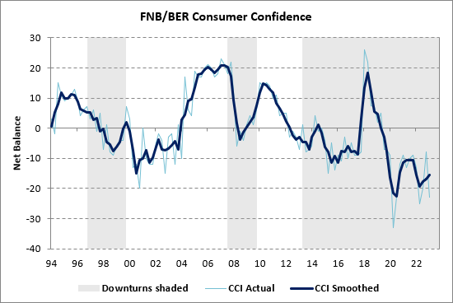
Details
All three sub-indices of the CCI declined dramatically during the first quarter of 2023. The economic outlook and time-to-buy durable goods sub-indices of the CCI dropped by 15 and 17 index points respectively, and, at -34, are now both deep in negative territory. The vast majority of consumers therefore expect a deterioration in South Africa’s economic growth over the next 12 months and consider the present time as highly inappropriate to purchase durable goods (e.g. vehicles, furniture, household appliances and electronic goods). The household financial outlook sub-index of the CCI fell 14 index points to -1 during the first quarter, reversing the gains made during the 2022 festive season. While consumers no longer expect their household finances to improve over the next year, they are nevertheless considerably less pessimistic about their own financial prospects compared to their gloomy expectations for the economy in general.
 | 20Q3 | 20Q4 | 21Q1 | 21Q2 | 21Q3 | 21Q4 | 22Q1 | 22Q2 | 22Q3 | 22Q4 | 23Q1
Overall FNB/BER CCI | -23 | -12 | -9 | -13 | -10 | -9 | -13 | -25 | -20 | -8 | -23
Economic outlook | -23 | -12 | -5 | -14 | -14 | -12 | -18 | -39 | -31 | -19 | -34
Household financial outlook | -2 | 6 | 10 | 10 | 12 | 14 | 8 | -5 | -2 | 13 | -1
Suitability of the present time to buy durable goods | -44 | -30 | -32 | -36 | -29 | -30 | -28 | -32 | -28 | -17 | -34

A more detailed breakdown of the CCI shows that the confidence levels of high-income households (earning more than R20 000 per month) deteriorated the most during the first quarter, crashing from -10 to -31 index points. Bar the reading of -33 recorded during the initial panicked level 5 lockdown period in 2020Q2, this is the lowest reading for high-income confidence since the commencement of the series in 1995. Affluent consumers are especially concerned about the outlook for the economy, with this sub-index nosediving from -18 to a new historic low of -51 in the first quarter. The confidence levels of middle-income households (earning between R5 000 and R20 000 p.m.) dropped from -6 to -21, while low-income confidence (earning less than R5 000 p.m.) slumped from -6 to -17 index points.
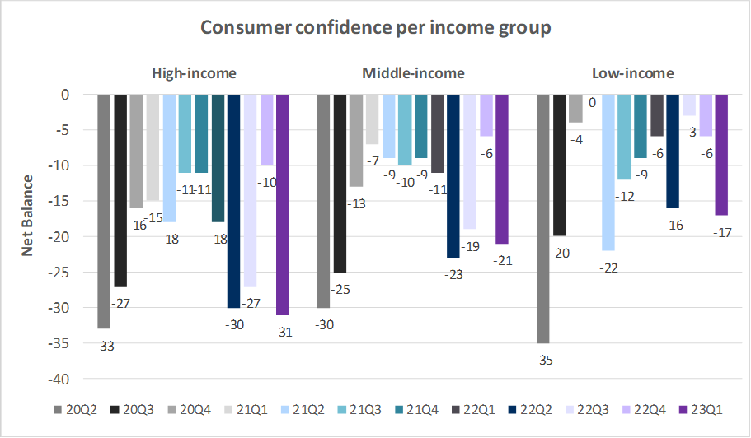
FNB Chief Economist Mamello Matikinca-Ngwenya said that "The alarming increase in power outages since December and the concomitant deterioration in South Africa’s economic prospects no doubt rocked consumer sentiment during the first quarter. Spiralling food prices, another interest rate hike and a sharp depreciation in the rand exchange rate likely added insult to injury. However, further job creation in the still-recovering services sector may have softened the blow to low- and middle-income confidence.”
Bottom line
The big drop in the FNB/BER Consumer Confidence Index mirrors the substantial deterioration in retailer sentiment during the first quarter (with the BER’s retailer confidence index contracting from 42 to 34 index points, the weakest level since 2020Q2). “The about-turn in consumer confidence points to a marked decline in consumers’ willingness to spend and foreshadows a significant slowdown in real consumer spending growth relative to the surprisingly strong rate recorded during the fourth quarter. The fact that high-income confidence declined the most is doubly alarming for the outlook for household expenditure, as affluent consumers also have the greatest spending power,” said Matikinca-Ngwenya.
With an increasing number of high-income households now investing (at considerable cost) in solar power and other backup power systems, these households will in all likelihood need to slash their discretionary spending in order to balance their budgets. Consequently, sales volumes of big-ticket durable goods items such as new vehicles, furniture and household appliances are likely to face increased pressure in coming months, although replacement purchases of electronic goods due to load-shedding related breakdowns should counter some of the adverse impact. With some upward (recovery) momentum still buffering the services sector (e.g. hotels, restaurants, transport, recreation and tourism related services), the retail sector will likely bare the brunt of the impact of the confidence collapse.
Background
Consumer confidence surveys provide regular assessments of consumer attitudes and expectations and are used to evaluate economic trends and prospects. The surveys are designed to explore why changes in consumer expectations occur and how these changes influence consumer spending and saving decisions.
The FNB/BER CCI combines the results of three questions posed to adults in South Africa, namely the expected performance of the economy, the expected financial position of households and the rating of the appropriateness of the present time to buy durable goods, such as furniture, appliances and electronic equipment.
Until the second quarter of 2019, the FNB/BER CCI was based on face-to-face interviews of between 2 000 and 2 500 urban adults. The BER switched to telephone call surveys in the third quarter of 2019. The 500 respondents are representative of the racial and household income composition of the urban adult population of South Africa. Internationally, the majority of CCIs is based on telephone call surveys.
Consumer confidence is expressed as a net balance. The net balance is derived as the percentage of respondents expecting an improvement / good time to buy durable goods less the percentage expecting a deterioration / bad time to buy durable goods.
A low level of confidence indicates that consumers are concerned about the future. They may be worried about job security, pay raises and bonuses. With such a frame of mind, consumers tend to cut spending to basic necessities (e.g. food and services) to free up income for debt repayment. If confidence is high, consumers tend to incur debt (or reduce savings) and increase spending on discretionary items, such as furniture, household equipment, motor vehicles, clothing and footwear. Some of these items are often financed on credit. Spending on these items declines when confidence is low, as households can generally delay their purchase without experiencing an immediate deterioration in living conditions.
A rise in consumer confidence reflects an increased willingness of consumers to spend. However, this willingness only translates into actual sales if consumers’ ability to spend improves. Their ability to spend depends on their inflation adjusted after-tax income and the availability of credit. A rise in consumer confidence could therefore result in an upturn in household consumption spending in general and retail and motor vehicle sales in particular. The opposite applies when the level of consumer confidence declines.

[1] The first quarter CCI survey was conducted by means of a telephone call survey between 27 February and 9 March 2023.

