AB InBev: The king of beer
INTERVIEW MOTIVATION
Xx March 2023: As the world's largest and most profitable brewer, Anheuser-Busch InBev (AB InBev) faces investment concerns and risks that are overly reflected in the current stock price. Despite the market's unease, there is significant potential for the company to grow its beer volumes, reduce input costs, and manage its high levels of debt.
This is the view of Jithen Pillay, analyst at Allan Gray, who says that the investment case for the brewer is strong, despite the current market sentiment.
“There is significant potential for long-term growth and cash flow generation for ANH, and investors should not overlook the company's potential,” says Pillay.
Reasons he cites for this include that the company's new CEO is focused on organically growing the share of the company's products, increasing beer consumption in previously underserved areas, and introducing new and innovative beverages. ANH's e-commerce app, BEES, has also helped increase sales, with material runway for growth. Despite high input cost inflation, the company is positioned to weather these challenges through disciplined pricing, a tiered-price portfolio of beer brands, and the migration of middle-to-high-income consumers to its global brands. Finally, despite its high debt levels, ANH has access to extremely favorable debt terms.
We recommend an interview with Pillay who can discuss:
- Why he believes the investment case for AB InBev is strong
- How the market is pricing in concerns, and why this could create an opportunity for investors
- What happened to share following Ab InBev’s acquisition of South African Breweries (SAB)
- Are there headwinds in the current environment that may impact the stock?
- The long-term growth prospects for the brewer

OPINION EDITORIAL
Media target: Daily Maverick, Financial Mail Investors’ Monthly, Business Day (will be pitched on an exclusive basis first).
Word count: 884
AB InBev: The king of beer
By Jithen Pillay, analyst at Allan Gray
The market has several concerns about brewer Anheuser-Busch InBev which are currently weighing on its share price. We believe the company’s fundamentals are robust. Jithen Pillay explains why investors could be missing out on a cheap round.
Anheuser-Busch InBev (AB InBev or ANH) is the world’s largest and most profitable brewer, with more than 500 beer brands and operations in nearly 50 countries. ANH brews one in four beers globally – more than twice that of its nearest rival, Heineken.
Local consumers will be very familiar with South African Breweries (SAB), which ANH acquired in October 2016 for US$103bn. Since the acquisition, ANH has been a poor investment in both absolute and relative terms, as shown in Graphs 1 and 2: The share is down 34% cumulatively in rands versus the FTSE/JSE All Share Index (ALSI), which is up 44% over the same period. The picture is even worse in US dollars: ANH is down 48% for the period, in contrast to the S&P 500, which is up 81%.
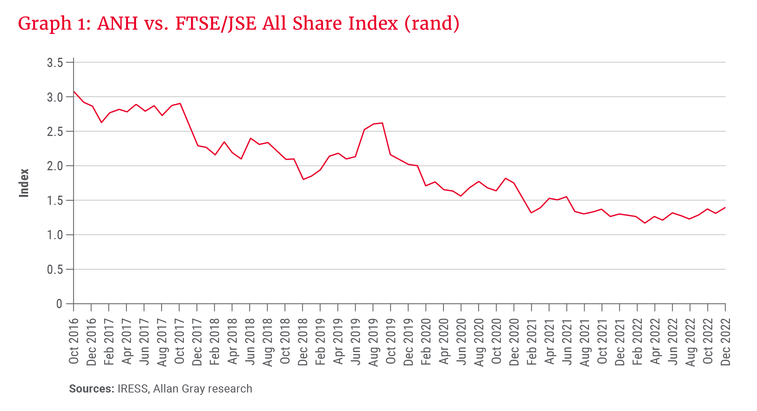
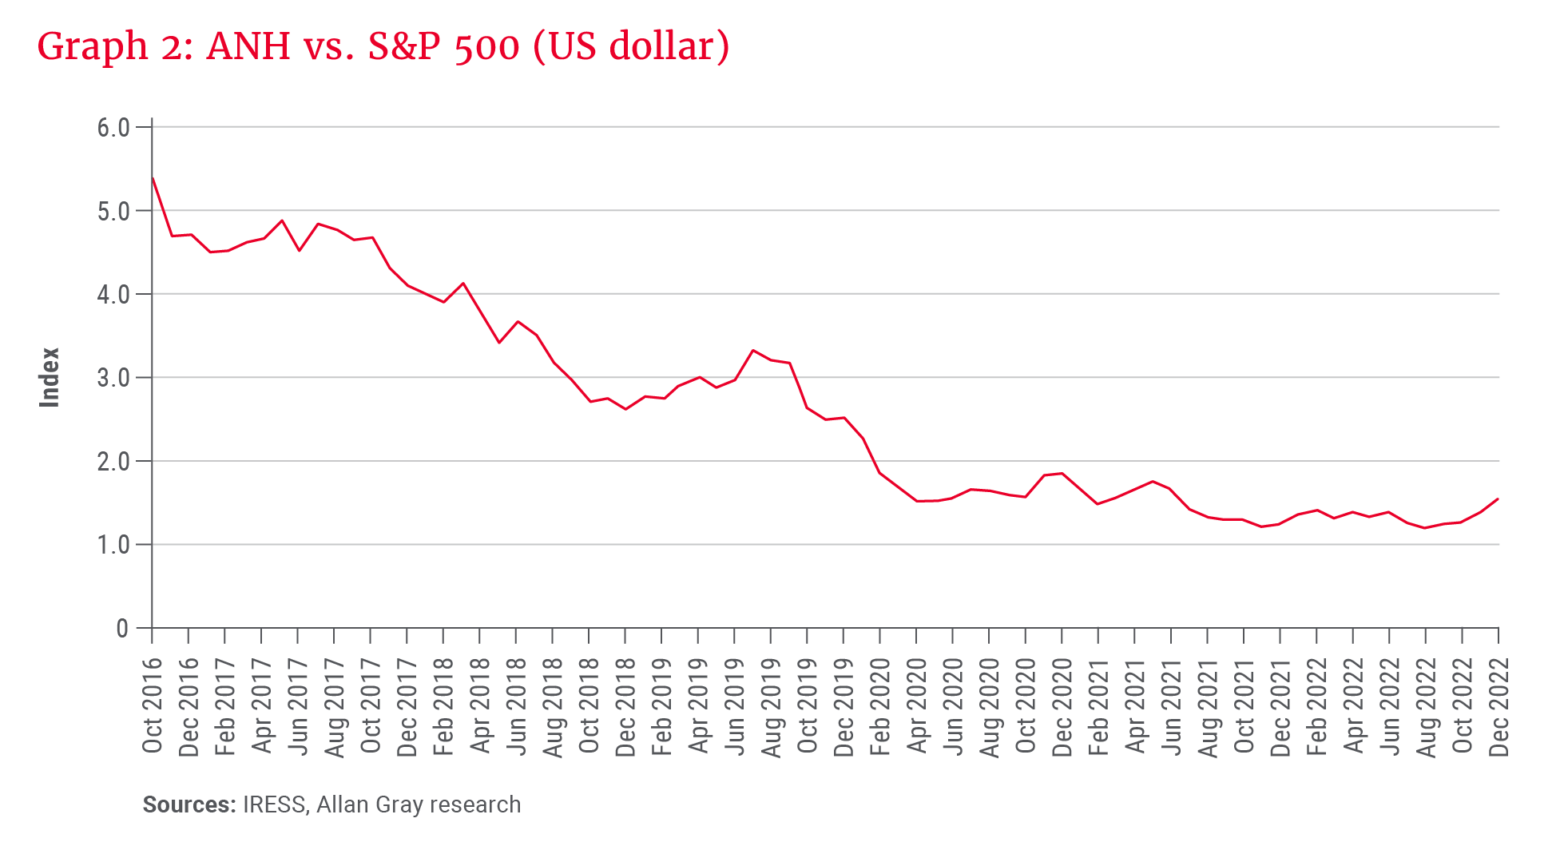

Dispelling the market’s unease
Below we outline three of the market’s main concerns regarding ANH, and why we believe these risks are too severely discounted in its current share price.

Concern 1: Slim growth prospects for ANH’s beer volumes
Graph 3 shows ANH’s rolling 12-month organic sales volumes (per quarter). Volumes were flat in the three years following the SAB acquisition – a poor outcome given ANH’s mostly emerging market focus. However, there has been a step change since Michel Doukeris took over as chief executive officer in July 2021.
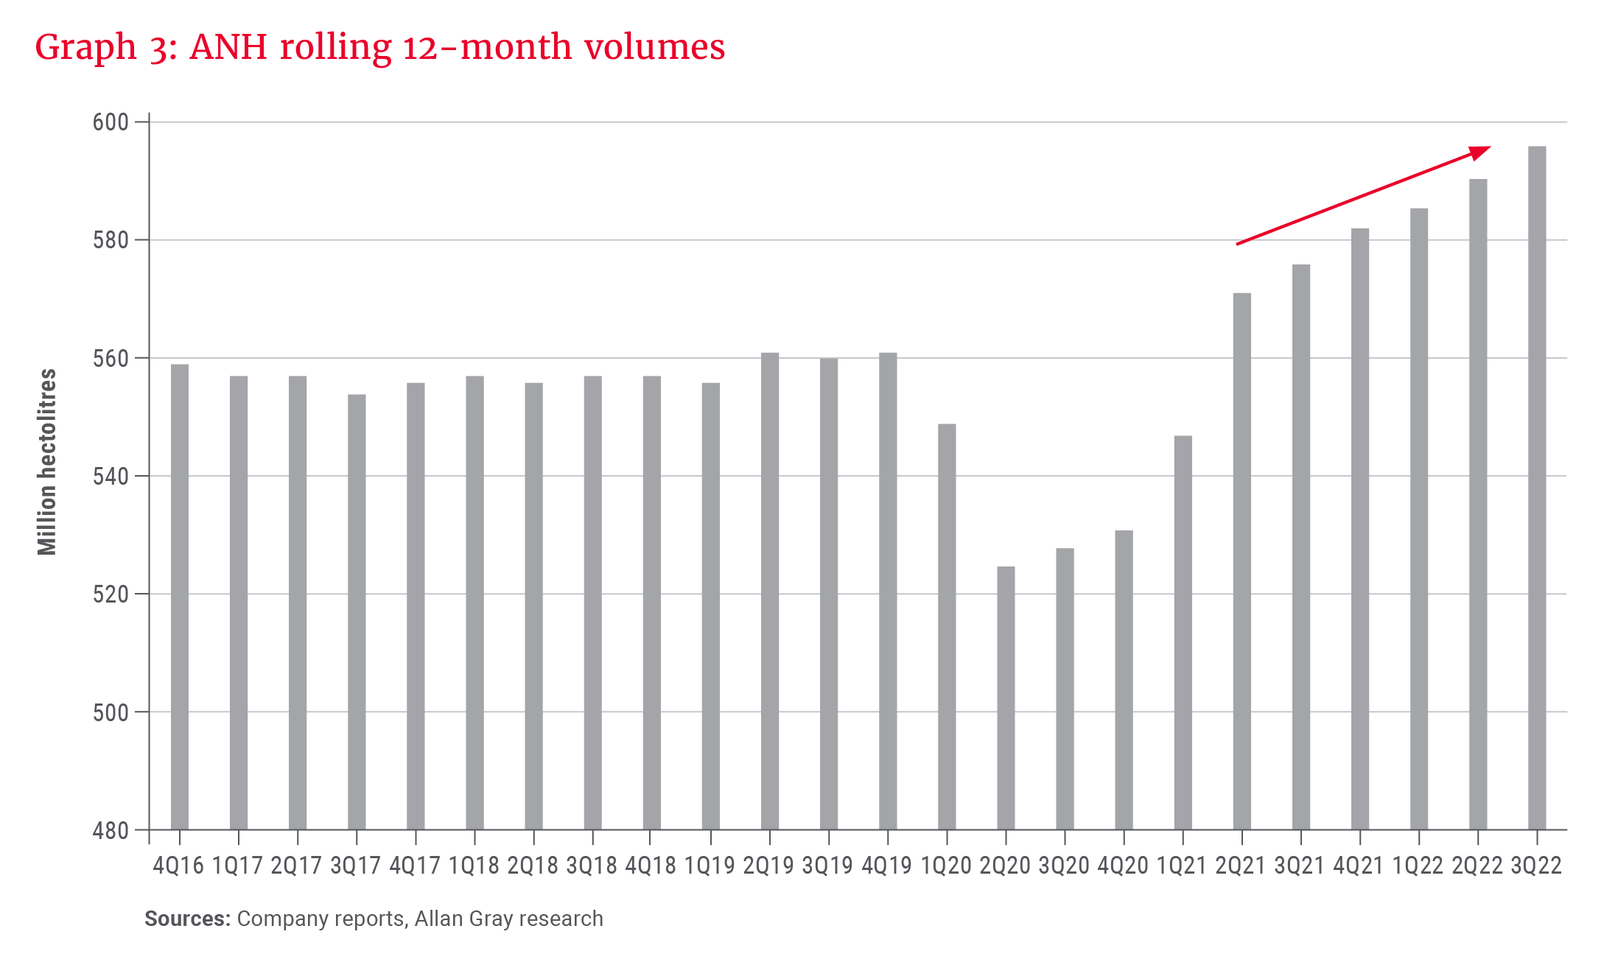
There are two main reasons for the change in trajectory:
- Mindset change: The new management team is focused on organically growing ANH’s share of throat (both with new innovative beverages and promoting beer consumption in previously underserved areas). Colombia is a good example of this: ANH dominates the market and beer consumption per capita is high by emerging market standards. Despite this dominance, the company continues to grow volumes strongly, recently achieving the highest beer per capita consumption in 25 years.
- E-commerce and marketplace platform: ANH launched its e-commerce app (called BEES) in 2019. Beer sales to customers still occur largely via physical channels, with salespeople visiting retailers regularly to take orders. The BEES app removes the administrative burden from the interaction and allows salespeople to focus on sales development. BEES is live in 19 markets, comprising 57% of ANH’s revenue. There is material runway for BEES to further grow ANH’s volumes.
While it is true that spirits took volume share of throat globally from beer in the decade to 2016, in the five years thereafter, beer grew its volume share ahead of both spirits and wine (driven by new innovations such as hard seltzer).

Concern 2: High input cost inflation will squeeze ANH’s margins
Barley and aluminium are material inputs in producing a can of beer. From their closing 2020 prices to their 2022 peaks, the barley and aluminium prices rose 134% and 77% respectively in US dollars. ANH also sells its beer mostly in emerging markets, whose currencies have been weak relative to the US dollar.
The above were headwinds for ANH: Its gross profit margin for the nine months to September 2022 was 7% lower than 2019 (a period not impacted by COVID-19). However, we believe ANH is better positioned to weather high input cost inflation (that all consumer-packaged goods companies are faced with).

Concern 3: ANH has too much debt
ANH’s net debt is high (US$76bn at end-June 2022) following its purchase of SAB. However, the terms of its debt are extremely favourable. It is low-cost (4% coupon) and almost fully fixed-rate. The debt is also long-dated (16-year weighted average maturity) with negligible near-term expiries. Lastly, the debt has no financial covenants attached to it.
We believe ANH could reduce its debt quickly if desired, given the company converts more than 100% of its earnings into cash flow (ANH only needs to pay suppliers after it receives payment from its customers). It is less likely that this cash flow would be wasted on expensive acquisitions going forward, given the company’s stated focus on organic growth. Emerging market currencies look overly weak compared to the US dollar; if this reverses, it will also be a tailwind for ANH, given most of its debt is US dollar- and euro-denominated.
In a high-inflation and rising interest rate world, a large quantum of cheap, fixed-rate and far-dated debt could be an advantage for ANH rather than a hindrance.

ANH’s prospects
On balance, we believe the market is overly pessimistic about ANH’s prospects. Current earnings are not high, and ANH can generate strong organic cash flows (which are more uncertain in other industries). Trading on less than 15 times our assessment of the company’s normal earnings, we believe ANH is a useful addition to an investor’s portfolio, particularly given a local market that is heavily exposed to South Africa- and China-specific risks (ANH earns 4% and 9% of its revenue in South Africa and China respectively).
-ends-

