
January 2022 BETI report to accompany press release
Date: 09 February 2022

BETI rise of 6.2% in January hides weakness in the underlying economy

The BankservAfrica Economic Transaction Index (BETI) increased by 6.2% year on year. However, one must remember that January 2021 was hampered by a number of lockdown restrictions, such as the closure of restaurants and entertainment places, like cinemas, in the early evening under the strict curfew conditions. The sale of alcohol was prohibited at shops and bars while borders were closed, limiting travel.
The tougher lockdown level restrictions, which began in mid-December 2021, moved to higher levels at the end of December. The early curfew in January and the closure of beaches in holiday areas impeded travel and tourism even in the local market. Furthermore, the load shedding in December 2020 and January 2021 impacted the base, on which the January 2022 BETI is measured.
Therefore, the 6.2% growth must be considered against the BETI levels in January 2021, which held the weakest growth level of 1.2% between October 2020 – January 2022.
The BETI headline number recorded a high increase - but recent changes suggest lower growth. The December 2021 and January 2022 change recorded a slight decline of 0.2%, while the quarter-on-quarter change shows a flattish increase of 0.1%. Furthermore, the BETI Index of 126 points was the lowest in three months.
Unlike local tourism and car sales, which both reported strong increases, the lack of long-distance foreign tourism held the BETI back a little in January 2022.
Moreover, some electricity interruption – both on a local and national level – has somewhat slowed the economy. South Africa is not getting the full benefit of high commodity prices as infrastructure theft has meant that coal and iron ore are not exporting to their potential value.
However, as South Africa is now in lockdown level 1, we expect to see more progress in the economy’s growth. If January 2022 turns out to be the weakest level for the BETI in 2022 – as January 2021 was – we can expect good growth this year.
Low forecast for Q1 2022 growth
Observing the close correlation between the BETI and South Africa’s economic GDP, one expects Q1 2022 growth to be somewhat lower than one would hope. As we did not report on the BETI in December 2021, we would like to point out that Q4 2021 GDP growth should be positive but far lower than the first two quarters of 2021.
The low growth recorded in the Q4 2021 GDP has resulted in a slower start for 2022 than 2021 had. Growth of about 2% for 2022 is more likely than 3% or more.
All in all, although the 6.2% year-on-year BETI growth appears strong, the BETI is off to a subdued start to 2022. The lack of foreign tourism and infrastructure problems have had a dire impact on economic activity.

The number of transactions in the BETI
It is not unusual for the number of transactions in January to fall below the December figure due to the seasonality of transactions. However, the total amount of 114 988 683 transactions recorded in January 2022 is the lowest in nine months.
The standardised nominal value of transactions was R960.8 billion, which was 15.7% higher than January 2021. One must realise that inflation, as measured by the CPI (excluding Homeowner equivalent rent and PPI) is now far higher than it was in nearly five years. The deflator is estimated to be 8% higher on a year-on-year basis for January 2022.
Graph 1: Quarter-on-quarter percentage change in the BETI and SARB Co-Incident Index
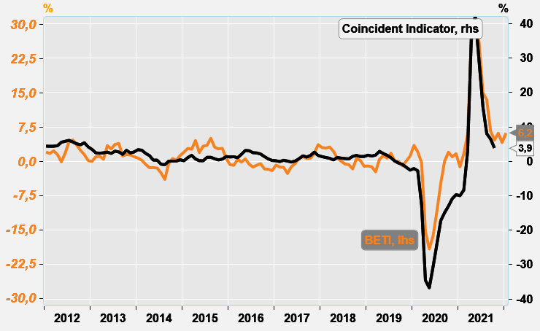
Source: Economists.co.za and BankservAfrica

Graph 2: BETI: Flattening out after a recovery?
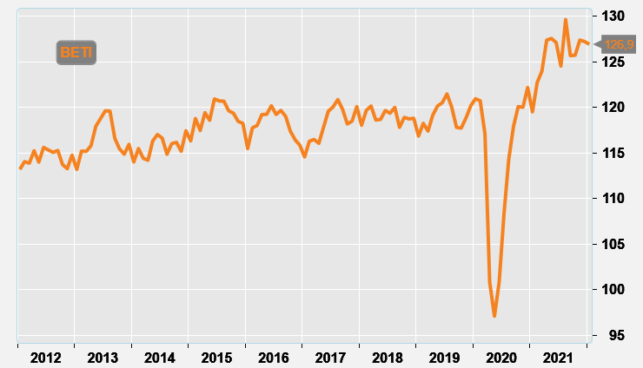
Source: Economists.co.za and BankservAfrica

Table 1: The BankservAfrica Economic Transaction Index
 | The BETI Index | The headline BETI % change | BETI quarterly % change | BETI monthly % change
01-Jan-20 | 121,0 | 3,5% | 1,2% | 0,7%
01-Feb-20 | 120,7 | 2,1% | 2,1% | -0,2%
01-Mar-20 | 117,1 | -0,3% | 0,6% | -3,0%
01-Apr-20 | 100,8 | -15,4% | -5,9% | -13,9%
01-May-20 | 97,1 | -19,2% | -13,0% | -3,7%
01-Jun-20 | 100,9 | -16,3% | -16,7% | 3,9%
01-Jul-20 | 108,3 | -10,9% | -9,6% | 7,3%
01-Aug-20 | 114,3 | -4,8% | 2,7% | 5,5%
01-Sep-20 | 117,9 | 0,1% | 13,9% | 3,2%
01-Oct-20 | 120,1 | 2,0% | 15,0% | 1,9%
01-Nov-20 | 120,0 | 1,0% | 10,7% | -0,1%
01-Dec-20 | 122,2 | 1,7% | 6,4% | 1,8%
01-Jan-21 | 119,5 | -1,2% | 2,7% | -2,2%
01-Feb-21 | 122,7 | 1,7% | 1,8% | 2,7%
01-Mar-21 | 124,0 | 5,9% | 1,1% | 1,0%
01-Apr-21 | 127,4 | 26,4% | 3,4% | 2,8%
01-May-21 | 127,6 | 31,4% | 4,0% | 0,1%
01-Jun-21 | 127,1 | 26,0% | 4,3% | -0,4%
01-Jul-21 | 124,5 | 15,0% | 1,4% | -2,0%
01-Aug-21 | 129,6 | 13,5% | 0,6% | 4,1%
01-Sep-21 | 125,7 | 6,6% | -0,6% | -3,1%
01-Oct-21 | 125,7 | 4,7% | 0,5% | 0,0%
01-Nov-21 | 127,4 | 6,2% | -0,7% | 1,3%
01-Dec-21 | 127,2 | 4,1% | 0,1% | -0,1%
01-Jan-22 | 126,9 | 6,2% | 0,1% | -0,2%
Source: BankservAfrica and Economists.co.za

Table 2: The volume and average value of transactions and the standardised BETI in nominal terms
 | Nominal standardised value of transactions | Number of transactions | Average transaction value | Change in transaction volume
01-Jan-20 | 827 069 468 236 | 98 568 174 | 8339 | 3,2%
01-Feb-20 | 921 749 299 725 | 101 662 462 | 8522 | 4,9%
01-Mar-20 | 891 197 747 730 | 103 280 758 | 8822 | 3,3%
01-Apr-20 | 679 399 945 727 | 90 027 122 | 6960 | -12,9%
01-May-20 | 703 813 457 711 | 92 353 231 | 7348 | -9,1%
01-Jun-20 | 795 028 150 576 | 99 747 038 | 7821 | 6,5%
01-Jul-20 | 842 860 988 641 | 107 166 184 | 8258 | 2,4%
01-Aug-20 | 894 409 284 562 | 103 606 195 | 8388 | -0,7%
01-Sep-20 | 931 179 397 577 | 105 595 111 | 8653 | 5,9%
01-Oct-20 | 948 772 152 278 | 113 464 522 | 8549 | 11,7%
01-Nov-20 | 973 059 693 766 | 105 494 728 | 9051 | 0,7%
01-Dec-20 | 1 039 056 126 408 | 117 705 373 | 8773 | 13,0%
01-Jan-21 | 830 431 229 519 | 99 046 275 | 8084 | 0,5%
01-Feb-21 | 985 568 635 898 | 105 369 295 | 8671 | 3,6%
01-Mar-21 | 1 016 197 489 145 | 121 094 342 | 8603 | 17,2%
01-Apr-21 | 1 034 989 208 807 | 114 992 885 | 8301 | 27,7%
01-May-21 | 999 971 999 135 | 114 860 839 | 8652 | 24,4%
01-Jun-21 | 1 000 598 759 677 | 115 994 019 | 8464 | 16,3%
01-Jul-21 | 971 405 321 598 | 122 534 840 | 8083 | 14,3%
01-Aug-21 | 1 079 970 334 333 | 139 115 440 | 7738 | 34,3%
01-Sep-21 | 1 016 856 555 770 | 122 463 947 | 8379 | 16,0%
01-Oct-21 | 1 036 674 654 205 | 126 082 582 | 8171 | 11,1%
01-Nov-21 | 1 129 846 454 139 | 127 206 375 | 8715 | 20,6%
01-Dec-21 | 1 147 364 076 089 | 128 960 377 | 8842 | 9,6%
01-Jan-22 | 960 782 863 733 | 114 988 683 | 8304 | 16,1%
Source: BankservAfrica and Economists.co.za

