Four years on
Old Mutual Wealth Investment Strategist, Izak Odendaal
Four years ago, the unthinkable happened. The World Health Organisation declared Covid-19 to be a global pandemic on 11 March 2020, and over the subsequent days, many countries-imposed lockdowns, including South Africa. Equity markets went into freefall and the mad dash for cash ensued saw traditionally safe-haven US Treasury prices fall (though briefly). Remarkably, by 17 March, Moderna commenced the first human trials on its mRNA vaccine. By November of that year, positive results were announced, while Pfizer and BioNTech also announced successful trials of their jointly produced vaccine. An estimated seven million people have so far lost their lives due to Covid – an immense tragedy – but the vaccines eventually saved many millions more and enabled a gradual return to normal.

Equity markets bottomed on 23 March 2020 with the announcement of a massive intervention by the US Federal Reserve that would effectively backstop the entire financial system. It also slashed interest rates down to zero. On 25 March, the US signed the CARES Act into law, injecting $2.2 trillion into the US economy. Other governments announced similar, though smaller, stimulus packages.

Chart 1: Global equities in US dollars since the start of 2020

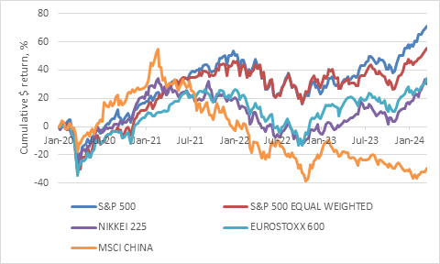

Source: LSEG Datastream

The old saying “don’t fight the Fed” proved to be true as equities rallied on the back of its support for the financial system even as economies contracted at the fastest pace ever, effectively shutting down.

But it also proved to be true when inflation turned out to be more entrenched than initially thought. When the Fed and other central banks turned their attention to fighting inflation in 2022, equity and bond markets fell simultaneously in what was the worst year for global balanced portfolios in decades. 2023 saw a recovery in fits and starts, amid concerns that interest rates would remain elevated for an extended period, leading to a recession in the US and elsewhere.

Where do we stand today?

One notable feature of this entire four-year period is that the US equity market continued its outperformance over the rest of the world, stretching back to 2009. There was a moment when it seemed China would emerge from the pandemic in a stronger position than the West, and this was reflected in market pricing. The exact opposite happened of course, and the MSCI China Index is still 30% below pre-Covid levels today.

Chart 2: Ratio of US to non-US equities in dollars

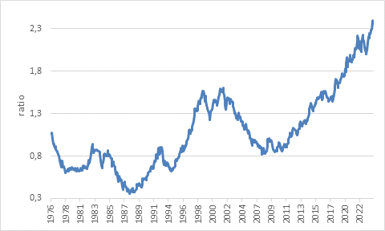

Source: LSEG Datastream

There are several reasons for this. A strong US dollar over this period penalises the returns of other markets. US economic growth has been a lot more resilient than other developed economies. For instance, when the Russian invasion of Ukraine sparked an energy crisis across Europe and other regions, the US, being a major oil and gas producer, experienced a much smaller impact. When the Fed started hiking rates, the impact on households and firms with fixed-rate debt was limited, whereas in many other countries (like South Africa) variable rate debt is common and borrowers had to take it on the chin.

The US government’s seemingly endless willingness – and ability – to borrow money also helped. The CARES act package was followed up by another stimulus injection in December 2020, the $1.9 trillion American Rescue Plan in March 2021, and President Biden’s signature (but misleadingly named) Inflation Reduction Act. The latter, among other things, provides multi-billion-dollar support for the construction of microchip and battery manufacturing facilities. The flipside is that US government debt will continue to rise steadily in the years ahead.

And then there is technology. The rapid forced shift to work-from-home was a major boost for technology companies, though short-lived in some cases. Zoom’s share price jumped sevenfold in 2020 but it trades back near pre-Covid levels today. The excitement today is not so much about video conferencing, online shopping or streaming entertainment. It is about generative artificial intelligence (AI).

Nvidia, supplier of the high-spec microchips that are used to run AI models, is a recent joiner to the ranks of the tech giants, coming seemingly out of nowhere to become the world’s third most valuable company in the company of Microsoft, Amazon, Apple and Alphabet (parent company of Google). These are all US firms.

These companies were born as ideas in the heads of founders, who are often students at America’s elite universities. To turn these ideas into businesses requires an entrepreneurial, risk-taking culture, but also funding. The US has an unrivalled financial ecosystem with venture capital firms that specialise in investing in all the growth stages of these start-ups. Increasingly, US markets are also attracting international technology firms when they list for the first time. Firms can access a much larger investor base and earn higher valuations this way, much to the chagrin of politicians in their home countries.

Led by these tech companies, US earnings growth has been stronger than other markets. But investors have also been prepared to pay up for this growth. The US price: earnings (PE) ratios have risen much faster than elsewhere. The S&P 500 traded on a similar forward PE ratio to non-US equities in 2010. Today it is substantially more expensive.

Rising sun, rising again
It is not as if non-US equities have gone nowhere, however. In particular, Japan, the land of the rising sun seems to be rising again. Or at least its stock market is. The Japanese Nikkei 225 index finally surpassed its all-time high level (excluding dividends), 34 years later.

Chart 3: Nikkei 225 Index in yen

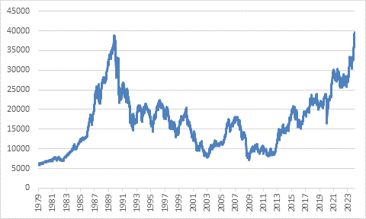

Source: LSEG Datastream

For a long time, the Japanese market was the retort to the idea that equities always rise over time. The point, though, is that there was a massive bubble in the late 1980s, not just in Japanese stocks but also in real estate. The Nikkei traded at 40 times forward earnings at its peak, compared to only 15 times today. Buying into such an overvalued market virtually guaranteed poor returns for many years. It was complicated by the long-term damage done to the Japanese economy, particularly the banking sector, by the bursting of the property bubble. Equity bubbles tend to have limited impact on the real economy when they pop, but real estate is typically bought with debt that weighs down economic activity for years.

The recent strength in Japanese shares is largely driven by these companies becoming more shareholder-focused over the past decade. There is still room to unwind cross-shareholdings and return cash to investors. The long-term prospects for the Japanese economy remain constrained by a declining population. Nonetheless, the Bank of Japan might finally have the confidence to end its eight-year experiment with negative interest rates.

While the rest of the world has been debating whether the inflationary surge of the past two years will recede, the question in Japan has been whether it will stay. The recent annual round of wage negotiations between unions and large firms, known as shunto, looks set to deliver the biggest wage increases in a decade. It would be ironic if it took a global pandemic to finally shake Japan out of its long deflationary funk.

Bubble spotting
The long, painfully slow post-bubble recovery of the Japanese market forces us to ask if there is a similar risk to the current AI euphoria. Now it should be noted that bubbles are difficult to spot in real time, because there is always good argument to be made for why the investment in question is trading at lofty levels.

Wall Street Journal columnist James McIntosh put it succinctly this week: “The problem in a bubble isn’t usually that the story is wrong, but that the price is wrong, because investors are wildly overoptimistic about how fast or how profitable the changes will be.”

Think about the 1990s dotcom bubble. We all use the internet today, so the dotcom boosters weren’t wrong, and some of the big names of that era are still around today. But investors underestimated how long it would take for this revolutionary technology to take off and become entrenched in daily life, and therefore overpaid for the shares.

The problem with AI is that we don’t yet know who the real winners will be. It is an expensive, specialised business, so the current front-runners are the deep-pocketed Silicon Valley giants. These are not speculative businesses, but already cash-generating machines. However, competition could still emerge from anywhere in this new field. Remember how the pioneers in the mobile phone business, Motorola, Nokia and BlackBerry, have long since surrendered leadership, for instance. The ultimate winners might also turn out be firms in other fields – finance, medicine, retail – that use AI models on their internal data to cut costs and improve processes, products and services. We just don’t know. So, while the short answer is no, it doesn’t seem as if we’re in bubble territory, there is reason to be circumspect. A lot of good news is priced in already, not just in AI but across US equities.

Chart 4: Forward price: earnings ratios
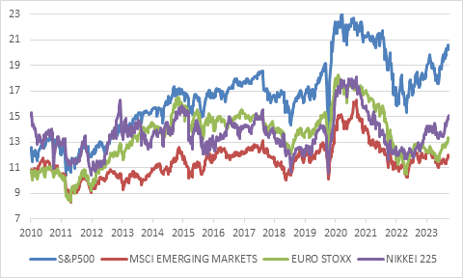

Source: LSEG Datastream

A vaccine for your wealth
It is remarkable that in the space of four years we’ve experienced a pandemic and shutdown of the global economy, wars and a once-in-a-generation surge in inflation, record interest rate increases, and now talk of a technological revolution and an equity bubble. It recalls Lenin’s quote that there are decades where nothing happens; and there are weeks where decades happen. It feels like time compressed and many years of history squeezed into the past four. The world that has emerged from the pandemic is also a very different and much more uncertain than the one that went into it.

However, throughout this tumultuous period, investors would have benefited from time-tested investing principles. Think of it as a vaccine for your wealth. Trying to time the market in these chaotic years would have probably resulted in failure. Staying invested in a diversified portfolio throughout the ups and down would have served most investors well.

This note returns on 4 April. Thank you for reading!

